LAB 5: Sequence Diagram – Library Management System
Submitted by: Vanshika Mudgal Reg No: 202401100200340 Subject: Software Engineering Lab

Aim
To draw the sequence diagram of the Library Management System for the Issue Book scenario, showing how the objects interact with each other in time order.

Theory
A sequence diagram is an interaction diagram that shows how objects communicate with each other through messages, arranged in the order in which they happen. Time flows from top to bottom.
The elements used in the diagram are:
- Actor / Object: a participant of the interaction, drawn as a box at the top.
- Lifeline: the dashed vertical line below a participant that shows its existence over time.
- Message: a horizontal arrow from one lifeline to another, labelled with the operation that is called. A solid arrow is a call.
- Return message: a dashed arrow that sends the result back to the caller.
- Combined fragment (alt): a box that shows alternative paths. Only the path whose condition is true is executed, and the paths are separated by a dashed line.

Scenario
The scenario drawn is Issue Book. The librarian enters the member ID and the ISBN of the book. The system checks whether the member is eligible and whether the book is available. If both are true, an issue record is created, the stock of the book is reduced and a confirmation is shown to the librarian. Otherwise the request is rejected.

Objects Used
Object | Role
Librarian | The actor who starts the issue request.
:LibrarySystem | The control object that receives the request and coordinates the other objects.
:Member | Holds the details of the member and tells whether the member is eligible.
:Book | Holds the details of the book and its available copies.
:BookIssue | The record that is created when a book is issued.

Message Sequence
No. | From | To | Message | Description
1 | Librarian | :LibrarySystem | issueBook(id, isbn) | The librarian sends the member ID and the book ISBN.
2 | :LibrarySystem | :Member | checkEligibility(id) | The system checks the pending fine and the issue limit of the member.
3 | :Member | :LibrarySystem | eligible | Return message with the eligibility result.
4 | :LibrarySystem | :Book | isAvailable(isbn) | The system checks whether a copy of the book is available.
5 | :Book | :LibrarySystem | available | Return message with the availability result.
6 | :LibrarySystem | :BookIssue | createIssue(id, isbn) | Valid request: the issue record is created with the issue date and due date.
7 | :BookIssue | :LibrarySystem | issueId | Return message with the new issue ID.
8 | :LibrarySystem | :Book | updateStock(-1) | Valid request: the available copies of the book are reduced by one.
9 | :LibrarySystem | Librarian | issue confirmed | Valid request: the confirmation is shown to the librarian.
10 | :LibrarySystem | Librarian | request rejected | Otherwise: the request is rejected and the librarian is informed.

Sequence Diagram
The sequence diagram of the Issue Book scenario is shown below.
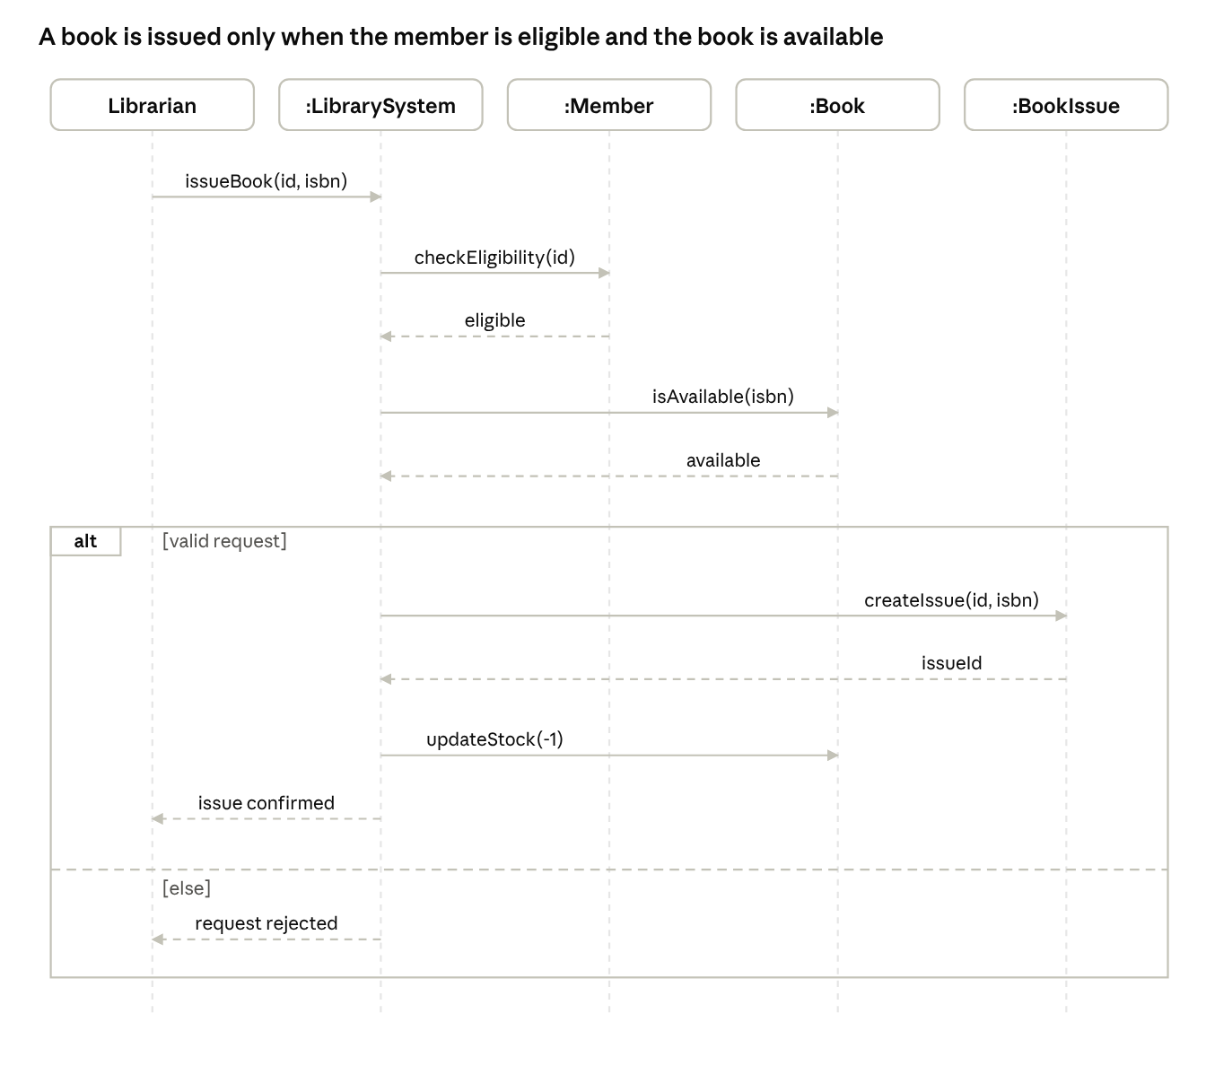
sequence diagram · 5 lifelines, 1 alt fragment
Figure 1: Sequence diagram of the Issue Book scenario in the Library Management System.

Conclusion
The sequence diagram of the Issue Book scenario of the Library Management System was drawn. It shows the order of the messages between the Librarian, LibrarySystem, Member, Book and BookIssue objects, and the alternative path for a request that is not valid.

