LAB 6: Sequence Diagram – Library Management System
Submitted by: Vanshika Mudgal Reg No: 202401100200340 Subject: Software Engineering Lab

Aim
To draw the sequence diagram of the Library Management System for the Return Book and Pay Fine scenario, showing how the objects interact with each other in time order.

Theory
A sequence diagram is an interaction diagram that shows how objects communicate with each other through messages, arranged in the order in which they happen. Time flows from top to bottom.
The elements used in the diagram are:
- Actor / Object: a participant of the interaction, drawn as a box at the top.
- Lifeline: the dashed vertical line below a participant that shows its existence over time.
- Message: a horizontal arrow from one lifeline to another, labelled with the operation that is called. A solid arrow is a call.
- Return message: a dashed arrow that sends the result back to the caller.
- Combined fragment (alt): a box that shows alternative paths. Only the path whose condition is true is executed, and the paths are separated by a dashed line.

Scenario
The scenario drawn is Return Book. The librarian enters the issue ID of the book that the member returns. The system finds the issue record and calculates the fine. If a fine is due, a fine record is created, the librarian collects the amount from the member and the fine is marked as paid. If there is no fine, nothing more is needed. In both cases the system then increases the stock of the book and confirms the return to the librarian.

Objects Used
Object | Role
Librarian | The actor who accepts the returned book.
:LibrarySystem | The control object that receives the request and coordinates the other objects.
:BookIssue | The record of the issued book. It holds the due date and calculates the fine.
:Fine | The penalty record that is created for a late return and marked as paid later.
:Book | The book whose available copies increase after the return.

Message Sequence
No. | From | To | Message | Description
1 | Librarian | :LibrarySystem | returnBook(issueId) | The librarian sends the issue ID of the returned book.
2 | :LibrarySystem | :BookIssue | getIssueDetails(id) | The system asks for the details of the issue record.
3 | :BookIssue | :LibrarySystem | dueDate | Return message with the due date.
4 | :LibrarySystem | :BookIssue | calculateFine() | The system asks the record to calculate the fine from the due date and the return date.
5 | :BookIssue | :LibrarySystem | fineAmount | Return message with the fine amount.
6 | :LibrarySystem | :Fine | createFine(id, amt) | Fine due: a fine record is created.
7 | :Fine | :LibrarySystem | fineId | Return message with the new fine ID.
8 | :LibrarySystem | Librarian | fine due | Fine due: the librarian is told to collect the fine.
9 | Librarian | :LibrarySystem | payFine(fineId) | Fine due: the librarian records the payment of the member.
10 | :LibrarySystem | :Fine | markPaid() | Fine due: the fine is marked as paid.
11 | :Fine | :LibrarySystem | paid | Return message that the fine is paid.
12 | :LibrarySystem | Librarian | no fine | Otherwise: the librarian is told that no fine is due.
13 | :LibrarySystem | :Book | updateStock(+1) | The available copies of the book are increased by one.
14 | :LibrarySystem | Librarian | return completed | The completion of the return is shown to the librarian.

Sequence Diagram
The sequence diagram of the Return Book and Pay Fine scenario is shown below.
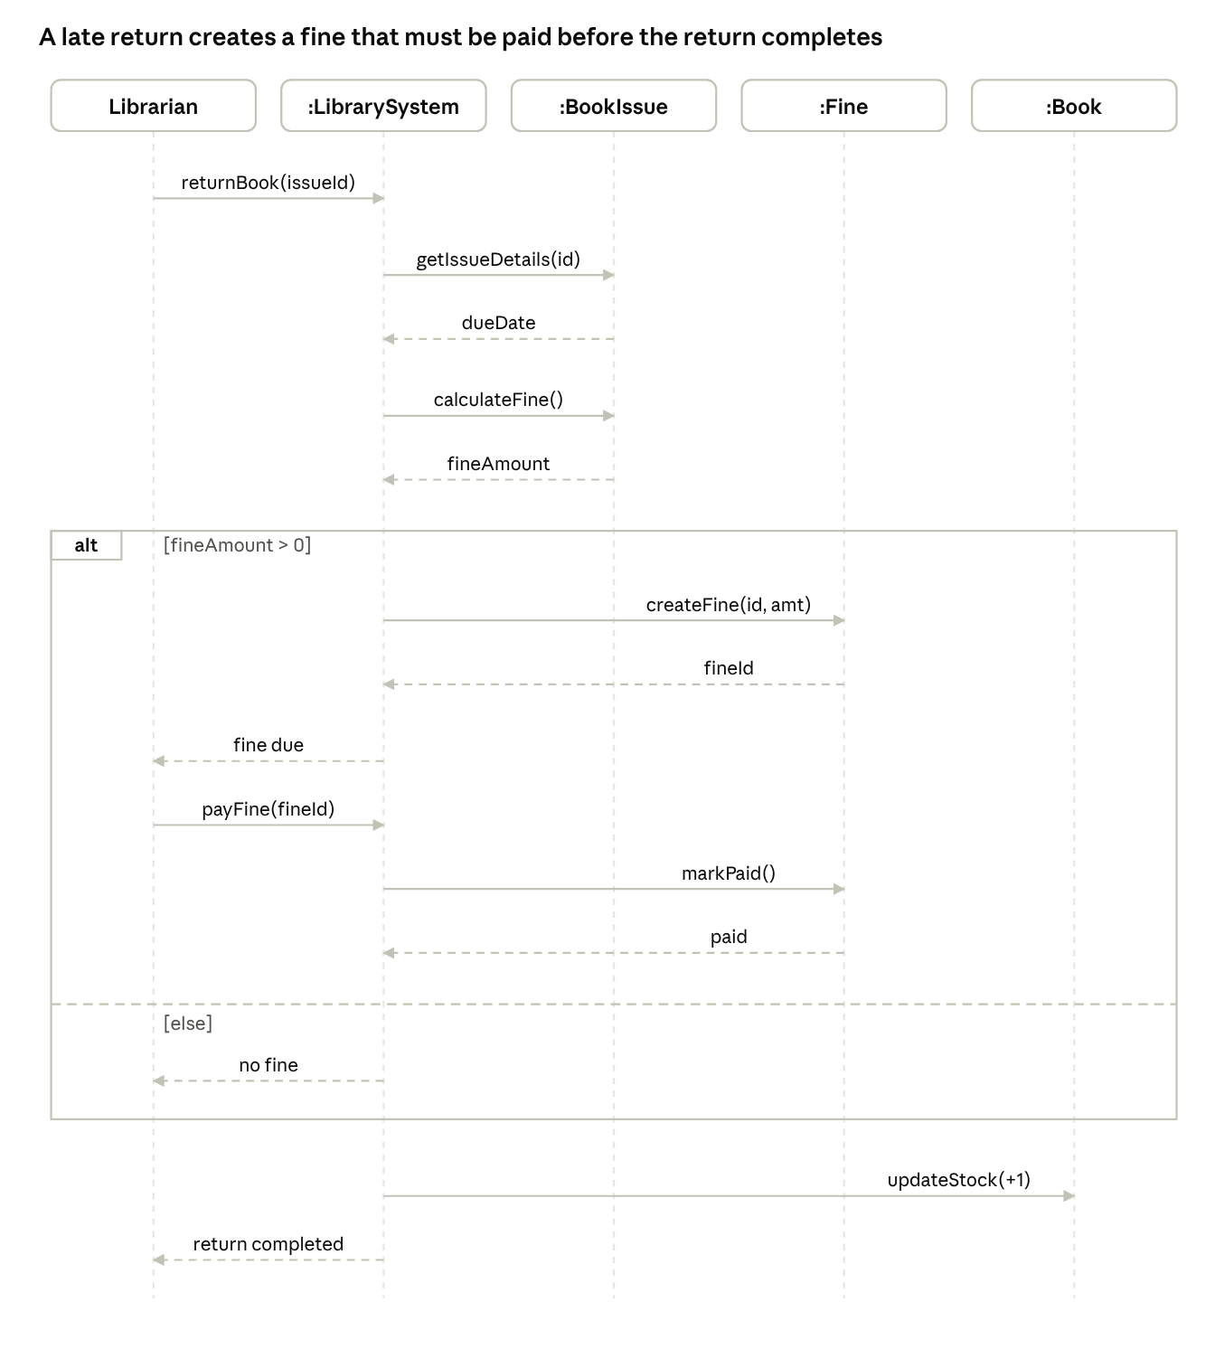
sequence diagram · 5 lifelines, 1 alt fragment
Figure 1: Sequence diagram of the Return Book and Pay Fine scenario in the Library Management System.

Conclusion
The sequence diagram of the Return Book and Pay Fine scenario of the Library Management System was drawn. It shows the order of the messages between the Librarian, LibrarySystem, BookIssue, Fine and Book objects, and the alternative paths for a return with a fine and a return without a fine.

