LAB 7: Collaboration Diagram – Library Management System
Submitted by: Vanshika Mudgal Reg No: 202401100200340 Subject: Software Engineering Lab

Aim
To draw the collaboration (communication) diagram of the Library Management System for the Issue Book scenario, showing how the objects are linked and which messages they exchange.

Theory
A collaboration diagram, called a communication diagram in UML 2, is an interaction diagram that shows the objects of a system, the links between them and the messages that are passed along those links. It shows the same information as a sequence diagram, but the stress is on the structure (who is connected to whom) and not on the time order.
The elements used in the diagram are:
- Object / Actor: a participant of the interaction, drawn as a box.
- Link: a solid line between two objects that can communicate with each other.
- Message: an arrow or label written along a link. The direction of the message is shown by the arrow symbol.
- Sequence number: the number written before every message (1, 2, 3 ...) that shows the order of the messages.
- Guard condition: a condition in square brackets, such as [valid], written before a message. The message is sent only if the condition is true.

Scenario
The scenario drawn is Issue Book, which is the same scenario as the sequence diagram of Lab 5. The librarian sends the member ID and the ISBN to the system. The system checks the member and the book. If the request is valid, it creates the issue record, reduces the stock of the book and confirms to the librarian. Otherwise the request is rejected.

Objects Used
Object | Role
Librarian | The actor who starts the issue request.
:LibrarySystem | The control object that receives the request and coordinates the other objects.
:Member | Holds the details of the member and tells whether the member is eligible.
:Book | Holds the details of the book and its available copies.
:BookIssue | The record that is created when a book is issued.

Messages
No. | From | To | Message | Description
1 | Librarian | :LibrarySystem | issueBook(id, isbn) | The librarian sends the member ID and the book ISBN.
2 | :LibrarySystem | :Member | checkEligibility(id) | The system checks the pending fine and the issue limit of the member.
3 | :Member | :LibrarySystem | eligible | The eligibility result is returned.
4 | :LibrarySystem | :Book | isAvailable(isbn) | The system checks whether a copy of the book is available.
5 | :Book | :LibrarySystem | available | The availability result is returned.
6 | :LibrarySystem | :BookIssue | [valid] createIssue(id, isbn) | If the request is valid, the issue record is created.
7 | :BookIssue | :LibrarySystem | issueId | The ID of the new issue record is returned.
8 | :LibrarySystem | :Book | [valid] updateStock(-1) | If the request is valid, the available copies are reduced by one.
9 | :LibrarySystem | Librarian | [valid] confirmed | If the request is valid, the confirmation is shown to the librarian.
10 | :LibrarySystem | Librarian | [else] rejected | Otherwise the request is rejected.

Collaboration Diagram
The collaboration diagram of the Issue Book scenario is shown below. The arrow symbols next to each message show its direction along the link.
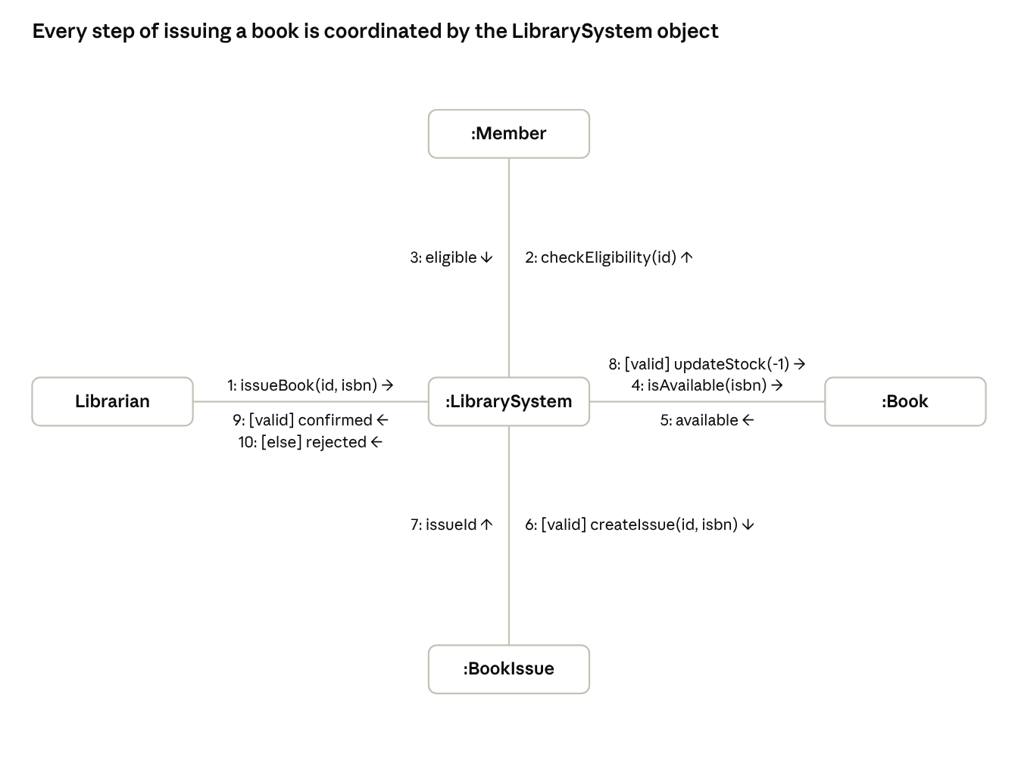
collaboration diagram · 5 objects, 10 numbered messages
Figure 1: Collaboration diagram of the Issue Book scenario in the Library Management System.

Sequence Diagram and Collaboration Diagram
Point | Sequence diagram | Collaboration diagram
Main stress | Time order of the messages | Links between the objects
Order of messages | Shown by the vertical position | Shown by the sequence numbers
Layout | Objects in a row at the top with lifelines | Objects placed freely with links between them
Best used for | Showing the flow of one scenario in detail | Showing which objects work together

Conclusion
The collaboration diagram of the Issue Book scenario of the Library Management System was drawn. It shows the Librarian, LibrarySystem, Member, Book and BookIssue objects, the links between them and the numbered messages that they exchange.

