LAB 8: State Transition Diagram – ATM System
Submitted by: Vanshika Mudgal
REG NO: 202401100200340
Subject: Software Engineering Lab

Aim
To draw the state transition diagram of an ATM (Automated Teller Machine) showing the states of the machine and the events that move it from one state to another while a customer uses it.

Theory
A state transition diagram is a behavioural UML diagram that shows the different states an object or system can be in during its life and how it moves from one state to another when an event occurs. It is useful for systems whose behaviour depends on what has already happened, such as an ATM that must remember whether the card is inserted and the PIN is verified.
The elements used in the diagram are:
- Initial state: a filled circle that shows where the system starts.
- State: a rounded rectangle that shows a condition in which the system waits for an event.
- Transition: an arrow that connects one state to the next state.
- Event / condition: the label on a transition that tells what causes the change, such as insert card or correct PIN.
- Self-transition: an arrow that starts and ends at the same state, for example a wrong PIN attempt.
- Final state: a circle with a filled centre that shows where the life of the system ends.

Process Description
The process drawn is a customer using the ATM. The machine has eight states: Idle, Card Inserted, PIN Verification, Transaction Menu, Withdraw Cash, Balance Enquiry, Card Blocked and Card Ejected.
- The ATM stays in the Idle state until a customer inserts a card. The machine then reads the card. If the card is invalid it is ejected.
- If the card is read correctly, the ATM asks for the PIN. A wrong PIN keeps the machine in the PIN Verification state, and after 3 wrong attempts the card is blocked and retained.
- If the PIN is correct, the Transaction Menu is shown. The customer can select withdraw or balance enquiry.
- After cash is dispensed (or the withdrawal fails due to insufficient funds) or the balance is displayed, the ATM returns to the Transaction Menu.
- When the customer cancels or exits, the card is ejected. After the card is taken the process ends and the machine becomes ready for the next customer.

States and Transitions

No. | Current State | Event / Condition | Next State
1 | Start | ATM switched on | Idle
2 | Idle | Insert card | Card Inserted
3 | Card Inserted | Card read OK | PIN Verification
4 | Card Inserted | Invalid card | Card Ejected
5 | PIN Verification | Correct PIN | Transaction Menu
6 | PIN Verification | Wrong PIN (attempts < 3) | PIN Verification
7 | PIN Verification | 3 wrong attempts | Card Blocked
8 | Transaction Menu | Select withdraw | Withdraw Cash
9 | Transaction Menu | Select balance | Balance Enquiry
10 | Transaction Menu | Cancel / exit | Card Ejected
11 | Withdraw Cash | Cash dispensed / insufficient funds | Transaction Menu
12 | Balance Enquiry | Display done | Transaction Menu
13 | Card Blocked | Retain card | Card Ejected
14 | Card Ejected | Card taken | End
15 | Card Ejected | Machine ready | Idle

State Transition Diagram
The state transition diagram of the ATM is shown below.

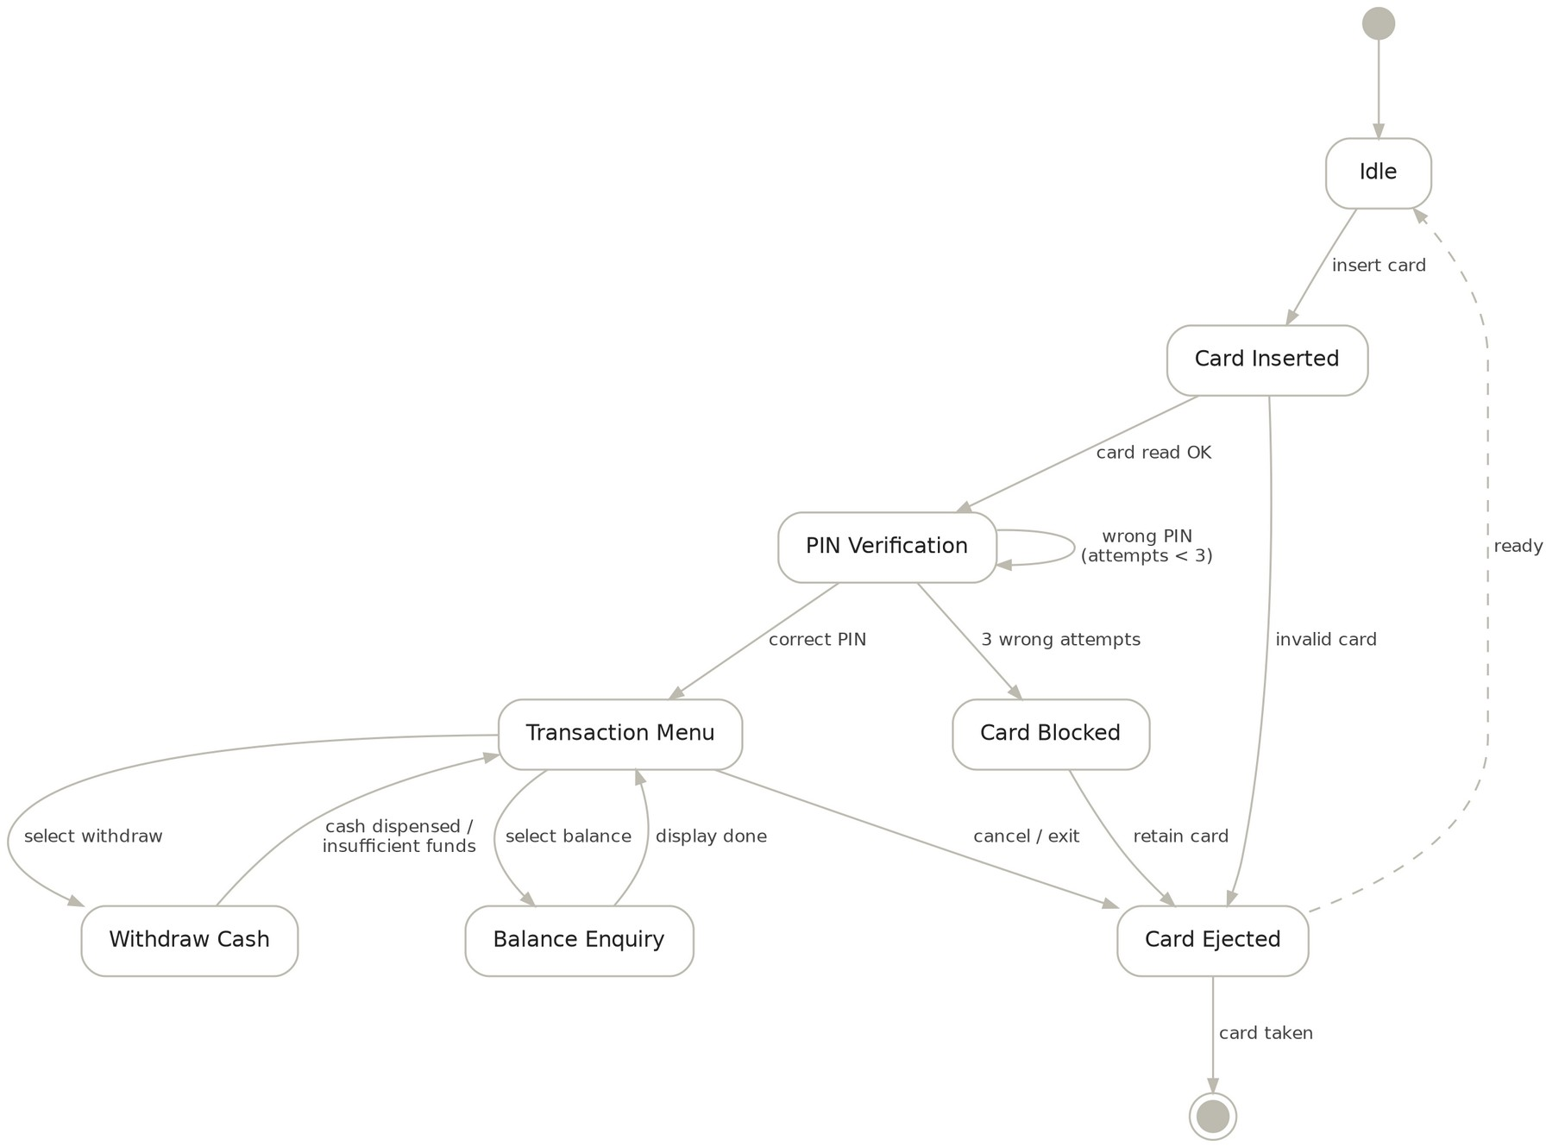
Only a card with the correct PIN reaches the menu; three wrong PINs block the card
state transition diagram · 8 states, 15 transitions
Figure 1: State transition diagram of the ATM system.

Conclusion
The state transition diagram of the ATM system was drawn showing eight states along with the initial and final states. It shows the complete flow from inserting the card to ejecting it, including the events for invalid card, wrong PIN, card blocking, withdrawal and balance enquiry.

