LAB 9: Component Diagram – ATM System
Submitted by: Vanshika Mudgal
Reg No: 202401100200340
Subject: Software Engineering Lab

Aim
To draw the component diagram of the ATM (Automated Teller Machine) system showing its main software and hardware components and the interfaces through which they depend on each other.

Theory
A component diagram is a structural UML diagram that shows how a system is divided into components and how these components are connected to each other. A component is a modular, replaceable part of the system that hides its inner details and communicates with other components only through its interfaces. It is mostly used in the design phase to understand the physical structure of the system.
The elements used in the diagram are:
- Component: a rectangle with a small component symbol that shows a part of the system, such as the ATM Controller.
- Interface: the set of services that a component offers to or needs from other components, such as IAuthenticate.
- Dependency: a dashed arrow from a component that uses a service to the component that provides it, labelled with the interface name.
- Package / node: a rounded boundary that groups related components, such as the ATM Machine and the Bank.

Process Description
The component diagram drawn is for the ATM system. It has nine components placed in two groups: the ATM Machine and the Bank.
- The Card Reader and the Keypad & Screen collect the card data and the user input and pass them to the ATM Controller through the ICardData and IUserInput interfaces.
- The ATM Controller is the central component. It asks the Authentication Manager to verify the user (IAuthenticate) and asks the Transaction Manager to carry out the chosen transaction (ITransaction).
- The Authentication Manager sends the card number and PIN to the Bank Server (IVerifyPIN) for verification.
- The Transaction Manager checks and updates the balance through the Bank Server (IAccount), then uses the Cash Dispenser (IDispense) to give the cash and the Receipt Printer (IPrint) to print the receipt.
- The Bank Server keeps the account details in the Account Database and reads or updates them through the IData interface.

Components and Their Responsibilities

No. | Component | Responsibility | Interface
1 | Card Reader | Reads the card inserted by the customer | ICardData (provides)
2 | Keypad & Screen | Takes PIN and choices, shows messages | IUserInput (provides)
3 | ATM Controller | Controls the overall flow of the ATM | Uses IAuthenticate, ITransaction
4 | Authentication Manager | Verifies the card and the PIN | IAuthenticate (provides), uses IVerifyPIN
5 | Transaction Manager | Handles withdrawal and balance enquiry | ITransaction (provides), uses IAccount, IDispense, IPrint
6 | Cash Dispenser | Dispenses the cash | IDispense (provides)
7 | Receipt Printer | Prints the receipt | IPrint (provides)
8 | Bank Server | Checks PIN and updates the account | IVerifyPIN, IAccount (provide), uses IData
9 | Account Database | Stores account and balance data | IData (provides)

Component Diagram
The component diagram of the ATM system is shown below.

The ATM Controller connects the devices with the services; the Bank holds the data
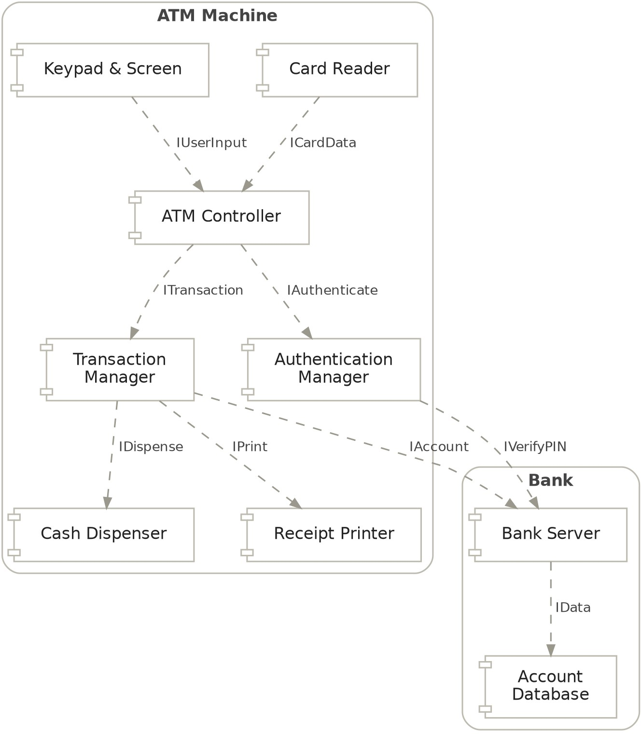
component diagram · 9 components, 9 dependencies
Figure 1: Component diagram of the ATM system.

Conclusion
The component diagram of the ATM system was drawn showing nine components grouped into the ATM Machine and the Bank. It shows how the ATM Controller works with the authentication, transaction and device components through interfaces, and how these depend on the Bank Server and the Account Database.

