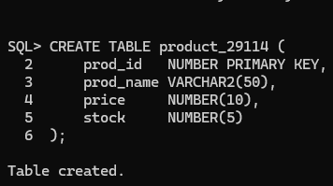
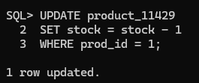
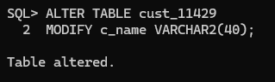

Perfect 👍 I’ll write this as a real-life, story-based case study, but still 100% aligned with your actual data and tables, so teachers love it.
You can directly use this in your project.

📘 CASE STUDY
Sales Order Management System – Real Life Scenario

1️⃣ Background
ABC Electronics is a retail store located in Mumbai that sells electronic products such as laptops, smartphones, printers, and computer accessories.
To manage its daily business operations, the store uses a Sales Order Management System to keep track of customers, products, and sales orders.
The system stores data in three main tables:
- Customer
- Product
- Orders

2️⃣ Real Life Problem
Earlier, ABC Electronics maintained customer and order details manually, which often led to:
- Duplicate customer records
- Difficulty in tracking product stock
- Errors in order status updates
To overcome these issues, the store implemented a database-driven Sales Order System using SQL.

3️⃣ System Implementation (Real Data Scenario)
👤 Customers Visiting the Store
Customers such as Rajesh Patel, Priya Sharma, Amit Desai, Sneha Gupta, and Vikram Singh visit the store to purchase electronic items.
Their personal details like address, phone number, and email are stored in the Customer table.

📦 Products Available in Store
The store sells the following products:
- Dell Inspiron 15 Laptop
- Samsung Galaxy S24
- Apple iPhone 15 Pro
- Logitech Wireless Mouse
- HP LaserJet Printer
Each product has a unique product ID, price, and available stock, which is maintained in the Product table.

🧾 Order Processing (Day-to-Day Operations)
When a customer places an order, the following steps occur:
- The customer selects a product.
- The sales executive checks product availability.
- An order is created in the system.
- Order status is updated based on delivery progress.

4️⃣ Real Life Order Scenarios (Based on Actual Data)
🟢 Scenario 1
Rajesh Patel purchases 1 Dell Inspiron 15 Laptop on 10 January 2026.
The order is processed successfully and marked as Completed.

🟡 Scenario 2
Priya Sharma orders a Samsung Galaxy S24 on 11 January 2026.
The product is packed and dispatched, so the order status is Shipped.

🔵 Scenario 3
Amit Desai places an order for an Apple iPhone 15 Pro on 12 January 2026.
Due to payment verification, the order remains Pending.

🟢 Scenario 4
Sneha Gupta buys 2 Logitech Wireless Mouse units on 12 January 2026.
The order is delivered successfully and marked as Completed.

🟡 Scenario 5
Vikram Singh purchases an HP LaserJet Printer on 13 January 2026.
The order is dispatched and marked as Shipped.

5️⃣ Role of Database Tables in Real Life
📌 Customer Table
Stores customer information so repeat customers do not need to re-enter their details.
📌 Product Table
Helps the store monitor product prices and available stock in real time.
📌 Orders Table
Tracks which customer ordered which product, quantity ordered, order date, and current status.

6️⃣ Benefits of the System
- Faster order processing
- Accurate stock management
- Easy tracking of order status
- Reduced data redundancy
- Improved customer service

7️⃣ Conclusion
The Sales Order Management System helps ABC Electronics manage its real-world sales operations efficiently.
By using relational tables and SQL queries, the store ensures accurate record-keeping, smooth order tracking, and better decision-making.

If you want, I can:
- make this shorter (exam-friendly)
- add flow diagram
- link this case study with ER diagram explanation
Just say 👍

