**EXPERIMENT NO. 4 - Flask Application using GET and POST**

|  |  |
| --- | --- |
| **Name of Student** | **Vanshika Ambwani** |
| **Class Roll No** | **D15A 2** |
| **D.O.P.** |  |
| **D.O.S.** |  |
| **Sign and Grade** |  |

**EXPERIMENT 4**

**AIM :**

To design a Flask application that showcases URL building and demonstrates the use of HTTP methods (GET and POST) for handling user input and processing data.

**PROBLEM STATEMENT :**

Create a Flask application with the following requirements:

1. A homepage (/) with links to a "Profile" page and a "Submit" page using the url_for() function.
2. The "Profile" page (/profile/<username>) dynamically displays a user’s name passed in the URL.
3. A "Submit" page (/submit) displays a form to collect the user’s name and age. The form uses the POST method to send the data, and the server displays a confirmation message with the input.

**Theory:**

1. **What is a route in Flask, and how is it defined?**

A route is a URL pattern linked to a function in Flask using the @app.route() decorator.

**Example:**

@app.route('/') def home(): return "Welcome!”

1. **How can you pass parameters in a URL route?**

Parameters can be passed using angle brackets (< >) in the route. Flask will capture these values and pass them to the function as arguments. You can also specify data types like <int:id> or <string:name>.

**Example:**

@app.route('/user/<string:name>') def greet_user(name):

return f"Hello, {name}!"

1. **What happens if two routes in a Flask application have the same URL pattern?**

If two routes share the same URL, Flask will use the last-defined route and override the previous one. This causes unexpected behavior and conflicts.

**Example:**

@app.route('/hello') def hello1():

return "Hello from function 1"

@app.route('/hello') def hello2():

return "Hello from function 2"

# Only "Hello from function 2" will be shown.

1. **What are the commonly used HTTP methods in web applications?**

* HTTP methods define the type of request a client sends to a server.
* GET: Retrieve data (e.g., accessing a web page).
* POST: Send data to the server (e.g., submitting a form).
* PUT: Update existing data.
* DELETE: Remove data.
* PATCH: Partially update data.

1. **What is a dynamic route in Flask?**

A dynamic route allows variables to be embedded within the URL, making it more flexible. The data in the URL is passed to the function for further processing.

**Example:**

@app.route('/profile/<username>') def show_profile(username):

return f"Welcome to {username}'s Profile!"

1. **Write an example of a dynamic route that accepts a username as a parameter.** @app.route('/user/<username>') def welcome_user(username):

return f"Hello, {username}! Glad to see you here."

1. **What is the purpose of enabling debug mode in Flask?**

Debug Mode is used during development for easy troubleshooting. It enables:

**Automatic Code Reloading:** The app restarts when code changes.

**Detailed Error Messages:** Displays an interactive debugger in case of an error. It should be disabled in production for security reasons.

1. **How do you enable debug mode in a Flask application?**

You can enable debug mode using one of these methods: Using app.run() export FLASK_ENV=development

flask run

**CODE:**

app.py from flask import Flask, request, url_for, redirect, session

app = Flask(__name__) app.secret_key = "supersecretkey"

@app.route('/') def home():

return f'''

<html>

<head>

<style>

body {{ background: linear-gradient(to right, #00c9ff, #92fe9d); text-align: center; color: white; }}

a {{ display: inline-block; margin: 10px; padding: 10px; background: rgba(0, 0, 0,

0.2); text-decoration: none; color: white; border-radius: 5px; }} a:hover {{ background: rgba(0, 0, 0, 0.5); }}

</style>

</head>

<body>

<h1>Welcome to the Homepage</h1>

<a href="{url_for('profile')}">Go to Profile</a>

<a href="{url_for('submit')}">Go to Submit Page</a>

</body>

</html>

'''

@app.route('/profile') def profile():

name = session.get('name', 'Guest') age = session.get('age', 'Unknown')

return f'''

<html>

<head>

<style>

body {{ background: linear-gradient(to right, #007adf, #00ecbc); text-align: center; color: white; }} </style>

</head>

<body>

<h1>Profile Page</h1>

<p><strong>Name:</strong> {name}</p>

<p><strong>Age:</strong> {age}</p>

<a href="{url_for('home')}">Back to Homepage</a>

</body>

</html>

'''

@app.route('/submit', methods=['GET', 'POST']) def submit(): if request.method == 'POST':

session['name'] = request.form.get('name', 'Unknown') session['age'] = request.form.get('age', 'Unknown') return redirect(url_for('profile'))

return '''

<html>

<head>

<style>

body { background: linear-gradient(to right, #ff512f, #dd2476); text-align: center; color: ; }

form { display: inline-block; background: rgba(0, 0, 0, 0.2); padding: 20px; border-radius: 10px; } input { margin: 5px; padding: 10px; border-radius: 5px; border: none; } input[type="submit"] { background: rgba(0, 0, 0, 0.5); color: white; cursor: pointer; } </style>

</head>

<body>

<h1>Submit Page</h1>

<form method="post">

<label for="name">Name:</label>

<input type="text" id="name" name="name" required><br>

<label for="age">Age:</label>

<input type="number" id="age" name="age" required><br>

<input type="submit" value="Submit">

</form>

<a href="{url_for('home')}">Back to Homepage</a>

</body>

</html>

'''

if __name__ == '__main__': app.run(debug=True)

**OUTPUT :**

**Homepage:** Displays a welcome message with navigation links to the "Profile" and "Submit" pages.

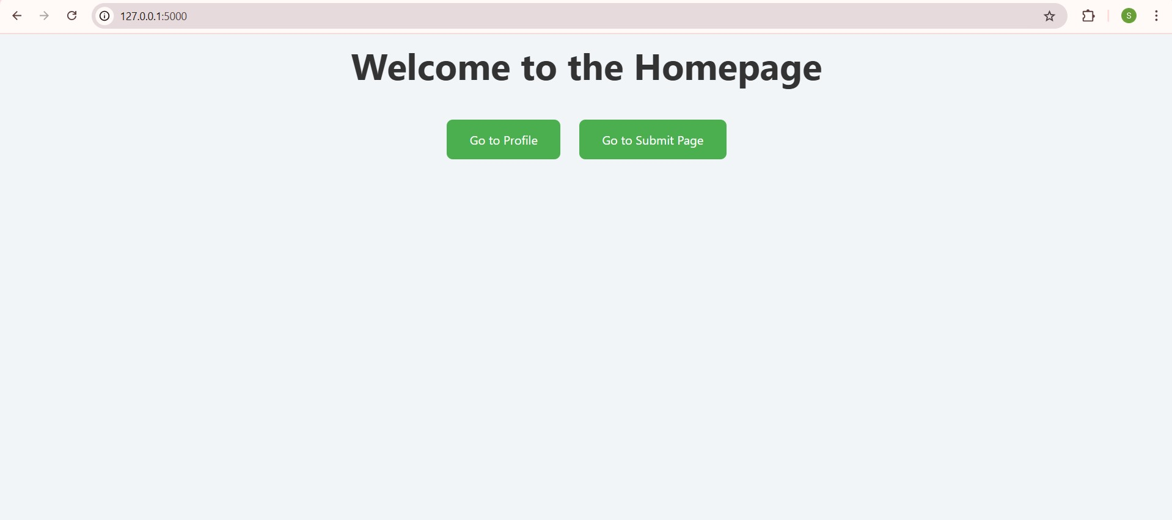

**Submit Page:** Displays a form to collect the user's name and age. Upon submitting, the data is stored using a session, and the user is redirected to the Profile page.

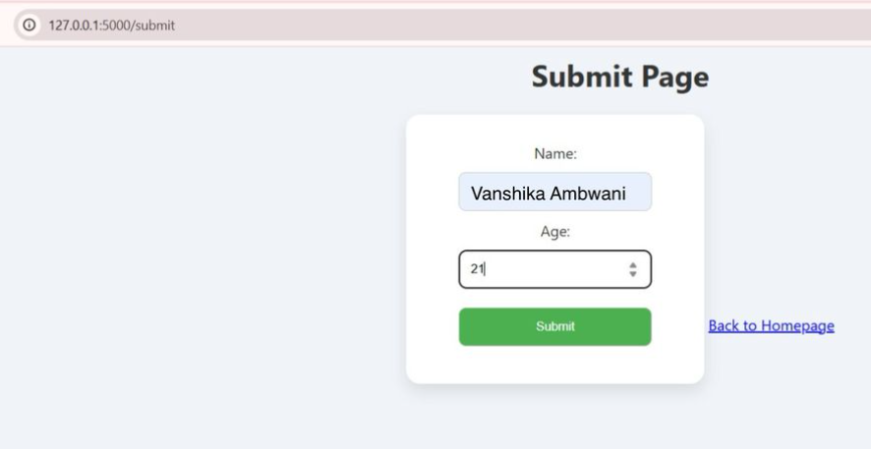

**Profile Page:** Displays the submitted name and age dynamically. If no data is submitted, it shows "Guest" and "Unknown" as default values**.**

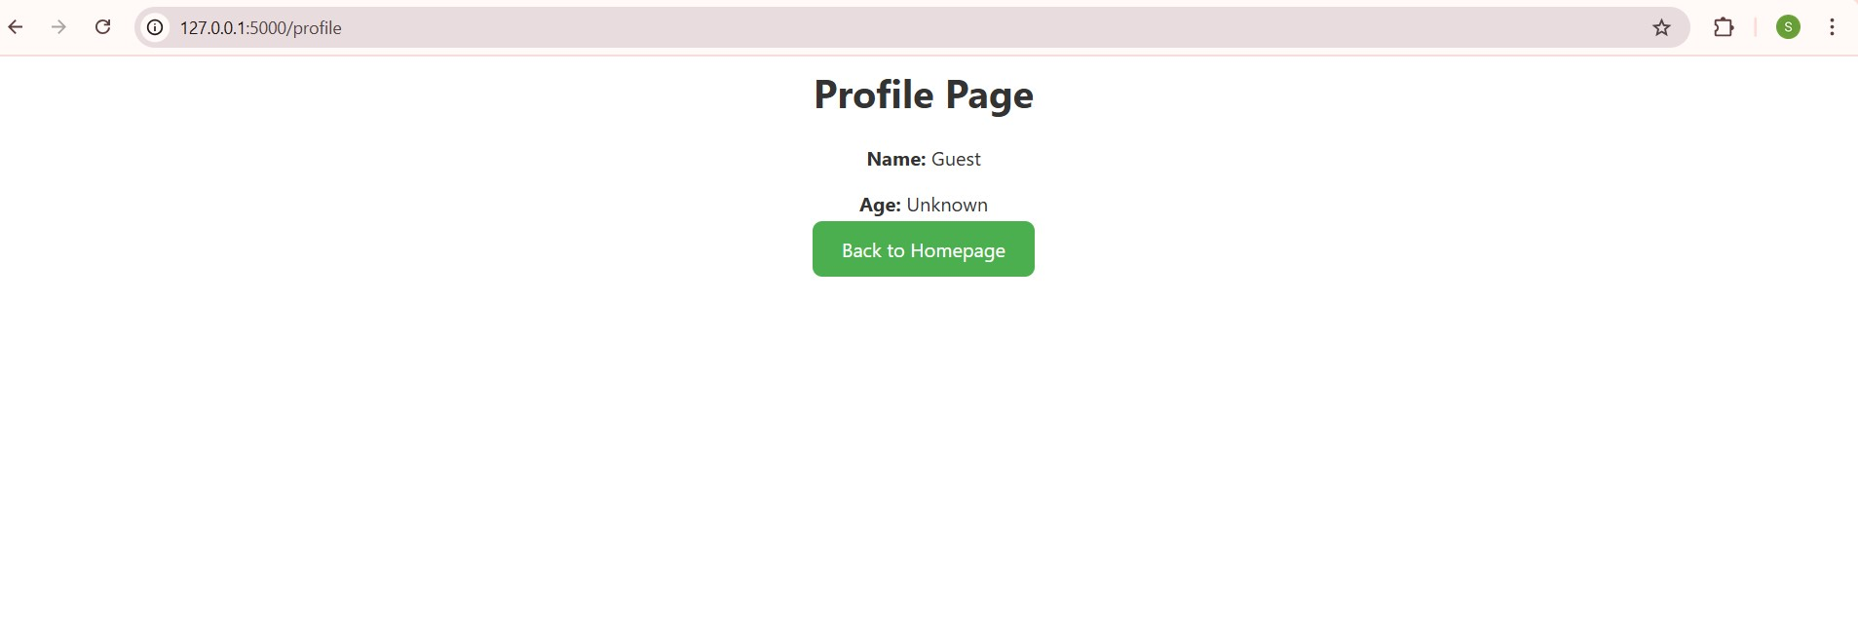

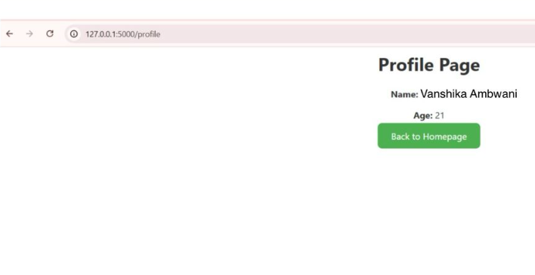

**Conclusion:**

The experiment demonstrated the creation of a simple Flask application using GET and POST methods. The application effectively handled dynamic routing using URL parameters and processed user input via a form using the POST method. Additionally, it showcased URL building using the url_for() function and maintained user data using sessions.