**EXPERIMENT NO. 6**

|  |  |
| --- | --- |
| **Name of Student** | **Vanshika Ambwani** |
| **Class Roll No** | **D15A 02** |
| **D.O.P.** |  |
| **D.O.S.** |  |
| **Sign and Grade** |  |

**EXPERIMENT NO. 6**

**AIM:** To study CRUD operations in MongoDB

**PROBLEM STATEMENT:**

Create a database, create a collection, insert data, query and manipulate data using various MongoDB operations.

1. Create a database named "inventory".
2. Create a collection named "products" with the fields: (ProductID, ProductName, Category, Price, Stock).
3. Insert 10 documents into the "products" collection.
4. Display all the documents in the "products" collection.
5. Display all the products in the "Electronics" category.
6. Display all the products in ascending order of their names.
7. Display the details of the first 5 products.
8. Display the categories of products with a specific name.
9. Display the number of products in the "Electronics" category.
10. Display all the products without showing the "_id" field.
11. Display all the distinct categories of products.
12. Display products in the "Electronics" category with prices greater than 50 but less than 100.
13. Change the price of a product.
14. Delete a particular product entry.

**THEORY:**

1. **Describe some of the features of MongoDB?** 
   * **Document-Oriented:** Stores data as flexible, JSON-like documents (BSON).
   * **Flexible Schema:** No fixed structure, supports dynamic data.
   * **Horizontal Scalability:** Uses sharding to manage large datasets.
   * **Replication:** Ensures high availability with replica sets.
   * **Indexing:** Supports various indexes for faster query execution.
   * **Aggregation Framework:** Provides powerful data processing using pipelines.
   * **Ad-hoc Queries:** Enables complex queries with ease.

1. **What are Documents and Collections in MongoDB?**

**Documents:** JSON-like records storing data in key-value pairs. Example:

{

"_id": "101",

"name": "Alice",

"age": 28,

"email": "alice@example.com"

}

**Collections:** A group of documents, equivalent to tables in relational databases. They don’t enforce strict schemas, allowing flexibility.

1. **When to use MongoDB?** 
   * Big Data Applications: Efficient for large, unstructured data.
   * E-commerce Platforms: Ideal for product catalogs with dynamic attributes.
   * Content Management Systems (CMS): Supports frequent changes in data models.
   * Real-Time Analytics: Processes and analyzes data rapidly.
   * IoT and Mobile Apps: Manages sensor data and app data effectively.
   * Social Networks: Scales well for user-generated content.

1. **What is Sharding in MongoDB?**

**Sharding:** Distributes data across multiple servers to handle large datasets. **Shard Key:** A field in documents used to split data across shards.

**Components:**

* + **Shards:** Store actual data.
  + **Config Servers:** Maintain metadata and sharding configuration.
  + **Mongos:** Routes queries to the appropriate shards.

**Benefits:**

* + Supports large-scale data management.
  + Improves read and write performance.
  + Ensures fault tolerance and high availability.

**OUTPUT:**

# Insert Data (Create Operation)

1. Open your inventory collection.

2.

Click

**"Insert**

**Document"**

(

top-right

).

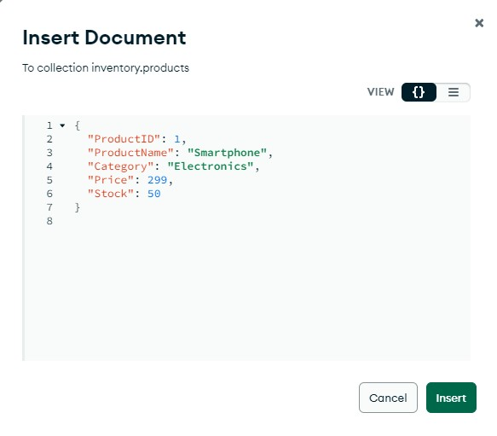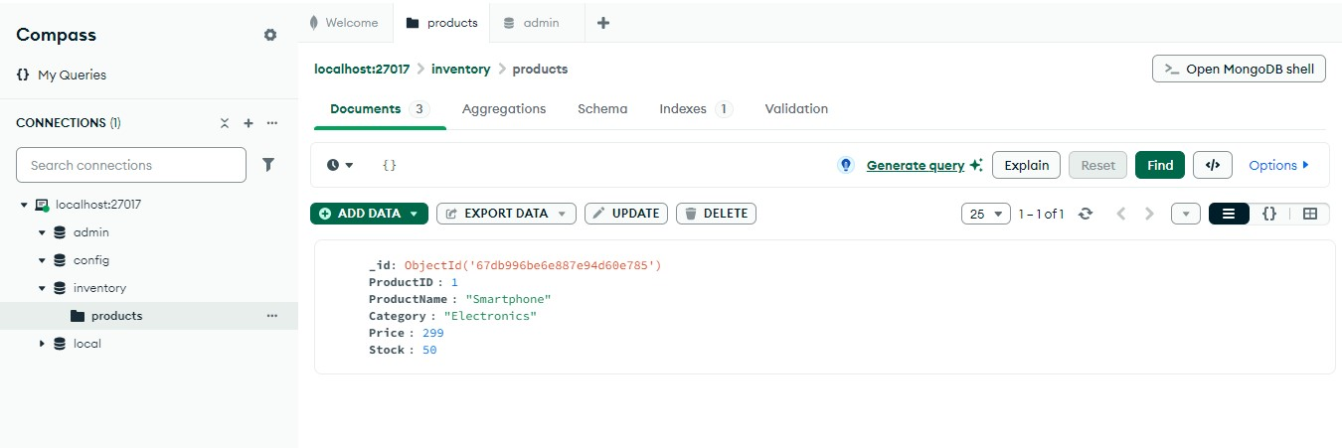

Added

more

data

to

the

database

-

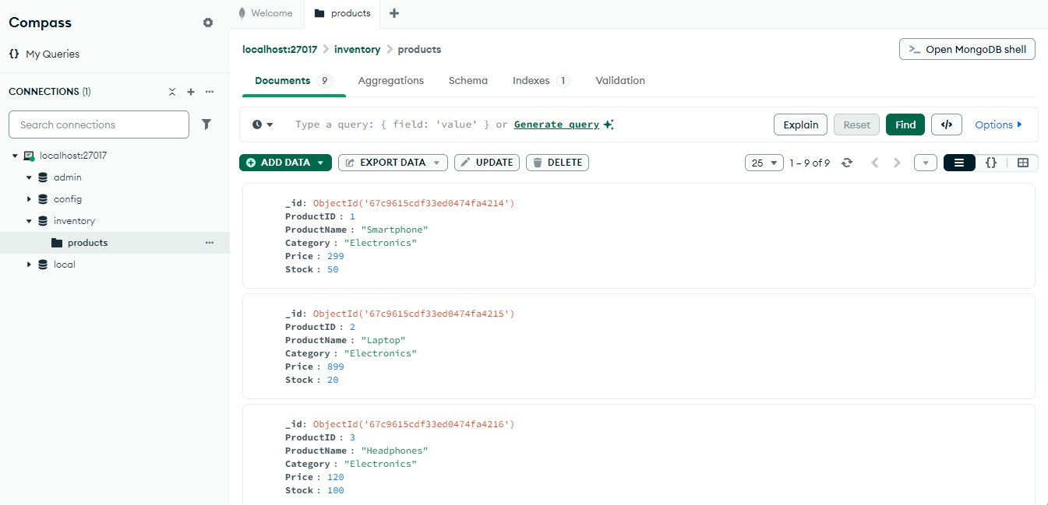

# Read Data (Retrieve Documents)

1. Click on the inventory collection.
2. In the **"FILTER"** field, enter queries to retrieve data.
3. **Get all products:** 
   * Query:

{}

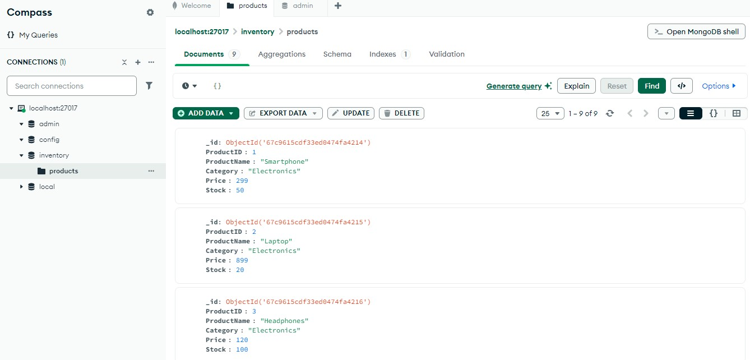

1. **Get a specific product by ProductID:** 
   * Query:

{

"ProductID":

1

}

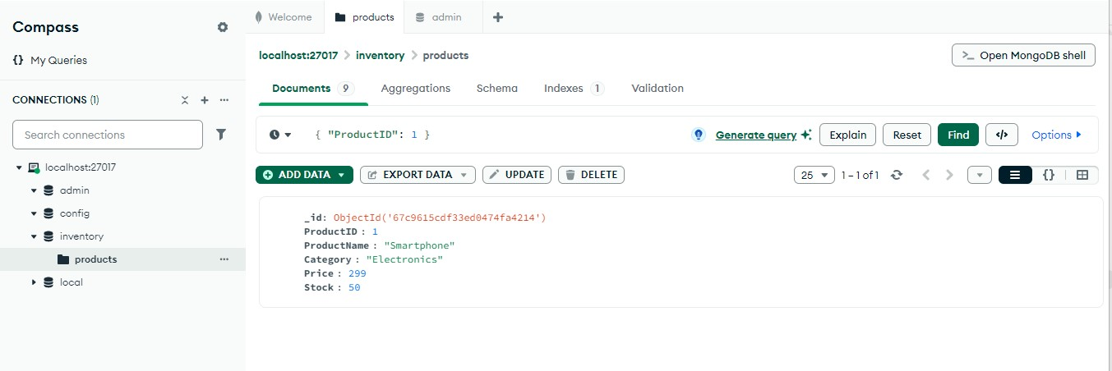

1. **Get products with price greater than 200:** 
   * Query:

{ "Price": { "$gt": 200 } }

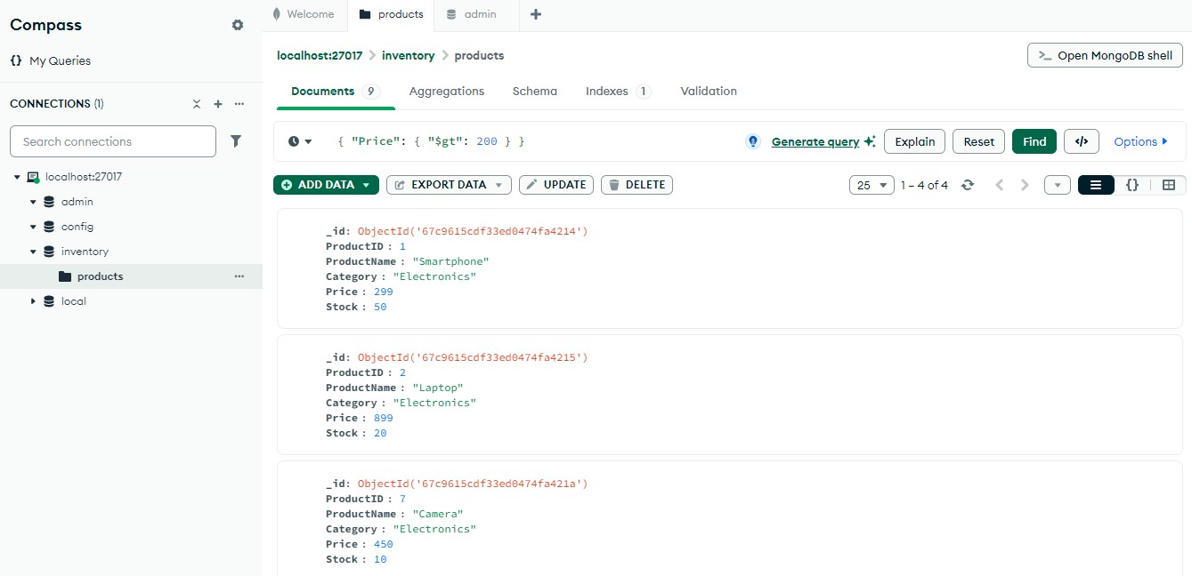

1. **Get all products in the "Electronics" category:** 
   * Query:

{

"Category":

"Electronics"

}

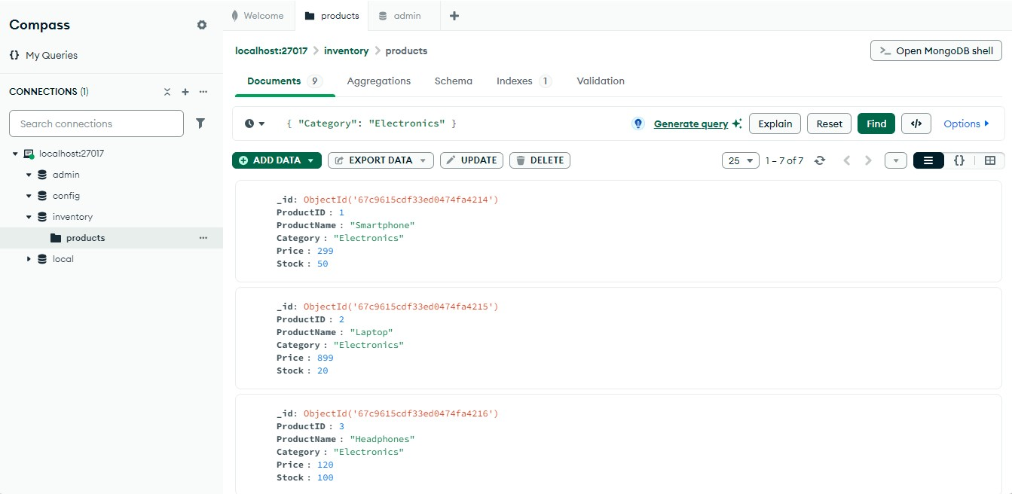

# Update Data

1. **Update the price of a product:**

**Filter Query** (to find the product):

{ "ProductID": 1 }

**Update Query**:

{ "$set": { "Price": 349 } }

●

Click

**"Update"**

.

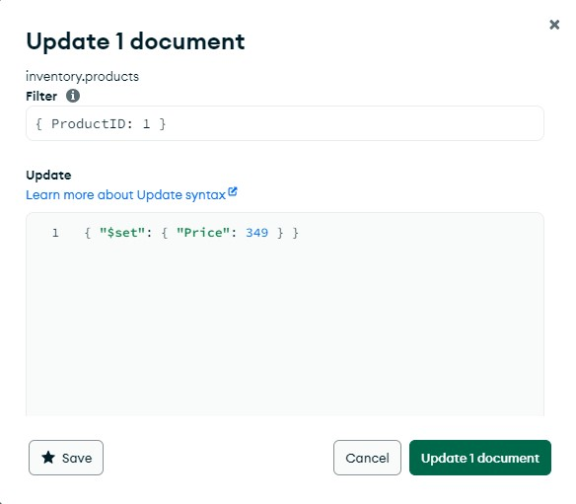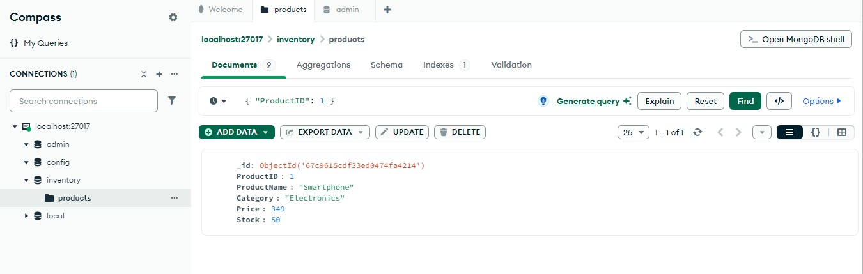

1. **Add a new field "Discount" to all products:**

**Filter Query**:

{ "Category": "Electronics" }

**Update Query**:

{ "$set": { "Discount": true } }

● Click **"Update Many"**.

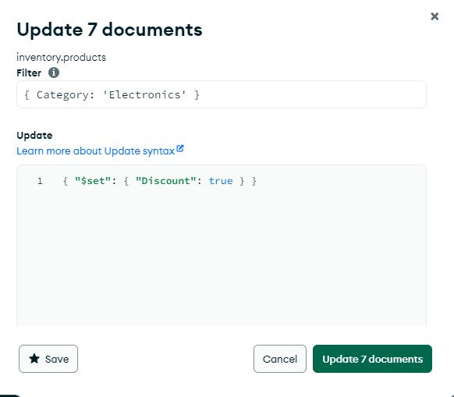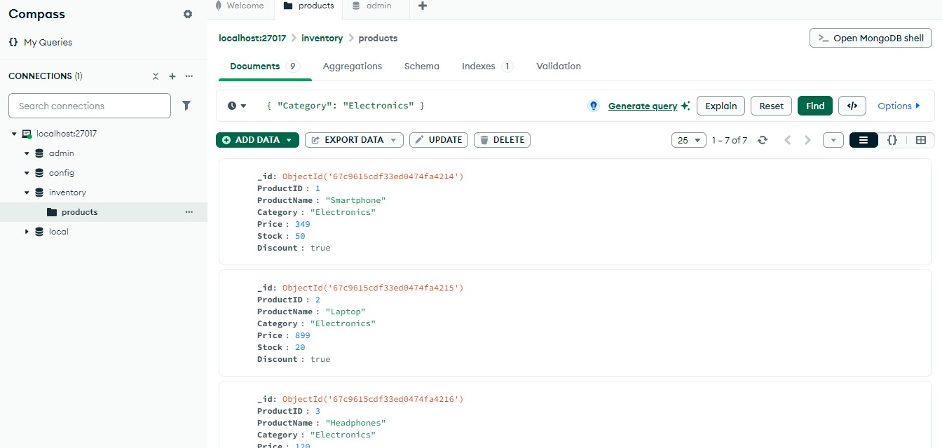

# Delete Data

1. Click on the inventory collection.
2. Click "**FILTER**" and enter the query to find the document you want to delete.
3. Click "**DELETE**".
4. **Delete a specific product:**

**Filter Query:**

**{ "ProductID": 2 }**

**●**

**Click**

**"Delete**

**One".**

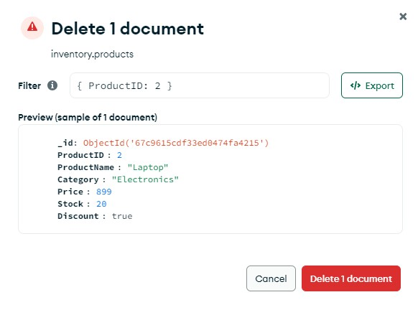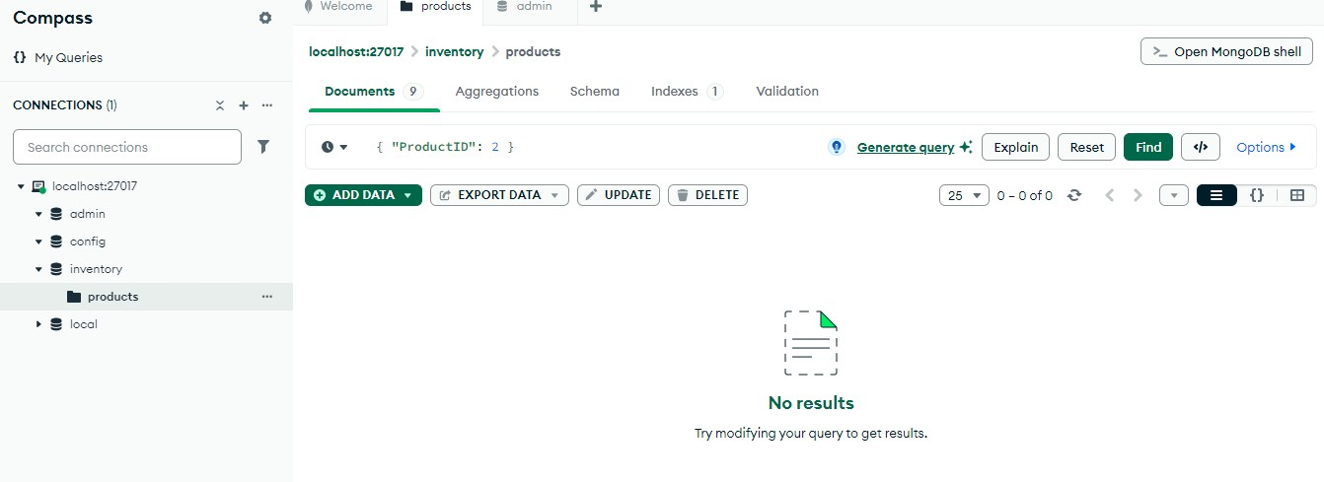

1. **Delete all products in the "Electronics" category:**

**Filter Query:**

**{ "Category": "Electronics" } ● Click "Delete Many".**

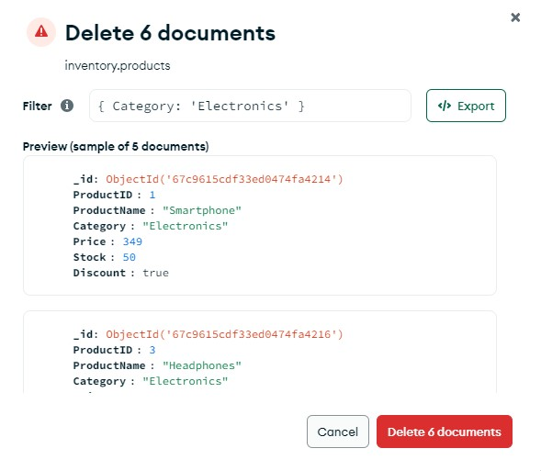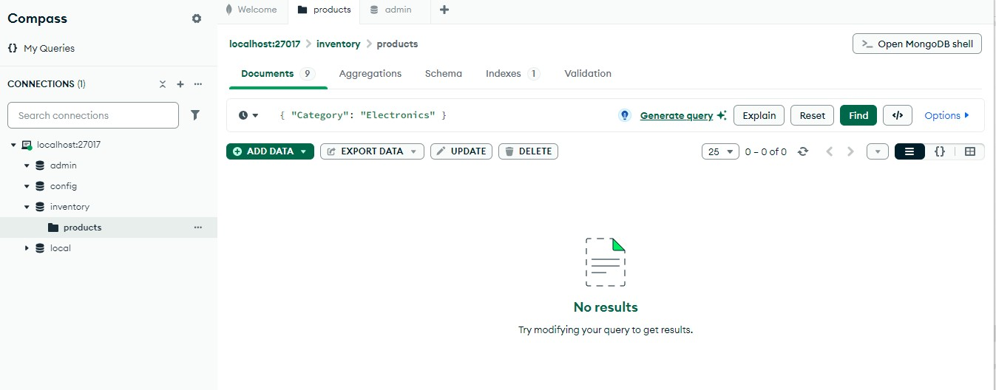

# CONCLUSION

Through this experiment, we successfully performed **CRUD operations** in **MongoDB**, including **creating a database**, **inserting documents**, **querying data**, **updating records**, and **deleting entries**. We also explored filtering data, sorting, and aggregation queries.

MongoDB's document-oriented structure and flexible schema make it an ideal choice for handling large-scale, unstructured data in real-world applications.