**Name : Vanshika Ambwani**

# Class : D15A

**Roll no. :** **02**

**Experiment – 1 (A): Web Analytics**

1. **Aim:** To study a Web Analytics Tool 2. **Theory:**

**a. What is web analytics? List some Web analytics tools and their features** Ans: Web analytics is the process of collecting, measuring, analyzing, and reporting web data to understand and optimize web usage. It helps track user behavior, website performance, and marketing effectiveness, allowing businesses to improve user experience, conversion rates, and overall digital strategy.

Web Analytics Tools and Their Features

Here are some widely used web analytics tools along with their key features:

* Google Analytics
  1. Tracks website traffic, user demographics, and behavior

○ Provides real-time data and audience insights

○ Offers funnel analysis and goal tracking

* Adobe Analytics
  1. Advanced segmentation and predictive analytics

○ Customer journey mapping and real-time reporting

○ AI-powered insights through Adobe Sensei

* Matomo (formerly Piwik)
  1. Open-source and self-hosted analytics

○ GDPR and privacy-compliant tracking

○ Heatmaps and session recordings

* Clicky
  1. Real-time visitor tracking

○ Heatmaps and uptime monitoring

○ Custom event tracking

* Mixpanel
  1. Focuses on user behavior analytics

○ Tracks customer engagement and retention

○ A/B testing and funnel analysis

* Crazy Egg
  1. Heatmaps and scroll maps

○ A/B testing and session recordings

○ Conversion tracking

**b. Why is it important to learn web analytics?**

It is essential to learn about web analytics due to the following reasons:

* Improves Website Performance – Helps identify weak points in user experience and optimize site speed, navigation, and responsiveness.
* Enhances User Engagement – Understand user behavior and preferences to tailor content and design accordingly.
* Optimizes Marketing Campaigns – Measures ROI on marketing efforts and adjusts strategies based on data insights.
* Boosts Conversion Rates – Identifies where users drop off in the sales funnel and improves conversion paths.
* Supports Data-Driven Decision Making – Enables businesses to make informed decisions rather than relying on intuition.
* SEO Optimization – Tracks search engine rankings, bounce rates, and traffic sources for better SEO strategies.

**c. What are your KPI selected for your website?**

The KPIs for my **food delivery app** are as follows:

1. **Traffic KPIs** o Total Visitors & Unique Visitors
   * Page Views
   * Traffic Sources (Direct, Search, Referral)
2. **Engagement KPIs** o Average Session Duration o Pages Per Session
3. **User Interaction KPIs** o Number of Orders Placed o Clicks on Restaurant Listings

3. **Output:**

**Host link of your website:** [**website**](https://restaurant-three-lemon.vercel.app/)

**Screenshot 01:**

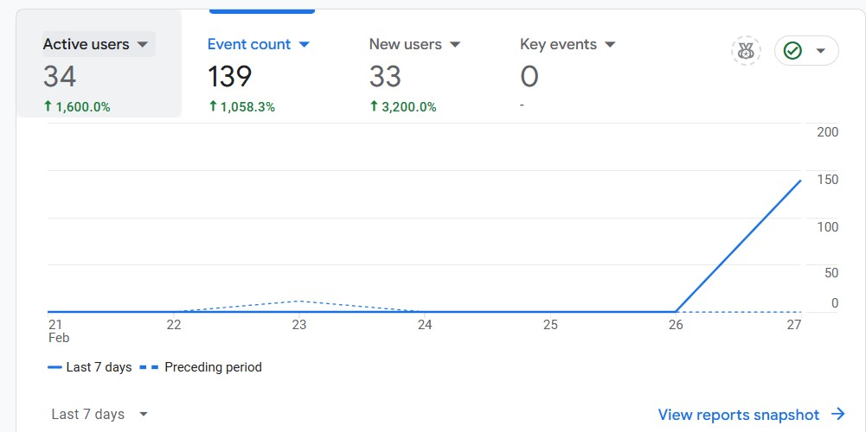

**Observation/ Inference:**The website has 12 active users, all new, meaning no returning visitors. The average engagement time is 25 seconds, indicating medium interaction. A traffic spike on February 19 suggests an external referral or event. The total revenue is ₹0.00, as expected for a non-commercial site.

**Action to be taken:** To improve engagement, I could have added more content like live offers and a bit more animation on the webpage. Encourage returning visitors with updates or announcements. Analyze the traffic spike to identify what worked.

**Screenshot 02:**

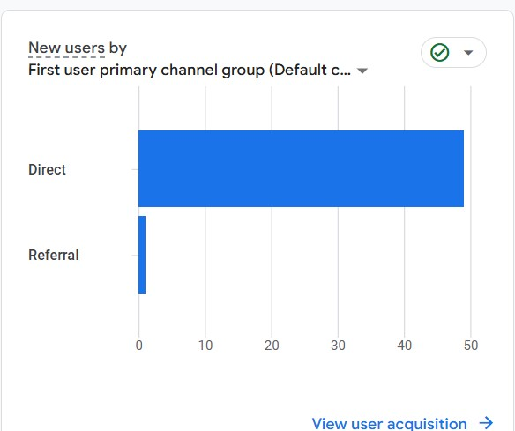

**Observation:** Most users (direct traffic) accessed the website by typing the URL or using a bookmark, while a few came from referrals (external links). This suggests that users are primarily finding the website through direct sharing rather than external promotions.

**Action to be taken:** According to me, I could have tried to improve referral traffic by promoting the website through social media, emails, or other websites. Improve SEO strategies to attract organic search traffic. Track referral sources to identify valuable external platforms.

**Screenshot 03:**

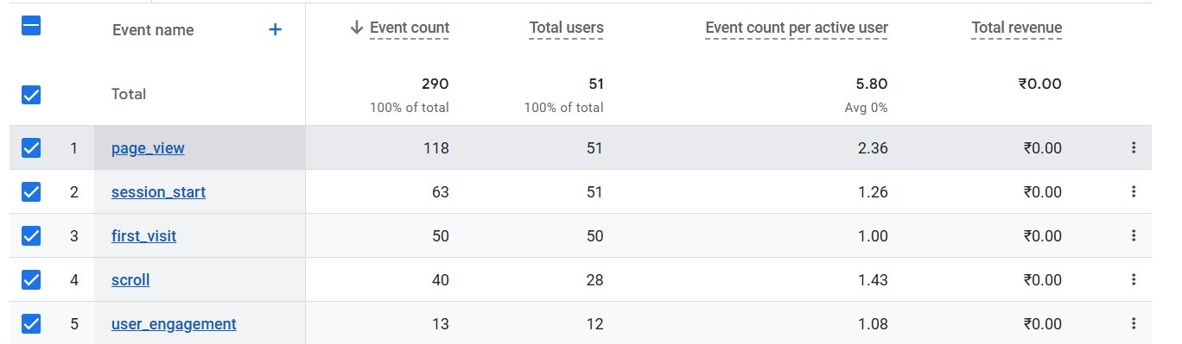

**Observation:** Page views dominate with 32 events, indicating high interest in content. Session starts (13) and first visits (13) match the total user count, showing accurate tracking of new users. Scrolling activity (4) and user engagement events (15) are lower, suggesting limited deep interactions. The event count per active user is 6.1, indicating moderate interaction. No revenue is recorded.

**Action to be taken:**To enhance engagement on a food booking site, incorporate interactive elements like high-quality food videos showcasing dishes, infographics highlighting meal ingredients or popular choices ,Enhance engagement on the food booking site by implementing a streak system similar to Duolingo, rewarding users for consistently ordering healthy meals

**Screenshot 04:**

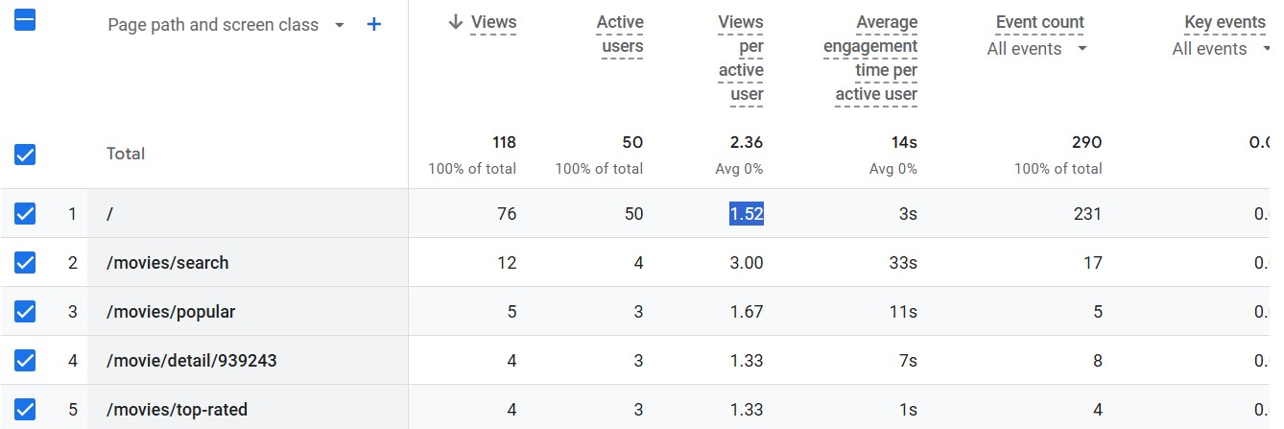

**Observation:** The homepage ( / ) is the most visited page with 25 views and 12 active users, showing strong engagement.Users on the homepage average 2.08 views per user and spend 24 seconds on the page.The contact page ( /contact.html ) has only 1 user, but they visited it 5times, indicating strong intent.The blog page ( /blog.html ) has low engagement with only 1 view and 3 seconds of engagement time.

**Action to be taken:** The homepage drives most user actions, contributing 70 out of 80 total events recorded.Other pages generate minimal user interaction, meaning content or UI improvements are needed and we observed in contact page that only one user is trying to contact us so we can enhance our response team.

**Screenshot 05:**

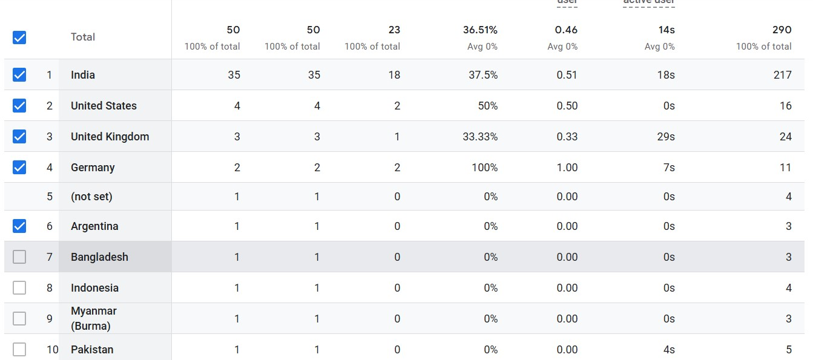

**Observation:** Mumbai has the highest user activity, with 5 active users, indicating it is the primary traffic source.Navi Mumbai follows with 3 active users, showing a moderate level of engagement.Pune has only 1 active user, suggesting lower engagement from this city.

**Action to be taken:** Localized marketing efforts in Mumbai and Navi Mumbai could yield better engagement and conversions.Pune has low engagement, so targeted promotions or ads might help attract more users.consider location-based discounts or offers for Mumbai and Navi Mumbai users and specially for pune to increase the number of users.

**Conclusion:**

By analyzing the website's performance using Google Analytics, I identified several areas for improvement, including reducing the bounce rate, increasing engagement, and enhancing conversions. Implementing SEO techniques, optimizing mobile experience, and refining CTA elements will help improve the website's effectiveness.