

Database Management Lab File (ENCS205)

Bachelor of Technology in
Computer Science and Engineering

B. Tech CSE (Core) 4 Semester

School of Engineering & Technology

K. R. MANGALAM UNIVERSITY Sohna, Haryana 122103, India Jan-2026

Submitted By: | Submitted To:
Vanshika Dubey (2401010067) | MS. Mansi Kajal

Lab Sheet-1
Objective:
- To design ER diagrams and convert entities and relationships into relational tables using proper schema notation.
Instructions:
- Open your preferred Database Management System (DBMS) tool.
- Create a new database named DBMS_YourName.
- Draw ER diagrams for the given scenarios.
- Convert entities and relationships into relational schemas.
- Create tables using the derived schemas.

Relational Schema

PART A – COLLEGE DATABASE
STUDENT ( USN, SName, Address, Phone, Gender )
SEMSEC ( SSID, Sem, Sec )
CLASS ( USN, SSID )
SUBJECT ( Subcode, Title, Sem, Credits )
IAMARKS ( USN, Subcode, SSID, Test1, Test2, Test3, FinalIA )
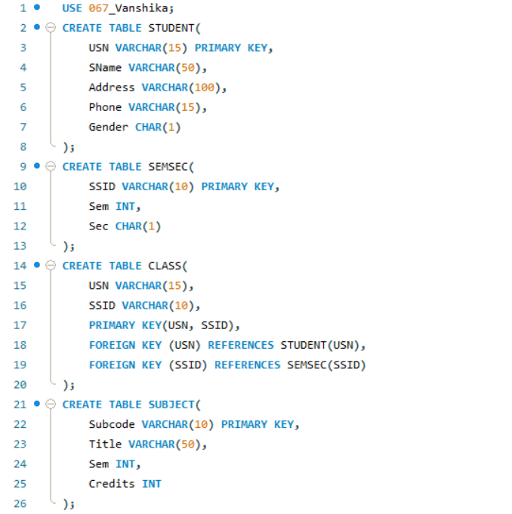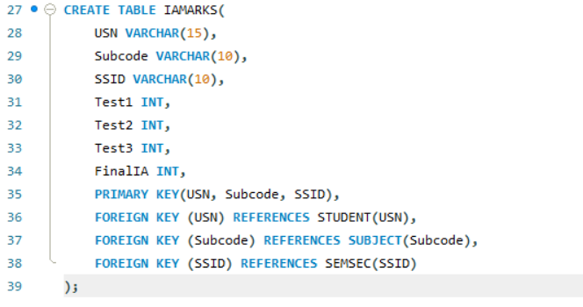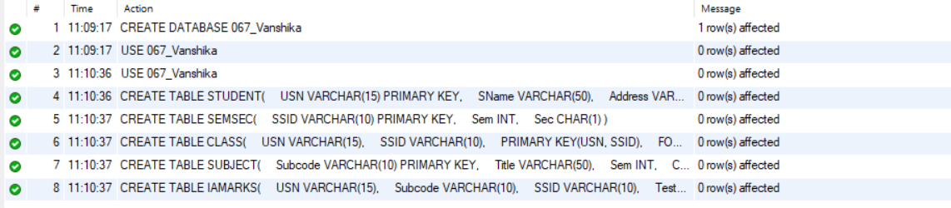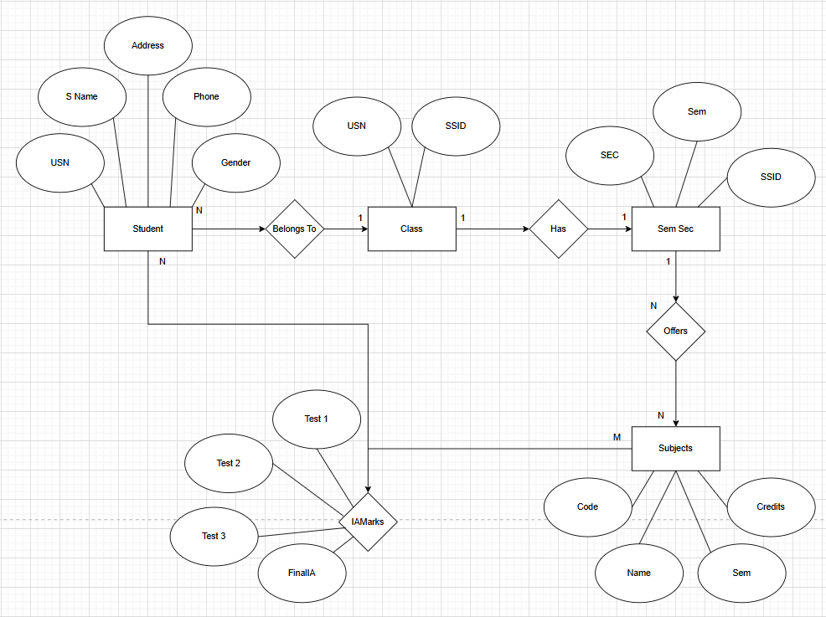

PART B – COMPANY DATABASE

EMPLOYEE ( SSN, Name, Address, Sex, Salary, Superssn, Dno )
DEPARTMENT ( Dno, Dname, Mgrssn, Mgrstartdate )
DLOCATION ( Dno, Dloc )
PROJECT ( PNo, PName, PLocation, DNo )
WORKS_ON ( SSN, PNo, Hours )
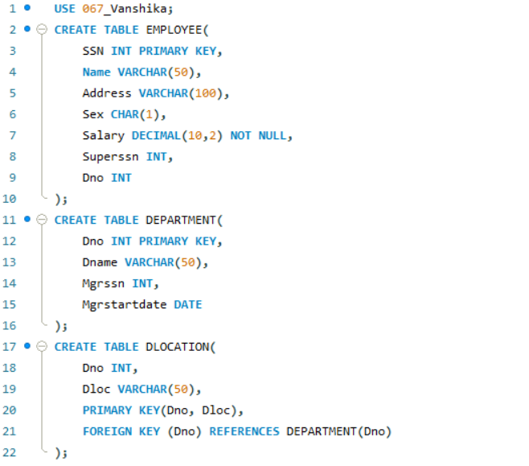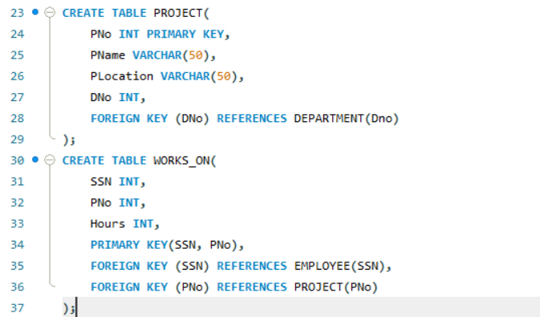
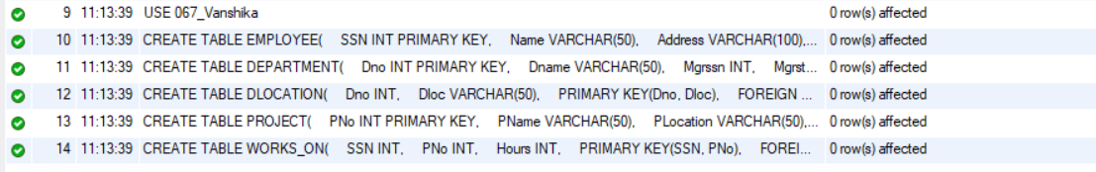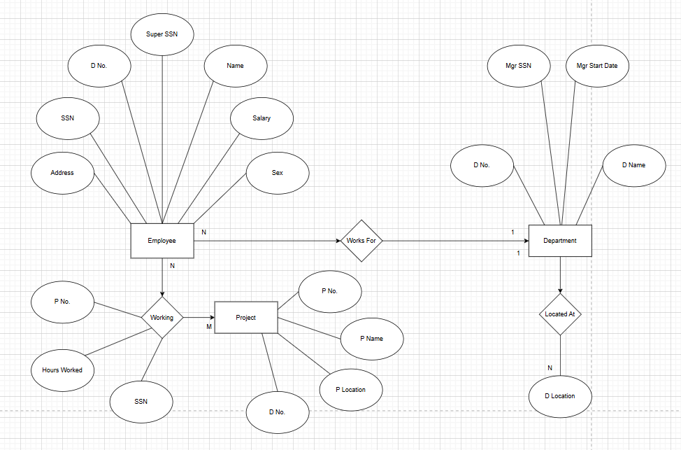

PART C – CUSTOMER SALE SCHEMA

Database Schema for a customer-sale scenario
CUSTOMER(Cust id : integer, cust_name: string)
ITEM(item_id: integer, item_name:string, price: integer) SALE(bill_no:integer,bill_data:date,cust_id: integer, item_id: integer, qty_sold: integer)
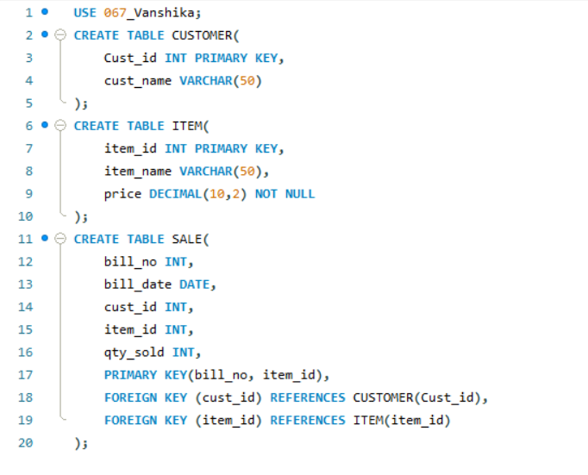
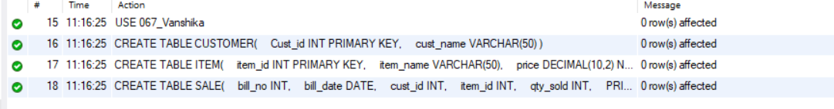

DDL Questions (Data Definition Language):
- Write SQL statements to create all the above relations with appropriate PRIMARY KEY and FOREIGN KEY constraints.

In the above given screenshots while creating the table we have created relations with appropriate PRIMARY KEY and FOREIGN KEY so we have performed this DDL command already.

- Add a new column Email to the STUDENT relation.

- Apply NOT NULL constraints to Salary and Price attributes.
- Rename attribute SName to StudentName in STUDENT relation.
- Drop the DLOCATION relation.
DML Questions (Data Manipulation Language):

- Insert at least 10 tuples into CUSTOMER, ITEM, and SALE relations.
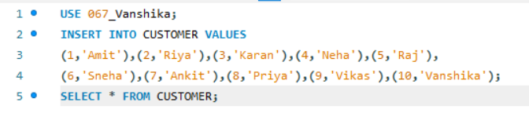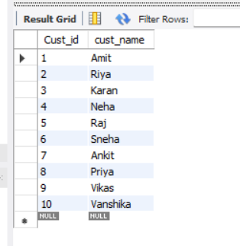
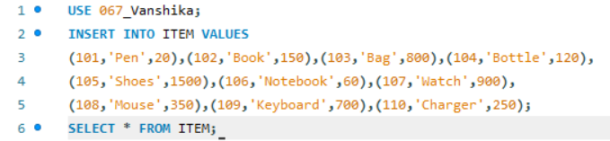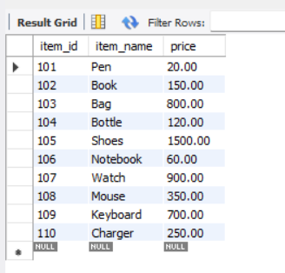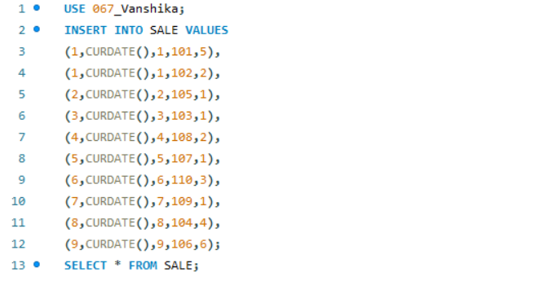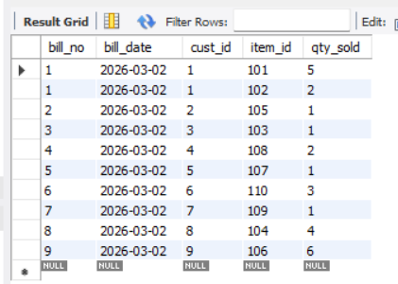

- List all bills of the current date with customer names and item names. 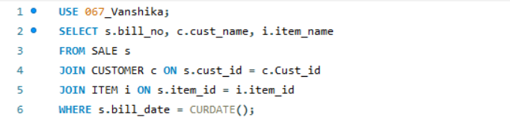 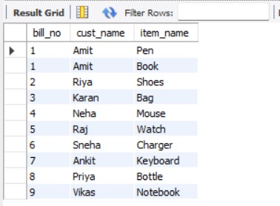

- Display total bill amount using quantity and price.
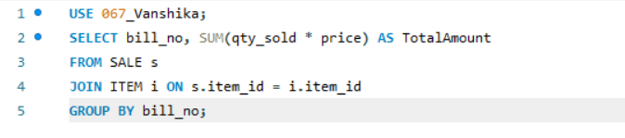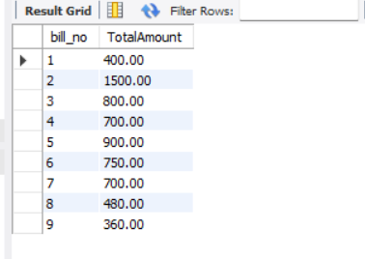

- List customers who purchased products priced above 200.
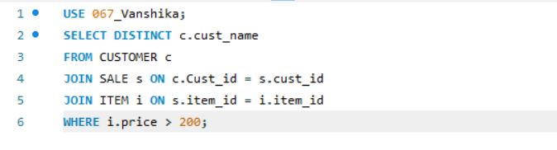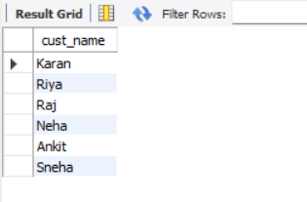

- Count the number of products purchased by each customer. 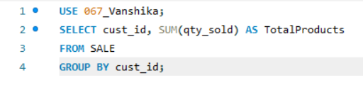 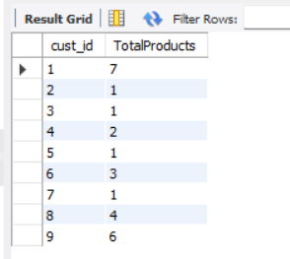

- List products purchased by customer having Cust_id = 5. 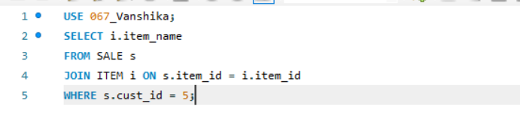 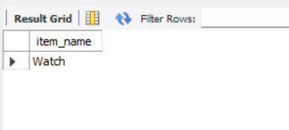

- Create a VIEW showing bill_no, bill_date, cust_id, item_id, price, qty,sold, amount. 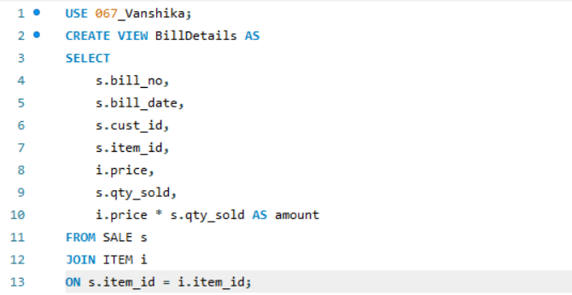

- Create a VIEW showing daily sales date-wise for the last one week. 