The Thirsty Cloud
Study guide: what we are doing, why, and how every number is calculated
DSS5202 Sustainable Systems Analysis · Group 29 term paper
Personal learning companion, not part of the submission.

Check it yourself
Every number in this guide was recalculated independently from the formulas shown here, and the results match the project outputs (outputs/tables/*.csv) to the last decimal place, including the S1 net present costs to the dollar.
All values are the base case, per 1 MWh of IT energy unless stated otherwise. If an input in config/assumptions.csv changes and the model is rerun, the numbers here will change too.

How to read this guide
- Sections 1–6 explain the problem and the water arithmetic.
- Sections 7–12 explain the assessment methods (LCA, LCC, eLCC, IRR, frontier) with formulas, diagrams and worked calculations for each option.
- Section 13 is the parameter register: every input, its range, source and the reason for the base value.
- Coloured boxes: blue = why a number was chosen, green = check it yourself, amber = watch out, purple = link to your lecture notes.

Contents
1. The objective in plain words
1.1 The four alternatives
1.2 The three capacity scenarios
1.3 The functional unit
2. Data and processing
2.1 What the status labels mean
3. IT capacity, PUE and WUE
3.1 IT capacity: power, not energy
3.2 PUE: how much extra energy the building uses
3.3 WUE: how much water per unit of IT energy
4. Demand model: how much water each option needs
4.1 IT energy with a ramp-up
4.2 Water demand
5. Cooling tower physics: evaporation, blowdown and CoC
5.1 Two separate water losses
5.2 Cycles of concentration (CoC)
5.3 Worked calculation: A1/A2 at CoC 3
5.4 Does the heat balance support 2.1?
6. Water arithmetic for A3 and A4
6.1 A3: high CoC + 70% blowdown recovery
6.2 A4: dry coolers with wet trim
7. Assessment methods: overview and link to lectures
8. LCA: how the carbon of each option is calculated
8.1 The four ISO phases
8.2 System boundary
8.3 The formula
8.4 The grid emission factor
8.5 Worked calculation for each option
8.6 Interpretation: hotspots
8.7 Other inventory flows (not converted to impact)
9. LCC: how the cost of each option is calculated
9.1 The tools from lecture 03
9.2 Levelised cost of water (LCOW)
9.3 Two viewpoints
9.4 Social cost per MWh
9.5 Operator cost per MWh
9.6 Why the cheapest option changes between views
9.7 Net present cost (NPC) over 2027–2035
10. Environmental LCC (eLCC)
10.1 Is eLCC needed, or is normal cost enough?
11. IRR, payback and incremental analysis
11.1 Operator view (8%)
11.2 Social view (3%)
12. Cost vs carbon: the efficient frontier
13. Parameter register: every number and why it was chosen
14. Summary and what could change the answer
14.1 Break-even values (outputs/tables/breakeven.csv)
14.2 Main limitations to remember

(If the contents list is empty, right-click it in Word and choose Update Field.)

1. The objective in plain words
Singapore is approving new data-centre capacity. Data centres turn almost all their electricity into heat, and that heat has to be removed. In Singapore this is usually done with cooling towers, which work by evaporating water. So more data centres means more water demand in a country that has to import, recycle or desalinate its water.
The question: for new data-centre capacity built over 2027–2035, which way of supplying and using cooling water is best when we look at water, carbon, cost and wider decision criteria together?

1.1 The four alternatives
ID | What it is | Water source | Key idea
A1 | Conventional wet cooling towers | Desalinated seawater | Today's standard tower, supplied with desalinated water
A2 | Conventional wet cooling towers | NEWater (recycled) | Same towers, cheaper and lower-energy water
A3 | High-concentration towers + blowdown recovery | NEWater | Reuse the water more times (CoC 8) and recover 70% of what is drained
A4 | Dry coolers + wet trim | NEWater | Mostly air cooling; water only on hot hours, but more fan electricity
Table 1. Alternatives. All four share the same liquid-cooled IT equipment, so none gets credit for something the others also have.

1.2 The three capacity scenarios
Scenario | IT capacity | Built from | Status
S1 | 200 MW | 2027 | Real DC-CFA2 allocation (verified)
S2 | 200 + 300 = 500 MW | 2027, 2028 | Hypothetical growth (team scenario)
S3 | 200 + 300 + 200 = 700 MW | 2027, 2028, 2029 | Hypothetical growth (team scenario)
Table 2. Scenarios. Most per-MWh results are the same in every scenario; scale only changes the totals.

1.3 The functional unit
To compare fairly, everything is expressed per one common unit of service, the functional unit:
Functional unit = heat rejection for 1 MWh of IT energy, including the make-up water it needs
Link to lecture notes
Lecture 02 (LCA): the functional unit is the quantified function that all alternatives must deliver. Here every option delivers the same cooling for 1 MWh of IT energy, so their water, carbon and cost can be compared directly.

2. Data and processing
The pipeline downloads public data (data/raw/), cleans it into tidy tables (data/processed/), and keeps every numeric assumption in one file, config/assumptions.csv (61 rows, each with low/base/high values, a source and a status).
Data group | Source | What it is used for
Weather | Open-Meteo hourly, Jurong Island, 2015–2025 (96,432 hours) | Counting hot hours when dry coolers need water (A4)
Water | PUB tariffs and water sales; data.gov.sg / SingStat | Operator water prices (S$3.24, S$2.50) and national scale check (669.3 Mm³/yr)
Electricity | EMA Singapore Energy Statistics 2026; EMC USEP prices | Grid emission factor (0.404 kg/kWh in 2025); electricity price proxy
Policy | EDB/IMDA DC-CFA2; IMDA Green DC Roadmap; MDDI speech | 200 MW is IT load (MDDI speech, para 28); WUE target ≤ 2.0 (Roadmap p.16)
Benchmarks | PUB water-efficiency benchmark; LBNL 2024; operator reports | WUE of wet cooling = 2.1 m³/MWh
Cost context | Keppel Marina East and NEWater PPP prices; eco-cost workbook | Cross-checks on water cost; carbon valuation
Table 3. Data groups.

2.1 What the status labels mean
Status | Meaning | Example
verified | Checked against an official source | Grid factor 0.404; tariffs S$3.24 and S$2.50
benchmark-derived | Taken from a published benchmark | WUE 2.1 (PUB)
to-verify | Literature value, not yet confirmed for Singapore | Utilisation 70%; NEWater energy 0.7 kWh/m³
proxy | Stand-in value derived from related data | Electricity prices S$0.20 and S$0.25
team-judgement | Reasoned assumption with no direct source | Dry-cooler penalty 0.05 PUE; recovery capex
scenario | A chosen case, not a forecast | Horizon 2027–2035; carbon price S$65/t from 2030
Table 4. Status labels. Team-judgement inputs are the weakest, which is why the sensitivity analysis tests them hardest.

3. IT capacity, PUE and WUE

3.1 IT capacity: power, not energy
200 MW is the IT power the servers can draw at full load (an instantaneous rate), not an annual total. To get energy per year we multiply by hours and by how busy the servers are on average:
IT energy (MWh/yr) = IT capacity (MW) × utilisation × 8,760 h
= 200 × 0.70 × 8,760 = 1,226,400 MWh/yr (at maturity)
Why this number?
200 MW IT: DC-CFA2 allocated four 50 MW tranches. MDDI clarified this is IT load, so it is not divided by PUE (mw_basis_it_share = 1.0, verified).
70% utilisation (range 50–85%): a team choice with no direct source (status to-verify; no evidence-register entry). The bounds come from LBNL 2024: 50% average capacity utilisation for US data centres (p.8), and 75–85% operational time for AI-training servers (p.28). 70% sits between them, reflecting new AI-oriented capacity.
Utilisation also changes A3/A4 cost per MWh, because equipment is paid per MW but spread over MWh. At 50%, A3’s operator cost rises to about S$5.29, just above A2’s S$5.25 (break-even ≈ 51%).

3.2 PUE: how much extra energy the building uses
PUE = total facility energy / IT energy
A PUE of 1.22 means that for every 1 kWh the servers use, the building uses 0.22 kWh more for cooling, power losses, lights and so on. (assumptions.csv lists ‘PUE ≤ 1.25’ as a DC-CFA2 requirement, but no saved source confirms it; status to-verify, context only. No calculation uses it.)
For this project only the difference in PUE between options matters (ΔPUE). A4's fans and dry coolers add ΔPUE = 0.05:
Extra electricity = ΔPUE × 1,000 kWh/MWh = 0.05 × 1,000 = 50 kWh per MWh of IT energy
Why × 1,000? Because 1 MWh = 1,000 kWh. If PUE rises by 0.05, the facility uses 0.05 kWh more per kWh of IT, which is 50 kWh more per MWh of IT.
Watch out
ΔPUE = 0.05 is a team judgement (range 0.02–0.10), not a measured value. It is the single most influential input for A4 (largest tornado swing). A4 only matches A2 if the penalty is about 0.002–0.003, almost zero.

3.3 WUE: how much water per unit of IT energy
WUE = site water use (m³) / IT energy (MWh) [m³/MWh = L/kWh]
m³/MWh and L/kWh are the same number: 1 m³ = 1,000 L and 1 MWh = 1,000 kWh, so the thousands cancel. PUB's benchmark for wet-cooled data centres is 2.1 m³/MWh; IMDA's roadmap target is ≤ 2.0.
Option | WUE (m³/MWh) | How it is obtained
A1, A2 | 2.10 | PUB benchmark (wet towers at CoC ≈ 3)
A3 | 1.46 | Tower mass balance at CoC 8 with 70% blowdown recovery (Section 5)
A4 | 0.4955 | 80% of heat to dry coolers that need water only on hot hours (Section 6)
Table 5. WUE by option.

4. Demand model: how much water each option needs

4.1 IT energy with a ramp-up
A new data centre does not run at full load on day one. The model ramps load linearly over 3 years (team assumption):
ramp(y) = min(1, (y − start + 1) / 3)
IT energy(y) = MW × 0.70 × ramp(y) × 8,760
Year | Ramp factor | IT energy, S1 (MWh) | A2 water (m³) = MWh × 2.1
2027 | 0.333 | 408,800 | 858,480
2028 | 0.667 | 817,600 | 1,716,960
2029 | 1.000 | 1,226,400 | 2,575,440
2030 | 1.000 | 1,226,400 | 2,575,440
2031 | 1.000 | 1,226,400 | 2,575,440
2032 | 1.000 | 1,226,400 | 2,575,440
2033 | 1.000 | 1,226,400 | 2,575,440
2034 | 1.000 | 1,226,400 | 2,575,440
2035 | 1.000 | 1,226,400 | 2,575,440
Table 6. S1 IT energy and A2 water by year. Total 2027–2035 = 9,811,200 MWh; × 2.1 = 20,603,520 m³ (matches npc_by_scenario.csv).
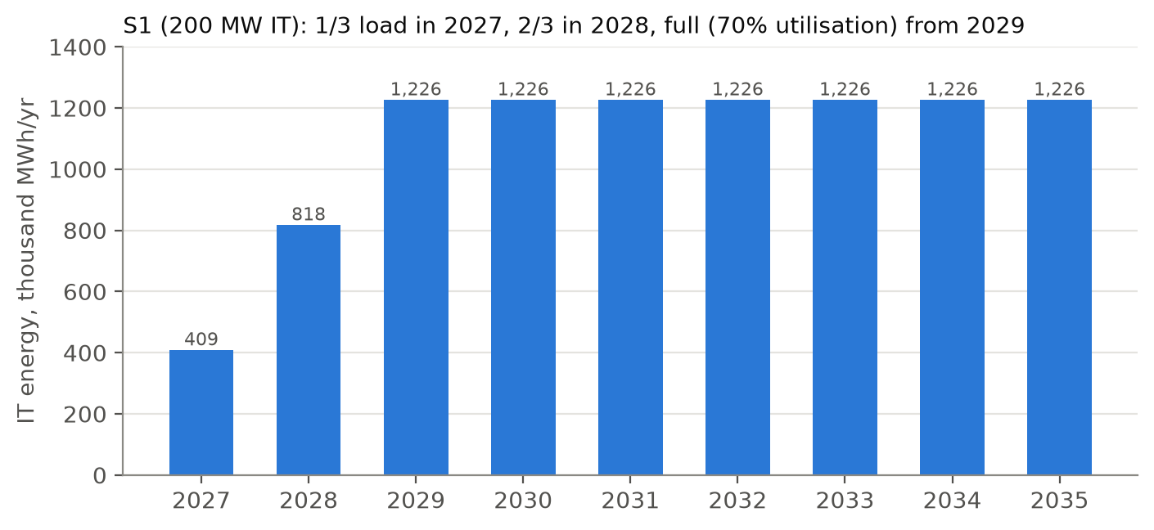
Figure 1. IT energy ramp for S1.

4.2 Water demand
Water (m³/yr) = IT energy (MWh/yr) × WUE (m³/MWh)
Option | WUE | Water at maturity (m³/yr) | Per day (m³) | Share of national sales (669.3 Mm³)
A1 | 2.1000 | 2,575,440 | 7,056 | 0.38%
A2 | 2.1000 | 2,575,440 | 7,056 | 0.38%
A3 | 1.4600 | 1,790,544 | 4,906 | 0.27%
A4 | 0.4955 | 607,709 | 1,665 | 0.09%
Table 7. S1 water demand at maturity (matches data/processed/scale_check.txt).
Check it yourself
A2: 1,226,400 × 2.1 = 2,575,440 m³/yr. Divided by 365 = 7,056 m³/day. Divided by 669.3 million = 0.385%, shown as 0.38%.

5. Cooling tower physics: evaporation, blowdown and CoC

5.1 Two separate water losses
- Evaporation (E): water that turns to vapour and carries heat away. This is what does the cooling. It is fixed by the amount of heat: same heat → same evaporation, whatever the water quality.
- Blowdown (B): water deliberately drained to stop minerals building up. Evaporation leaves minerals behind, so the water left in the tower gets saltier; draining some and topping up with fresh water keeps it in check.
- Make-up (M): the fresh water added to replace both. M = E + B.

5.2 Cycles of concentration (CoC)
CoC is how many times more concentrated the tower water is than the fresh make-up water. Minerals enter only with make-up and leave only with blowdown, so at steady state:
Minerals in = minerals out: M × c_makeup = B × c_tower
CoC = c_tower / c_makeup = M / B
Since M = E + B: B = E / (CoC − 1) and E = M × (CoC − 1) / CoC
Why higher CoC saves water: evaporation stays the same (same heat), but you drain less. At CoC 3, you drain 1 m³ for every 2 m³ evaporated. At CoC 8, you drain 1 m³ for every 7 m³ evaporated. The water is reused more times before it is thrown away.

5.3 Worked calculation: A1/A2 at CoC 3
Start: M = 2.10 m³/MWh (PUB benchmark), CoC = 3
E = 2.10 × (3 − 1) / 3 = 2.10 × 0.6667 = 1.40 m³
B = 1.40 / (3 − 1) = 0.70 m³
Check: E + B = 1.40 + 0.70 = 2.10 ✓

5.4 Does the heat balance support 2.1?
The model also estimates evaporation from physics (3.6 MJ per kWh ÷ latent heat × heat-rejection factor × evaporative fraction) as a sanity check:
Case | Evaporation (m³/MWh) | WUE at CoC 3 | WUE at CoC 8
Low inputs | 1.278 | 1.917 | 1.460
Base inputs | 1.536 | 2.304 | 1.756
High inputs | 1.830 | 2.744 | 2.091
Table 8. Heat-balance check (data/processed/wue_heat_balance.csv).
The PUB benchmark of 2.1 sits inside the physics range (1.9–2.7), so it is plausible. The model uses the benchmark rather than the physics estimate, which is calibration, not independent validation.

6. Water arithmetic for A3 and A4

6.1 A3: high CoC + 70% blowdown recovery
Two steps. Each step's starting value is stated explicitly.
Step A (evaporation, unchanged by CoC):
E = 2.10 × (3 − 1)/3 = 1.40 m³
Step B (raise CoC from 3 to 8): blowdown is calculated from E, not from 0.70
gross blowdown = 1.40 / (8 − 1) = 1.40 / 7 = 0.20 m³
Step C (recover 70% of the 0.20, not of 0.70):
recovered = 0.20 × 0.70 = 0.14 m³ (treated and sent back to the tower)
discharged = 0.20 − 0.14 = 0.06 m³ (leaves the site)
Step D (fresh water needed):
M = E + discharged = 1.40 + 0.06 = 1.46 m³/MWh
The recovered 0.14 m³ is internal recycling, so it is not extra make-up. It does cost treatment energy: 0.14 × 1.0 kWh/m³ = 0.14 kWh/MWh.
Why this number?
CoC 8 (range 6–12): best practice with side-stream treatment or electro-oxidation (to-verify). 70% recovery (50–80%): illustrative team value for blowdown RO. 1.0 kWh/m³ (0.5–2.0) to treat recovered water.

6.2 A4: dry coolers with wet trim
Weather data: hours above 30 °C = 4,335 of 96,432 = 4.4954%
Dry part: 0.80 of heat × 0.044954 of hours × 2.1 = 0.0755 m³
Wet part: 0.20 of heat × all hours × 2.1 = 0.4200 m³
WUE(A4) = 0.0755 + 0.4200 = 0.4955 m³/MWh
Why this number?
30 °C threshold (27–32 °C): the facility water loop runs at about 35 °C (ASHRAE W32/W40 class), and a dry cooler needs roughly a 5 K approach, so above about 30 °C air alone cannot do the job.
80% liquid heat share (70–90%): the share of heat routed to the dry loop. The rest (20%) still goes to a wet tower all year. Both are team judgements.
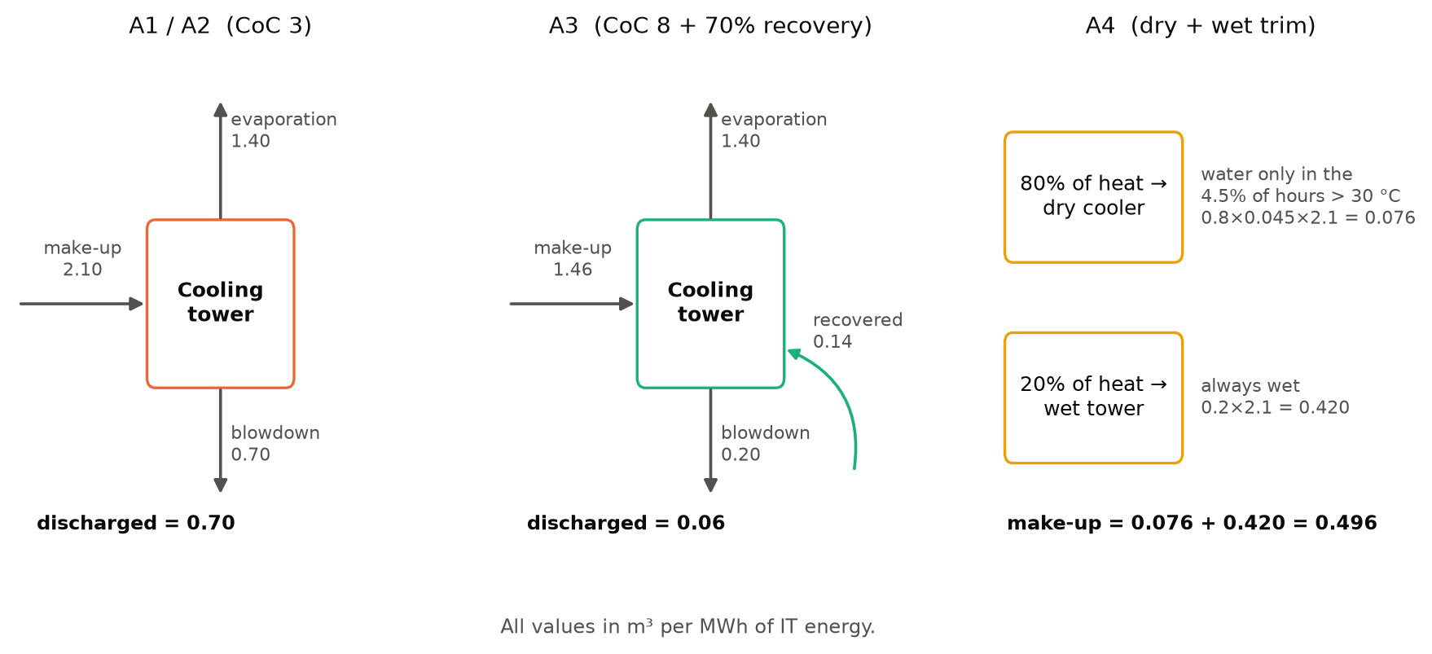
Figure 2. Water balance of each option, m³ per MWh of IT energy.

7. Assessment methods: overview and link to lectures
Lecture | Method | Used here? | Role in this project
01 Intro | Systems thinking, functional unit | Yes | Problem framing; 1 MWh IT functional unit
02 LCA | Life cycle assessment | Yes (simplified) | Carbon (GWP) per MWh for each option
03 LCC | CRF, NPV, EUAC, LCOE, eLCC, dominance | Yes | Cost per MWh, NPC 2027–35, eLCC sensitivity, cost-carbon frontier
04 AHP | Analytic hierarchy process | Yes | Combines economic, environmental, water-security and implementation criteria
05 MODM | Pareto / non-dominated solutions | Concept only | Efficient frontier of the four options (no optimisation model)
06 EEIOA | Environmentally extended input-output | No | Economy-wide sector method; our question is process-level. Possible future work for equipment embodied emissions
07 DEA | Data envelopment analysis | No | Needs many observed comparable units; we have four designed options
— | Monte Carlo, tornado, break-even | Yes | Tests how robust rankings are to uncertain inputs
Table 9. Methods map.
Watch out
If asked why EEIOA or DEA were not used: EEIOA works with national sector tables (S$ of output → emissions), which are too coarse to tell four cooling designs apart. DEA ranks the efficiency of many real units with observed inputs and outputs; we have four engineered alternatives, not a sample of units.

8. LCA: how the carbon of each option is calculated

8.1 The four ISO phases
ISO phase (lecture 02) | In this project
1. Goal and scope | Compare climate impact of A1–A4. Functional unit: 1 MWh IT. Partial (gate-to-gate) boundary. Only GWP100 (kg CO₂e).
2. Inventory (LCI) | kWh of electricity and m³ of water, brine and discharge per MWh IT.
3. Impact assessment (LCIA) | Characterisation: kWh × grid factor → kg CO₂; m³ × non-energy factor → kg CO₂e.
4. Interpretation | Hotspots, sensitivity (tornado), break-even values, low-carbon-grid scenario.
Table 10. LCA phases.

8.2 System boundary
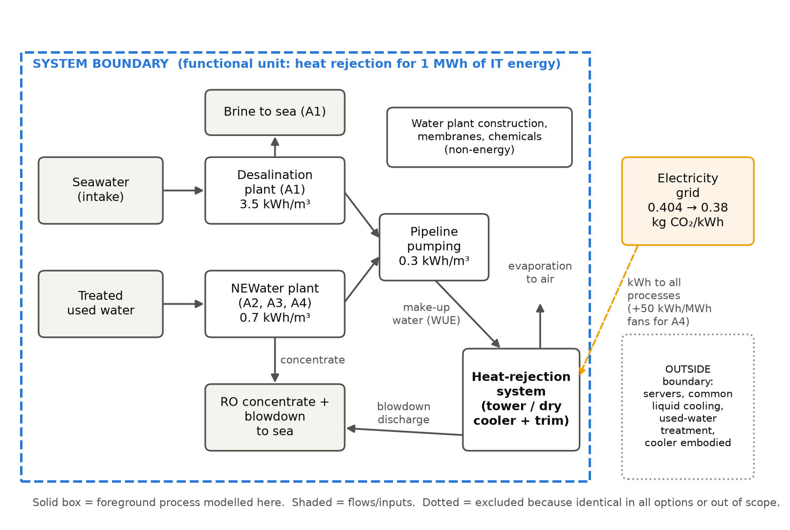
Figure 3. System boundary. Servers and common liquid cooling are excluded because they are identical in all options, so they cancel out in a comparison.
Link to lecture notes
This is a comparative, partial LCA: excluding identical processes is allowed when the goal is to compare alternatives, because they add the same amount to each. The trade-off is that results are not full data-centre footprints; they are only the differences caused by the cooling-water choice.

8.3 The formula
kWh_prod = WUE × SEC_source (desal 3.5, NEWater 0.7 kWh/m³)
kWh_conv = WUE × 0.3 (pumping to Jurong Island)
kWh_onsite = recovered × 1.0 (A3 only: 0.14 m³)
kWh_dc = ΔPUE × 1,000 (A4 only: 50 kWh)

GWP = (kWh_prod + kWh_conv + kWh_onsite + kWh_dc) × EF_grid + WUE × GHG_nonenergy

8.4 The grid emission factor
EF(y) = 0.404 + (0.38 − 0.404) × (y − 2025) / 10
Mean over 2027–2035 = EF(2031) = 0.404 − 0.0024 × 6 = 0.3896 kg CO₂/kWh
Because the line is straight, the average over nine evenly spaced years equals the middle year (2031). Per-MWh results use 0.3896; the multi-year NPC uses each year's own value.
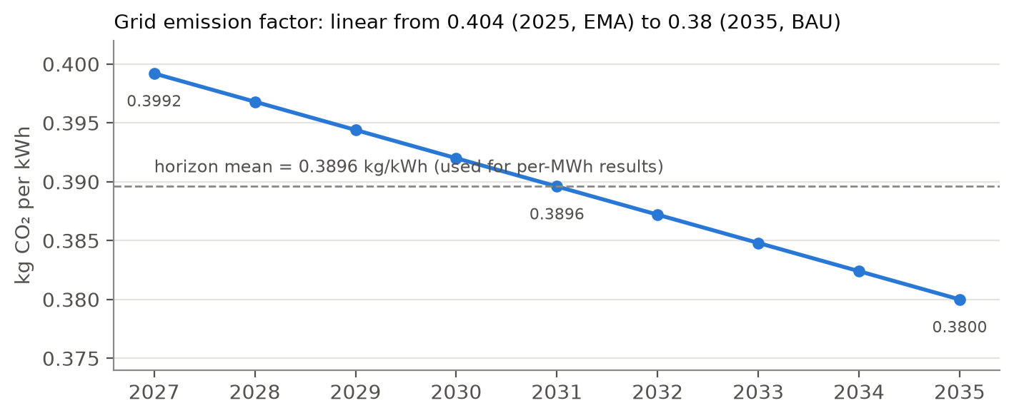
Figure 4. Grid emission factor path (business as usual).
Why this number?
0.404 is EMA's 2025 value (verified). 0.38 in 2035 is a straight-line extrapolation of the 2005–2025 trend (0.526 → 0.404): team judgement. A low-carbon case (0.25 in 2035) is run separately. The policy that 50% of DC electricity must be 'green' is not counted as zero emissions.

8.5 Worked calculation for each option
 | WUE | kWh prod | kWh conv | kWh onsite | kWh fans | kWh total | CO₂ water elec. | CO₂ non-energy | CO₂ fans | Total kg CO₂e
A1 | 2.100 | 7.350 | 0.630 | 0.00 | 0 | 7.98 | 3.109 | 0.315 | 0.00 | 3.424
A2 | 2.100 | 1.470 | 0.630 | 0.00 | 0 | 2.10 | 0.818 | 0.168 | 0.00 | 0.986
A3 | 1.460 | 1.022 | 0.438 | 0.14 | 0 | 1.60 | 0.623 | 0.117 | 0.00 | 0.740
A4 | 0.496 | 0.347 | 0.149 | 0.00 | 50 | 50.50 | 0.193 | 0.040 | 19.48 | 19.713
Table 11. LCA inventory and impact per MWh IT (matches outputs/tables/lca_inventory.csv).

A1: desalination + towers
Production: 2.10 × 3.5 = 7.35 kWh
Pumping: 2.10 × 0.3 = 0.63 kWh → 7.98 kWh × 0.3896 = 3.109 kg
Non-energy: 2.10 × 0.15 = 0.315 kg
Total = 3.109 + 0.315 = 3.42 kg CO₂e/MWh

A2: NEWater + towers
Production: 2.10 × 0.7 = 1.47 kWh
Pumping: 2.10 × 0.3 = 0.63 kWh → 2.10 kWh × 0.3896 = 0.818 kg
Non-energy: 2.10 × 0.08 = 0.168 kg
Total = 0.818 + 0.168 = 0.99 kg CO₂e/MWh

A3: high CoC + recovery
Production: 1.46 × 0.7 = 1.022 kWh
Pumping: 1.46 × 0.3 = 0.438 kWh
Treatment: 0.14 × 1.0 = 0.140 kWh → 1.60 kWh × 0.3896 = 0.623 kg
Non-energy: 1.46 × 0.08 = 0.117 kg
Total = 0.623 + 0.117 = 0.74 kg CO₂e/MWh (lowest)

A4: dry + trim
Production: 0.4955 × 0.7 = 0.347 kWh
Pumping: 0.4955 × 0.3 = 0.149 kWh → 0.496 kWh × 0.3896 = 0.193 kg
Non-energy: 0.4955 × 0.08 = 0.040 kg
Fans: 0.05 × 1,000 = 50 kWh → 50 × 0.3896 = 19.48 kg
Total = 0.193 + 0.040 + 19.48 = 19.71 kg CO₂e/MWh
Why this number?
3.5 kWh/m³ desal (2.0–4.0): PUB's historical reference (verified); <2 is a future target, not current performance. 0.7 kWh/m³ NEWater (0.6–1.0): Changi NEWater study 0.6–0.8 (to-verify); counts only the extra advanced treatment, because used water must be treated anyway. 0.3 kWh/m³ pumping (0.2–0.5): literature (to-verify). Non-energy 0.15 / 0.08 kg/m³: illustrative proxies for plant construction, membranes and chemicals (team judgement).

8.6 Interpretation: hotspots
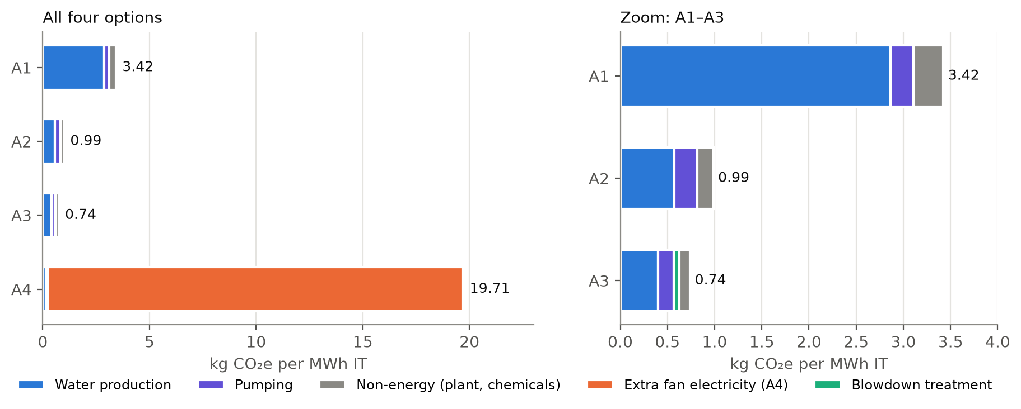
Figure 5. Carbon by component. Left: all options. Right: zoom on A1–A3.
- A1: desalination energy is the hotspot (7.35 of 7.98 kWh, 92%). Desal water carries about 3.5× the carbon of NEWater.
- A3: lowest carbon. It saves water without adding much electricity.
- A4: fan electricity is 19.48 of 19.71 kg (99%). It saves water but shifts the burden to electricity: a classic trade-off (lecture 02, burden shifting).
- Carbon is driven almost entirely by electricity, so a cleaner grid helps every option, A4 most.

8.7 Other inventory flows (not converted to impact)
Brine = WUE × (1/recovery − 1) SWRO recovery 0.45, NEWater RO 0.75
A1: 2.10 × (1/0.45 − 1) = 2.10 × 1.222 = 2.57 m³/MWh
A2: 2.10 × (1/0.75 − 1) = 2.10 × 0.333 = 0.70 m³/MWh
Blowdown discharge: A1/A2 = 2.10/3 = 0.70; A3 = 0.06; A4 = 0.4955/3 = 0.165
These are reported as inventory only. A full LCA would characterise them (for example marine ecotoxicity), which is out of scope.

9. LCC: how the cost of each option is calculated

9.1 The tools from lecture 03
Capital Recovery Factor (CRF) spreads a one-off capital cost P into equal yearly payments A over N years at interest rate i. It is the [A/P, i, N] factor:
CRF = A/P = i(1 + i)^N / ((1 + i)^N − 1)
Use | i | N | (1+i)^N | Calculation | CRF
Water plants (social) | 3% | 25 | 2.0938 | 0.03 × 2.0938 / 1.0938 | 0.05743
On-site equipment (social) | 3% | 15 | 1.5580 | 0.03 × 1.5580 / 0.5580 | 0.08377
On-site equipment (operator) | 8% | 15 | 3.1722 | 0.08 × 3.1722 / 2.1722 | 0.11683
Table 12. CRF values used. The inverse, 1/CRF, is the [P/A] factor: 11.938 at 3%/15 yr and 8.559 at 8%/15 yr.

9.2 Levelised cost of water (LCOW)
LCOW is to water what LCOE is to electricity (lecture 03, section 4.1): the price per m³ that exactly recovers all lifetime costs.
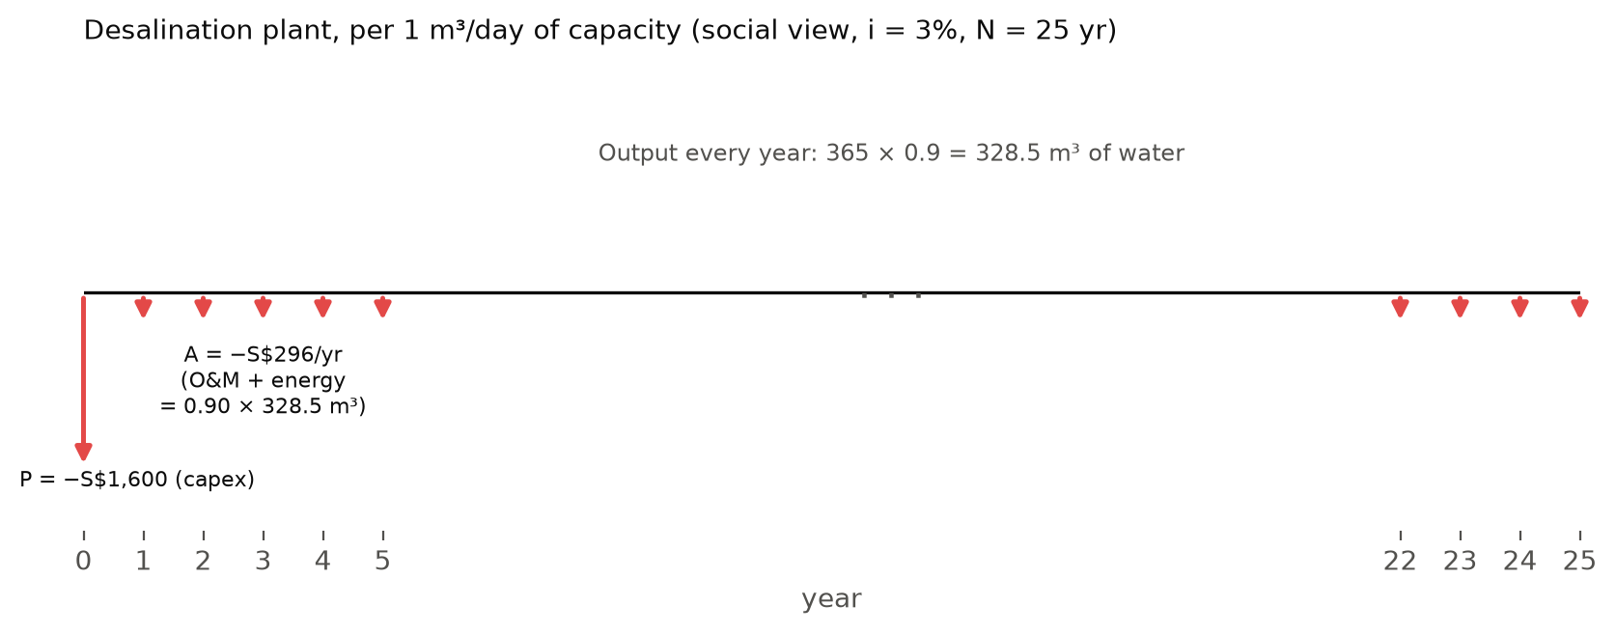
Figure 6. Cash flow diagram for 1 m³/day of desalination capacity. Down arrows are costs. LCOW turns the capex P into an annuity and divides everything by annual output.
LCOW = CRF × capex / (365 × capacity factor) + O&M + SEC × electricity price

Desal: 0.05743 × 1,600 / 328.5 = 0.280
+ O&M 0.20 + 3.5 × 0.20 = 0.70 → LCOW = S$1.18/m³
NEWater: 0.05743 × 1,000 / 328.5 = 0.175
+ O&M 0.10 + 0.7 × 0.20 = 0.14 → LCOW = S$0.41/m³
Source | Capital | O&M | Energy | LCOW (bottom-up) | PPP check (top-down) | Price users pay
Desal | 0.280 | 0.200 | 0.700 | 1.180 | 1.08 (Keppel Marina East) | 3.24
NEWater | 0.175 | 0.100 | 0.140 | 0.415 | 0.30 (Changi/Sembcorp) | 2.50
Table 13. LCOW (S$/m³). The bottom-up values are close to actual PPP contract prices, which supports the inputs.
Why this number?
Capex S$1,600 and S$1,000 per m³/day (team judgement, anchored to Tuas 2018). 25-year life (20–30), informed by 25-year water concessions. 90% capacity factor (85–95%): typical PPP availability. S$0.20/kWh for plant electricity: USEP wholesale 2023–25 average S$0.176 plus about S$0.03 network charges (proxy).

9.3 Two viewpoints
 | Social (resource) view | Operator view
Question | What does it cost Singapore in real resources? | What does the data-centre company pay?
Water price | LCOW + pumping (S$0.06/m³) | PUB tariff: potable S$3.24, NEWater S$2.50
Electricity | S$0.20/kWh | S$0.25/kWh
Discount rate | 3% | 8% (company WACC)
Taxes, carbon | Excluded (they are transfers, not resource use) | Included in tariffs
Table 14. Two LCC perspectives (lecture 03: LCC 'includes all costs borne by different actors').
Why this number?
3% social rate (2–5%): matches the lecture eLCC example; public projects use low rates. 8% WACC (6–10%): typical private cost of capital (lecture LCOE case uses 10%). S$2.50 NEWater = tariff 1.28 + Water Conservation Tax 0.13 + waterborne tax 1.09 (verified). S$0.25/kWh retail proxy.

9.4 Social cost per MWh
Social = WUE × (LCOW + 0.06) + CRF(3%,15) × capex/(0.7 × 8,760) + kWh_extra × 0.20
(0.7 × 8,760 = 6,132 MWh of IT energy per MW per year)
A1 = 2.10 × (1.180 + 0.06) = 2.60
A2 = 2.10 × (0.415 + 0.06) = 1.00
A3 = 1.46 × 0.475 = 0.693 + 0.08377 × 60,000/6,132 = 0.820
+ 0.14 × 0.20 = 0.028 = 1.54
A4 = 0.4955 × 0.475 = 0.235 + 0.08377 × 100,000/6,132 = 1.366
+ 50 × 0.20 = 10.00 = 11.60

9.5 Operator cost per MWh
Operator = WUE × tariff + CRF(8%,15) × capex/6,132 + kWh_extra × 0.25
A1 = 2.10 × 3.24 = 6.80
A2 = 2.10 × 2.50 = 5.25
A3 = 1.46 × 2.50 = 3.65 + 0.11683 × 60,000/6,132 = 1.143 + 0.035 = 4.83
A4 = 0.4955 × 2.50 = 1.239 + 0.11683 × 100,000/6,132 = 1.905 + 12.5 = 15.64
 | Social: water | equipment | energy | Social total | Operator: water | equipment | energy | Operator total
A1 | 2.60 | 0.00 | 0.00 | 2.60 | 6.80 | 0.00 | 0.00 | 6.80
A2 | 1.00 | 0.00 | 0.00 | 1.00 | 5.25 | 0.00 | 0.00 | 5.25
A3 | 0.69 | 0.82 | 0.03 | 1.54 | 3.65 | 1.14 | 0.03 | 4.83
A4 | 0.24 | 1.37 | 10.00 | 11.60 | 1.24 | 1.91 | 12.50 | 15.64
Table 15. Cost per MWh IT, S$ (matches outputs/tables/lcc_per_mwh.csv).
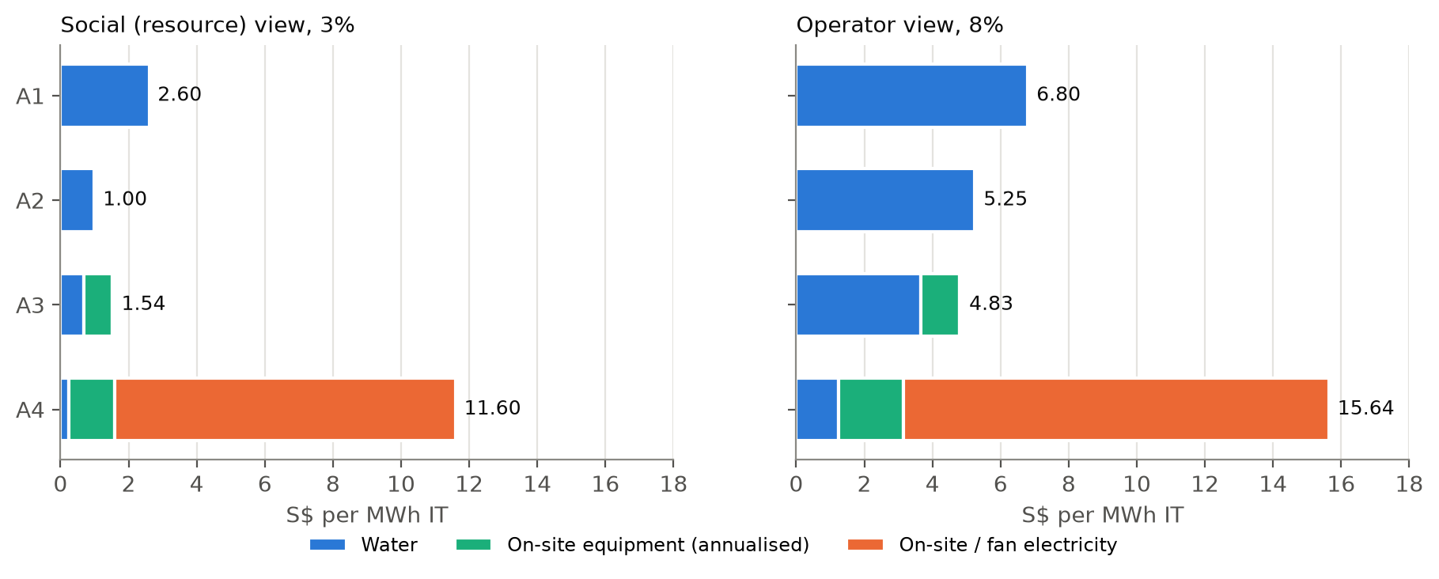
Figure 7. Cost breakdown in both views.

9.6 Why the cheapest option changes between views
Water A3 saves vs A2: 2.10 − 1.46 = 0.64 m³/MWh
Social: 0.64 × 0.475 = S$0.30 saved < S$0.82 + 0.03 extra cost → A3 costs more
Operator: 0.64 × 2.50 = S$1.60 saved > S$1.14 + 0.04 extra cost → A3 costs less
Break-even tariff: (1.143 + 0.035) / 0.64 = S$1.84/m³
The operator pays a tariff that includes taxes, so saving water is worth much more to them than the real resource cost of that water. Above a NEWater price of S$1.84/m³, A3 pays off for the operator.

9.7 Net present cost (NPC) over 2027–2035
The per-MWh numbers assume a mature, fully loaded plant. The NPC instead adds up every year's actual cost, discounted to 2026 (lecture 03, NPV):
NPC = Σ_y [ variable cost per MWh × MWh(y) + capital annuity(y) ] / (1 + r)^(y − 2026)
capital annuity = commissioned MW × capex per MW × CRF(r, 15) (paid even in ramp years)
EUAC per MWh = NPC / Σ_y MWh(y)/(1 + r)^(y − 2026)
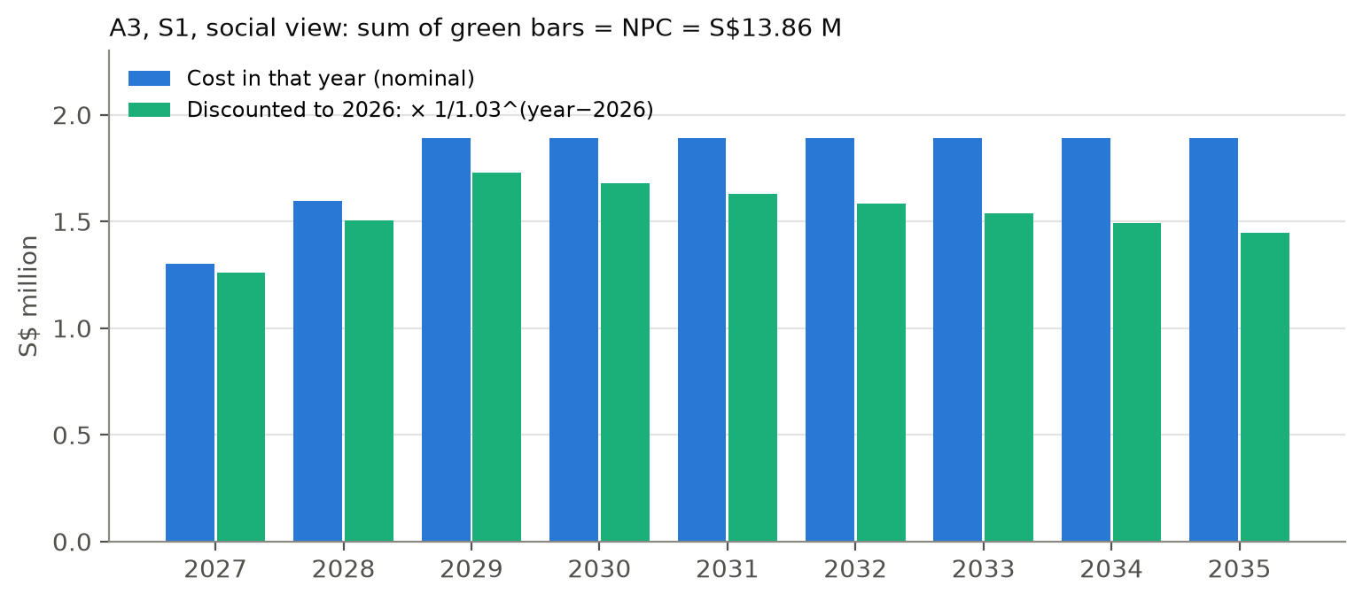
Figure 8. Annual cost of A3 in S1 (social view), before and after discounting.
Year | MWh IT | Variable cost (S$) | Capital annuity (S$) | Discount factor | PV (S$)
2027 | 408,800 | 294,841 | 1,005,199 | 0.9709 | 1,262,175
2028 | 817,600 | 589,682 | 1,005,199 | 0.9426 | 1,503,328
2029 | 1,226,400 | 884,523 | 1,005,199 | 0.9151 | 1,729,363
2030 | 1,226,400 | 884,523 | 1,005,199 | 0.8885 | 1,678,993
2031 | 1,226,400 | 884,523 | 1,005,199 | 0.8626 | 1,630,090
2032 | 1,226,400 | 884,523 | 1,005,199 | 0.8375 | 1,582,612
2033 | 1,226,400 | 884,523 | 1,005,199 | 0.8131 | 1,536,517
2034 | 1,226,400 | 884,523 | 1,005,199 | 0.7894 | 1,491,764
2035 | 1,226,400 | 884,523 | 1,005,199 | 0.7664 | 1,448,314
Total |  |  |  |  | 13,863,155
Table 16. A3, S1, social view, year by year. Variable cost = (1.541 − 0.820) × MWh; capital = 200 MW × 60,000 × 0.08377 = S$1,005,199/yr.
S1 (S$ million) | A1 | A2 | A3 | A4
NPC social (3%) | 21.79 | 8.35 | 13.86 | 98.71
EUAC social (S$/MWh) | 2.60 | 1.00 | 1.66 | 11.79
NPC operator (8%) | 44.59 | 34.41 | 32.91 | 104.64
EUAC operator (S$/MWh) | 6.80 | 5.25 | 5.02 | 15.97
Table 17. S1 net present cost and equivalent uniform annual cost (matches npc_by_scenario.csv).
Watch out
Why is A3's EUAC (1.66 social, 5.02 operator) higher than its per-MWh cost (1.54, 4.83)? The equipment is bought for the full 200 MW from 2027, but the servers only reach full load in 2029. In 2027–28 the capital is spread over fewer MWh. A1 and A2 have no on-site capital, so their EUAC equals their per-MWh cost.

10. Environmental LCC (eLCC)
Lecture 03, section 3: eLCC = economic cost + monetised environmental cost. The project monetises CO₂ in two ways:
Carbon-price equivalent = kg CO₂ / 1,000 × mean carbon price
mean price 2027–35 = (45 + 51.67 + 58.33 + 65 × 6) / 9 = 545 / 9 = S$60.56/t
Eco-cost = kg CO₂ × 0.15 €/kg × 1.45 S$/€ = kg CO₂ × S$0.2175
 | kg CO₂e | Social cost | + carbon price | eLCC (tax) | + eco-cost | eLCC (eco)
A1 | 3.42 | 2.60 | 0.207 | 2.81 | 0.745 | 3.35
A2 | 0.99 | 1.00 | 0.060 | 1.06 | 0.214 | 1.21
A3 | 0.74 | 1.54 | 0.045 | 1.59 | 0.161 | 1.70
A4 | 19.71 | 11.60 | 1.194 | 12.80 | 4.288 | 15.89
Table 18. eLCC per MWh IT, S$. Ranking is unchanged: A2 < A3 < A1 < A4.

10.1 Is eLCC needed, or is normal cost enough?
Normal cost is the main result; eLCC is a sensitivity check. Reasons:
- It does not change the ranking. Carbon is too small a share of cost to flip A2 and A3.
- No double counting in AHP. Carbon is already a separate AHP criterion next to cost.
- Carbon tax is already in electricity prices. Singapore's tax is paid by power stations and passed through in tariffs.
- The carbon value is very uncertain. S$61/t (tax) vs S$218/t (eco-cost): more than 3× apart.
Why this number?
S$45/t for 2026–27 (verified, NCCS). S$65/t from 2030 = midpoint of the published S$50–80 range (scenario). Eco-cost 0.15 €/kg from the course eco-cost workbook (2025 CO₂ row). 1.45 S$/€ illustrative exchange rate.

11. IRR, payback and incremental analysis
Is IRR needed? Not as a main method. IRR is for investments that earn money. All four options give the same service (cooling) with no revenue, so the lecture rule applies: compare present worth of costs (NPC/EUAC) and choose the lowest.
Where IRR helps: A3 can be seen as an extra investment on top of A2: pay more for equipment now, save water every year. That incremental cash flow has an IRR.
Watch out
These incremental IRR and payback numbers are not in the project outputs or paper. They were calculated for this guide from the same inputs. Add them to the code before citing them in the paper.
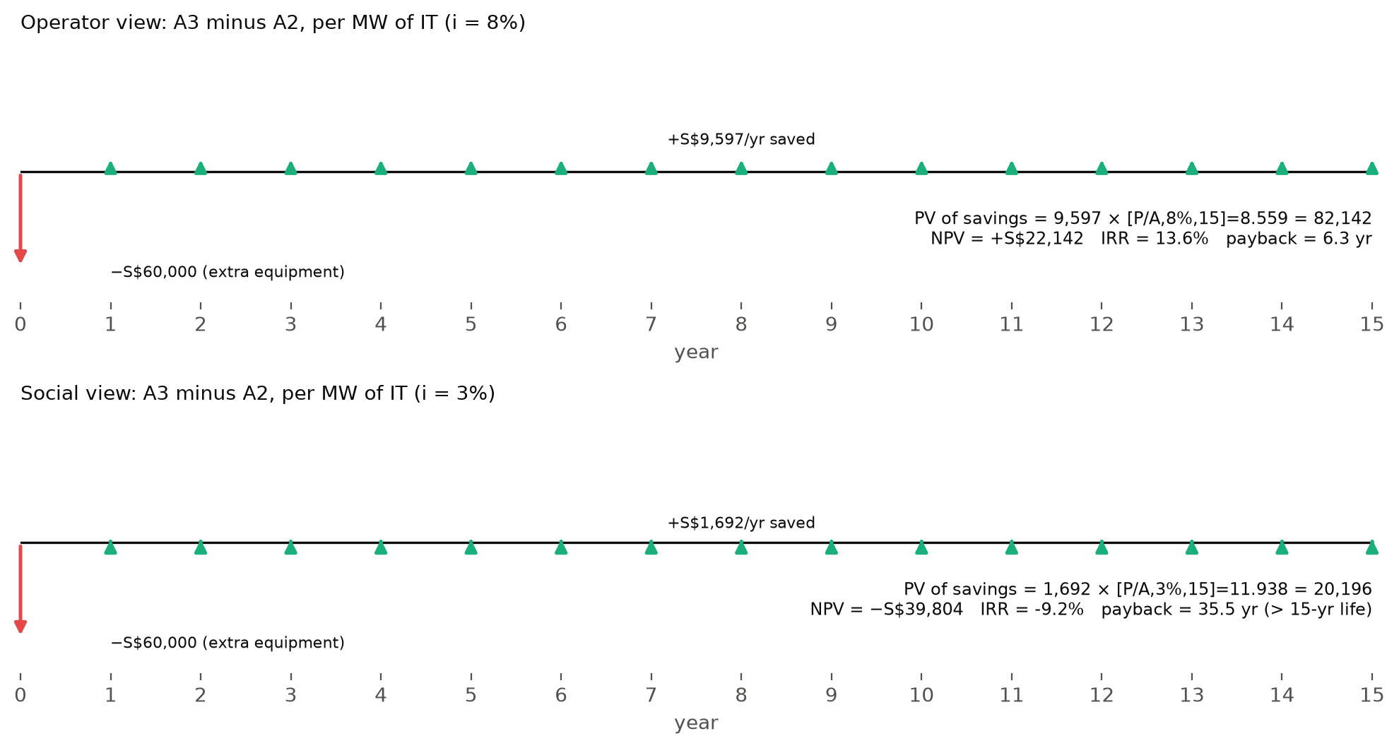
Figure 9. Incremental cash flow diagrams, A3 minus A2, per MW of IT. Arrows are not to the same scale across panels.

11.1 Operator view (8%)
Extra capex: P = S$60,000 per MW
Saving per MWh: 0.64 × 2.50 − 0.14 × 0.25 = 1.600 − 0.035 = S$1.565
Saving per year: 1.565 × 6,132 = S$9,597
NPV = 9,597 × [P/A, 8%, 15] − 60,000 = 9,597 × 8.559 − 60,000 = +S$22,142
Simple payback = 60,000 / 9,597 = 6.3 years
IRR: find i where [P/A, i, 15] = 60,000 / 9,597 = 6.252 → i = 13.6%
(tables: 13% → 6.462, 14% → 6.142, so i lies between them)
IRR 13.6% > 8% WACC, so A3 is a worthwhile investment for the operator.

11.2 Social view (3%)
Saving per MWh: 0.64 × 0.475 − 0.14 × 0.20 = 0.304 − 0.028 = S$0.276
Saving per year: 0.276 × 6,132 = S$1,692
NPV = 1,692 × 11.938 − 60,000 = −S$39,804
Simple payback = 35.5 years (longer than the 15-year life) → IRR = -9.2%
Check it yourself
PV of the social savings = 1,692 × 11.938 = S$20,196. That equals the project's own break-even capex for A3 (S$20,196 in outputs/tables/breakeven.csv), so the IRR arithmetic and the model agree.
Method | Include?
LCC / NPC / EUAC | Yes: main result (done)
eLCC | Yes: sensitivity (done)
Incremental IRR / payback, A3 vs A2 | Optional: one or two sentences in the discussion
IRR as a main ranking method | No: the options have no revenue
Table 19. Which financial metrics to use.

12. Cost vs carbon: the efficient frontier
Instead of adding cost and carbon together, the project uses dominance (lecture 03 section 3.2, lecture 05 Pareto): an option is dominated if another is at least as good on every criterion and better on one.
 | Social cost (S$/MWh) | kg CO₂e/MWh | Water (m³/MWh) | Dominated on cost-carbon?
A1 | 2.60 | 3.42 | 2.10 | Yes, by A2 (cheaper and lower carbon)
A2 | 1.00 | 0.99 | 2.10 | No: cheapest
A3 | 1.54 | 0.74 | 1.46 | No: lowest carbon
A4 | 11.60 | 19.71 | 0.50 | Yes, by A2 and A3
Table 20. Dominance check.
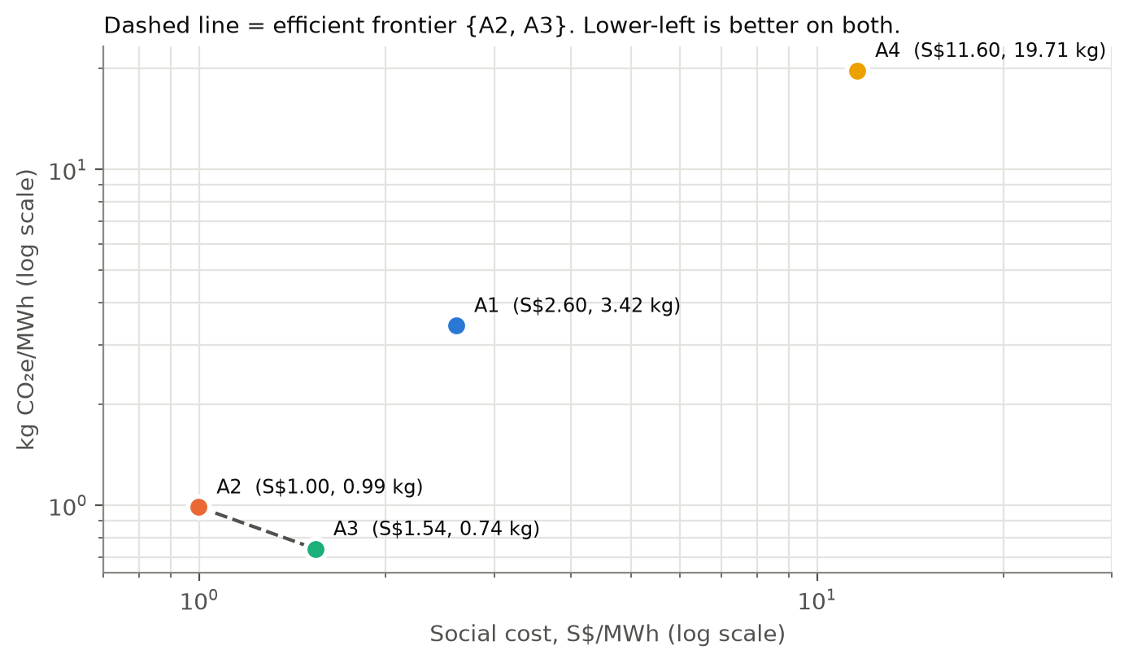
Figure 10. Cost-carbon frontier (log scales so all four fit).
Efficient frontier on cost and carbon = {A2, A3}. Moving from A2 to A3 costs (1.54 − 1.00) = S$0.54 more per MWh to save (0.99 − 0.74) = 0.25 kg CO₂, an implied abatement cost of about S$2,200/t, which is far above any carbon price. On cost and water, A4 also joins the frontier (it uses the least water), which is why the project needs AHP to weigh water security.

13. Parameter register: every number and why it was chosen
Base values with ranges (low–high) from config/assumptions.csv. Ranges are used in the tornado and Monte Carlo analyses.
Parameter | Base | Range | Status | Rationale / source
Demand
IT capacity S1 | 200 MW | 200 | verified | DC-CFA2: four 50 MW IT allocations; MDDI says IT load, not facility power
Extra capacity S2 / S3 | +300 / +200 MW | 0–500 | team | Hypothetical growth cases, not announced
Utilisation | 0.70 | 0.50–0.85 | to-verify | Team choice between LBNL 50% (p.8) and AI-training 75–85% (p.28); no direct source
Ramp-up | 3 yr | 2–5 | team | New halls fill gradually
WUE wet towers | 2.1 m³/MWh | 2.0–2.2 | benchmark | PUB sectoral benchmark (Dec 2025); IMDA median 2.2
CoC typical / best | 3 / 8 | 2.5–4 / 6–12 | to-verify | IMDA roadmap discussion; side-stream treatment literature
Blowdown recovery | 70% | 50–80% | team | Illustrative blowdown RO recovery
Trim threshold | 30 °C | 27–32 | team | 35 °C facility water minus ~5 K approach
Heat share to dry loop | 80% | 70–90% | team | No facility heat balance available
ΔPUE dry vs wet | 0.05 | 0.02–0.10 | team | Illustrative; most influential input for A4
LCA
SEC desalination | 3.5 kWh/m³ | 2.0–4.0 | verified | PUB historical reference; <2 is a target
SEC NEWater | 0.7 kWh/m³ | 0.6–1.0 | to-verify | Changi NEWater study 0.6–0.8
SEC pumping | 0.3 kWh/m³ | 0.2–0.5 | to-verify | Literature; same for all options
SEC blowdown treatment | 1.0 kWh/m³ | 0.5–2.0 | to-verify | Vendor/literature range
Non-energy GHG desal / NEWater | 0.15 / 0.08 kg/m³ | 0.05–0.4 / 0.03–0.2 | team | Proxy for construction, membranes, chemicals
Grid EF 2025 | 0.404 kg/kWh | fixed | verified | EMA SES 2026 Table 2.3
Grid EF 2035 BAU / low-carbon | 0.38 / 0.25 | 0.36–0.40 / 0.15–0.30 | team / to-verify | Trend extrapolation; imports + solar case
SWRO / NEWater recovery | 0.45 / 0.75 | 0.40–0.50 / 0.70–0.85 | team | Used only for brine inventory
LCC
Capex desal / NEWater | 1,600 / 1,000 S$ per m³/d | 1,300–2,500 / 700–1,500 | team | Anchored to Tuas 2018; not a quote
O&M desal / NEWater | 0.20 / 0.10 S$/m³ | 0.1–0.3 / 0.05–0.2 | to-verify | Literature/PPP
Plant life / capacity factor | 25 yr / 0.90 | 20–30 / 0.85–0.95 | team | 25-yr concessions; PPP availability
Electricity, plants (social) | S$0.20/kWh | 0.15–0.25 | proxy | USEP 2023–25 mean 0.176 + ~0.03 network
Electricity, operator | S$0.25/kWh | 0.20–0.30 | proxy | Retail price proxy
Tariff potable / NEWater | S$3.24 / 2.50 | fixed | verified | PUB, from April 2025, before GST
Capex A3 recovery | S$60,000/MW | 30k–120k | team | No vendor quote; break-even S$20,196
Capex A4 dry premium | S$100,000/MW | 0–300k | team | No vendor quote
Equipment life | 15 yr | 10–20 | team | Industry practice
Discount social / private | 3% / 8% | 2–5 / 6–10 | team | Lecture eLCC (3%) and LCOE (10%) examples
Carbon tax 2026 / 2030 | S$45 / 65 per t | 45 / 50–80 | verified / scenario | NCCS; 65 = midpoint of range
Eco-cost CO₂ | 0.15 €/kg × 1.45 | 0.123–0.2 | benchmark | Course eco-cost workbook
Discharge treatment cost | S$0/m³ | 0–1.09 | team | Tested as a structural case
Table 21. Parameter register.

14. Summary and what could change the answer
 | Water (m³) | Electricity (kWh) | CO₂e (kg) | Social (S$) | Operator (S$) | AHP rank
A1 | 2.10 | 7.98 | 3.42 | 2.60 | 6.80 | 3
A2 | 2.10 | 2.10 | 0.99 | 1.00 | 5.25 | 2
A3 | 1.46 | 1.60 | 0.74 | 1.54 | 4.83 | 1
A4 | 0.50 | 50.50 | 19.71 | 11.60 | 15.64 | 4
Table 22. Headline results per MWh IT (matches headline.csv). AHP is covered next.
In one line: electricity drives both carbon and cost. A1 loses on desalination energy, A4 on fan electricity; A2 is cheapest for society; A3 has the lowest carbon and is cheapest for the operator.

14.1 Break-even values (outputs/tables/breakeven.csv)
Question | Base | Break-even | Meaning
ΔPUE at which A4 matches A2 on cost / GHG | 0.05 | ≈ −0.003 / 0.002 | A4 only competes if dry cooling adds almost no electricity
NEWater tariff at which A3 = A2 for operator | S$2.50 | S$1.84 | Today's tariff is well above break-even
A3 capex at which A3 = A2 socially | S$60,000 | S$20,196 | Recovery equipment would need to be ~3× cheaper
Desal energy at which A1 = A2 on GHG | 3.5 kWh/m³ | 0.52 kWh/m³ | Physically unrealistic for seawater RO
Table 23. Break-even values.

14.2 Main limitations to remember
- Partial LCA: only GWP; servers, liquid cooling and cooler embodied emissions are excluded.
- Several key inputs are team judgements (ΔPUE, recovery capex, non-energy factors, AHP judgements).
- WUE 2.1 is calibrated to a benchmark, not independently validated.
- Results are conditional screening, not a site-level design decision.

