Name: Vanshika Khatri
Class: D15C
Roll No.: 30
EXPERIMENT – 2
Aim
To implement and analyze Multiple Linear Regression, Ridge Regression, and Lasso Regression on a real-world dataset and evaluate their effectiveness in predicting housing prices.

Dataset Source
https://www.kaggle.com/datasets/vedavyasv/usa-housing

Dataset Description
The USA Housing Dataset is a real-world dataset that provides information about housing prices across different regions of the United States. It is widely used for analyzing how economic and housing-related factors influence property pricing.
The dataset contains approximately 5000 entries, where each row corresponds to a specific housing instance. The data is available in CSV format and is organized in a structured tabular form. Since most of the variables are numerical, the dataset is well-suited for regression algorithms and requires minimal preprocessing.
Dataset Attributes:
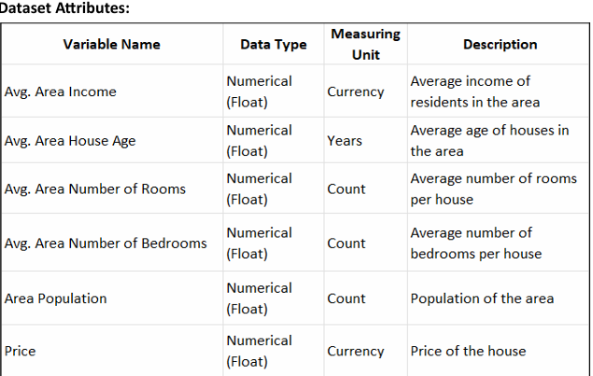
Target Variable
- Price: A continuous numerical variable representing the cost of a house. This variable is used as the dependent variable for Multiple Linear Regression, Ridge Regression, and Lasso Regression models.

Theory
Multiple Linear Regression
Multiple Linear Regression is an extension of Simple Linear Regression and is used to model the relationship between a dependent variable and multiple independent variables simultaneously.
In real-world scenarios like housing price prediction, relying on a single feature is insufficient. House prices are influenced by several factors such as income levels, population, number of rooms, and property age. Multiple Linear Regression allows all these variables to contribute collectively to the prediction.
This results in a model that represents a multidimensional relationship between features and the target variable.

Mathematical Formulation
For a single variable:
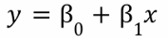
For multiple variables:
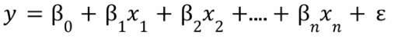
Where:
- y is the dependent variable (house price)
- x1 ,x2 ,…,xn are the independent variables (housing features)
- β0 is the intercept, representing the predicted value of y when all x values are zero
- β1 ,β2 ,…,βn are regression coefficients that represent the effect of each feature on the house price
- ε is the error term, representing unexplained variation
Assumptions of Multiple Linear Regression
- Linear relationship between predictors and target
- No strong correlation among independent variables
- Constant variance of residuals
- Residuals follow a normal distribution

Algorithm Limitations
Multicollinearity
When independent variables are highly correlated, the model struggles to estimate their individual effects.
Failure Condition: Leads to unstable coefficients and reduces interpretability.

Overfitting
Including too many features can make the model overly complex.
Failure Condition: The model may perform well on training data but poorly on unseen data.

Lack of Interaction Modeling
The model assumes each feature independently contributes to the output.
Failure Condition: Cannot capture relationships where features influence each other.

Methodology / Workflow
Data Collection
The dataset is imported into a Pandas DataFrame for analysis and processing.
Data Preprocessing
- The non-numeric Address column is removed
- Remaining features are verified
- Feature scaling is applied to normalize data
Train-Test Split
The dataset is divided into training (80%) and testing (20%) subsets.
Model Training and Prediction
A Multiple Linear Regression model is trained using the training data and then used to generate predictions for the test set.
Model Evaluation
The model is evaluated using:
- Root Mean Squared Error (RMSE)
- R² Score
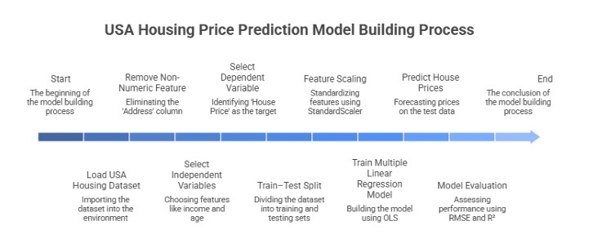

Code:
# ==============================
# STEP 1: IMPORT LIBRARIES
# ==============================
import pandas as pd
import numpy as np
import matplotlib.pyplot as plt
import seaborn as sns

from sklearn.model_selection import train_test_split
from sklearn.linear_model import LinearRegression
from sklearn.preprocessing import StandardScaler
from sklearn.metrics import mean_squared_error, r2_score

# ==============================
# STEP 2: LOAD DATASET
# ==============================
data = pd.read_csv("USA_Housing.csv")

# ==============================
# STEP 3: DEFINE FEATURES & TARGET
# ==============================
features = data.drop(['Price', 'Address'], axis=1)
target = data['Price']

# ==============================
# STEP 4: SPLIT DATA
# ==============================
X_train, X_test, y_train, y_test = train_test_split(
features, target, test_size=0.2, random_state=42
)

# ==============================
# STEP 5: FEATURE SCALING
# ==============================
scaler = StandardScaler()

X_train_scaled = scaler.fit_transform(X_train)
X_test_scaled = scaler.transform(X_test)

# ==============================
# STEP 6: TRAIN MODEL
# ==============================
model = LinearRegression()
model.fit(X_train_scaled, y_train)

# ==============================
# STEP 7: MAKE PREDICTIONS
# ==============================
predictions = model.predict(X_test_scaled)

# ==============================
# STEP 8: EVALUATE MODEL
# ==============================
rmse_value = np.sqrt(mean_squared_error(y_test, predictions))
r2_value = r2_score(y_test, predictions)

print("===== MULTIPLE LINEAR REGRESSION OUTPUT =====")
print("RMSE:", rmse_value)
print("R2 Score:", r2_value)

# ==============================
# STEP 9: VISUALIZATION
# ==============================
plt.figure(figsize=(8, 6))

sns.scatterplot(x=y_test, y=predictions)

# Ideal line
plt.plot(
[y_test.min(), y_test.max()],
[y_test.min(), y_test.max()],
linestyle='--'
)

plt.xlabel("Actual House Prices")
plt.ylabel("Predicted House Prices")
plt.title("Actual vs Predicted Prices (Multiple Linear Regression)")

plt.show()
OUTPUT:
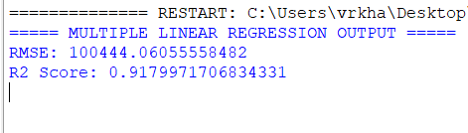
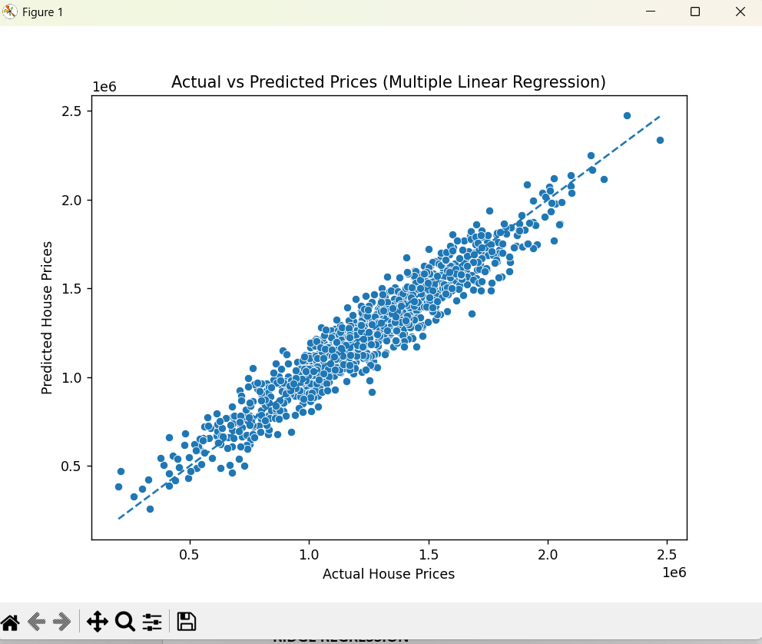

Performance Analysis
- RMSE: Indicates the average deviation between predicted and actual values
- R² Score: Represents how well the model explains variance in the data
The obtained results show that the model effectively captures key relationships between input variables and housing prices, making it a strong baseline model.

Hyperparameter Tuning
Multiple Linear Regression does not involve tunable hyperparameters, as it computes coefficients directly using the Ordinary Least Squares method.
To overcome limitations such as overfitting and multicollinearity, regularized models like Ridge and Lasso are introduced.

RIDGE REGRESSION
Theory
Ridge Regression is a variation of Multiple Linear Regression that introduces a penalty term to reduce model complexity and improve generalization.
In datasets where features are correlated, such as housing data, standard regression may produce unstable coefficients. Ridge Regression addresses this by shrinking coefficient values, resulting in a more stable model.

Mathematical Formulation
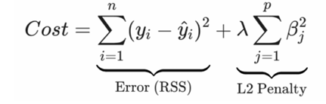
Where:
- yi is the actual house price
- y^i is the predicted house price
- βj are the regression coefficients
- λ (alpha) is the regularization
The first term represents the sum of squared errors , while the second term penalizes large coefficient values. As λ\lambdaλ increases, the penalty becomes stronger, forcing coefficients to shrink toward zero.Unlike Lasso Regression, Ridge Regression does not eliminate features entirely ; instead, it reduces their influence smoothly.

Assumptions
- Linear relationship between variables
- Features must be scaled
- Handles correlated features effectively

Limitations
No Feature Elimination
All features remain in the model, though their influence is reduced.
Dependence on λ
Choosing an incorrect value can lead to underfitting or overfitting.
Scaling Requirement
Unscaled features may distort regularization effects.

Methodolgy/Workflow:
Data Collection:
The USA Housing dataset is imported into the working environment, which includes various numerical features related to housing along with the target variable, Price.
Data Preprocessing:
The Address column is removed since it contains textual (non-numeric) information that cannot be directly used for model training. The remaining features are already numerical. To ensure that all features contribute equally during model training, feature scaling is performed using StandardScaler.
Train–Test Split:
The dataset is partitioned into two subsets: 80% of the data is used for training the model, while the remaining 20% is reserved for testing its performance on unseen data.
Baseline Model Training:
Initially, a Ridge Regression model is trained using default hyperparameters. This serves as a baseline to understand the model’s initial performance before optimization.
Hyperparameter Tuning:
The regularization parameter (λ) is fine-tuned using GridSearchCV, which applies cross-validation to evaluate multiple values and select the optimal one.
Prediction and Evaluation:
The optimized Ridge Regression model is then used to predict house prices on the test dataset. Its performance is assessed using evaluation metrics such as RMSE and R² score to measure prediction accuracy and model effectiveness.
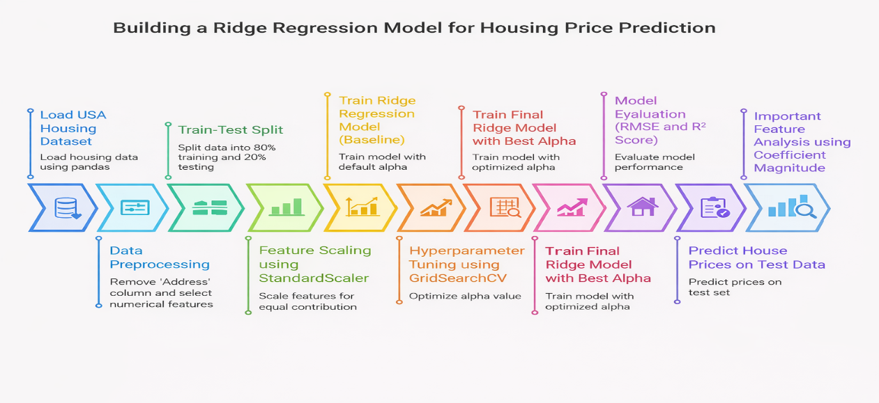

Code:
# ======================================
# STEP 1: IMPORT REQUIRED LIBRARIES
# ======================================
import pandas as pd
import numpy as np
import matplotlib.pyplot as plt

from sklearn.model_selection import train_test_split, GridSearchCV
from sklearn.linear_model import Ridge
from sklearn.preprocessing import StandardScaler
from sklearn.metrics import mean_squared_error, r2_score

# ======================================
# STEP 2: LOAD DATASET
# ======================================
data = pd.read_csv("USA_Housing.csv")

# ======================================
# STEP 3: PREPARE FEATURES & TARGET
# ======================================
X = data.drop(['Price', 'Address'], axis=1)
y = data['Price']

# ======================================
# STEP 4: SPLIT DATA INTO TRAIN & TEST
# ======================================
X_train, X_test, y_train, y_test = train_test_split(
X, y, test_size=0.2, random_state=42
)

# ======================================
# STEP 5: FEATURE SCALING
# ======================================
scaler = StandardScaler()

X_train_scaled = scaler.fit_transform(X_train)
X_test_scaled = scaler.transform(X_test)

# ======================================
# RIDGE REGRESSION (BASE MODEL)
# ======================================
ridge_model = Ridge()
ridge_model.fit(X_train_scaled, y_train)

pred_default = ridge_model.predict(X_test_scaled)

rmse_default = np.sqrt(mean_squared_error(y_test, pred_default))
r2_default = r2_score(y_test, pred_default)

print("===== RIDGE REGRESSION (DEFAULT) =====")
print(f"RMSE: {rmse_default:.2f} USD")
print(f"R2 Score: {r2_default:.4f}")

# ======================================
# RIDGE REGRESSION (WITH TUNING)
# ======================================
param_grid = {
'alpha': np.logspace(-2, 2, 50)
}

grid_search = GridSearchCV(
Ridge(),
param_grid,
cv=5,
scoring='r2'
)

grid_search.fit(X_train_scaled, y_train)

best_ridge_model = grid_search.best_estimator_

pred_tuned = best_ridge_model.predict(X_test_scaled)

rmse_tuned = np.sqrt(mean_squared_error(y_test, pred_tuned))
r2_tuned = r2_score(y_test, pred_tuned)

print("\n===== RIDGE REGRESSION (TUNED) =====")
print("Best Alpha:", grid_search.best_params_)
print(f"RMSE: {rmse_tuned:.2f} USD")
print(f"R2 Score: {r2_tuned:.4f}")

# ======================================
# FEATURE IMPORTANCE (RIDGE)
# ======================================
feature_importance = pd.Series(
best_ridge_model.coef_,
index=X.columns
).abs().sort_values(ascending=False)

print("\nTop 5 Important Features (Ridge):")
print(feature_importance.head(5))

# ======================================
# VISUALIZATION OF COEFFICIENTS
# ======================================
plt.figure(figsize=(10, 5))

feature_importance.head(10).plot(kind='bar')

plt.title("Top 10 Features based on Ridge Coefficients")
plt.ylabel("Absolute Coefficient Magnitude")

plt.show()
OUTPUT:
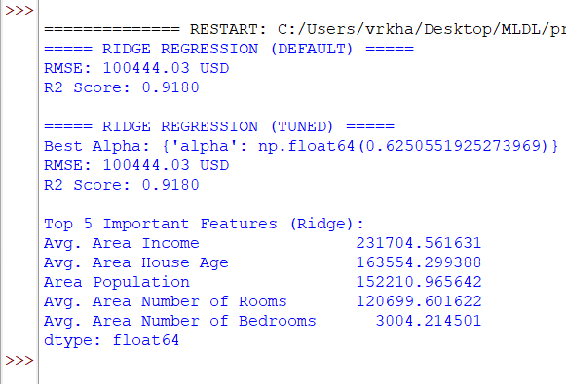
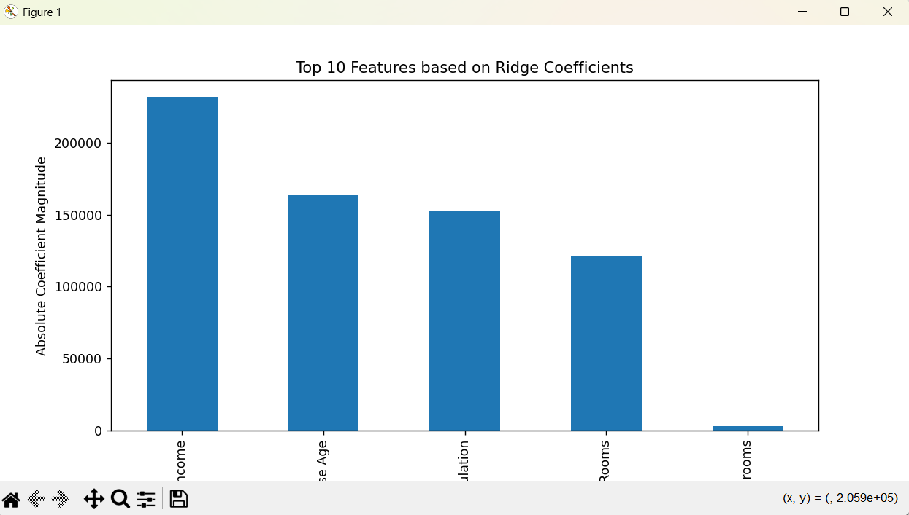

Performance Analysis
The Ridge Regression model is evaluated using Root Mean Squared Error (RMSE) and R² score .
- RMSE measures the average prediction error in USD , indicating how far predicted house prices deviate from actual values.
- R² score represents the proportion of variance in house prices explained by the model. Compared to Multiple Linear Regression, Ridge Regression typically produces more stable coefficients and improved generalization, especially when predictor variables are correlated.

Hyperparameter Tuning
Different values of λ are tested using cross-validation. The value that maximizes model performance is selected.
This ensures a balance between bias and variance.

LASSO REGRESSION
Theory
Lasso Regression (Least Absolute Shrinkage and Selection Operator) is a regularized linear regression technique that extends Multiple Linear Regression by adding a penalty term to the loss function. Like Ridge Regression, it is used to control model complexity and prevent overfitting. However, Lasso Regression has an additional advantage: it can automatically perform feature selection. In datasets such as USA Housing, not all input variables contribute equally to house price prediction. Some features may have very little influence on the target variable. Lasso Regression helps identify these less important features by shrinking their coefficients exactly to zero, thereby removing them from the model. This makes Lasso Regression especially useful when model interpretability is important and when we want to identify the most influential housing attributes affecting price.
Mathematical Formulation
The objective (loss) function is expressed as:
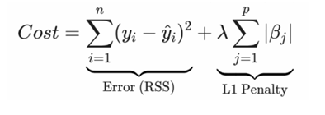
Where:
- yi is the actual house price
- y^i is the predicted house price
- βj are the regression coefficients
- λ (alpha) is the regularization parameter

Assumptions
Lasso Regression follows most of the assumptions of Multiple Linear Regression, with additional considerations:
- Linearity: The relationship between independent variables and the target variable is assumed to be linear.
- Feature Scaling: Input features must be scaled so that the regularization penalty is applied uniformly.
- Sparsity Preference: Lasso assumes that only a subset of features significantly influences the target variable.

Limitations
Instability with Correlated Features
Lasso may randomly select one feature among correlated ones.
Sensitivity to λ
A large λ may remove important features.
Scaling Requirement
Feature normalization is necessary for consistent results.

Methodology
Data Collection:
The USA Housing dataset is imported into the system, which includes various numerical features related to housing along with the target variable, Price.
Data Preprocessing:
The Address column is removed since it contains non-numeric information that cannot be used directly by the model. All other features are numerical. To ensure balanced contribution of each feature, scaling is performed using StandardScaler.
Train–Test Split:
The dataset is divided into two parts: 80% is used for training the model, while the remaining 20% is used for testing to evaluate how well the model generalizes to unseen data.
Baseline Model Training:
A Lasso Regression model is first trained using its default settings to establish an initial performance benchmark.
Hyperparameter Tuning:
The regularization parameter (λ) is optimized using GridSearchCV, which applies cross-validation to identify the most suitable value.
Prediction and Evaluation:
The optimized Lasso model is then used to generate predictions on the test dataset. Its performance is assessed using RMSE and R² score to measure prediction accuracy and model effectiveness.
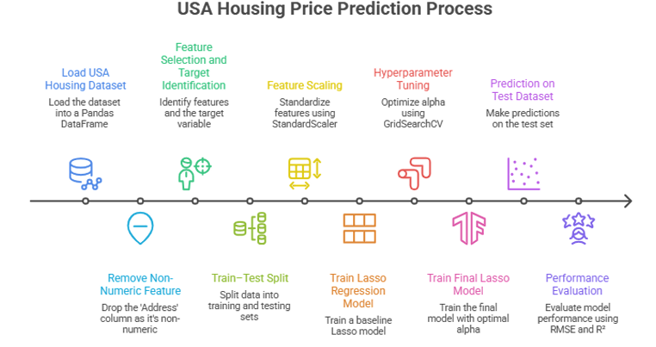

CODE:
# ======================================
# STEP 1: IMPORT LIBRARIES
# ======================================
import pandas as pd
import numpy as np
import matplotlib.pyplot as plt

from sklearn.model_selection import train_test_split, GridSearchCV
from sklearn.linear_model import Lasso
from sklearn.preprocessing import StandardScaler
from sklearn.metrics import mean_squared_error, r2_score

# ======================================
# STEP 2: LOAD DATASET
# ======================================
data = pd.read_csv("USA_Housing.csv")

# ======================================
# STEP 3: FEATURE SELECTION
# ======================================
X = data.drop(['Price', 'Address'], axis=1)
y = data['Price']

# ======================================
# STEP 4: TRAIN-TEST SPLIT
# ======================================
X_train, X_test, y_train, y_test = train_test_split(
X, y, test_size=0.2, random_state=42
)

# ======================================
# STEP 5: FEATURE SCALING
# ======================================
scaler = StandardScaler()

X_train_scaled = scaler.fit_transform(X_train)
X_test_scaled = scaler.transform(X_test)

# ======================================
# LASSO REGRESSION (BASE MODEL)
# ======================================
lasso_model = Lasso(max_iter=5000)
lasso_model.fit(X_train_scaled, y_train)

pred_default = lasso_model.predict(X_test_scaled)

rmse_default = np.sqrt(mean_squared_error(y_test, pred_default))
r2_default = r2_score(y_test, pred_default)

print("===== LASSO REGRESSION (DEFAULT) =====")
print(f"RMSE: {rmse_default:.2f} USD")
print(f"R2 Score: {r2_default:.4f}")

# ======================================
# LASSO REGRESSION (WITH TUNING)
# ======================================
param_grid = {
'alpha': np.logspace(-4, 1, 50)
}

grid_search = GridSearchCV(
Lasso(max_iter=5000),
param_grid,
cv=5,
scoring='r2'
)

grid_search.fit(X_train_scaled, y_train)

best_lasso_model = grid_search.best_estimator_

pred_tuned = best_lasso_model.predict(X_test_scaled)

rmse_tuned = np.sqrt(mean_squared_error(y_test, pred_tuned))
r2_tuned = r2_score(y_test, pred_tuned)

print("\n===== LASSO REGRESSION (TUNED) =====")
print("Best Alpha:", grid_search.best_params_)
print(f"RMSE: {rmse_tuned:.2f} USD")
print(f"R2 Score: {r2_tuned:.4f}")

# ======================================
# FEATURE IMPORTANCE (LASSO)
# ======================================
feature_importance = pd.Series(
best_lasso_model.coef_,
index=X.columns
).abs().sort_values(ascending=False)

print("\nTop 5 Important Features (Lasso):")
print(feature_importance.head(5))

# ======================================
# VISUALIZATION
# ======================================
plt.figure(figsize=(10, 5))

feature_importance.head(10).plot(kind='bar')

plt.title("Top 10 Features based on Lasso Coefficients")
plt.ylabel("Absolute Coefficient Magnitude")

plt.show()
OUTPUT:
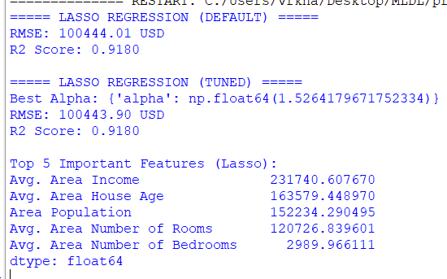
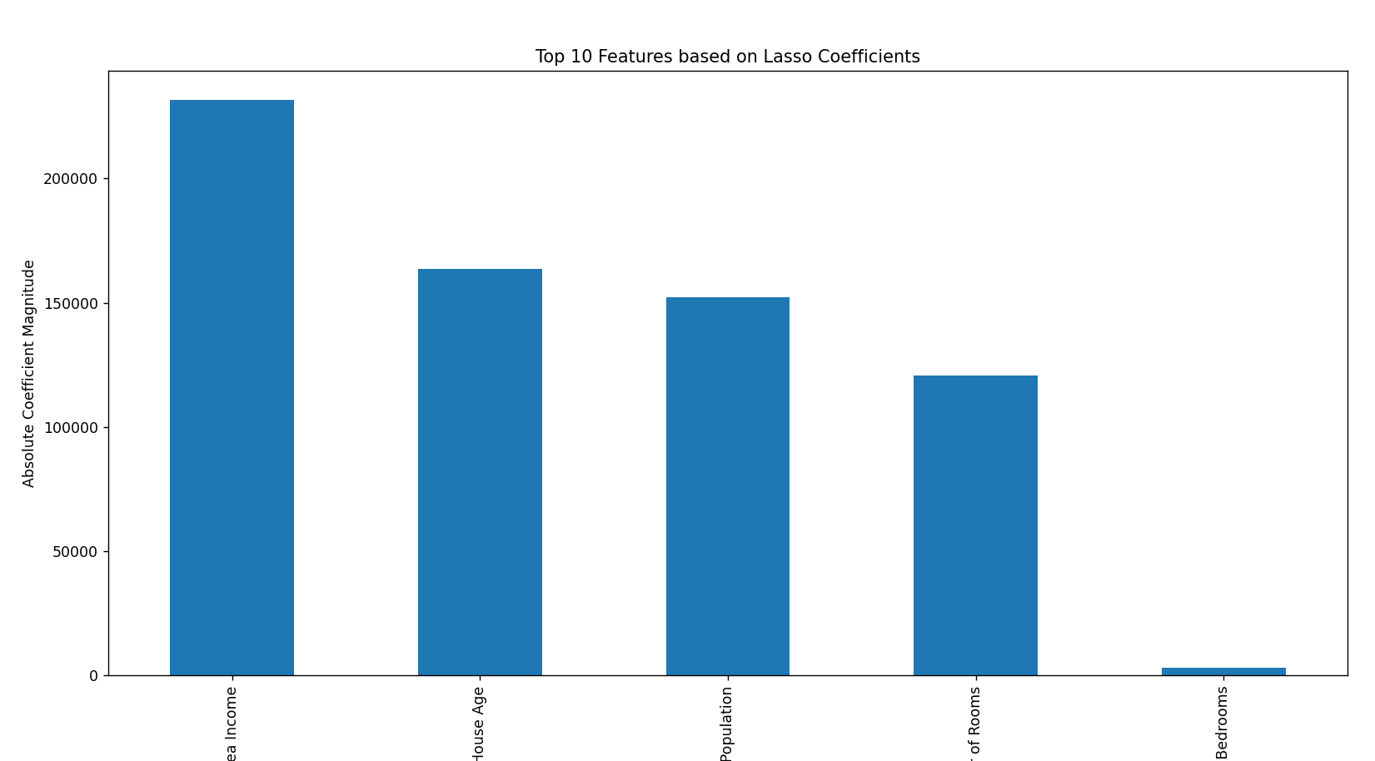
Performance Analysis
- RMSE shows prediction error
- R² indicates model effectiveness
Lasso improves interpretability by reducing the number of active features.

Hyperparameter Tuning
Different values of λ are evaluated using cross-validation, and the best-performing value is selected based on R² score.
This ensures that only the most relevant features are retained.

Conclusion
In this experiment, three regression techniques were applied to predict housing prices:
- Multiple Linear Regression served as a baseline model
- Ridge Regression improved stability by reducing the effect of multicollinearity
- Lasso Regression enhanced interpretability by performing feature selection
The results demonstrate that regularization techniques significantly improve model performance and generalization ability. These methods are essential for handling real-world datasets where feature correlation and complexity are common challenges.

