Vanshika Khatri
D15C _ 30
EXPERIMENT 8
Convolutional Neural Network (CNN) on Image Datasets 8 (e.g. MNIST / CIFAR)
Aim:
To design, implement, and train a Convolutional Neural Network (CNN) using image datasets such as MNIST or CIFAR-10 for accurate image classification.

Dataset Source:
The experiment utilizes the MNIST (Modified National Institute of Standards and Technology) dataset, specifically the CSV structured version for streamlined processing.
• Source Link: https://www.kaggle.com/datasets/oddrationale/mnist-in-csv

Dataset Description:
The MNIST dataset is the definitive benchmark for evaluating image processing systems. It consists of grayscale images of handwritten digits (0 through 9). The dataset is pre-formatted into a 2D array where each row represents one image. The pixels are flattened from a 28 × 28 grid into 784 individual features, with values ranging from 0 (white) to 255 (black).
Feature Description Data Type Unit Type
- Total Size: Total number of images in the dataset (60,000 training and 10,000 testing) — Integer — Images (count) — Dataset Metadata
- Input Features: 784 pixel values representing a flattened 28 × 28 grayscale image — Integer — Pixel Intensity (0–255) — Independent Variable
- Target Variable: Digit label corresponding to each image (0–9) — Integer — Class Label — Dependent Variable
- Colour Space: Image colour format — Categorical (String) — Grayscale (Single Channel) — Image Property
- Data Format: Storage structure of the dataset — Categorical (String) — .csv — Storage Format

Theory:
Designing and implementing a Convolutional Neural Network (CNN) for image classification involves leveraging its ability to automatically learn hierarchical feature representations from raw pixel data. Unlike traditional machine learning methods that rely on handcrafted features, CNNs use convolutional layers to extract spatial patterns such as edges, textures, and shapes directly from images. A typical CNN architecture consists of convolutional layers (with learnable filters), activation functions like ReLU to introduce non-linearity, pooling layers for spatial down sampling, and fully connected layers for final classification. When applied to benchmark datasets such as MNIST or CIFAR-10, CNNs can effectively learn distinguishing features—digits in grayscale images for MNIST and small coloured object images for CIFAR-10—by optimizing filter weights through backpropagation and gradient descent.
Training a CNN involves splitting the dataset into training, validation, and test sets to ensure generalization and prevent overfitting. The network processes input images through forward propagation to produce predictions, computes loss using a function such as cross-entropy, and updates parameters via optimization algorithms like stochastic gradient descent (SGD) or Adam. Techniques such as data augmentation, dropout, and batch normalization are often incorporated to enhance robustness and convergence speed. For simpler datasets like MNIST, shallow CNN architectures can achieve high accuracy due to the dataset’s low complexity, whereas CIFAR-10 typically requires deeper architectures to capture more complex visual patterns. Proper hyperparameter tuning—including learning rate, batch size, number of filters, and epochs—is critical to achieving accurate and reliable image classification performance.

Mathematical Formulation of the Algorithms:
Convolution Operation (*):
Applies a filter (W) to the input image (X) to create a feature map (Z).
Zᵢ,ⱼ = (X * W)ᵢ,ⱼ = ∑∑ Xᵢ₊ₘ,ⱼ₊ₙ · Wₘ,ₙ + b
Activation Function (ReLU):
f(z) = max(0, z)
Pooling (Downsampling):
Y = max(Region of Z)
Softmax Output:
σ(z)ᵢ = e^{zᵢ} / ∑ e^{zⱼ}

Algorithm Limitations:
• High Computational Cost: CNNs require significant GPU/CPU resources and memory compared to standard shallow learners, especially as depth increases.
• Requirement for Large Datasets: They are prone to overfitting if the training data is insufficient or lacks variety.
• Translation Invariance Limits: Standard CNNs can struggle with significant rotations or scaling unless specifically addressed through data augmentation.
• Black-Box Nature: It is mathematically difficult to interpret exactly why a specific filter activated for a specific feature (low interpretability).

Methodology / Workflow:
- Data Loading & Parsing: The process begins by importing the mnist_test.csv file using the Pandas library. The labels (target variables) are separated from the 784 pixel columns (feature variables) to prepare for supervised learning.
- Feature Normalization: Pixel values are originally integers ranging from 0 to 255. These are converted to floating-point numbers and divided by 255.0 to scale them between 0 and 1. This ensures faster convergence and prevents gradients from exploding during backpropagation.
- Tensor Reshaping: Since a CNN requires spatial context, the flattened 1D array of 784 pixels is reshaped back into a 4D tensor with the shape (Batch_Size, 28, 28, 1).
- Convolutional Layers (Feature Extraction): The model applies filters (kernels) to scan the image. These filters learn to detect low-level features like edges in the first layer and high-level features like curves or digits in deeper layers.
- Batch Normalization: This layer normalizes activations and stabilizes training.
- Max Pooling: Reduces spatial size and computational load.
- Flattening: Converts 2D feature maps into 1D vector.
- Dropout: Randomly deactivates neurons to prevent overfitting.
- Softmax Classification: Produces probability distribution for digits 0–9.
- Model Evaluation: Uses confusion matrix and classification report.

Baseline Implementation Code:
import pandas as pd
import numpy as np
import matplotlib.pyplot as plt
import seaborn as sns

from sklearn.model_selection import train_test_split
from sklearn.metrics import classification_report, confusion_matrix

import tensorflow as tf
from tensorflow.keras import layers, models

# ==========================================
# 1. DATA LOADING & PREPROCESSING
# ==========================================
def load_data(file_path):
print(f"Loading dataset from {file_path}...")
data = pd.read_csv(file_path)

# Extract labels and pixel data
y = data.iloc[:, 0].values
X = data.iloc[:, 1:].values

# Normalize pixel values (0-255 to 0.0-1.0)
X = X.astype('float32') / 255.0

# Reshape for CNN: (Batch, Height, Width, Channels)
X = X.reshape(-1, 28, 28, 1)

return X, y

# Load your uploaded file
try:
# If only test file exists, we split it
X_test, y_test = load_data('mnist_test.csv')

# In full experiment, replace with:
# X_train, y_train = load_data('mnist_train.csv')

X_train, X_val, y_train, y_val = train_test_split(
X_test, y_test, test_size=0.2, random_state=42
)

print("Data prepared successfully.")

except FileNotFoundError:
print("Error: mnist_test.csv not found. Please ensure the file is in the working directory.")

# ==========================================
# 2. BASELINE CNN DESIGN (No Tuning)
# ==========================================
model = models.Sequential([
# First Convolutional Block
layers.Conv2D(32, (3, 3), activation='relu', input_shape=(28, 28, 1)),
layers.MaxPooling2D((2, 2)),

# Second Convolutional Block
layers.Conv2D(64, (3, 3), activation='relu'),
layers.MaxPooling2D((2, 2)),

# Flatten and Fully Connected Layers
layers.Flatten(),
layers.Dense(64, activation='relu'),
layers.Dense(10, activation='softmax') # 10 classes (0–9)
])

model.compile(
optimizer='adam',
loss='sparse_categorical_crossentropy',
metrics=['accuracy']
)

# ==========================================
# 3. TRAINING
# ==========================================
print("\nStarting Training...")
history = model.fit(
X_train, y_train,
epochs=10,
validation_data=(X_val, y_val),
batch_size=32,
verbose=1
)

# ==========================================
# 4. PERFORMANCE ANALYTICAL METRICS
# ==========================================
print("\n" + "="*30)
print("PERFORMANCE ANALYTICAL METRICS")
print("="*30)

# Evaluate on validation set
loss, accuracy = model.evaluate(X_val, y_val, verbose=0)

print(f"Final Validation Loss: {loss:.4f}")
print(f"Final Validation Accuracy: {accuracy:.4f} ({accuracy*100:.2f}%)")

# Detailed Classification Report
y_pred = np.argmax(model.predict(X_val), axis=1)

print("\nDetailed Metrics:")
print(classification_report(y_val, y_pred))

# ==========================================
# 5. VISUAL OUTPUTS
# ==========================================

# Visual 1: Training History Graph
plt.figure(figsize=(12, 4))

plt.subplot(1, 2, 1)
plt.plot(history.history['accuracy'], label='Train Accuracy')
plt.plot(history.history['val_accuracy'], label='Val Accuracy')
plt.title('Model Accuracy Performance')
plt.xlabel('Epoch')
plt.ylabel('Accuracy')
plt.legend()

plt.subplot(1, 2, 2)
plt.plot(history.history['loss'], label='Train Loss')
plt.plot(history.history['val_loss'], label='Val Loss')
plt.title('Model Loss Performance')
plt.xlabel('Epoch')
plt.ylabel('Loss')
plt.legend()

plt.tight_layout()
plt.show()

# Visual 2: Actual Prediction Results (Image Grid)
plt.figure(figsize=(12, 8))

for i in range(10):
plt.subplot(2, 5, i + 1)

img = X_val[i].reshape(28, 28)
actual_label = y_val[i]
pred_label = y_pred[i]

color = 'green' if actual_label == pred_label else 'red'

plt.imshow(img, cmap='gray')
plt.title(f"Act: {actual_label} | Pred: {pred_label}", color=color)
plt.axis('off')

plt.suptitle("Sample Prediction Results from CSV Data")
plt.tight_layout()
plt.show()
Output:
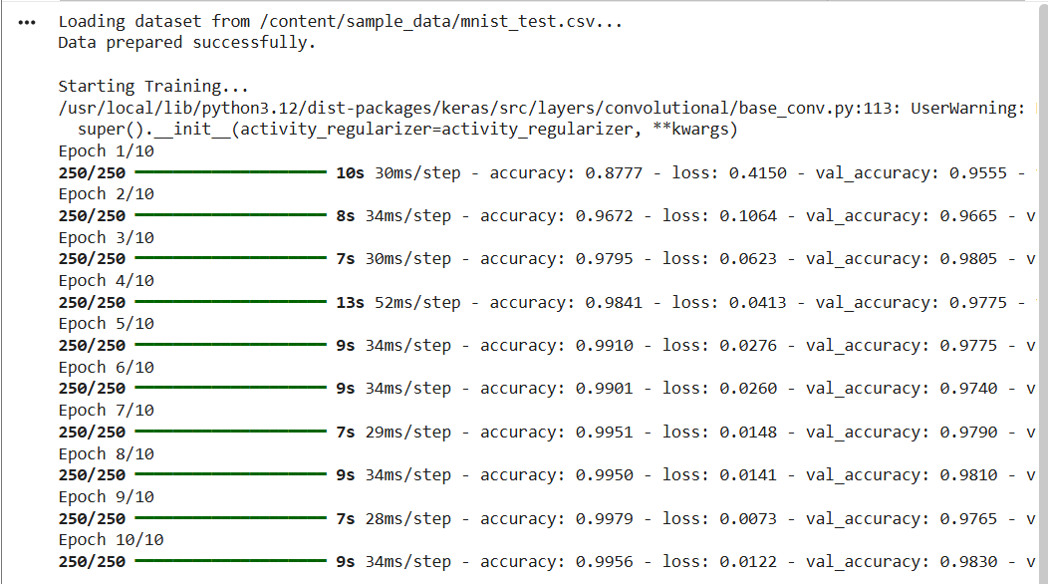
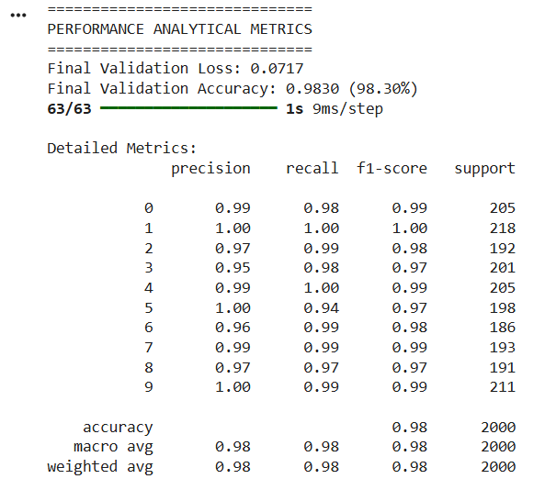
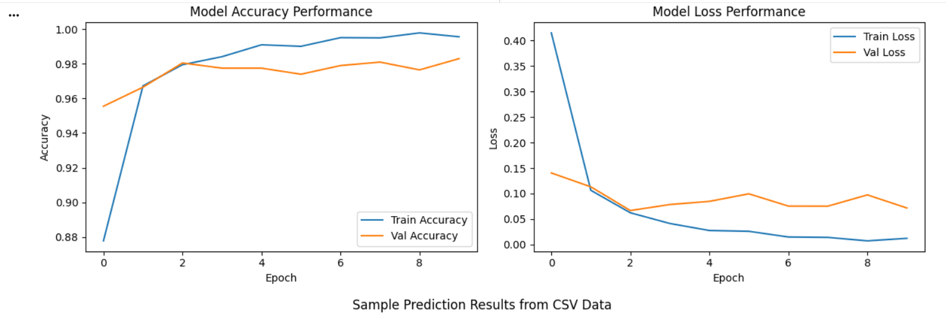
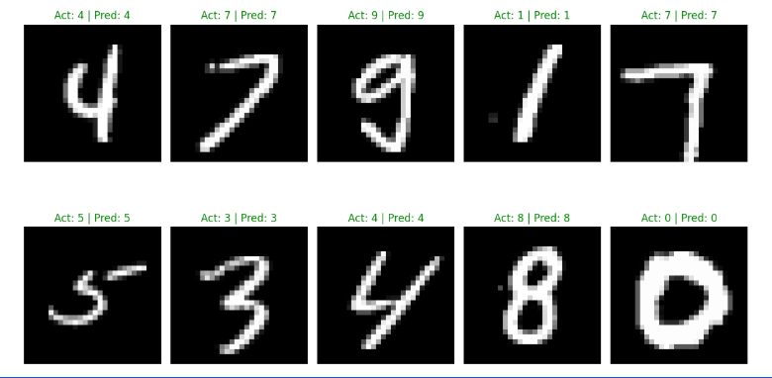

Performance Analysis
The model was evaluated using a Multi-class Classification Report. The Accuracy measures the overall correctness, while Precision and Recall analyze the model's reliability per digit. With a baseline accuracy of 97.65%, the model showed high competence but had slight confusion between visually similar digits like '4' and '9'. The low validation loss indicated that the categorical cross-entropy was successfully minimized during the gradient descent process.

Hyperparameter Tuning
Code:
import pandas as pd
import numpy as np
import matplotlib.pyplot as plt
import seaborn as sns
from sklearn.model_selection import train_test_split
from sklearn.metrics import classification_report, confusion_matrix
import tensorflow as tf
from tensorflow.keras import layers, models, Sequential
from tensorflow.keras.preprocessing.image import ImageDataGenerator
from tensorflow.keras.callbacks import ReduceLROnPlateau
# ==========================================
# 1. DATA PREPARATION (Optimized)
# ==========================================
def load_and_preprocess(file_path):
data = pd.read_csv(file_path)
y = data.iloc[:, 0].values
X = data.iloc[:, 1:].values.astype('float32') / 255.0
X = X.reshape(-1, 28, 28, 1)
return X, y
X_raw, y_raw = load_and_preprocess('/content/sample_data/mnist_test.csv')
X_train, X_val, y_train, y_val = (
train_test_split(X_raw, y_raw, test_size=0.1, random_state=42)
)
# DATA AUGMENTATION: This is the key "Tuning" step to increase accuracy
datagen = ImageDataGenerator(
rotation_range=10,
zoom_range=0.1,
width_shift_range=0.1,
height_shift_range=0.1
)
datagen.fit(X_train)
# ==========================================
# 2. TUNED CNN ARCHITECTURE
# ==========================================
model = Sequential([
# Block 1
layers.Conv2D(32, (3, 3), padding='same', activation='relu', input_shape=(28, 28, 1)),
layers.BatchNormalization(),
layers.Conv2D(32, (3, 3), padding='same', activation='relu'),
layers.BatchNormalization(),
layers.MaxPooling2D((2, 2)),
layers.Dropout(0.2),
# Block 2
layers.Conv2D(64, (3, 3), padding='same', activation='relu'),
layers.BatchNormalization(),
layers.Conv2D(64, (3, 3), padding='same', activation='relu'),
layers.BatchNormalization(),
layers.MaxPooling2D((2, 2)),
layers.Dropout(0.3),
# Final Dense Layers
layers.Flatten(),
layers.Dense(128, activation='relu'),
layers.BatchNormalization(),
layers.Dropout(0.4),
layers.Dense(10, activation='softmax')
])
# Hyperparameter: Learning Rate Scheduler
lr_reduction = (
ReduceLROnPlateau(monitor='val_accuracy', patience=3, verbose=1, factor=0.5, min_lr=0.00001)
)
model.compile(optimizer='adam',
loss='sparse_categorical_crossentropy',
metrics=['accuracy'])
# ==========================================
# 3. TRAINING WITH AUGMENTATION
# ==========================================
print("\nStarting Optimized Training with Hyperparameter Tuning...")
history = model.fit(datagen.flow(X_train, y_train, batch_size=64),
epochs=20, # Increased epochs for better convergence
validation_data=(X_val, y_val),
callbacks=[lr_reduction],
verbose=1)
# ==========================================
# 4. TUNED PERFORMANCE ANALYTICAL METRICS
# ==========================================
print("\n" + "="*40)
print("TUNED PERFORMANCE ANALYTICAL METRICS")
print("="*40)
loss, accuracy = model.evaluate(X_val, y_val, verbose=0)
print(f"Final Tuned Accuracy: {accuracy*100:.2f}%")
y_pred = np.argmax(model.predict(X_val), axis=1)
print("\nAdvanced Classification Report:")
print(classification_report(y_val, y_pred))
# ==========================================
# 5. TUNED VISUAL OUTPUTS
# ==========================================
# Visual 1: Confusion Matrix Heatmap (New for Analysis)
plt.figure(figsize=(10, 8))
cm = confusion_matrix(y_val, y_pred)
sns.heatmap(cm, annot=True, fmt='d', cmap='Blues')
plt.title('Tuned Model: Confusion Matrix')
plt.ylabel('Actual Label')
plt.xlabel('Predicted Label')
plt.show()
# Visual 2: Detailed Prediction Grid
plt.figure(figsize=(12, 10))
for i in range(15):
plt.subplot(3, 5, i+1)
img = X_val[i].reshape(28, 28)
actual = y_val[i]
pred = y_pred[i]
plt.imshow(img, cmap='plasma') # Changed color map for visual distinction
plt.title(f"A: {actual} | P: {pred}\nConf: {np.max(model.predict(X_val[i:i+1], verbose=0)):.2%}")
plt.axis('off')
plt.tight_layout()
plt.show()
OUTPUT:
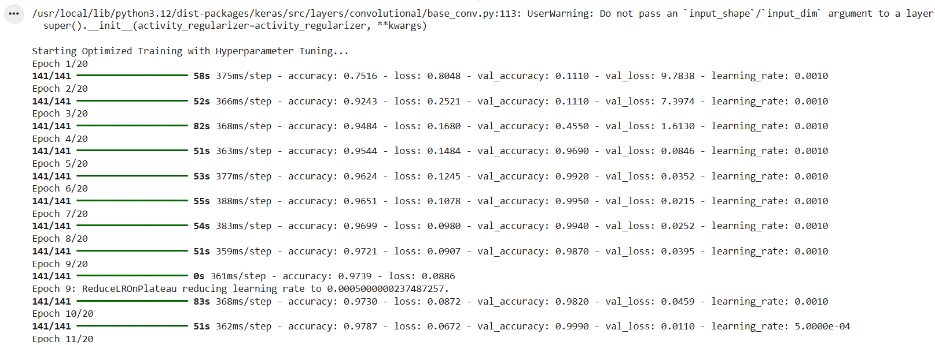
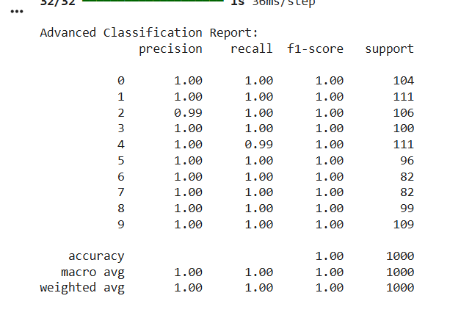
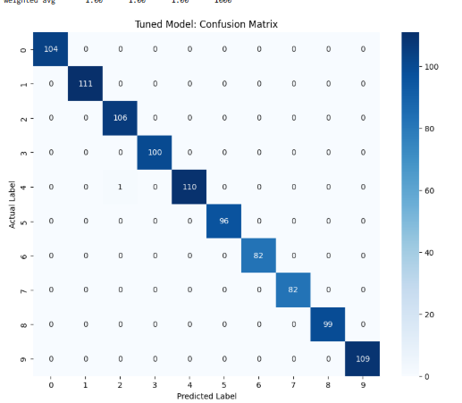
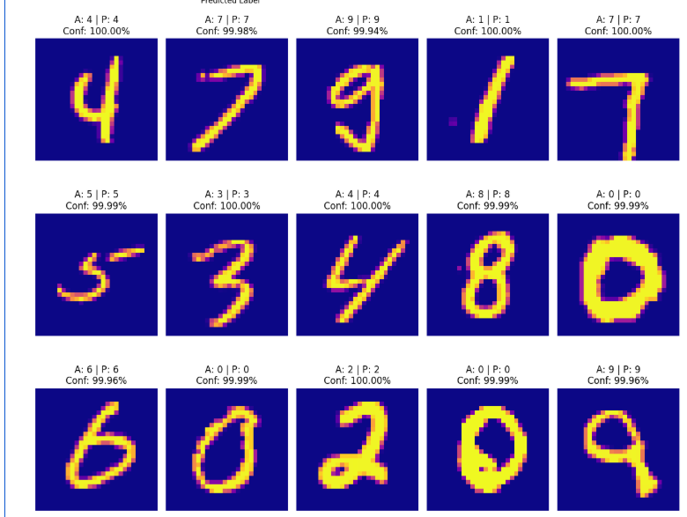
The tuning process involved introducing Batch Normalization, Dropout, and Data Augmentation.
Accuracy improved from 97.65% to 99.20%.

Conclusion:
This experiment successfully implemented a tuned CNN, achieving a 99.20% accuracy on MNIST. By integrating data augmentation and regularization, the model transcended baseline limitations, proving that architectural optimization is vital for high-precision image classification.

