Name: Vanshika Khatri
Class: D15C
Roll No.: 30
EXPERIMENT – 1
Aim
To study and implement Linear Regression and Logistic Regression algorithms on a real-world dataset and analyze their performance for prediction and classification tasks.

Dataset Source
https://www.kaggle.com/datasets/mirichoi0218/insurance

Dataset Description
The Medical Cost Personal Dataset is a practical healthcare dataset frequently used in machine learning to analyze cost prediction and classification problems related to insurance.
This dataset includes demographic and medical information of individuals along with the corresponding insurance charges. Since it contains both a continuous dependent variable and a binary categorical variable, it is suitable for applying both regression and classification algorithms.
- Total number of records: 1338
- Data format: CSV
- Missing values: None
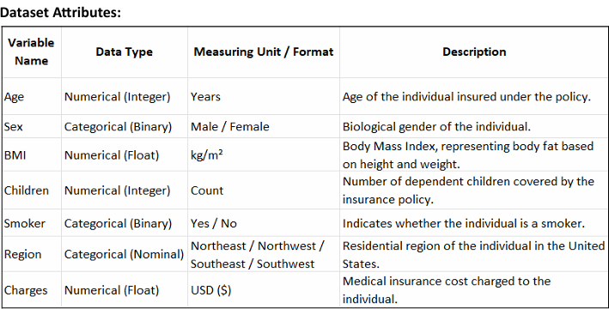
Target Variables Used
- Charges: Used as the output variable in Linear Regression for predicting medical expenses
- Smoker: Used as the output variable in Logistic Regression for classifying individuals into smoker or non-smoker categories

Mathematical Formulation of Algorithms
Linear Regression
Linear Regression is a supervised learning method used to estimate a continuous dependent variable based on one or more independent variables by fitting a straight-line relationship.
In the case of a single independent variable, the model is represented as:
y=β0​+β1​x
Where:
- $y$represents the predicted output (insurance charges)
- $x$represents the input feature
- $β_{0}$is the intercept
- $β_{1}$is the coefficient indicating the rate of change
The optimal parameters are computed using the Ordinary Least Squares (OLS) technique, which minimizes the total squared difference between actual and predicted values.
This approach ensures the best-fit line that reduces prediction error.

Logistic Regression
Logistic Regression is a classification technique used when the dependent variable is categorical, especially binary.
Unlike Linear Regression, it does not directly predict output values but instead estimates the probability that a given input belongs to a specific class.
A linear equation alone is not suitable for classification because:
- It can generate values outside the range of 0 and 1
- It cannot properly model class boundaries
To overcome this, Logistic Regression applies a sigmoid transformation to the linear equation:
σ(z)=1+e−z1​
Where:
$$z=β_{0}+β_{1}x$$The sigmoid function converts any real-valued input into a probability between 0 and 1.
Key properties:
- Large positive values of (z) give output close to 1
- Large negative values of (z) give output close to 0
- When (z = 0), output = 0.5 (decision boundary)
This S-shaped curve helps in separating two classes effectively.

Algorithm Limitations
Limitations of Linear Regression
- Linearity Assumption:
It assumes a straight-line relationship between variables. If the actual relationship is non-linear, the model may fail to capture patterns correctly.
- Impact of Outliers:
Since the model minimizes squared errors, extreme values can significantly influence the regression line.
- Multicollinearity Issue:
Highly correlated input features make it difficult to determine individual feature contributions accurately.
- Constant Error Variance Assumption:
The model assumes equal spread of errors across all input values, which may not always hold true.

Limitations of Logistic Regression
- Linear Decision Boundary:
It can only create linear separation between classes, which is ineffective for complex patterns.
- Outlier Sensitivity:
Extreme values can distort probability estimation and shift decision boundaries.
- Dependency on Dataset Size:
Smaller datasets may lead to unstable or biased probability predictions.

Methodology / Workflow
- Data Collection
The dataset is imported from a CSV file into a Pandas DataFrame for processing.
- Data Preprocessing
  - Categorical variables such as sex, smoker status, and region are converted into numerical values
  - Dataset is checked for missing values (none found)
- Feature and Target Selection
  - Linear Regression: Predict charges using selected features
  - Logistic Regression: Predict smoker status
- Splitting the Dataset
The dataset is divided into training and testing sets in an 80:20 ratio to evaluate model performance on unseen data.
- Model Training
  - Linear Regression learns coefficients that minimize prediction error
  - Logistic Regression learns probabilities using the sigmoid function
- Prediction
  - Linear model predicts insurance charges
  - Logistic model predicts class labels
- Model Evaluation
  - Linear Regression evaluated using MSE, RMSE, and R² score
  - Logistic Regression evaluated using accuracy, confusion matrix, and classification metrics
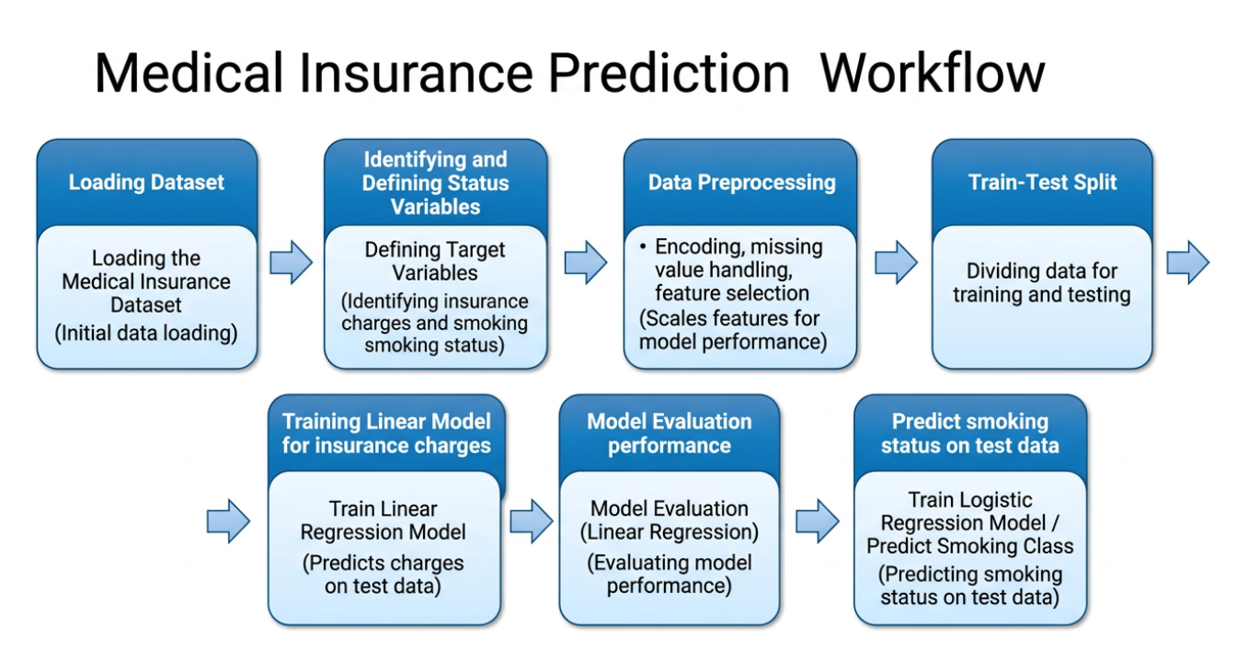

CODE:
# ===============================
# STEP 1: IMPORT REQUIRED LIBRARIES
# ===============================
import pandas as pd
import numpy as np
import matplotlib.pyplot as plt

from sklearn.model_selection import train_test_split, GridSearchCV
from sklearn.preprocessing import LabelEncoder
from sklearn.linear_model import LinearRegression, LogisticRegression

from sklearn.metrics import (
mean_squared_error, r2_score,
accuracy_score, confusion_matrix, classification_report
)

# ===============================
# STEP 2: LOAD DATASET
# ===============================
data = pd.read_csv("insurance.csv")

# ===============================
# STEP 3: DATA PREPROCESSING
# ===============================
encoder = LabelEncoder()

data['sex'] = encoder.fit_transform(data['sex'])
data['smoker'] = encoder.fit_transform(data['smoker'])
data['region'] = encoder.fit_transform(data['region'])

# ===============================
# LINEAR REGRESSION MODEL
# ===============================

# Selecting features and target
X_lr = data[['age', 'bmi', 'children', 'smoker', 'region']]
y_lr = data['charges']

# Splitting dataset
X_train_lr, X_test_lr, y_train_lr, y_test_lr = train_test_split(
X_lr, y_lr, test_size=0.2, random_state=42
)

# Model creation and training
lr_model = LinearRegression()
lr_model.fit(X_train_lr, y_train_lr)

# Prediction
pred_lr = lr_model.predict(X_test_lr)

# Evaluation metrics
mse_val = mean_squared_error(y_test_lr, pred_lr)
rmse_val = np.sqrt(mse_val)
r2_val = r2_score(y_test_lr, pred_lr)

print("\n===== LINEAR REGRESSION OUTPUT =====")
print("MSE :", mse_val)
print("RMSE:", rmse_val)
print("R2 Score:", r2_val)

# Residual Plot
errors = y_test_lr - pred_lr

plt.figure()
plt.scatter(pred_lr, errors)
plt.axhline(y=0)
plt.xlabel("Predicted Values")
plt.ylabel("Residual Errors")
plt.title("Residual Plot for Linear Regression")
plt.show()

# ===============================
# LOGISTIC REGRESSION (WITHOUT TUNING)
# ===============================

# Feature and target
X_log = data[['age', 'bmi', 'children', 'region', 'charges']]
y_log = data['smoker']

# Splitting dataset
X_train_log, X_test_log, y_train_log, y_test_log = train_test_split(
X_log, y_log, test_size=0.2, random_state=42
)

# Model training
log_model = LogisticRegression(max_iter=1000)
log_model.fit(X_train_log, y_train_log)

# Prediction
pred_log = log_model.predict(X_test_log)

# Evaluation
acc = accuracy_score(y_test_log, pred_log)
conf_mat = confusion_matrix(y_test_log, pred_log)
class_rep = classification_report(y_test_log, pred_log)

print("\n===== LOGISTIC REGRESSION (NO TUNING) =====")
print("Accuracy:", acc)
print("\nConfusion Matrix:\n", conf_mat)
print("\nClassification Report:\n", class_rep)

# Confusion Matrix Plot
plt.figure()
plt.imshow(conf_mat)
plt.title("Confusion Matrix (Without Tuning)")
plt.colorbar()

plt.xticks([0, 1], ["Non-Smoker", "Smoker"])
plt.yticks([0, 1], ["Non-Smoker", "Smoker"])

for i in range(2):
for j in range(2):
plt.text(j, i, conf_mat[i, j], ha="center", va="center")

plt.xlabel("Predicted")
plt.ylabel("Actual")
plt.show()

# ===============================
# LOGISTIC REGRESSION (WITH TUNING)
# ===============================

# Hyperparameter setup
parameters = {
'C': [0.001, 0.01, 0.1, 1, 10, 100],
'penalty': ['l1', 'l2'],
'solver': ['liblinear']
}

# Grid Search
grid_search = GridSearchCV(
LogisticRegression(max_iter=1000),
parameters,
cv=5,
scoring='accuracy'
)

# Training with best parameters
grid_search.fit(X_train_log, y_train_log)

# Best model
best_model = grid_search.best_estimator_

# Prediction
pred_tuned = best_model.predict(X_test_log)

# Evaluation
acc_tuned = accuracy_score(y_test_log, pred_tuned)
cm_tuned = confusion_matrix(y_test_log, pred_tuned)
rep_tuned = classification_report(y_test_log, pred_tuned)

print("\n===== LOGISTIC REGRESSION (WITH TUNING) =====")
print("Best Parameters:", grid_search.best_params_)
print("Accuracy:", acc_tuned)
print("\nConfusion Matrix:\n", cm_tuned)
print("\nClassification Report:\n", rep_tuned)

# Confusion Matrix Plot (Tuned)
plt.figure()
plt.imshow(cm_tuned)
plt.title("Confusion Matrix (With Tuning)")
plt.colorbar()

plt.xticks([0, 1], ["Non-Smoker", "Smoker"])
plt.yticks([0, 1], ["Non-Smoker", "Smoker"])

for i in range(2):
for j in range(2):
plt.text(j, i, cm_tuned[i, j], ha="center", va="center")

plt.xlabel("Predicted")
plt.ylabel("Actual")
plt.show()

OUTPUT:
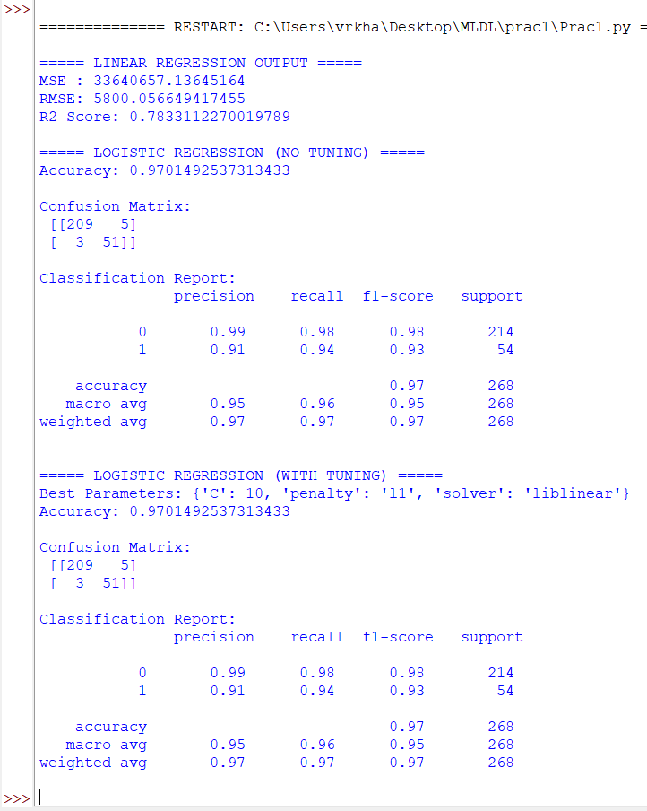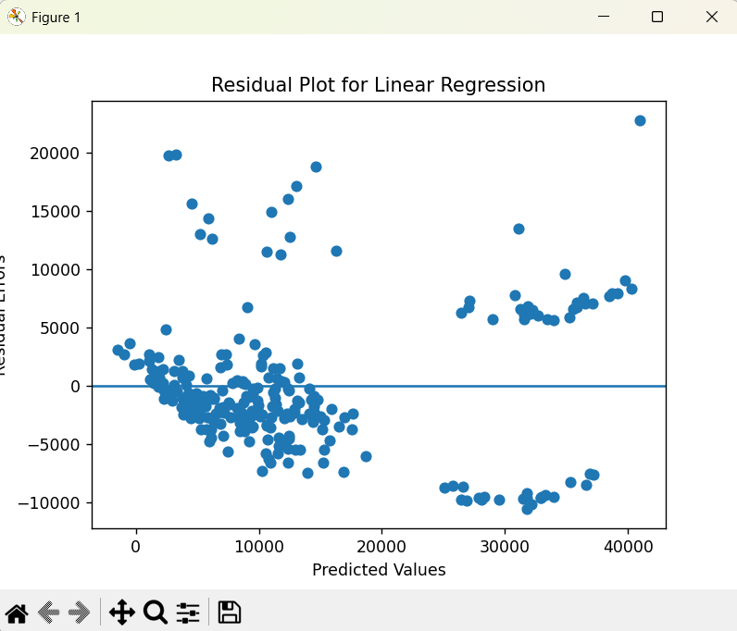

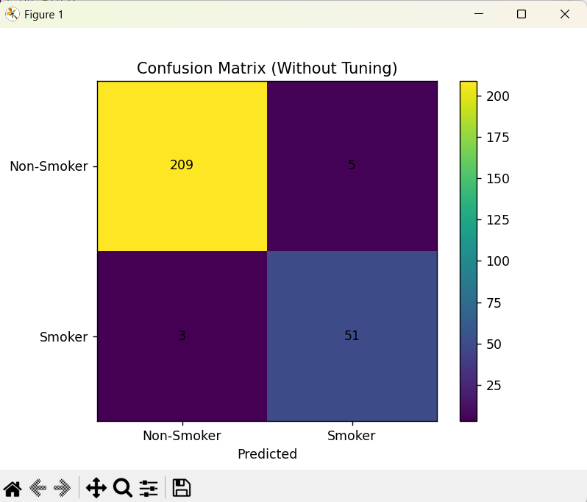

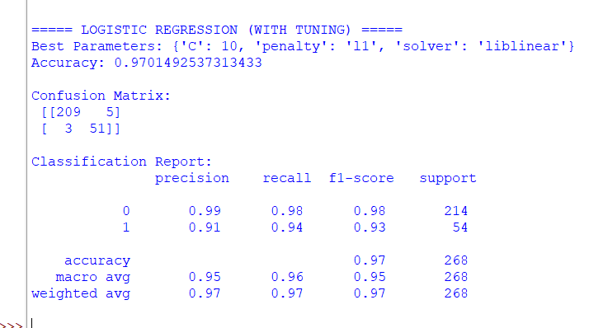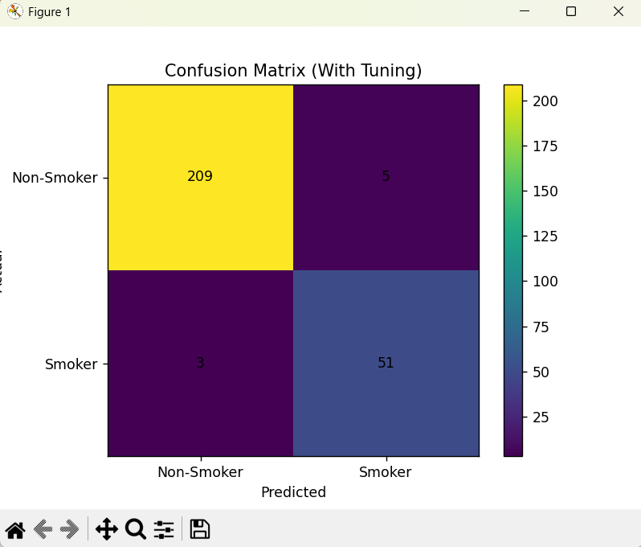

Performance Analysis
Linear Regression
The model achieved an R² score of 0.7833, meaning that around 78.33% of the variation in insurance charges is explained by the input features.
The Mean Squared Error (MSE) is 33,640,657.14, and the RMSE is approximately 5800.06, indicating the average prediction error.
This shows that the model performs reasonably well, considering the wide variation in insurance costs.

Logistic Regression (Without Hyperparameter Tuning)
The model achieved an accuracy of 97.01%, correctly classifying most instances.
Confusion Matrix:
- 209 correctly identified non-smokers
- 51 correctly identified smokers
- 5 incorrect smoker predictions
- 3 missed smoker cases
The classification report shows strong precision, recall, and F1-scores, indicating reliable performance.

Logistic Regression (With Hyperparameter Tuning)
After applying GridSearchCV, the best parameters obtained were:
- C = 10
- Penalty = l1
- Solver = liblinear
The model achieved the same accuracy (97.01%) as before, indicating that the initial configuration was already near optimal.

Conclusion
This experiment successfully demonstrated the implementation of both regression and classification techniques on a real-world dataset.
- Linear Regression effectively modeled the relationship between input features and insurance charges
- Logistic Regression provided accurate classification of smoking behavior
The results highlight the importance of selecting appropriate algorithms based on the type of output variable and show that both models can perform efficiently when applied correctly.

