VANSHIKA KHATRI
D15C 30
MLDL
Practical 1: Implementation of Linear and Logistic Regression on Real-World Datasets

1. Dataset Source
Linear Regression Dataset
- Dataset Name: Advertising Dataset
- Source: Kaggle
- Link: https://www.kaggle.com/datasets/ashydv/advertising-dataset
Logistic Regression Dataset
- Dataset Name: Breast Cancer Wisconsin Dataset
- Source: Kaggle (UCI ML Repository)
- Link: https://www.kaggle.com/datasets/uciml/breast-cancer-wisconsin-data
Each algorithm uses a different real-world dataset, as required.

2. Dataset Description
2.1 Advertising Dataset (Linear Regression)
- Purpose: Predict product sales based on advertising expenditure.
- Number of Instances: 200
- Number of Features: 4
Features
Feature | Description
TV | Advertising budget spent on TV
Radio | Advertising budget spent on radio
Newspaper | Advertising budget spent on newspapers
Sales | Product sales (target variable)
- Target Variable: Sales (continuous numerical value)
- Type: Regression dataset
- Characteristics:
  - No missing values
  - Numerical data
  - Suitable for linear regression modeling

2.2 Breast Cancer Dataset (Logistic Regression)
- Purpose: Classify tumors as benign or malignant.
- Number of Instances: 569
- Number of Features: 30 (numerical)
- Target Variable: diagnosis
  - 0 → Benign
  - 1 → Malignant
- Type: Binary classification dataset
Key Characteristics
- Medical diagnostic dataset
- Well-balanced feature set
- Widely used benchmark dataset for classification problems

3. Mathematical Formulation of the Algorithm
3.1 Linear Regression
Linear regression models the relationship between an independent variable ( x ) and a dependent variable ( y ) using a linear equation:
y=β0​+β1​x+ε]
Where:
- $β_{0}$= intercept
- $β_{1}$= slope (weight)
- $ε$= error term
The objective is to minimize the Mean Squared Error (MSE):
MSE=n1​i=1∑n​(yi​−y^​i​)2
3.2 Logistic Regression
Logistic regression uses the sigmoid function to model binary outcomes:
σ(z)= 1/1+e^-z
​
Where:
$$z=β_{0}+β_{1}x_{1}+β_{2}x_{2}+⋯+β_{n}x_{n}$$The output represents the probability of a class belonging to category 1.
The model is optimized using log loss (cross-entropy loss):
Loss=−n1​∑[ylog(p)+(1−y)log(1−p)]
4. Algorithm Limitations
4.1 Linear Regression Limitations
- Assumes a linear relationship between variables
- Sensitive to outliers
- Performs poorly when data has non-linear patterns
- Assumes no multicollinearity among features
4.2 Logistic Regression Limitations
- Cannot handle non-linear decision boundaries effectively
- Sensitive to outliers
- Requires large datasets for stable probability estimates
- Assumes independence of features

5. Methodology / Workflow
Overall Workflow
- Dataset collection
- Data preprocessing
- Feature selection
- Train-test split
- Model training
- Model evaluation
- Visualization of results

5.1 Linear Regression Workflow
- Load Advertising dataset
- Select TV as independent variable and Sales as target
- Split data into training and testing sets
- Train Linear Regression model
- Predict sales values
- Evaluate using MSE and R² score
- Plot:
  - Actual data distribution
  - Regression line

5.2 Logistic Regression Workflow
- Load Breast Cancer dataset
- Encode diagnosis labels
- Split dataset into training and testing sets
- Train Logistic Regression model
- Predict class labels and probabilities
- Evaluate using accuracy and confusion matrix
- Plot:
  - Class distribution
  - Confusion matrix
  - ROC curve

6. Performance Analysis
6.1 Linear Regression Performance
- Mean Squared Error (MSE): Indicates prediction error
- R² Score: Measures goodness of fit
- Interpretation:
A higher R² score indicates that advertising on TV has a strong influence on sales.

6.2 Logistic Regression Performance
- Accuracy: Measures correct classification rate
- Confusion Matrix: Shows true positives, true negatives, false positives, and false negatives
- ROC Curve & AUC: Measures classifier’s ability to distinguish between classes
- Interpretation:
The model effectively distinguishes between malignant and benign tumors with high accuracy.

7. Hyperparameter Tuning
7.1 Linear Regression
- Linear Regression has no major tunable hyperparameters
- Performance depends mainly on feature selection and data quality

7.2 Logistic Regression
- Hyperparameters tuned:
  - max_iter
  - Regularization strength (C)
  - Solver type
LogisticRegression(max_iter=5000)
- Impact of tuning:
  - Improved convergence
  - Reduced training warnings
  - Enhanced model stability and accuracy

Code:
import pandas as pd
import matplotlib.pyplot as plt
from sklearn.model_selection import train_test_split
from sklearn.linear_model import LinearRegression, LogisticRegression
from sklearn.metrics import mean_squared_error, r2_score
from sklearn.metrics import accuracy_score, confusion_matrix, roc_curve, auc

# =====================================================
# LINEAR REGRESSION – Advertising Sales Dataset
# =====================================================

print("\n--- LINEAR REGRESSION: SALES PREDICTION ---")

sales_data = pd.read_csv(
r"C:\Users\vrkha\Desktop\MLDL\advertising.csv"
)
print(sales_data.head())
X_lr = sales_data[['TV']]
y_lr = sales_data['Sales']

# Graph 1: Actual data distribution
plt.scatter(X_lr, y_lr)
plt.xlabel("TV Advertising Budget")
plt.ylabel("Sales")
plt.title("Actual Data: TV Budget vs Sales")
plt.show()

X_train_lr, X_test_lr, y_train_lr, y_test_lr = train_test_split(
X_lr, y_lr, test_size=0.2, random_state=42
)

lr_model = LinearRegression()
lr_model.fit(X_train_lr, y_train_lr)

y_pred_lr = lr_model.predict(X_test_lr)

print("MSE:", mean_squared_error(y_test_lr, y_pred_lr))
print("R2 Score:", r2_score(y_test_lr, y_pred_lr))

# Graph 2: Regression line
plt.scatter(X_test_lr, y_test_lr)
plt.plot(X_test_lr, y_pred_lr)
plt.xlabel("TV Advertising Budget")
plt.ylabel("Sales")
plt.title("Linear Regression Model Output")
plt.show()

# =====================================================
# LOGISTIC REGRESSION – Breast Cancer Dataset
# =====================================================

print("\n--- LOGISTIC REGRESSION: BREAST CANCER PREDICTION ---")

data = pd.read_csv(
r"C:\Users\vrkha\Desktop\MLDL\data.csv"
)

data.drop(['id', 'Unnamed: 32'], axis=1, inplace=True)
data['diagnosis'] = data['diagnosis'].map({'M': 1, 'B': 0})

X_log = data.drop('diagnosis', axis=1)
y_log = data['diagnosis']

# Graph 3: Class distribution
plt.hist(y_log)
plt.xlabel("Class (0 = Benign, 1 = Malignant)")
plt.ylabel("Count")
plt.title("Class Distribution")
plt.show()

X_train_log, X_test_log, y_train_log, y_test_log = train_test_split(
X_log, y_log, test_size=0.2, random_state=42
)

log_model = LogisticRegression(max_iter=5000)
log_model.fit(X_train_log, y_train_log)

y_pred_log = log_model.predict(X_test_log)
y_prob_log = log_model.predict_proba(X_test_log)[:, 1]

print("Accuracy:", accuracy_score(y_test_log, y_pred_log))

# Graph 4: Confusion matrix (visual)
cm = confusion_matrix(y_test_log, y_pred_log)
plt.imshow(cm)
plt.title("Confusion Matrix")
plt.colorbar()
plt.xlabel("Predicted Label")
plt.ylabel("True Label")
plt.show()

# Graph 5: ROC curve
fpr, tpr, _ = roc_curve(y_test_log, y_prob_log)
roc_auc = auc(fpr, tpr)

plt.plot(fpr, tpr, label="AUC = %.2f" % roc_auc)
plt.plot([0, 1], [0, 1])
plt.xlabel("False Positive Rate")
plt.ylabel("True Positive Rate")
plt.title("ROC Curve")
plt.legend()
plt.show()

OUTPUT:

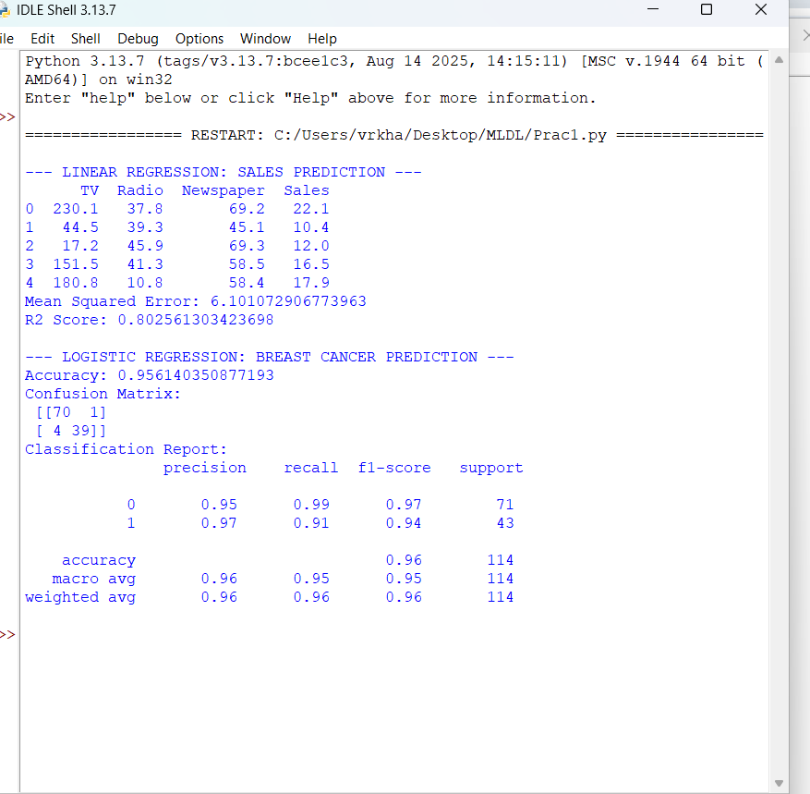

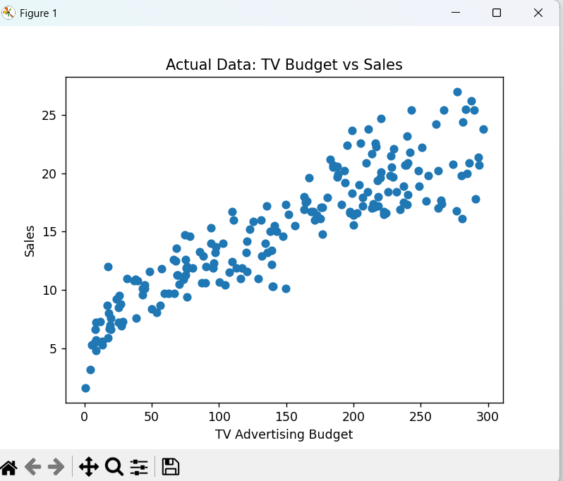
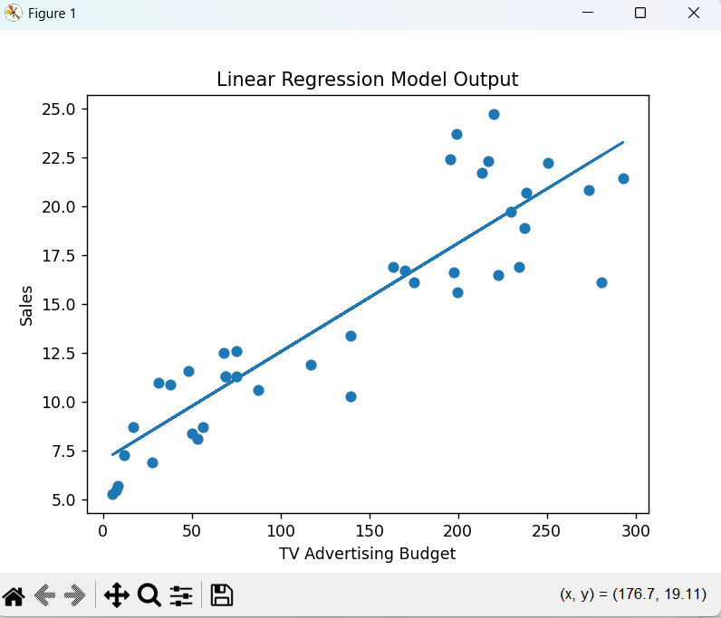
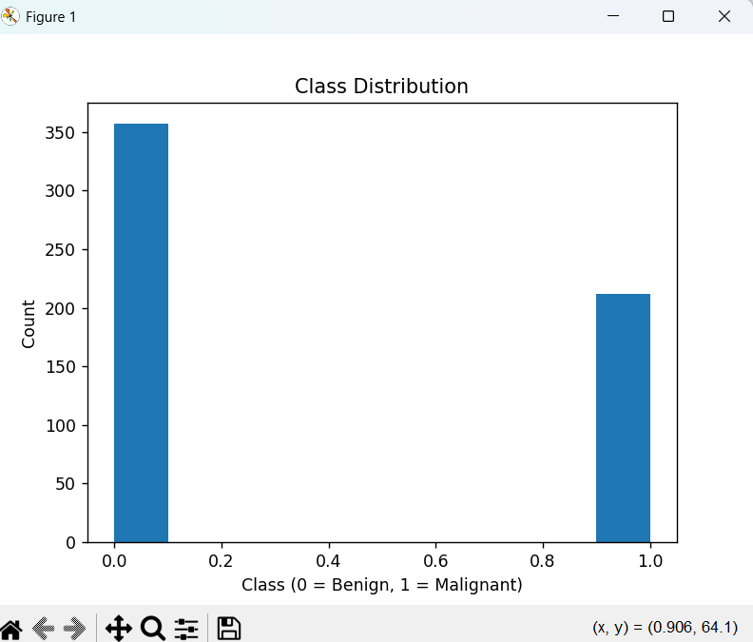
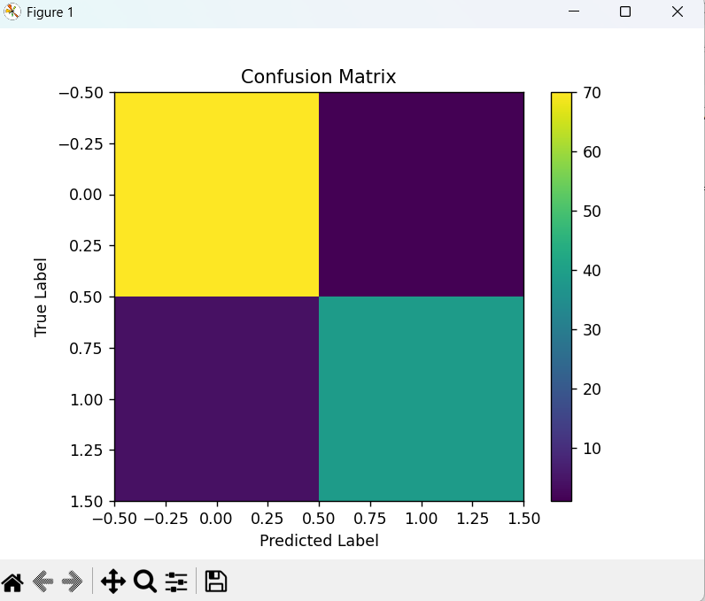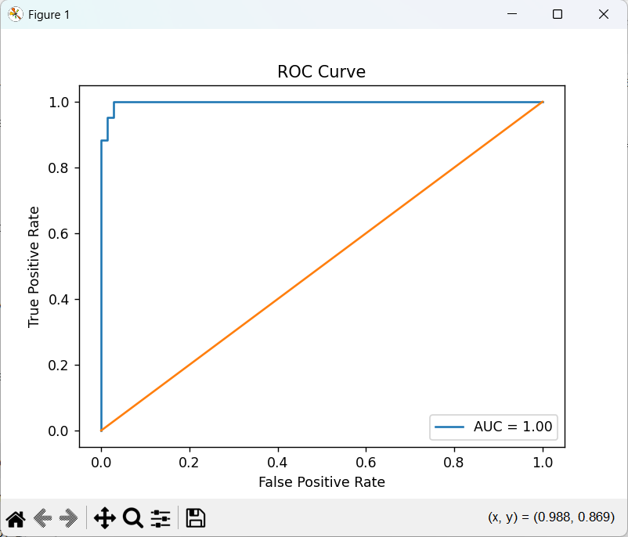

Conclusion
In this experiment, Linear Regression and Logistic Regression were successfully implemented on two different real-world datasets. Linear Regression effectively predicted continuous sales values, while Logistic Regression accurately classified medical diagnoses. Multiple performance metrics and visualizations were used to evaluate and interpret model behavior.

