**Customer Churn Analysis Documentation**

**Project Overview**

The **Customer Churn Analysis** project aims to explore and analyze the factors that contribute to customer churn, such as **contract types**, **payment methods**, **customer tenure**, and **demographic characteristics**. By identifying these factors, businesses can take actionable steps to improve customer retention and reduce churn.

The analysis was performed using Python, with a focus on **Exploratory Data Analysis (EDA)** to uncover patterns and relationships within the dataset. The dataset was downloaded from **Kaggle** and analyzed to derive insights into customer behavior.

**Objective**

The objective of this analysis is to:

* Understand the key factors influencing customer churn.
* Explore how customer tenure, contract type, and demographic factors (e.g., senior citizens, gender) contribute to churn.
* Provide actionable recommendations for businesses to improve customer retention.

**Step-by-Step Approach to Exploratory Data Analysis (EDA)**

**Step 1: Import Libraries**

The first step in the analysis is to import the necessary Python libraries. These libraries will be used for data manipulation, analysis, and visualization.

**Step 2: Import Data**

The dataset is loaded from a CSV file into a Pandas DataFrame, allowing us to manipulate and analyze the data.

**Step 3: Replace Blank Spaces in Total Charges with 0**

In the dataset, some entries in the TotalCharges column might contain blank spaces. We replace these blank spaces with 0 to ensure that the data is clean and ready for analysis.

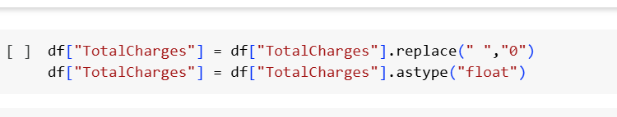

**Step 4: Check for Null Values**

We check for any missing (null) values in the dataset. This step helps ensure the quality of the data, as missing values can affect analysis and insights.

**Step 5: Descriptive Analysis**

We perform a basic descriptive analysis to summarize the statistics of the dataset. This helps us understand the central tendency, spread, and shape of the dataset's features.

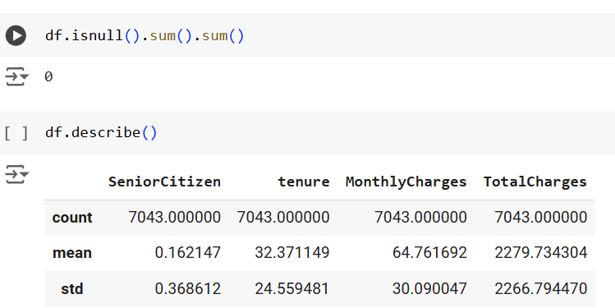

**Step 6: Check for Duplicate Customer IDs**

Next, we check if there are any duplicate customer IDs in the dataset. Duplicates can lead to skewed analysis, so it's important to handle them appropriately.

**Step 7: Convert 0 and 1 Values for Senior Citizens to "Yes" and "No"**

In the dataset, the SeniorCitizen column uses 0 and 1 to represent non-senior and senior citizens, respectively. We convert these values into more readable terms ("Yes" and "No").

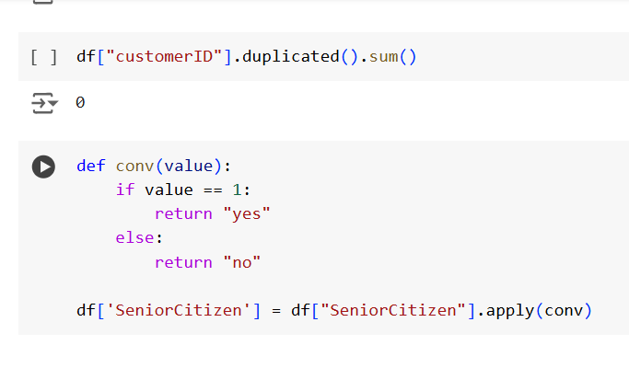

**Step 8: Check for No and % of People Who Churn**

We analyze the churn column to check the number and percentage of customers who have churn .

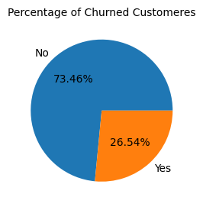

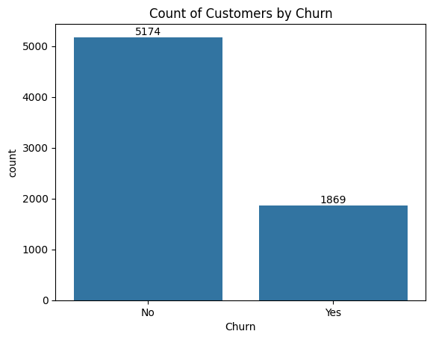

**Step 9: Churn Based on Gender**

We analyze churn rates based on gender. This will allow us to understand if there is any significant difference in churn between male and female customers.

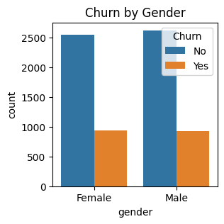

**Step 10: Count of Senior Citizens**

We calculate the number of senior citizens in the dataset and analyze how many senior customers are part of the overall population.

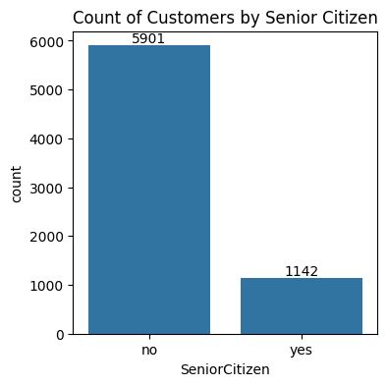

**Step 11: Churn Based on Senior Citizens by Stacked Bar Plot**

We visualize churn based on whether the customer is a senior citizen or not by using a stacked bar plot.

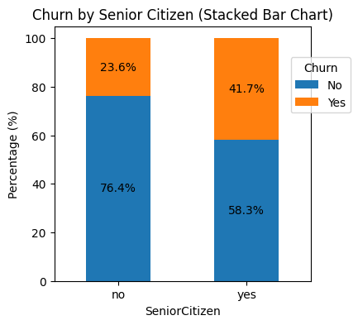

**Step 12: Churn Based on Tenure by Histplot**

We analyze churn based on customer tenure. This will help us understand if the length of a customer's relationship with the company has an effect on the likelihood of churn.

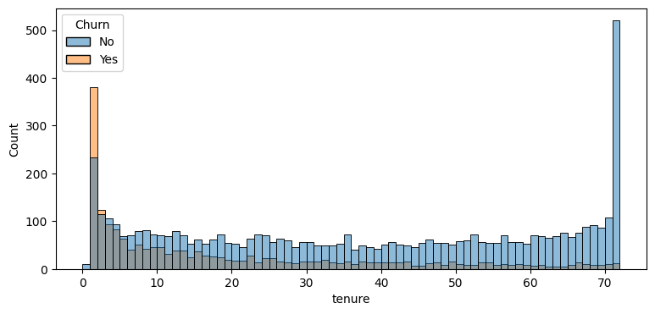

**Step 13: Churn Based on Contract Type**

We analyze churn rates based on the type of contract customers have (e.g., month-to-month, yearly, two-year). This will help us determine how contract length influences churn.

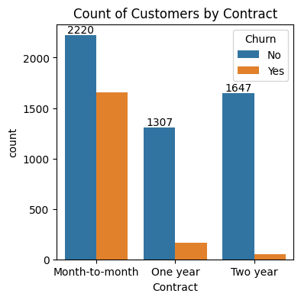

**Step 14: Churn Based on Services by Making Subplots**

Finally, we visualize how different services (e.g., internet service type, phone service, etc.) affect churn by creating subplots for each service category.

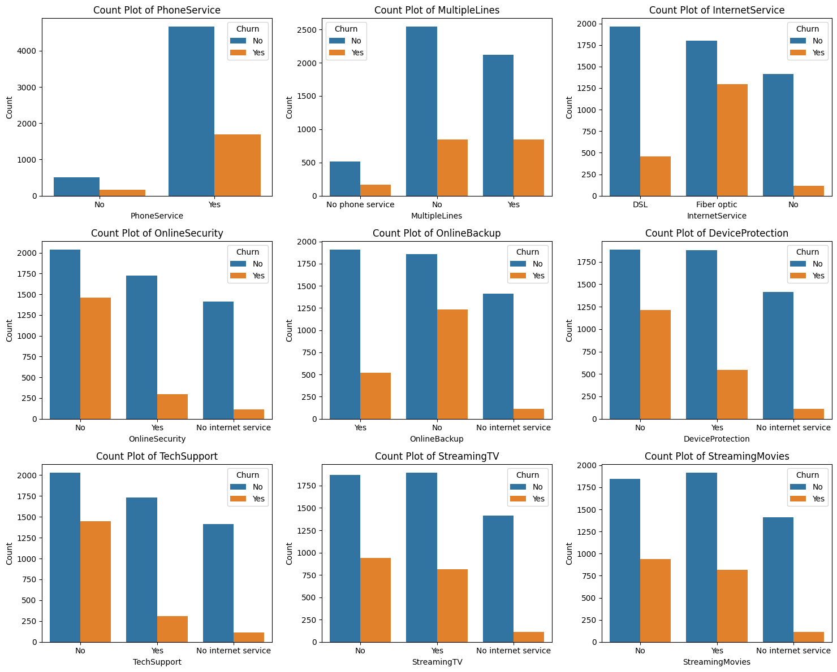

**Step 15: Churn Based on Payment Method**

In this step, we analyze how different **payment methods** affect churn rates. This helps us understand if certain payment methods (e.g., electronic check, credit card, etc.) correlate with higher churn rates. Visualizing this information can guide businesses to encourage customers to switch to more stable payment methods.

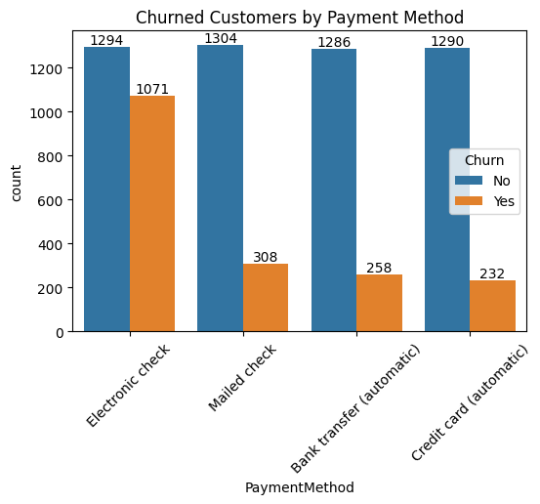

**Conclusion**

By following this step-by-step approach to Exploratory Data Analysis (EDA), we have uncovered several important insights into the factors influencing customer churn. Key findings include:

* Customers on **month-to-month contracts** are more likely to churn compared to those with longer-term contracts.
* **Senior citizens** have a higher churn rate compared to non-senior citizens.
* **Tenure** is a significant predictor of churn, with customers who have been with the company for a shorter time being more likely to churn.
* **Payment Method**: Customers using electronic checks tend to have higher churn rates, suggesting trust or convenience issues. Encouraging customers to switch to more reliable payment methods could reduce churn.

**Recommendations**

Based on the insights from this analysis, the following recommendations are made to reduce churn and improve customer retention:

• **Promote Long-Term Contracts**: Offering incentives for customers to commit to longer-term contracts could reduce churn.

• **Target Senior Citizens**: Developing retention strategies for senior citizens, such as personalized offers and better customer support, could help reduce churn in this demographic.

• **Focus on Early Customer Engagement**: Focus on retaining customers early in their tenure, as churn is more likely in the first year.

• **Improve Service Offerings**: Analyze service-related factors like internet service type, phone service, and online security to enhance customer satisfaction and reduce churn.