Diwali Expense Data Analysis (2024–2025)

1. Introduction
This report presents an analysis of personal Diwali expenses for the years 2024 and 2025. The objective is to track spending patterns, income, savings, and budget adherence, using Power BI and DAX to generate visualizations and key financial metrics. This project simulates an industry-standard financial analysis workflow applied to personal data.

2. Objective
- Analyze Diwali expenses and income for 2024 and 2025.
- Identify trends in spending and savings performance.
- Compare year-over-year financial behavior.
- Track category-wise spending and optimize future budgets.
- Apply financial KPIs commonly used in business to personal data.

3. Tools & Technologies
- Power BI: For data visualization, dashboards, and interactive reports.
- DAX (Data Analysis Expressions): For creating calculated columns and measures, such as total income, expenses, net savings, and budget accuracy.
- Excel / CSV: Source format for storing expense and income data.

4. Data Structure

The analysis uses a table named Expenses with the following columns:
Column Name | Description | Data Type
date | Date of expense or income | Date
Category | Income or Expense | Text
source | Source of income/expense | Text
item | Item purchased or income description | Text
item_category | Category of the item (e.g., Food, Clothing) | Text
description | Additional details | Text
amount | Amount spent or received | Numeric
payment_method | Mode of payment (Cash, Card, etc.) | Text
budget | Planned budget for the year | Numeric
saving_target | Target savings for the year | Numeric

5. Methodology / Step-by-Step Implementation
5.1 Data Preparation:

- Collected own data and structed by chatgpt for make it ready for analysis .
  - Created a new date table from existing table and connected it to the existing dataset using a many-to-one relationship via DAX.
Date = CALENDAR(MIN(Expenses[Date]), MAX(Expenses[Date]))
5.2 Year Column:
  - Added a calculated column to categorize data by year (2024 and 2025).
Year = YEAR(Expenses[Date])
5.3 Measures for Income & Expenses:
  - Created DAX measures to calculate total income and total expenses for both years.
expense2024 = CALCULATE(SUM(Expenses[Amount]),FILTER(Expenses,Expenses[Category] = "Expense" && Expenses[Year] = 2024 ))

expense2025 = CALCULATE(SUM(Expenses[Amount]),FILTER(Expenses,Expenses[Category] = "Expense" && Expenses[Year] = 2025 ))

income2024 = CALCULATE(SUM(Expenses[Amount]),FILTER(Expenses,Expenses[Category] = "income" && Expenses[Year] = 2024 ))

income2025 = CALCULATE(SUM(Expenses[Amount]),FILTER(Expenses,Expenses[Category] = "income" && Expenses[Year] = 2025 ))
5.4 Visual Cards:
  - Added card visuals to display total income and expenses for each year.
5.5 Category-wise Expense Analysis:
  - Created pie charts for 2024 and 2025 showing expense distribution by category.
5.6 Year-over-Year Comparison:
  - Created a DAX measures for calculating year-over-year expense and income for both years.
yoy income % = DIVIDE((Expenses[income2025]-Expenses[income2024]),Expenses[income2024])*100

yoy income % = DIVIDE((Expenses[income2025]-Expenses[income2024]),Expenses[income2024])*100

  - Built clustered bar charts comparing total expenses and income between 2024 and 2025.
5.7 Table Visuals:
  - Added table visuals to display measures for year-over-year comparison for income and expense metrics for both year.
5.8 Net Savings:
  - Created measures for net savings in both years and displayed them using bar charts.
Net saving 2024 = Expenses[income2024]-Expenses[expense2024]
Net saving 2025 = Expenses[income2025]-Expenses[expense2025]

5.9 Budget Accuracy:
  - Calculated budget accuracy measures for 2024 and 2025.
Buget Accuracy 2024 = (CALCULATE(
SELECTEDVALUE(Expenses[Budget]),
Expenses[Year] = 2024
)/Expenses[expense2024]) *100

Buget Accuracy 2025 = (CALCULATE(
SELECTEDVALUE(Expenses[Budget]),
Expenses[Year] = 2025
)/Expenses[expense2025]) *100
5.10 Saving Rate:
  - Created measures for saving rates and visualized them with cards.
saving rate 2024 = ((CALCULATE(
SELECTEDVALUE(Expenses[Budget]),
Expenses[Year] = 2024
)-Expenses[expense2024])/Expenses[expense2024]) *100

saving rate 2025 = ((CALCULATE(
SELECTEDVALUE(Expenses[Budget]),
Expenses[Year] = 2025
)-Expenses[expense2025])/Expenses[expense2025]) *100
5.11 Category-wise YoY Expenses:
  - Built bar charts to represent category-wise year-over-year expenses.
5.12 Total Savings:
  - Calculated total savings measures for both years.
saving2024 = CALCULATE(SELECTEDVALUE(Expenses[Budget]),Expenses[year] = 2024)- Expenses[expense2024]

saving2025 = CALCULATE(SELECTEDVALUE(Expenses[Budget]),Expenses[year] = 2025)- Expenses[expense2025]
5.13 Target Savings:
  - Extracted target savings from the dataset using DAX measure.
target2024 = CALCULATE(SELECTEDVALUE(Expenses[Saving_Target]),Expenses[Year]=2024)
target2025 = CALCULATE(SELECTEDVALUE(Expenses[Saving_Target]),Expenses[Year]=2025)
5.14 Gauge Chart for Target Achievement:
  - Created gauge visuals to indicate whether the savings target was met or exceeded.
5.15 Report Layout & Theme:
  - Arranged the report structure and applied a consistent color theme for readability and professional appearance.

6. Key Insights

6.1 Expense Trends
- 2024 total expenses: ₹64K
- 2025 total expenses: ₹25K
Insight: Reduced spending by ~61%, indicating strong optimization.

6.2 Saving Rate
- 2024: –34.70% → Overspending beyond budget
- 2025: +67.38% → Major improvement and controlled expenses

6.3 Spending by Category
- 2024: Puja items (36%) & Food (26%) dominated; Jewellery, Cosmetics, Gifts, Decorations <15% each
- 2025: Clothing (34%) & Gifts (31%) top; Puja items & Food drastically reduced

6.4 Year-to-Year Category Comparison
- Jewellery & Gifts slightly increased
- Puja items, Food, Cosmetics declined → Cost optimization

6.5 Savings vs Target
- 2024: Missed target (–₹22.16K)
- 2025: Exceeded target (₹16.96K vs ₹15K) → Excellent improvement
6.6 Variation in Income and expenses
- Income increased by 6.03% and expenses decrease by 60.59%
6.7 Net Saving
- Net savings for 2024 is ₹24.135k
- Net savings for 2025 is ₹16.957K
6.8 Budget Accuracy
- Budget accuracy 2024: 65.30%
- Budget Accuracy for 2025: 167.38%

7. Visualizations
- Cards: Total income, expenses, net savings, and saving rate
- Pie Charts: Category-wise expense distribution
- Clustered Bar Charts: Year-over-Year comparison
- Bar Charts: Net savings and category-wise YoY expenses
- Gauge Chart: Savings target achievement
- Tables: Detailed metrics

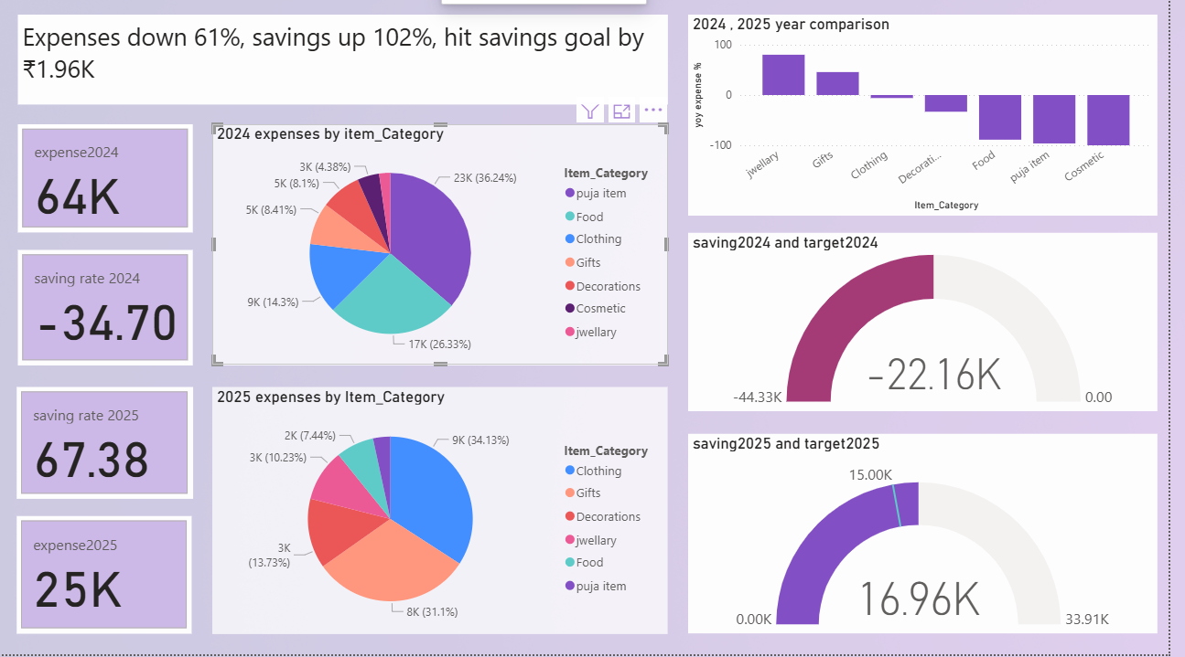

8. Conclusion
- Demonstrated personal finance analysis using industry-standard KPIs.
- Gained practical experience with Power BI dashboards and DAX measures.
- Successfully tracked, compared, and visualized financial performance for 2024 and 2025.
- Identified actionable insights for better expense management and savings planning in future years.

