FINANCIAL PERFORMANCE ANALYSIS
OF LEADING TECHNOLOGY COMPANIES
Analyzing Growth, Profitability and Financial Risk Using Python, SQL, Excel and Power BI
Project Report | FY2021–FY2025
Adobe • Alphabet • Amazon • Apple • Cisco • IBM • Meta • Microsoft • NVIDIA • Oracle

1. Executive Summary
This project compares ten leading technology companies across their reported fiscal years 2021–2025. The dataset contains 50 company-year observations. Four indicators are analyzed: revenue growth, net profit margin, return on assets (ROA), and liabilities as a percentage of assets. Python supports data analysis and visualization, SQL supports querying, Excel provides calculations and a dashboard, and Power BI presents interactive views.
In this sample, NVIDIA had the highest average revenue growth (75.42%), average net profit margin (36.62%) and average ROA (31.66%). Apple also recorded a high average ROA (27.93%). Oracle had the highest average liability-to-asset ratio (96.52%). These are historical descriptive findings, not forecasts or investment recommendations.

2. Research Question and Objectives
Research question: How did the financial performance of major technology companies change from 2021–2025, and what can their growth, profitability and financial-risk ratios tell us about their performance?
- Compare revenue growth across the ten companies.
- Assess profitability using net profit margin.
- Compare earnings relative to year-end assets using ROA.
- Compare balance-sheet leverage using liabilities divided by assets.
- Use descriptive statistics, trend charts, SQL queries and correlation analysis to identify patterns.

3. Data and Methodology
The dataset was assembled from SEC Company Facts data for Adobe, Alphabet, Amazon, Apple, Cisco, IBM, Meta, Microsoft, NVIDIA and Oracle. It contains 50 observations (10 companies × 5 fiscal years) and 11 fields: company, ticker, fiscal_year, revenue, net_income, total_assets, total_liabilities, revenue_growth_pct, net_profit_margin_pct, roa_pct and liability_to_asset_pct. Each company’s reported fiscal year is used as-is; fiscal years were not calendarized.
Ratios:
Metric | Formula
Revenue growth (%) | (Current revenue − prior-year revenue) / prior-year revenue × 100
Net profit margin (%) | Net income / revenue × 100
ROA (%) | Net income / year-end total assets × 100
Liability-to-asset (%) | Total liabilities / total assets × 100
Average revenue growth excludes FY2021 because FY2020 comparison data is not included. Ratios are represented in percentage points: for example, 24.23 means 24.23%, not 0.2423. For Amazon and Oracle, total liabilities were derived from total liabilities and stockholders’ equity minus stockholders’ equity where a consistent direct liabilities tag was unavailable for the full period.

4. Average Results
Company | Growth | Net margin | ROA | Liabilities/assets
NVIDIA | 75.42% | 36.62% | 31.66% | 38.19%
Microsoft | 13.86% | 35.88% | 17.90% | 50.77%
Meta | 14.67% | 30.05% | 18.47% | 32.97%
Alphabet | 11.85% | 27.23% | 20.07% | 29.49%
Apple | 3.36% | 25.48% | 27.93% | 82.78%
Adobe | 10.78% | 28.28% | 19.20% | 50.48%
Amazon | 11.15% | 6.40% | 6.42% | 60.26%
Cisco | 3.43% | 20.69% | 10.49% | 59.39%
IBM | 4.20% | 10.03% | 4.51% | 82.01%
Oracle | 9.24% | 21.65% | 7.55% | 96.52%

5. Interpretation of Findings

Growth
NVIDIA’s average revenue growth was much higher than that of the other companies, influenced by particularly strong growth in individual years. Its five-year average should not be assumed to represent a sustainable future growth rate. Meta and Microsoft also showed comparatively high average growth, while Apple and Cisco had lower averages in this period.

Profitability and asset returns
NVIDIA had the highest average net profit margin and ROA in the sample. Microsoft also showed a high average margin, while Apple’s average ROA was 27.93%. Net profit margin measures net income per unit of revenue; ROA compares net income with year-end assets. ROA may differ from calculations that use average assets.

Financial risk
Oracle’s average liability-to-asset ratio was highest at 96.52%, followed by Apple at 82.78% and IBM at 82.01%. A high ratio can indicate greater reliance on liabilities, but does not by itself prove financial distress; cash flow, debt terms, leases and business model also matter. Oracle’s annual maximum was above 100%, which merits cautious interpretation under the definitions used.

Correlation
Pair of ratios | Correlation
Revenue growth and net profit margin | 0.66
Revenue growth and ROA | 0.73
Revenue growth and liability-to-asset | −0.39
Net profit margin and ROA | 0.81
Net profit margin and liability-to-asset | −0.48
ROA and liability-to-asset | −0.41
Growth had positive correlations with net profit margin (0.66) and ROA (0.73), and net profit margin and ROA had a positive correlation (0.81). The liability-to-asset ratio was negatively correlated with the other three indicators in this dataset. Correlation indicates association, not causation; pooled observations may also reflect differences between firms.

6. Visualizations and Power BI Dashboard
The Python analysis includes six charts illustrating revenue growth, profitability, return on assets, financial leverage, revenue trends, and correlations among financial metrics. The Power BI dashboard presents these findings across three pages: Financial Overview, Growth & Profitability, and Financial Risk.
Figure 1. Average revenue growth by company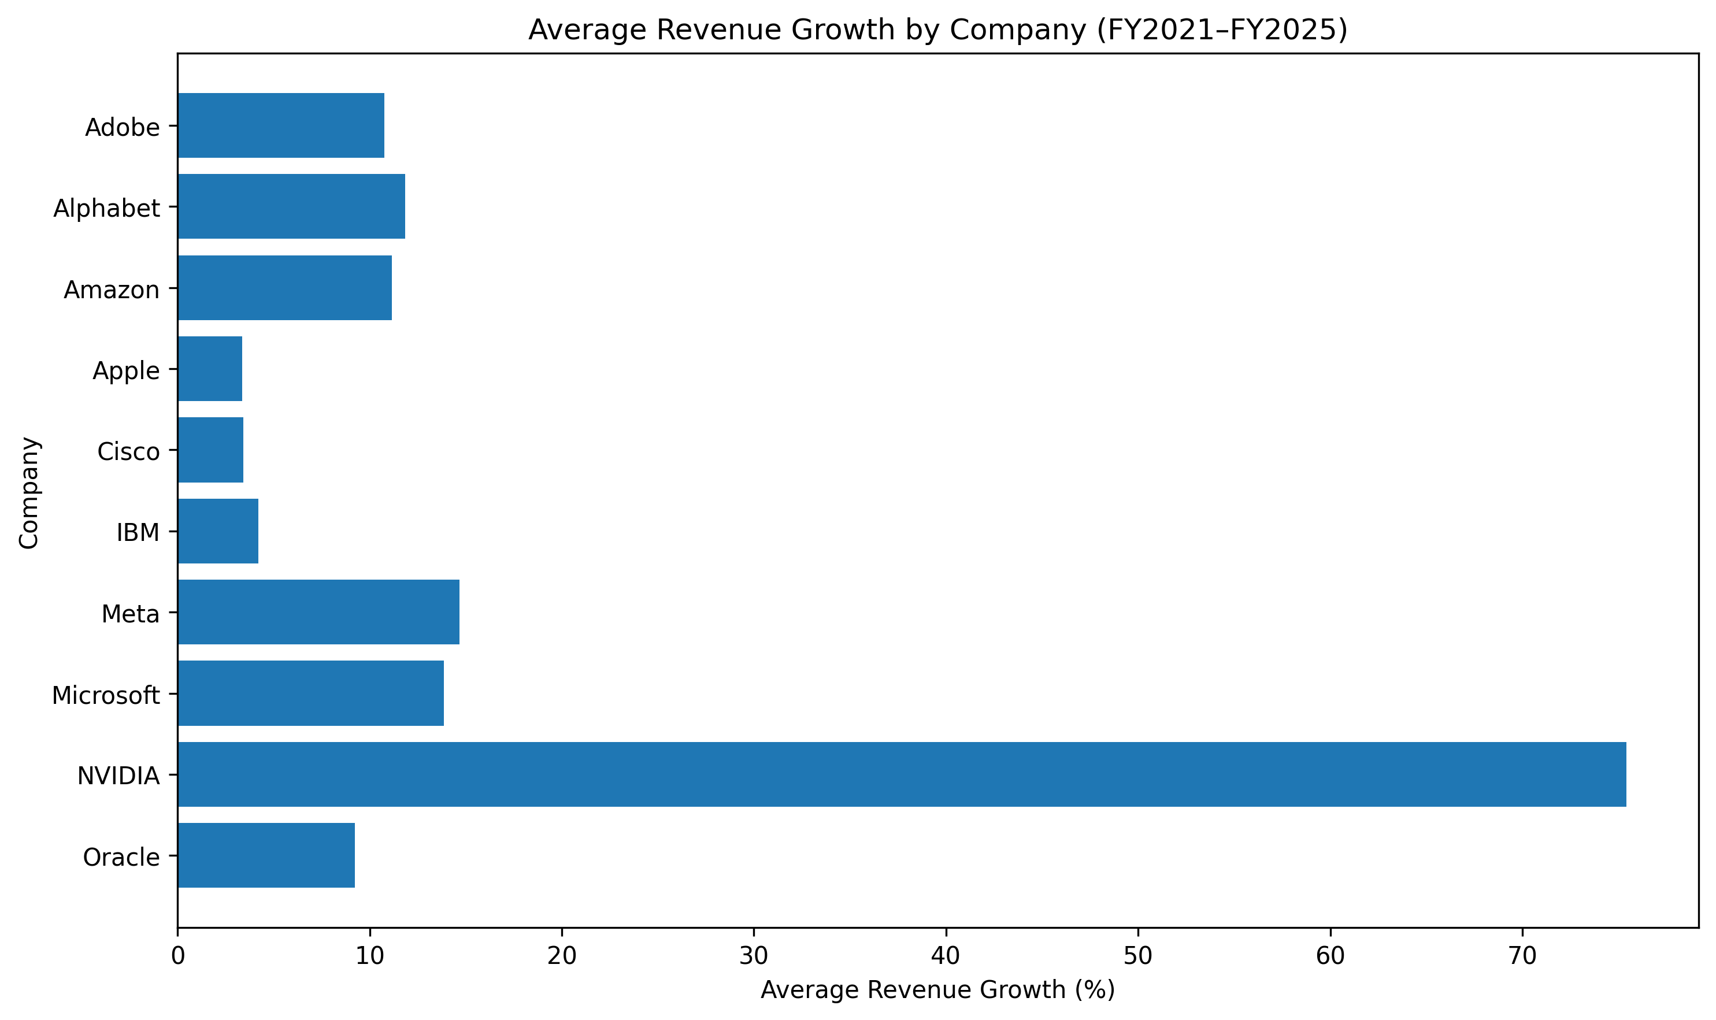

Figure 2. Average net profit margin by company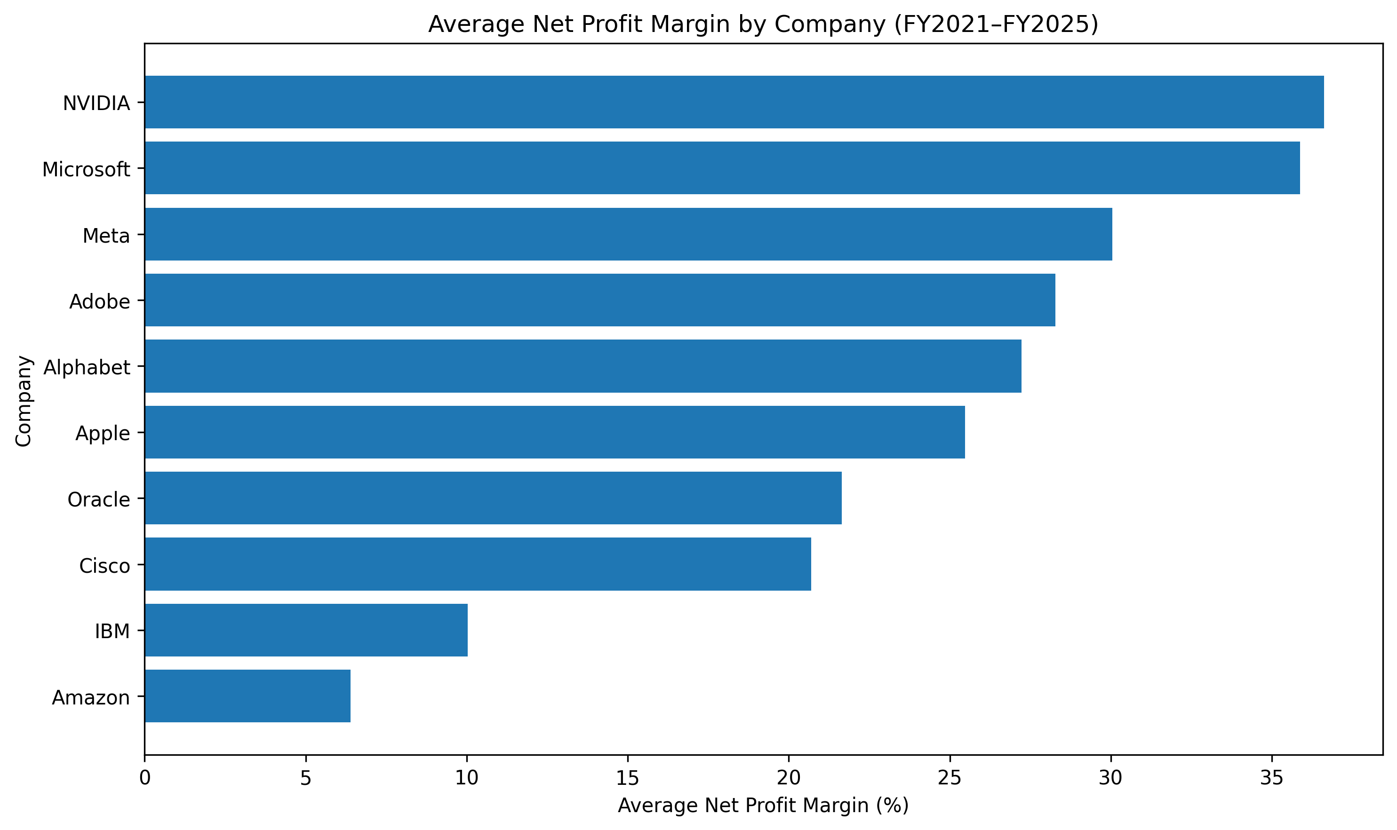
Figure 3. Average return on assets by company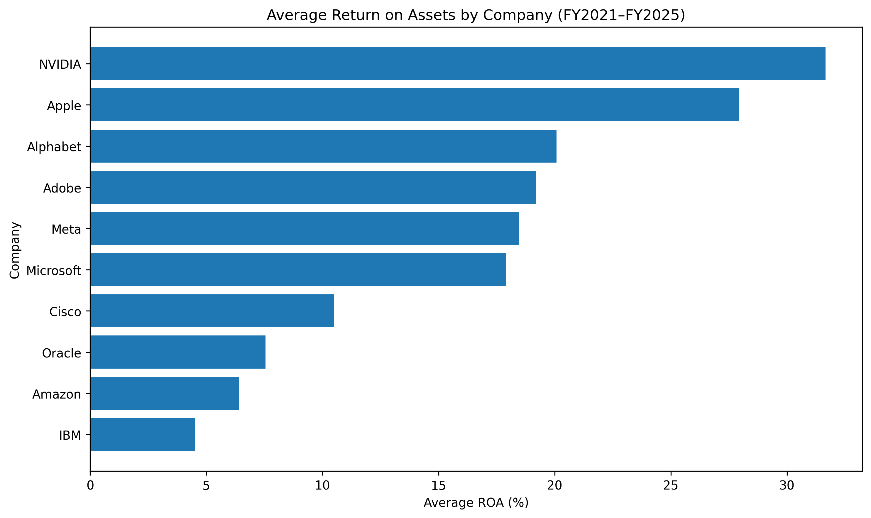

Figure 4. Average liability-to-asset ratio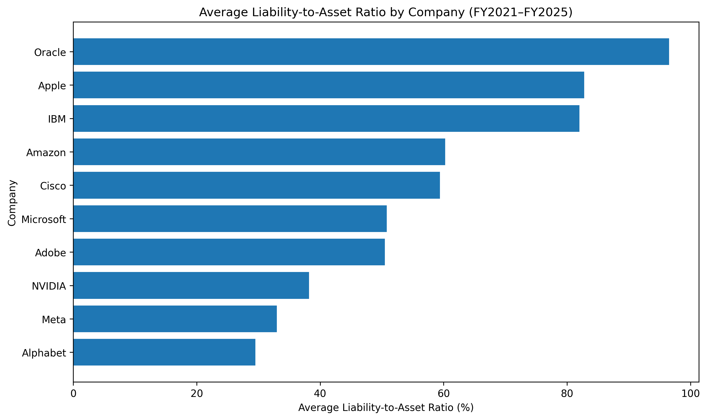
Figure 5. Revenue trends of technology companies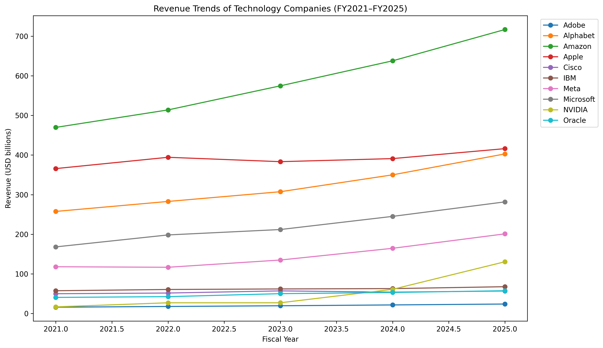
Figure 6. Correlation between financial performance ratios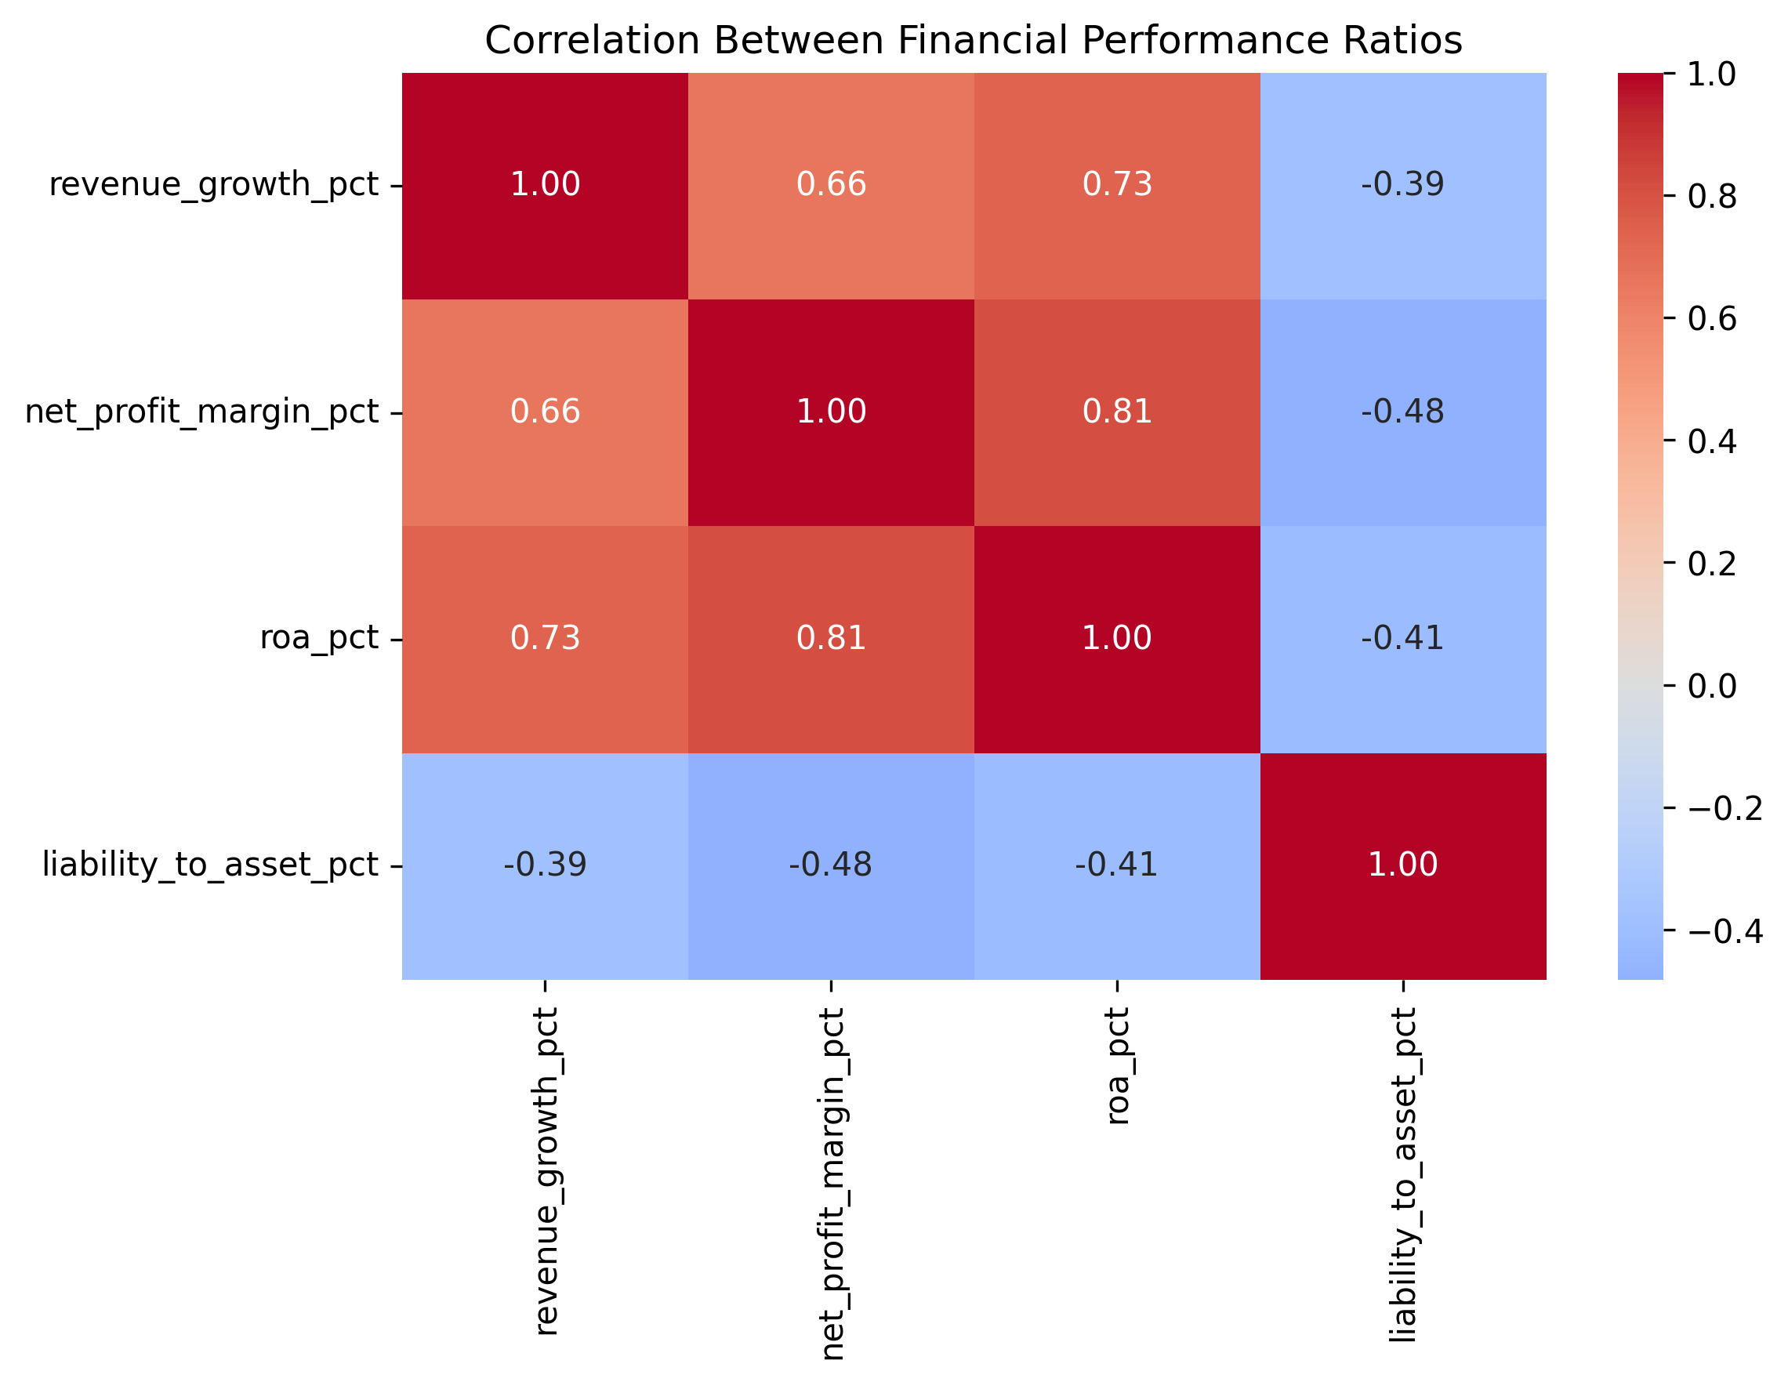
Power BI page 1. Financial Overview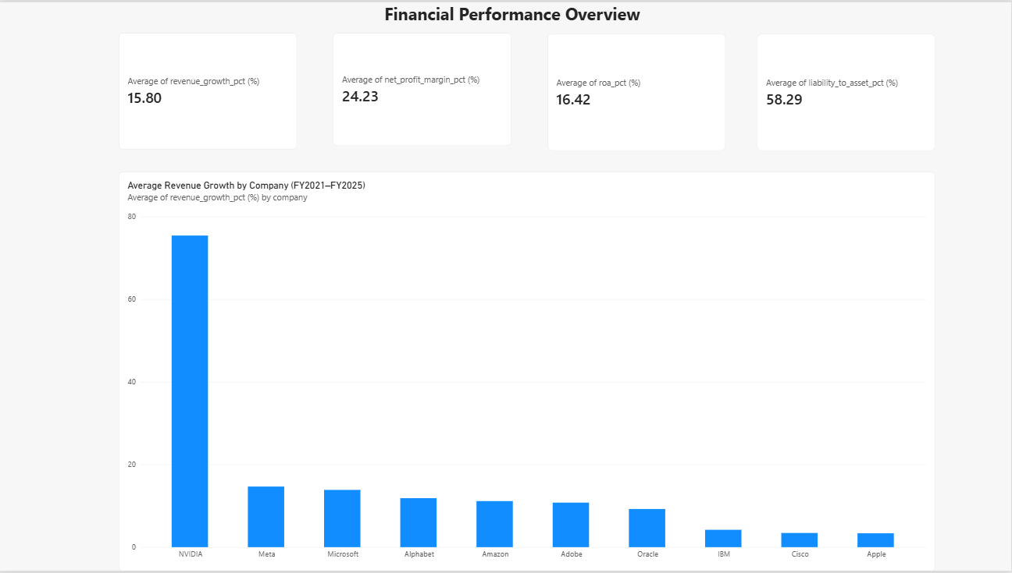

Power BI page 2. Growth & Profitability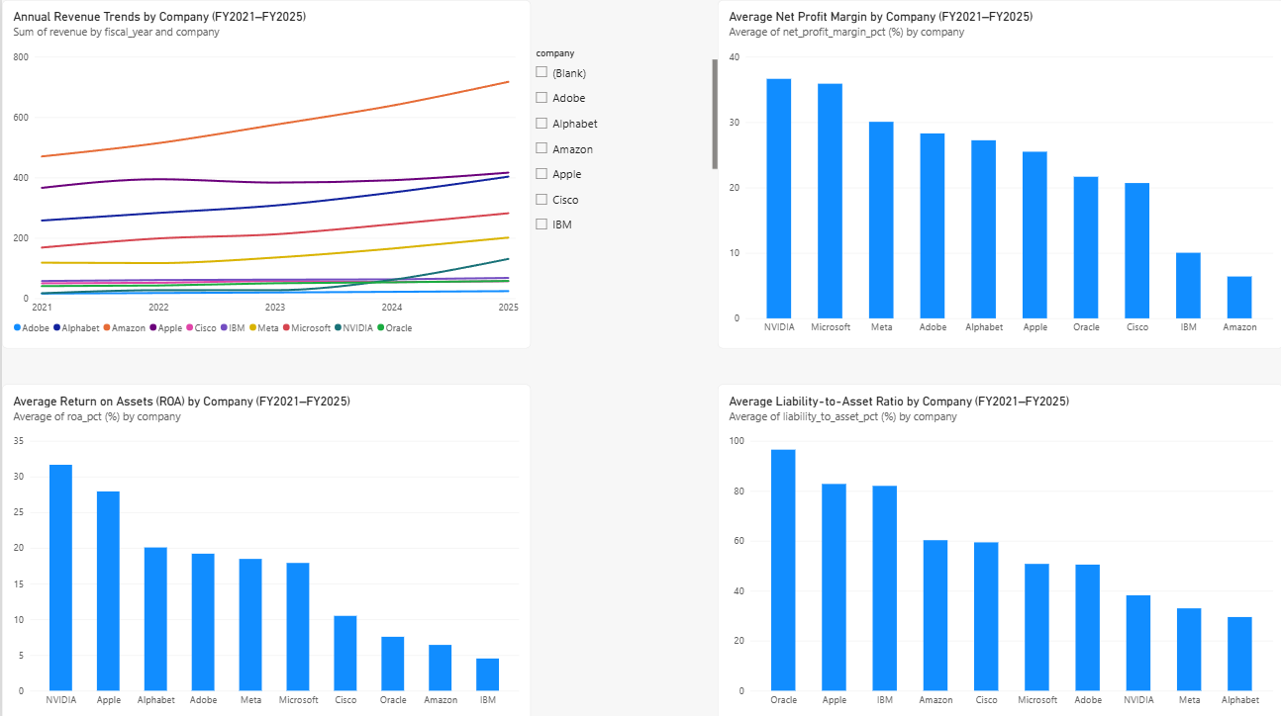
Power BI page 3. Financial Risk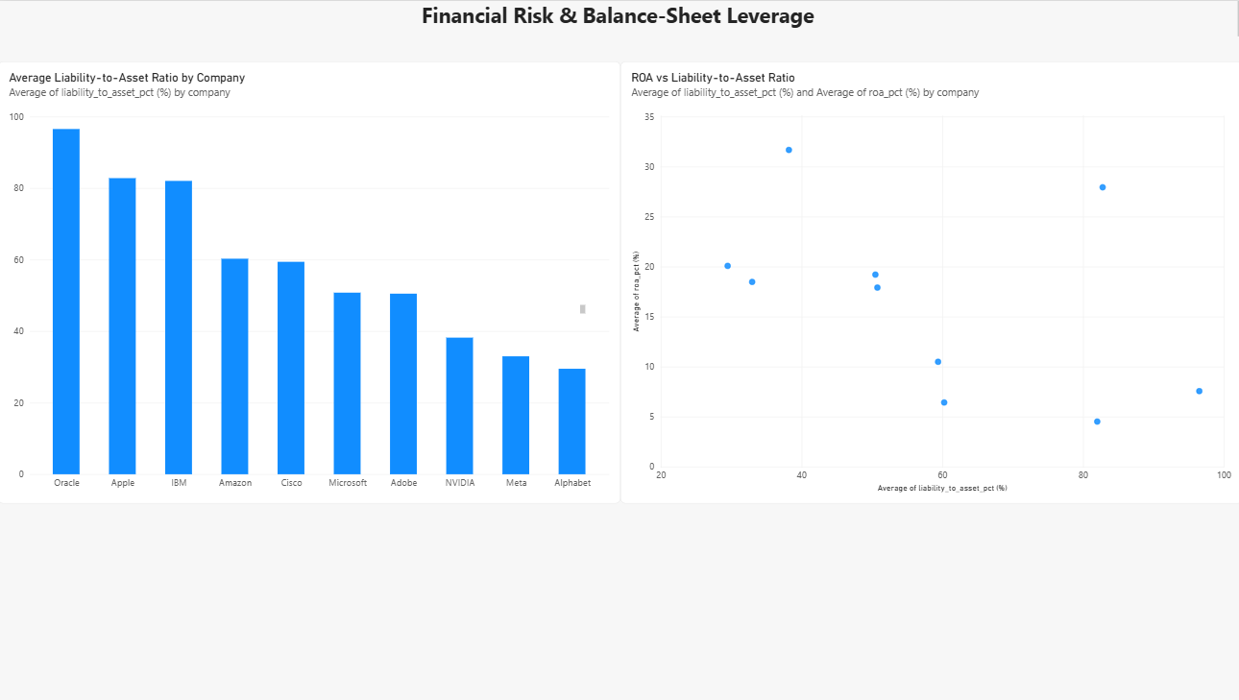

7. Tools Used
- Python (pandas, Matplotlib, Seaborn): data preparation, ratio calculations, summaries, charts and correlation heatmap.
- SQL / SQLite: aggregation, filtering, sorting and LAG() for prior-year revenue comparisons.
- Excel: raw data, financial analysis, company-level summary formulas and dashboard charts.
- Power BI: interactive pages for overview, growth and profitability, and financial risk.

8. Limitations
- The analysis covers ten selected companies, not the entire technology sector.
- Reported fiscal years differ by company and are not calendarized.
- FY2021 growth is unavailable because FY2020 data is not included.
- ROA uses year-end assets, not average assets.
- Liabilities for Amazon and Oracle were derived from balance-sheet components where a consistent direct tag was unavailable.
- Correlations are descriptive and do not establish causation.
- The analysis is historical and is not a forecast or investment recommendation.

9. Conclusion
The analysis highlights distinct financial performance patterns across the ten selected technology companies during FY2021–FY2025. NVIDIA recorded the highest average revenue growth, net profit margin and return on assets in the sample. Microsoft also demonstrated a high average net profit margin, while Oracle had the highest average liability-to-asset ratio. The correlation analysis identified associations among growth, profitability, asset returns and financial leverage; however, these relationships do not establish causation.
The project demonstrates an end-to-end workflow for collecting public financial data, calculating financial ratios, conducting descriptive analysis and presenting findings using Python, SQL, Excel and Power BI. The analysis is limited to ten technology companies and five fiscal years, and differences in fiscal year-ends and business models may affect comparisons. Future work could expand the sample, extend the period, validate calculations against individual company filings and compare companies within specific technology sub-industries.

Data Source

U.S. Securities and Exchange Commission (SEC), Company Facts dataset, accessed through the SEC’s public data resources. The analysis covers FY2021–FY2025. Financial ratios were calculated from reported financial statement data, using year-end total assets for return on assets. Fiscal years were retained as reported by each company.

