**Research Report: SMART PERSONAL FINANCE WITH PYTHON**

**---**By Vanshika Srivastava

Jims sec-3

**Introduction**

**Purpose of**  this project is to provide users with enhanced financial management and insights by leveraging advanced technologies.

**Libraries Used:**

Several Python libraries are :

* Pandas : **Purpose**: Data manipulation and analysis. It provides data structures and functions needed to handle structured data (e.g., CSV files, databases).
* Numpy : Numerical operations and array handling. Often used in conjunction with Pandas for numerical computations.
* NLTK (Natural Language Toolkit) : A suite of libraries and programs for symbolic and statistical NLP for tasks like tokenization, stemming, and parsing.
* Matplotlib : Plotting and visualization. Useful for creating static, animated, and interactive visualizations in Python.
* Tkinter : Tkinter is a standard Python library used for creating graphical user interfaces (GUIs). It is included with most Python installations, making it an accessible choice for building desktop applications.

**System Overview**

**System Architecture:**

The system architecture for smart personal finance management using AI and Python would typically be structured in layers, handling everything from data collection to insights and user interaction.

**Functional Components:**

* Data Aggregation Component
* Budgeting & Goal-Setting Component
* Financial Insights & Recommendations Component
* Data Storage & Backup Component

**System Requirements**

**Hardware Requirements:**

* Multi-core CPU (e.g., Intel Core i7 or AMD Ryzen 7) for running data processing and model training.

**Software Requirements:**

* Operating System (Linux/Windows)

**Design and Implementation**

**Design:**

The File will be an application which includes Date, Category, Description, Amount.

**Setup:**

1. Install necessary libraries in python

* Pandas
* Numpy
* Matplotlib
* Nltk

1. Writing the code for making an application.
2. Storing the data in a csv file.

**Code**

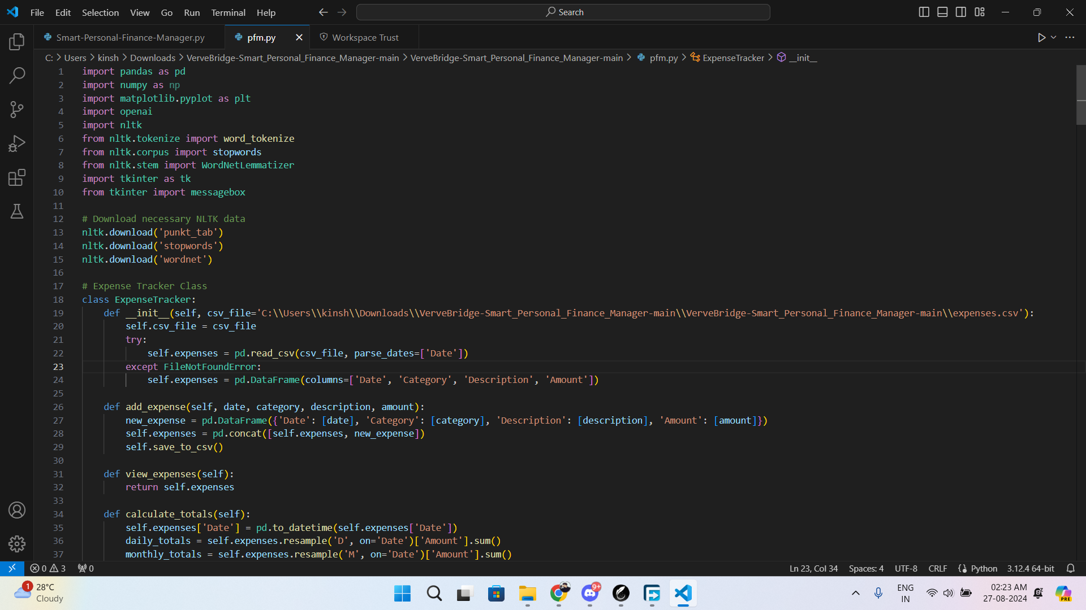

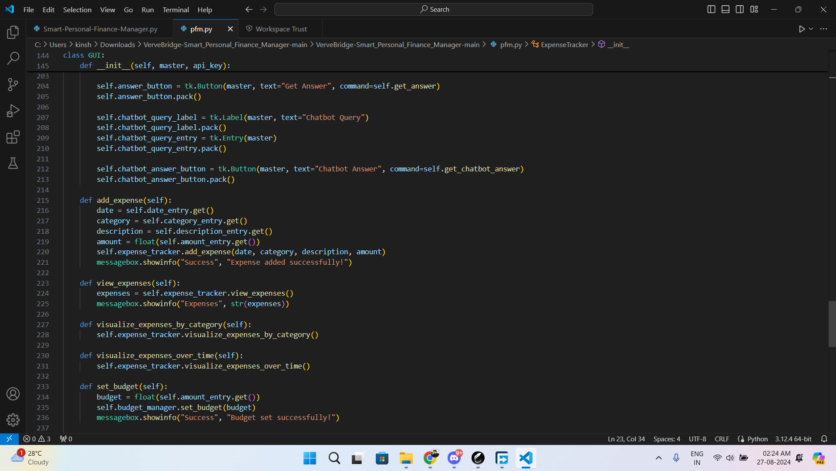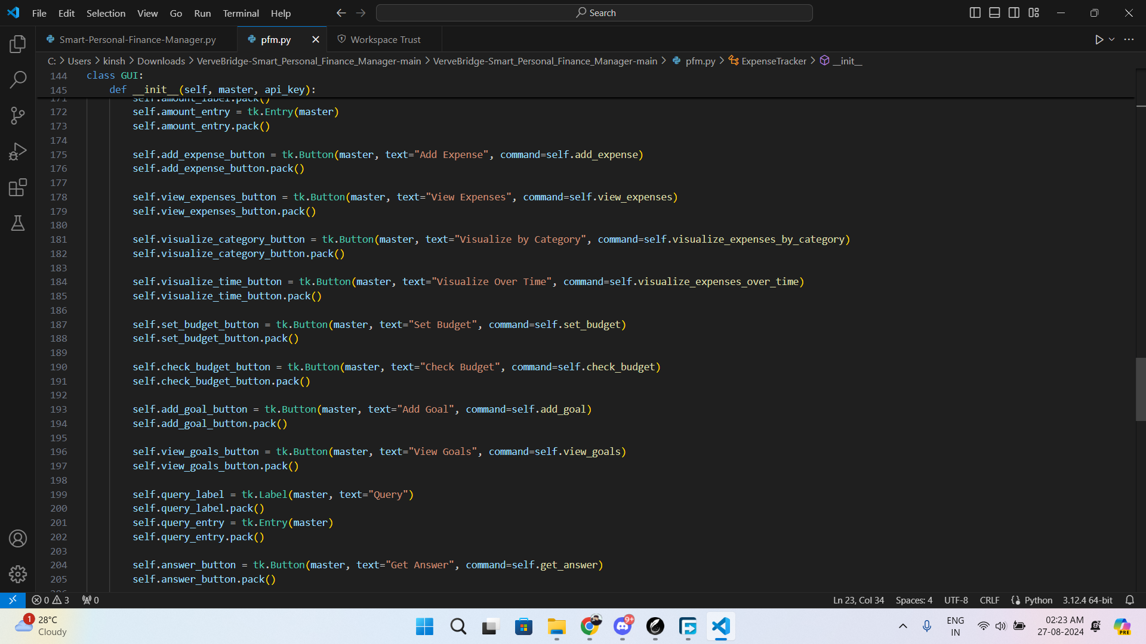 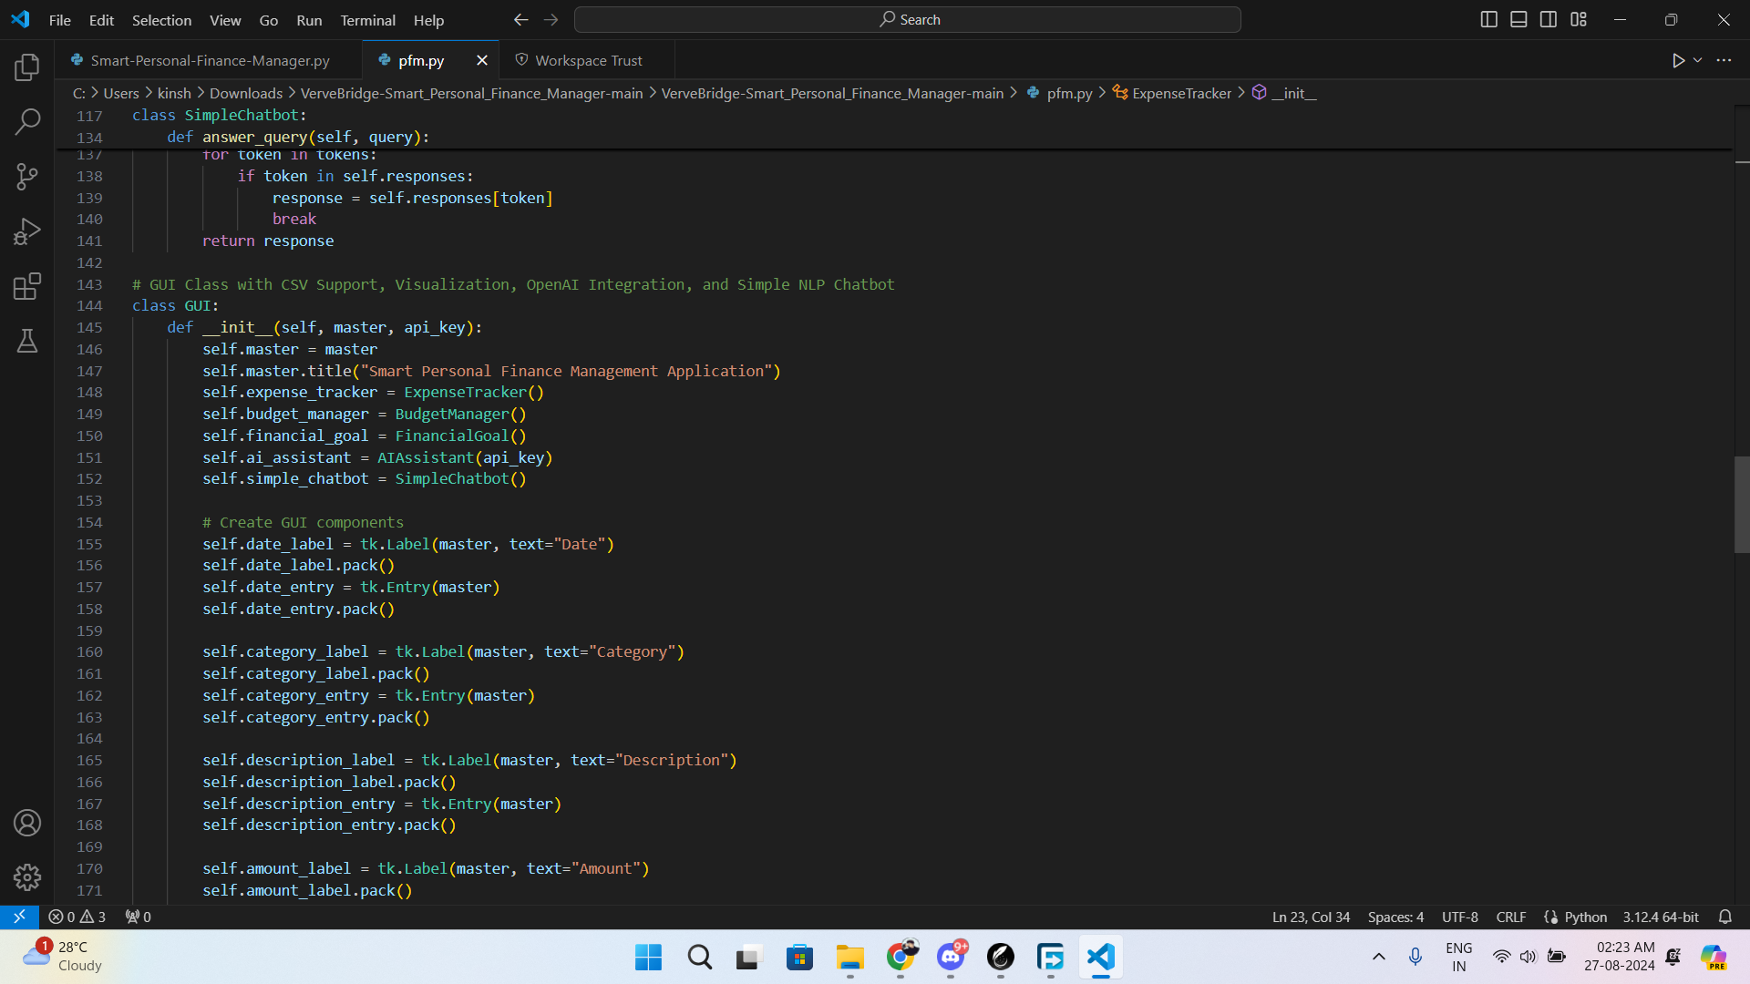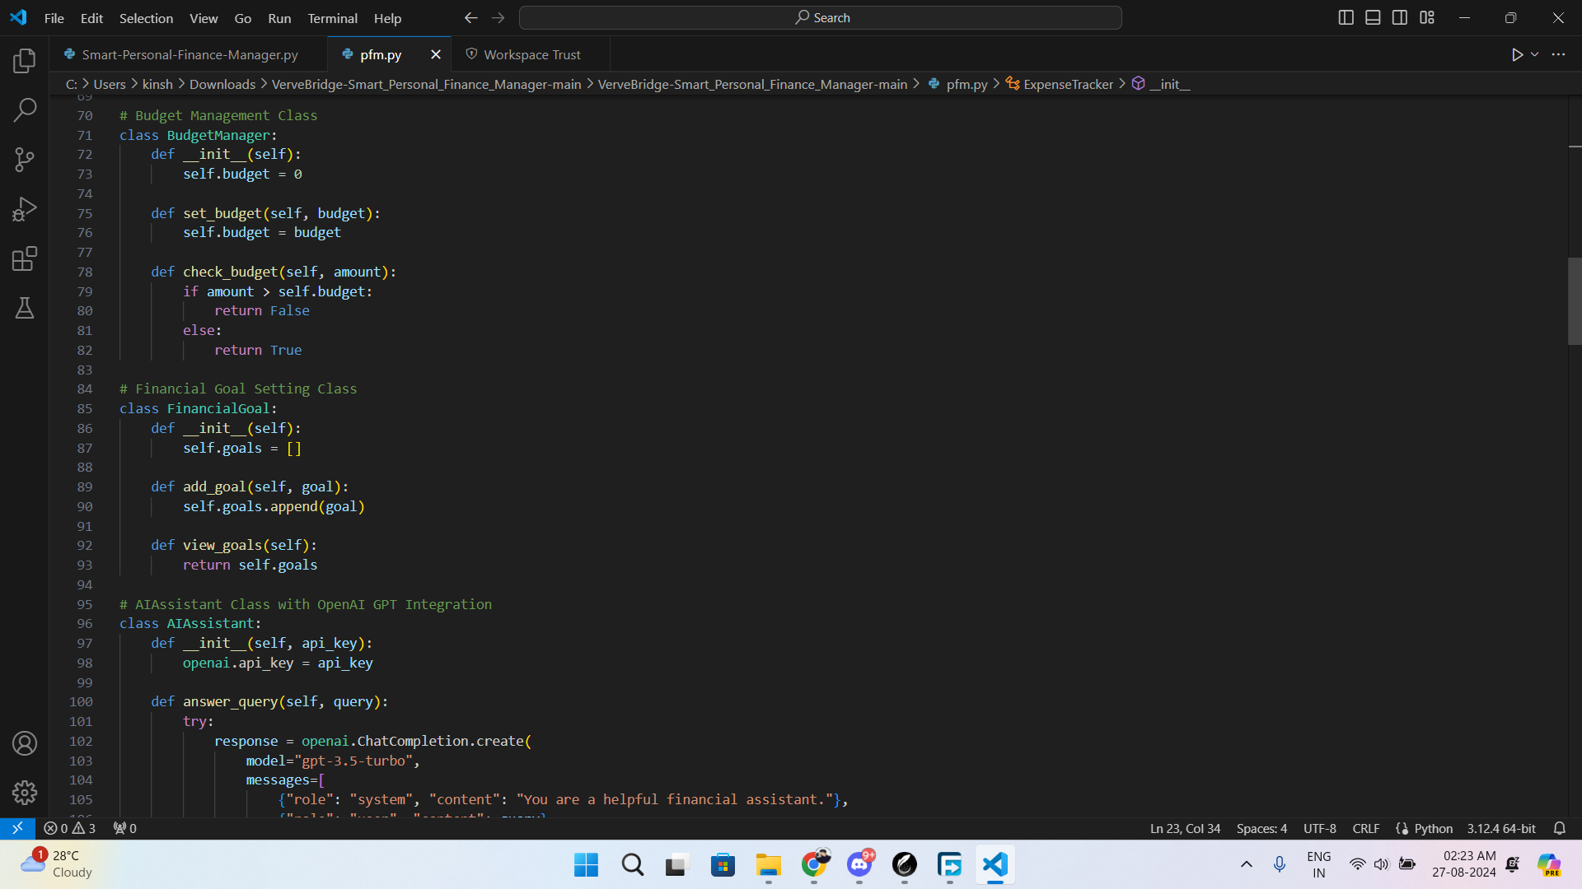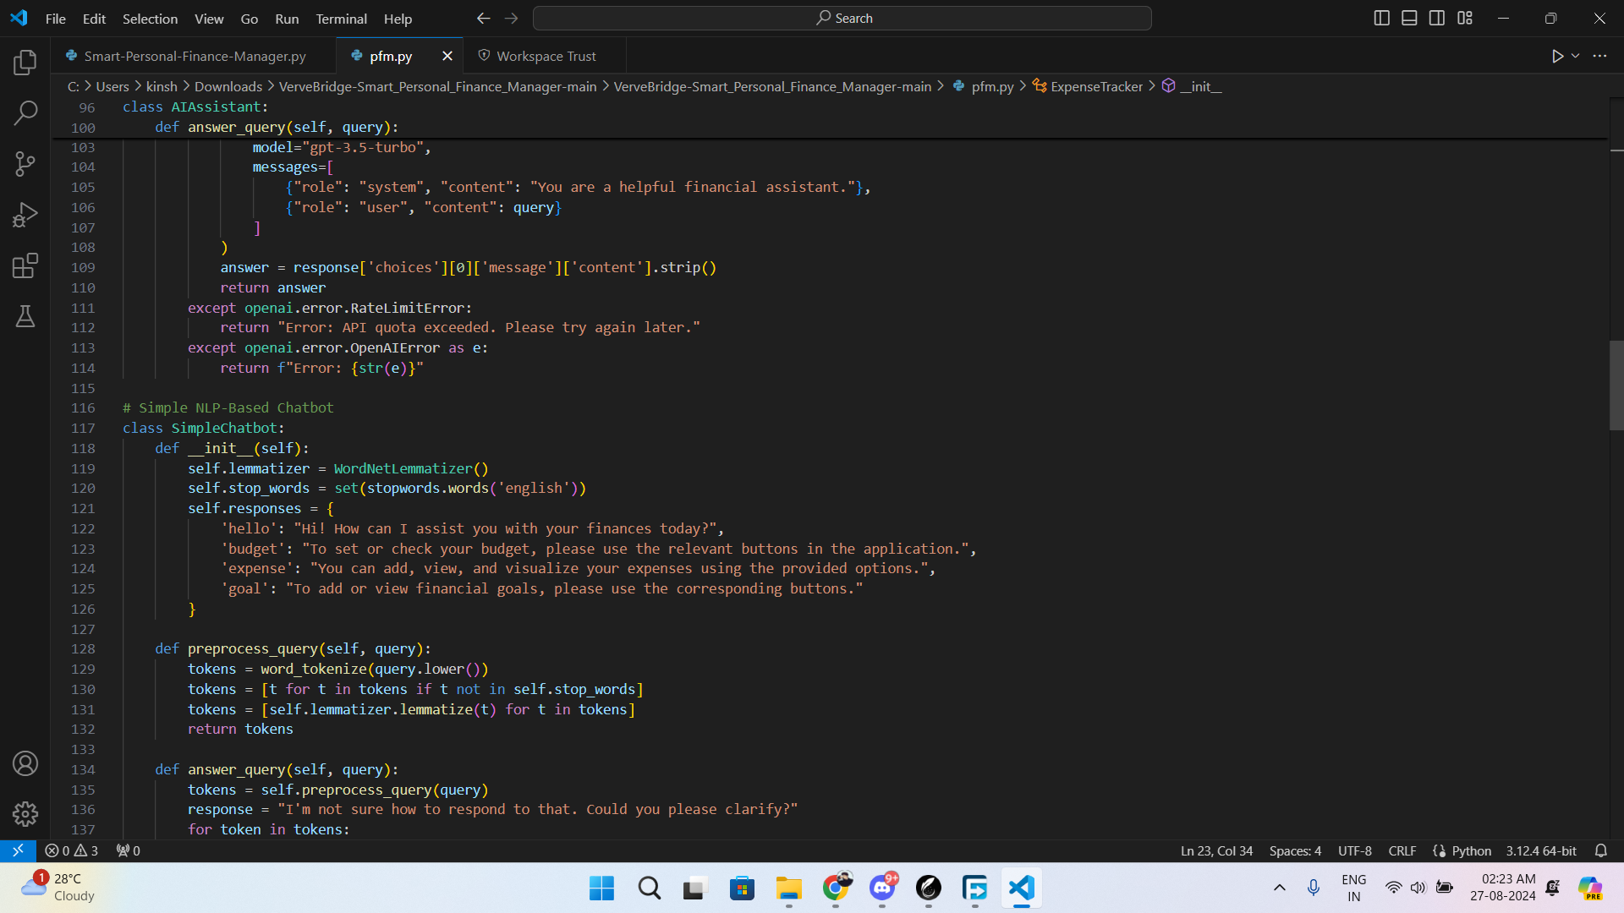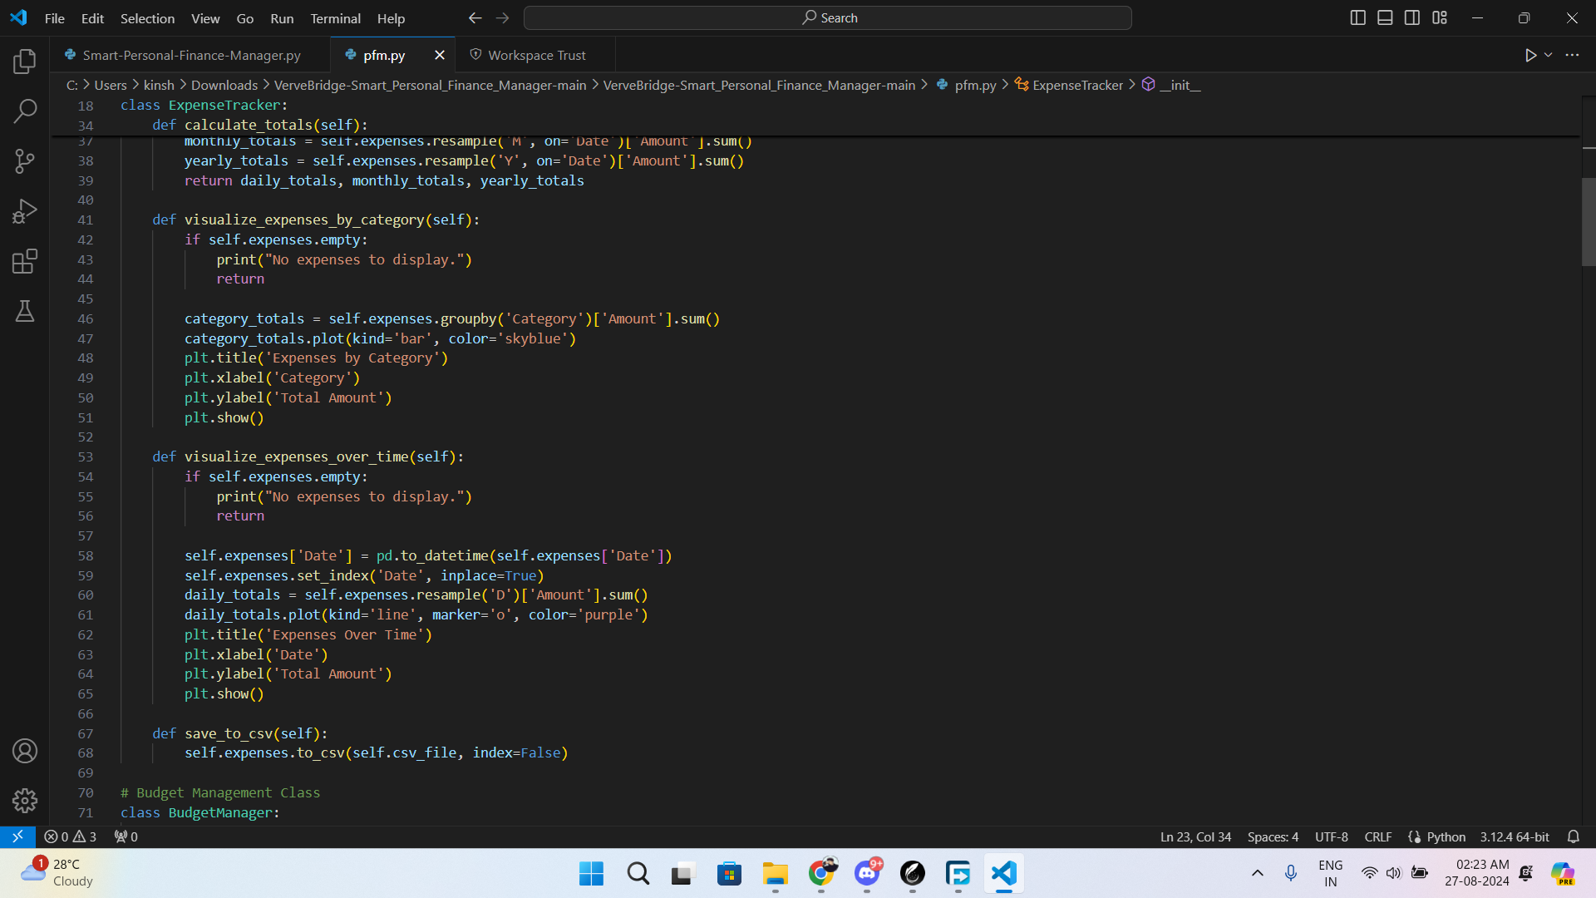

**Testing the Code**

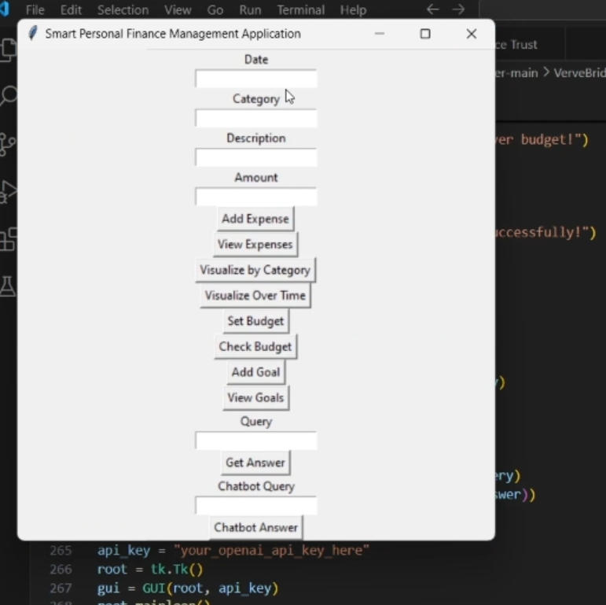

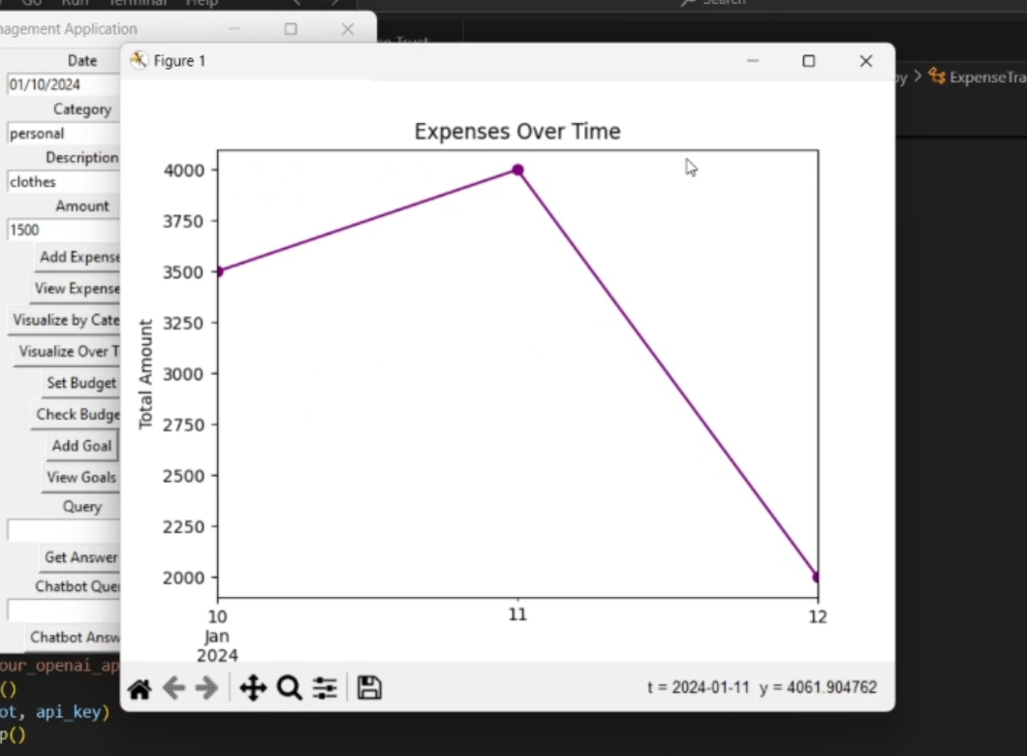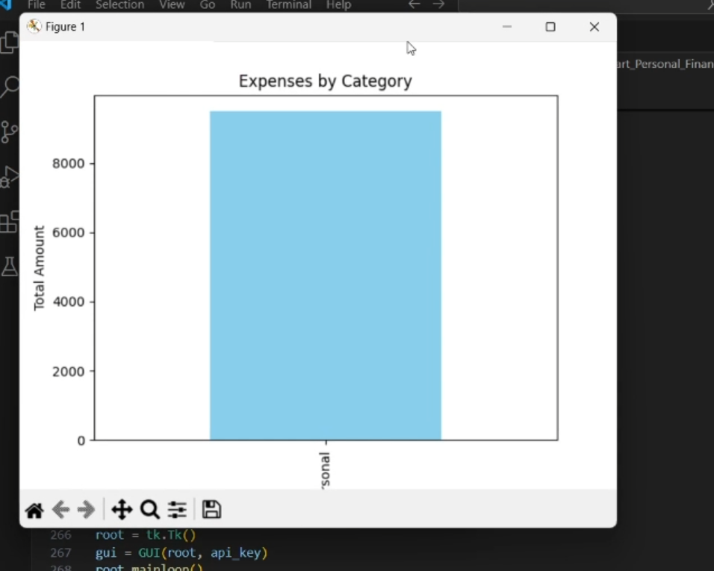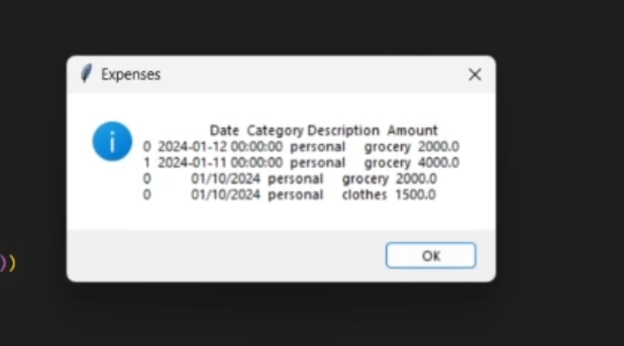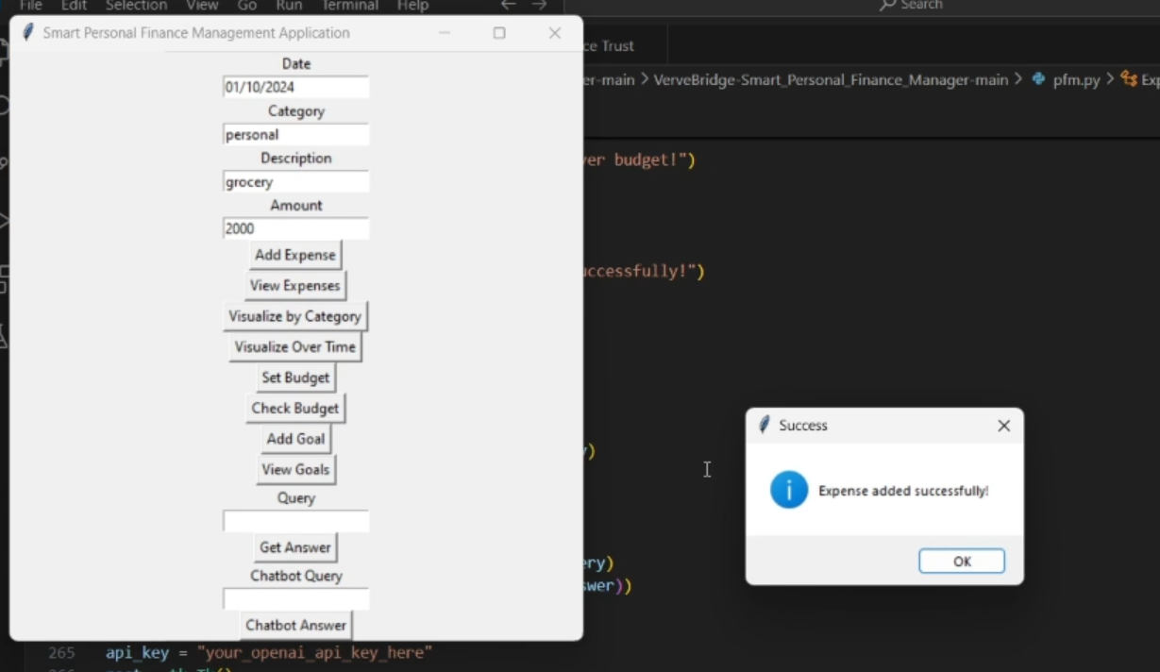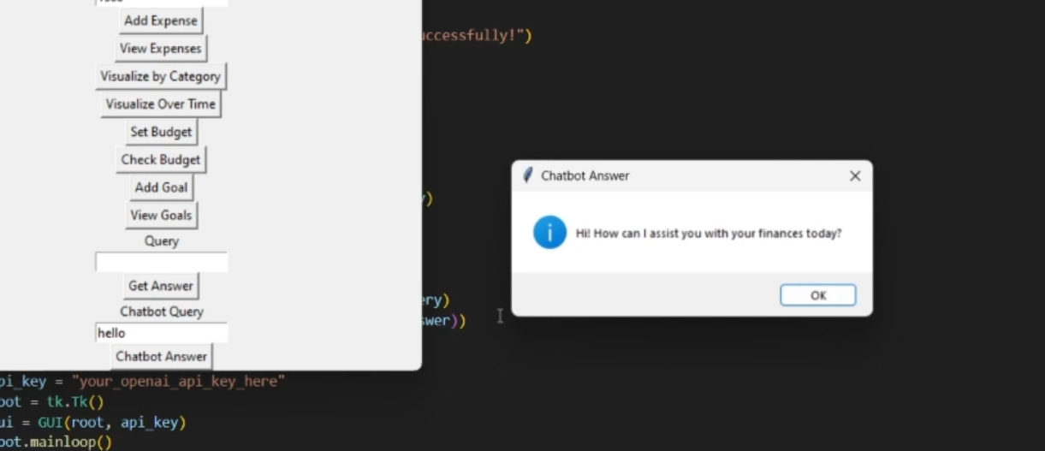

**Future Enhancements**

* Advanced AI and Personalization
* Enhanced User Interface and Experience
* Sustainability and Ethical Finance Features
* Advanced Analytics and Reporting

**Conclusion**

In conclusion, building a smart personal finance management system using AI and Python provides immense value by offering users personalized financial insights, real-time data processing, and automated budgeting and investment tools. The system architecture incorporates data aggregation, machine learning, API services, and an intuitive frontend to empower users with actionable financial advice. As the system evolves, future enhancements such as advanced AI models, deeper integrations with financial services, enhanced security features, and personalized user experiences will make it even more robust and user-friendly.