EVALUATING NATIONAL GREEN HYDROGEN MISSISON: A POLICY REVIEW

- Vanshika Singh
Introduction
With the growing demands of the expanding economies of the world, energy demand is expected to surge. Energy demand for India is expected to increase by 35% by 2030 (India Energy Outlook 2021). India’s hydrogen demand in 2020 was recorded at 6 million tonnes per annum (Kambali, 2024). This is primly driven by fertilizers production and refinery operations. It is estimated that this demand will further increase five-fold by 2050. this India’s commitment to sustainable development has necessitated policy initiatives such as the National Green Hydrogen Mission. This policy review examines the mission, its broader goals, its immediate actions, its potential while evaluating the rationale, alternatives and potential concerns.

Rationale for Green Hydrogen
At the UNFCCC COP 26, India pledged to Panchamrit- a set of five national targets as its Nationally Determined Contribution (NDCs). These are a) to achieve 500GW non-fossil energy capacity by 2030; b) half of the energy requirements to come from renewable energy by 2030; c) to reduce the total carbon emissions by one billion tonnes till 2030; d) reduce the carbon intensity of the economy by 45% by 2030; e) to achieve net zero emissions by 2070. All these targets entail an inherent focus on renewable energy. However, traditional renewables, like solar energy and wind energy, face two key issues variability and uncertainty. Further, India has yet to determine an effective way to integrate renewables into the grid. Though storing these renewables is easier through batteries, it comes with its own set of problems like dependence on China for lithium and rare earth minerals; reliability of batteries and; the toxic chemicals associated with them. Moreover, sectors like industry and heavy transport are challenging to decarbonize with the existing carbon technologies.

Hydrogen, on the other hand, is a clean secondary source which is easy to transport. To put things simply, an electrolyser uses a form of energy to break down water (H2O) into hydrogen (H2) and oxygen (O2). Depending upon the energy source for this breakdown, there are different colours of hydrogen. These sources include Water, petroleum, natural gas, biofuels, and wastewater sludge. Gupta et al (2023) has ranked solar energy as the most “prominent resource” for green hydrogen in India, followed by wind energy, small hydro and lastly biomass. Green hydrogen is when electrolysis of water is done by using electricity from renewable sources. It is a clean fuel as zero carbon emissions are produced as a by-product. Hydrogen, though with its own set of challenges, can be stored in storage tanks, chemically stored or natural underground storage. It can be transported via pipelines, trucks or tanker ships (Niti Aayog, 2022).

About the Mission
The NGHM, announced on the 74th Independence Day (2021), was approved by the cabinet in January, 2022. The initial phase of the policy was launched by the Ministry of Power in February 2022 setting the foundation for India’s hydrogen ecosystem. It focussed on the supply-side challenges with lower costs in hydrogen production. The comprehensive National Hydrogen Mission (NHM) document was released then. With an initial outlay of Rs 19,744 crores, it seeks to position India as the leading country for producing, utilizing and exporting Green Hydrogen and its related products. The mission aims to achieve the target 5 million tonnes per annum of green hydrogen production by 2030 while increasing the country’s renewable energy capacity to approximate 125GW.

The NHM outlines a two-phase strategy for sectoral growth. The first phase is set for 2023-24 to 2025-26 and focusses on integrating hydrogen in key sectors like refineries and fertilizers where easy adoption as a fuel can be facilitated. This phase emphasizes on demand creation while supporting affordable supply and enhancing domestic manufacturing capabilities. It will also drive research and development (R&D) and pilot projects across the value chain. Following this, the Ministry of New and Renewable Energy released guidelines for financing of testing facilities and infrastructure, with a Rs 200 crore outlay till 2025-26. It further elaborated on institutional backing for establishing standards and regulatory frameworks. The National Institute of Solar Energy (the implementation agency for this scheme) will identify testing facilities and call for proposals which will be then evaluated by a Project Appraisal Committee. MNRE will cover up to 100% of capital expenses for government organizations. The second phase set from 2026-27 to 2029-30 will focus on rapid expansion of green hydrogen to make it cost-competitive. Large scale projects will also be supported in sectors like steel, mobility and shipping with ongoing R&D to eventually extend to sectors like railways and aviation.

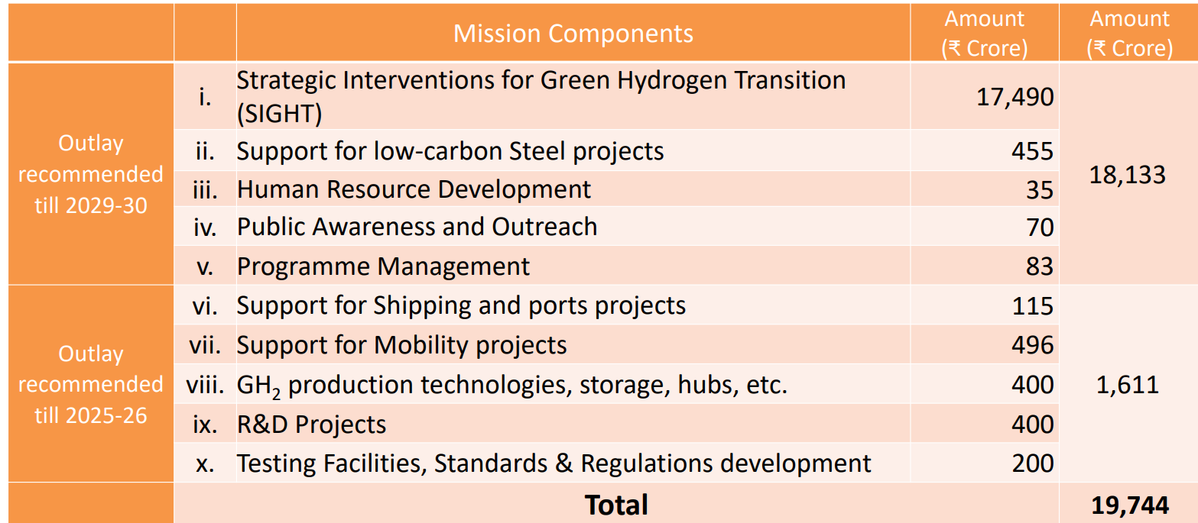
Source: World Resources Institute

To incentivize supply, the SIGHT program provides direct financial incentives for electrolyser manufacturing and green hydrogen production. The pilot projects’ design and aims will depend on the sectors it covers like industry, mobility, maritime, infrastructure and green hydrogen biomass. The R&D roadmap is outlined in three timeline-based projects - Mission Mode Projects (2022-27), Grand Challenge Projects (2022-30) and Blue Sky Projects (2022-35). The regulations and standards for hydrogen adoption will be based on the hydrogen value chain consisting of generation, conditioning, storage, application and end user.

Current Progress
Though the mission is in its early stages, investments and policy support has been in place. Policy measures have been initiated to lower renewable energy costs by MNRE, Ministry of Power and the state authorities. The World Resources Institute lists down state level policy actions. Uttar Pradesh has drafted an ambitious Draft Green Hydrogen Policy which provides significant incentives for businesses in the sector, such as a 14-year exemption from various charges. The policy has a special focus on electrolyser manufacturing as well. Madhya Pradesh’s Renewable Energy Policy has introduced tailored incentives for green hydrogen. The policy aids project financing through an interest subsidy of up to 5% for six years. Additionally, it provides a five-year exemption from electricity taxes, green industry incentives reaching ₹1 crore, and SGST refunds on capital equipment. Odisha is dedicated to establish two green hydrogen green ammonia hubs in the state. Further, green hydrogen projects have been exempted from cross-subsidy surcharges and state transmission charges for 20 years. There is a 100% exemption from electricity duties for 20 years, starting from the date of commercial production. Gujarat is offering SGST reimbursement of 80-100% for a period of 10 years.

Other than state-led efforts, various institutions have also geared up. GAIL Limited launched the country’s first project to blend hydrogen into the city gas distribution network in Indore, Madhya Pradesh. NTPC Limited began blending green hydrogen upto 8% into the PNG network at its Surat facility. NTPC has also deployed hydrogen-powered Fuel-Cell Electric Vehicle buses in Uttar Pradesh, and Leh.

Case for CCUS in India
At present, green hydrogen production is far expensive than brown or black hydrogen (produced from fossil fuels or natural gas). This calls the discussion for blue hydrogen. Blue Hydrogen is brown or grey hydrogen but with its carbon sequestered or repurposed. Dialogue around Carbon Capture Utilisation and Storage (CCUS) has been going around for a while in India, especially given the country’s heavy dependence on coal. Against the Rs 340- 420/kg current cost of green hydrogen, blue hydrogen could offer around Rs 168/kg price, thus boosting the hydrogen economy overall. Alternatively, cost-competitive green hydrogen can aid in urea production from green ammonia (produced from renewable energy sources), which has significant potential to use captured carbon (Niti Aayog, 2022).

Challenges to Green Hydrogen
Niti Aayog’s report on Harnessing Green Hydrogen highlights issues such as high costs, complex supply chains and regulatory issues in building a green hydrogen economy. Further, hydrogen can be produced via multiple ways and can be used in various industries, thus making its supply chain more intricate compared to oil and gas.

One significant issue for India is high production costs. Currently, green hydrogen’s production costs approximately $4-5 per kg, which is almost the double of the production costs involved in grey hydrogen (World Economic Forum, 2024). Electrolyzers make up about 30–50% of the overall costs associated with green hydrogen production. Another key issue is transportation. Until now there have been only few commercially viable and safe options for transportation of compressed hydrogen. Kar et al (2022) estimates that about 30% of the hydrogen energy is lost in the liquefaction process which in turn affects the operational costs of energy carriers. Kar (2022) thus further anticipates for prompt support from industry R&D to shorten development time for hydrogen technology. A significant challenge with storing compressed hydrogen is that due its low density it requires to be stored in much larger containers which thus increase costs. Thus, it will need substantial investment to upgrade infrastructure. Thus, World Economic Forum (2024) estimates that for a viable ecosystem in India, the green hydrogen costs need to come to around $2 per kilogram.

Further, resource shortages need to be addressed. According to the International Energy Agency, electrolyzing water takes up to 9 litres of water for every kilogram of hydrogen produced. Also, there is an absence of uniform global standards for green hydrogen in terms of definition, storage and usage. These vary country to country. Until very recently, no global standard was in place to define maximum emissions of green hydrogen.

Greenwashing
Greenwashing reflects the rising scepticism about environmental claims of “green” fuels. For instance, despite ArcelorMittal received over $1.2 billion in green hydrogen subsidies over the world, they are simultaneously constructing new coal-fired furnaces in India. Green hydrogen is “green” as it is produced from renewable energy sources like solar or wind energy. But if regular grid electricity is deployed, it is not a clean fuel as it is being made out to be (See graph by ICCT).
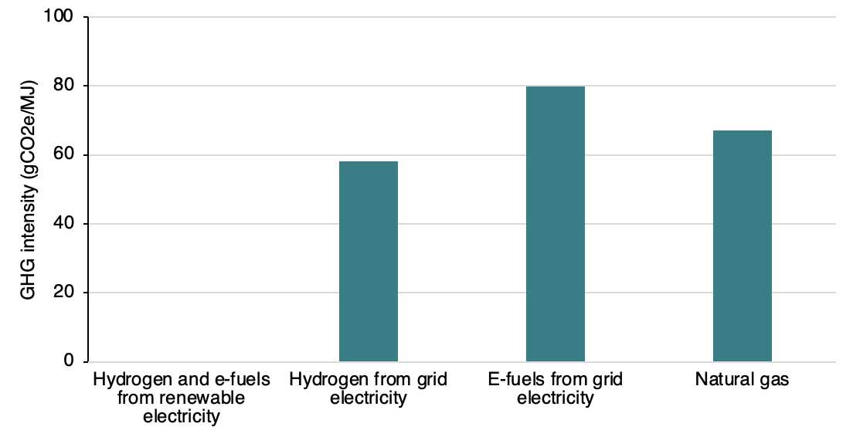
Source: Don’t let the industry greenwash green hydrogen. ICCT. 2021

Electrolysis for green hydrogen demands a large supply of renewable energy. Campaign Against Climate Change (CCAG) forecasts that in order to replace the current hydrogen production with green hydrogen, the requirement for wind and solar capacity would far exceed than what exists globally. For India, the case is not different. Though green hydrogen production in India can be supported well with the country’s renewable energy potential, but it necessitates swift expansion it its capacity. For instance, India’s solar energy potential is pegged at 748GW. However, at present, we have only installed just 9% of this potential at capacity of 70GW (MNRE). CCAG points out that despite more energy-efficient alternatives existing, ‘green’ solutions of such limited resource are advocated. It becomes more significant as decarbonizing our energy systems essentially requires focussing on energy efficiency instead of labelling resource extractions as “green”.

Development through “Green” Industrialisation
Gabor and Sylla (2023) analyse the green hydrogen model in Namibia, Africa through the lens of “derisking developmentalism” to highlight that heavy reliance on foreign capital reinforces dependency on Global North. This could replicate past extractive economic patterns. These concerns can also be found in India’s NGHM. Uttar Pradesh recently obtained around Rs 1.15 trillion in green hydrogen proposals from private players including foreign giants like Trafalgar Square Capital, Welspun Group and Hygenco Green Energies. World Bank granted $1.5 billion to finance NGHM. As India gazes foreign investment to meet funding gaps, this reliance can limit the state’s control over the development process, as foreign investors prioritise profits over regional benefits. The Nambian green hydrogen products are structed as enclaves which are very capital intensive with reliance on foreign technology. These generate isolated economic benefits while limiting broader industrial development. In India, there has been call for accelerating exports to establish the green hydrogen ecosystem. However, it is not without the risk of minimal integration with local industries and systems and thus less potential for domestic technological advancement. As discussed earlier, advancing domestic technology is required to achieve lower production costs. Moreover, “industrialisation-by-derisking” often bypasses rigorous accountability mechanisms so that private sector obligations are minimal. It could thus lead to the possibility of limiting the state’s role to only facilitate private investment rathe than a direct role in planning.

Conclusion
The NGHM looks as a promising step in India’s net zero emission path. It addresses demand and supply side challenges while setting ambitious targets. Achieving $2/kg price for green hydrogen remains crucial for the mission to achieve scalability and check out demand side and supply-side hurdles. The mission should promote innovation, especially domestic tech advancement, to decrease dependence on essential materials controlled by a few global suppliers. India should harness its unique position while leveraging the global momentum for green hydrogen ecosystems. However, beyond the green hydrogen fanfare, India should not lose sight of its potential consequences.

Policy Review Matrix

Key Stage | Review
Aims  and  Goals | NGHM aims to achieve 5 MMT per annum of green hydrogen (GH₂₎ production capacity by 2030; supplement aprox. 125GW renewable energy capacity; make India as a global hub of production, usage and export of GH₂ and; align with India’s broader goal of Net-Zero emissions by 2070. Though substantial progress has been made with respect to policy frameworks and pilot projects, the mission is still processing through its first phase and concrete outcome shave not been realized. Overcoming challenges related to cost will aid in achievement of the goals.
Methods | Amongst the multiple energy sources (solar, wind, biofuel, natural gas), solar energy promises the most potential for production of GH₂ through electrolysis of water. Major constraints include high production costs wherein electrolysers account for 30-50% of the overall cost. The current $4-5/kg cost needs to come down to aprox $2/kg to make GH₂ a viable and cheaper option than its current fossil fuel alternatives. Issues of transportation, storage, domestic R&D, resource shortage, demand creation and, global standards remain. India possesses vast untapped resource potential, especially of solar energy, for GH₂ production. India has mobilized significant financial resources with an initial outlay of Rs 19,744 crores. Practically the methods need to made consistent with the aims. Renewable energy generation needs to be scaled up to meet demands for GH_{2;} demand creation and incentivizing supply with high costs of electrolysers need to be rethought.
Implementation | The nearly practices have been largely consistent with NGHM. Various states have come up with policies and schemes offering tax exemptions, subsidies for electrolyser manufacturing, and infrastructure support. MNRE has outlined Rs 200 crore for testing and infrastructure development. Institutions like NTPC and GAIL are already working on hydrogen blending via their pilot projects, building a strong supply chain for green hydrogen.
Outcomes | NGHM envisages creation of 6 lakh new jobs, an investment of Rs 8 lakh crore, and to save Rs 1 lakh crore in imports. Further, it is expected to avert 50MMT per annum carbon dioxide emissions. It aims to build 60-100 GW electrolyser capacity. The mission has however not achieved significant scalability or cost competitiveness. Also, sectoral mandates of GH₂ consumption need to be set. Though the policy framework looks in the right direction, the state needs to adopt an action-centric approach. Amidst this, concerns of greenwashing and “green” industrialisation linger.

References:
De, A., & Thakker, A. (2023, February 20). India’s National Hydrogen Mission: India on a mission possible? KPMG. https://kpmg.com/in/en/home/insights/2023/02/india-national-hydrogen-mission-renewable-energy-sustainability-green-hydrogen.html
Gabor, D. and Sylla, N.S. (2023), Derisking Developmentalism: A Tale of Green Hydrogen. Dev Change, 54: 1169-1196. https://doi.org/10.1111/dech.12779
GOVERNMENT OF INDIA & MINISTRY OF NEW AND RENEWABLE ENERGY. (2023). NATIONAL GREEN HYDROGEN MISSION [Report]. https://cdnbbsr.s3waas.gov.in/s3716e1b8c6cd17b771da77391355749f3/uploads/2023/01/2023012338.pdf
Green Hydrogen Enabling Measures Roadmap for India. (2024, September 10). World Economic Forum. https://www.weforum.org/publications/green-hydrogen-enabling-measures-roadmap-for-adoption-in-india/
Greenwashing fossil fuels with carbon capture, hydrogen and biomass. (2024, November 9). Campaign Against Climate Change. https://www.campaigncc.org/greenwash
Gupta, S., Kumar, R., & Kumar, A. (2023). Green hydrogen in India: Prioritization of its potential and viable renewable source. International Journal of Hydrogen Energy, 50, 226–238. https://doi.org/10.1016/j.ijhydene.2023.08.166
Gyanendra Keshri, & Gyanendra Keshri. (2024, April 12). ‘Investments of $180-200 billion in green hydrogen expected in India by 2030.’ Deccan Herald. https://www.deccanherald.com/specials/investments-of-180-200-billion-in-green-hydrogen-expected-in-india-by-2030-2976527
How clean is green hydrogen? | MIT Climate Portal. (n.d.). MIT Climate Portal. https://climate.mit.edu/ask-mit/how-clean-green-hydrogen
Jha et al. (2022). Hydrogen economy in India: A status review. Wiley. https://doi.org/10.1002/wene.459
Kambli, R. (2024). Review on Challenges in India’s National Hydrogen Mission. International Journal of Scientific Research in Engineering and Management (IJSREM), 08(05). https://ijsrem.com/download/review-on-challenges-in-indias-national-hydrogen-mission/
Niti Aayog. (2022). Carbon Capture Utilization and Storage (CCUS): Policy Framework and its Deployment Mechanism in India. Retrieved November 2, 2024, from https://www.niti.gov.in/sites/default/files/2022-12/CCUS-Report.pdf
Ranevska, S. (2024, August 9). India working on new policy framework for CCUS implementation. Carbon Herald. https://carbonherald.com/india-working-on-new-policy-framework-for-ccus-implementation/
Ross, K. M., & Ross, K. M. (2024, January 31). The greenwashing trap: how green hydrogen can keep its promises. Power Technology. https://www.power-technology.com/features/the-greenwashing-trap-how-green-hydrogen-can-keep-its-promises/
Seema Prasad, & Seema Prasad. (2024, March 19). MNRE launches scheme to incentivise production of green hydrogen. Down to Earth. https://www.downtoearth.org.in/energy/mnre-launches-scheme-to-incentivise-production-of-green-hydrogen-94003
Solar Overview | MINISTRY OF NEW AND RENEWABLE ENERGY | India. (n.d.). https://mnre.gov.in/solar-overview/
Wahengbam, T. (2024, October 15). Benchmarking green hydrogen in India’s energy transition: Expensive but important for some uses - CSEP. CSEP - Centre for Social and Economic Progress. https://csep.org/technical-note/benchmarking-green-hydrogen-in-indias-energy-transition-expensive-but-important-for-some-uses/
World Bank Group. (2024, June 28). World Bank Approves Additional $1.5 Billion in Financing to Support India’s Low-Carbon Transition. World Bank. https://www.worldbank.org/en/news/press-release/2024/06/28/world-bank-approves-additional-1-5-billion-in-financing-to-support-india-s-low-carbon-transition
WRI. (2023). Review of India’s green Hydrogen mission. In Advancing the Net-Zero Agenda Through Regional Cooperation in Green Hydrogen in Asia. https://www.iges.or.jp/sites/default/files/inline-files/4-2_Deepak_Krishnan_NHEM_WRI%20India_22%20August%202023%20IGES.pdf

Coined in 1986, it is “Greenwashing is the act of making false or misleading statements about the environmental benefits of a product or practice. It can be a way for companies to continue or expand their polluting as well as related harmful behaviors, all while gaming the system or profiting off well-intentioned, sustainably minded consumers.” https://www.nrdc.org/stories/what-greenwashing
https://www.hydrogeninsight.com/industrial/greenwash-arcelormittal-taking-more-than-1-2bn-in-green-hydrogen-subsidies-while-building-new-coal-fired-furnaces-in-india/2-1-1406281
https://www.campaigncc.org/greenwash#:~:text=About%2096%25%20of%20current%20hydrogen,water%20using%20renewably%20produced%20electricity.
https://www.business-standard.com/india-news/up-secures-rs-1-15-trillion-worth-investment-in-green-hydrogen-sector-124091900955_1.html
https://www.worldbank.org/en/news/press-release/2024/06/28/world-bank-approves-additional-1-5-billion-in-financing-to-support-india-s-low-carbon-transition

