Report on EVM Discrepancies and Voter Perceptions: Field Visits to Patel Nagar, Baghpat, and Delhi University

- Vanshika Singh

Introduction
Elections are the bedrock of democracy and ensure that power is transferred through a transparent and credible process. In India, however, Electronic Voting Machines (EVMs) have been a subject of controversy in recent years. These apprehensions go beyond technical glitches to more fundamental socio-political fears involving caste, gender, and regional imbalances. This report is based on field visits to Patel Nagar, Baghpat, and Delhi University, aims to explore the multifaceted nature of voter skepticism toward EVMs. The observations presented are backed by on-ground interactions and recent news reports highlighting the discrepancies observed in EVMs across various states.

Background of EVM Usage in India
India introduced EVMs in the 1990s to address the logistical challenges of manual voting. Their key benefits include faster vote counting, reduced logistical costs, and minimizing human error. However, despite these advantages, the deployment of EVMs has been met with increasing criticism. Several political parties and civil society organizations have raised concerns about their vulnerability to hacking, lack of transparency, and potential misuse. While the Election Commission of India (ECI) maintains that EVMs are tamper-proof, skepticism persists, especially among vulnerable communities.

Discrepancies with EVMs in India have cropped up at various instances like mock polls in Kerala where ultimately Supreme Court intervention was sought (Business Today Desk, 2024); mismatches in number of votes in 538 constituencies wherein number of votes counted were higher than votes polled (The Wire, 2024) and; irregularities in voter turnout hikes to benefit select parties in certain constituencies (News Click, 2024).

Field Observations: Key Themes
1. Distrust in EVM Technology
In Patel Nagar and Baghpat, a significant portion of the electorate expressed doubts about the credibility of EVMs. Many cited anecdotal evidence from past elections, where discrepancies in vote counts led to suspicions of tampering. For example, during the 2022 Uttar Pradesh Assembly elections, reports surfaced about EVMs being transported without adequate security, fuelling concerns of vote manipulation.
These interviewees often cited examples of EVMs allegedly malfunctioning, where votes would be inadvertently cast for candidates. It is prevalent across various socio-economic groups but was notably intense among the marginalized- the communities which have been disenfranchised throughout history.

2. Gendered Dimensions of Voter Perceptions
The concerns with EVMs are ssentially gendered. Female voters, particularly in rural Baghpat and semi-urban Patel Nagar, had a weak sense of awareness and knowledge about the technology. In-depth interviews highlighted that women tend to depend on male members of the household for information on voting, which represents a wider cultural trend in political dependence. It was frequently reflected in a loss of faith in the process, where women feared their votes would not be registered properly.
In one case, for example, a group of women from Baghpat reportedly said they felt "kept out" of the polling process because they heard much less about political discourse and other election-related news. Indeed, socio-cultural forces at play discourage women's direct, participatory political involvement. Consequent to this, their opposition toward EVMs had not necessarily been due to lacking knowledge about technology, but it was a more generalized kind of exclusion.

3. Caste-Based Barriers to Trust in EVMs
EVMs have a very large place in caste dynamics with reference to voter trust. In both urban and rural settings, lower-caste voters questioned the systemic bias that may be used in the election outcome. Exclusion of marginalized castes has been going on for several decades from political processes and the use of technology like EVMs did not help much to improve their situation. Instead, it increased their anxieties, and most of them believe that technology can be used to the advantage of dominant castes or political parties.

Many Scheduled Castes respondents in Patel Nagar feared that their votes were "invisible" in the bigger electoral story. This sentiment resonates with general national reports pointing to a wide lack of trust amongst the marginalized sections of the population towards EVMs and institutional mechanisms at times overlooking and undermining their political agency.

Comparative Analysis with Recent Elections
1. Reports of EVM Discrepancies in State Elections
Recent newspaper reports have shed light on some of the EVM anomalies. For instance, As recently as the 2019 Lok Sabha elections, numerous news outlets reported cases of EVMs malfunctioning, thus returning wrong counts of votes. The ECI dismissed these claims as isolated incidents, the widespread media coverage intensified public suspicion. Moreover, political leaders have frequently called for reverting to paper ballots, citing the need for greater transparency and accountability.

The 2023 Karnataka Assembly elections also witnessed similar controversies. Reports indicated that several EVMs malfunctioned during the initial hours of polling, leading to delays and confusion among voters. Such incidents have reinforced the belief that EVMs are susceptible to errors, particularly in regions with poor administrative oversight.

While our survey revealed that 53% of the respondents supported the safety of the EVMs, 42% of the respondents did not support it. Notably 21.5% called for EVMs with VVPAT pointing to a compromise in confidence in EVMs’ convenience. A polarizing opinion was found in the 7.7% respondents who called for a ban on EVMs. Moreover, 13% of the respondents called for reconsideration of their use.

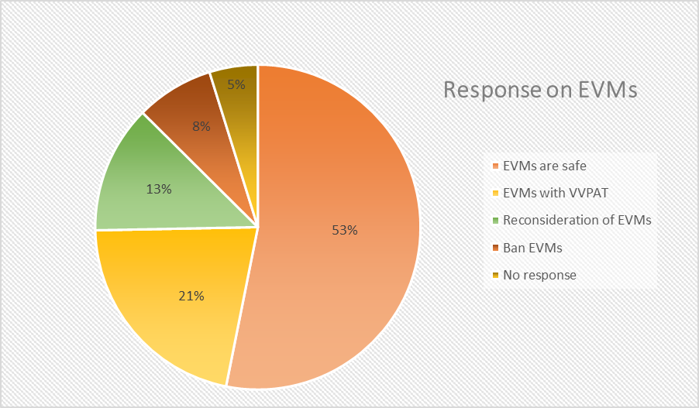

2. Public Perception vs. Official Assurance
Despite official assurances from the ECI about the integrity of EVMs, public perception remains divided. A survey conducted by a leading news agency found that nearly 45% of respondents believed EVMs could be tampered with. This skepticism was most pronounced in rural areas, where the availability of information about the electoral process is limited. The survey also revealed that voters from the low-income group and minority have been more critical of the credibility of the EVM feeling that there is a lack of transparency which created the doubts, thus demanding accountability from electoral authorities.

Socio-Political Implications of EVM Distrust
1. Erosion of Democratic Confidence
The constant suspicion and rumors about the EVMs have serious implications for India's democratic fabric. Once these voters realize that the electoral process is manipulated, their willingness to vote is reduced. This loss of confidence not only reduces voting turnout but also affects the legitimacy of an elected government in places such as Patel Nagar and Baghpat, where socio-economic vulnerabilities are already high, wherein this additional layer of electoral distrust deepens political disengagement.

2. Voter Suppression and Marginalization
The distrust in EVMs can cause voter suppression, especially among marginalized groups. When communities believe the polls do not count or that the electoral process is rigged they are less likely to participate. This was also experienced during our field visits. Where lower-caste as well as female voters hesitated to take part in the exercise. Such suppression lowers political representation from those groups and also perpetuates systemic inequalities.

Recommendations for Addressing EVM Concerns
1. Enhanced Voter Education Programs
To rebuild trust in EVMs, comprehensive voter education programs are essential. These programs should work on demystifying the technology behind EVMs and revealing common misconceptions and giving hands-on demonstrations. There should be special emphasis on when it reaches the poor and women, who bear the brunt of misinformation.

2. Greater Transparency in EVM Auditing
Introducing third-party audits of EVMs will enhance transparency and public confidence. Involving independent agencies in collaboration with civil society organizations to monitor the deployment, functioning, and post-election auditing of EVMs can be initiated. Regular public reports would further fortify public confidence in the voting process.

3. Strengthening Institutional Mechanisms
The ECI needs to strengthen its institutional mechanisms to address voter concerns more. They should proactively establish special helplines for grievances regarding EVMs. Conducting regular stakeholder consultations and public awareness of the safeguards in place to prevent tampering should be conducted.

Conclusion
The findings from Patel Nagar, Baghpat, and Delhi University suggest a critical need for addressing the rising skepticism towards EVMs in India. Guarantying assurance in electoral is not only a technical process but a socio-political imperative. It will mean implementing
targeted reforms and greater transparency that would aid India in gaining greater public confidence in its democratic institutions, so that every vote actually counts and every voice is really heard.
Pictures:
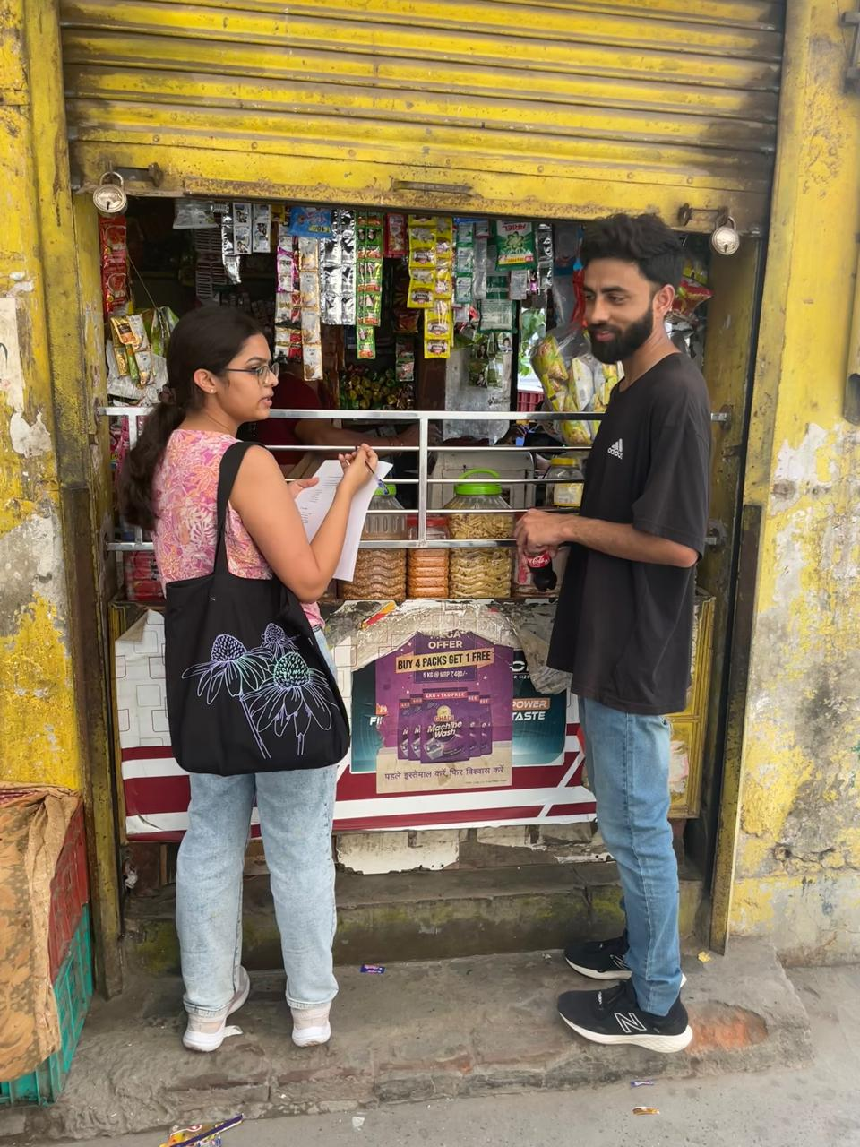
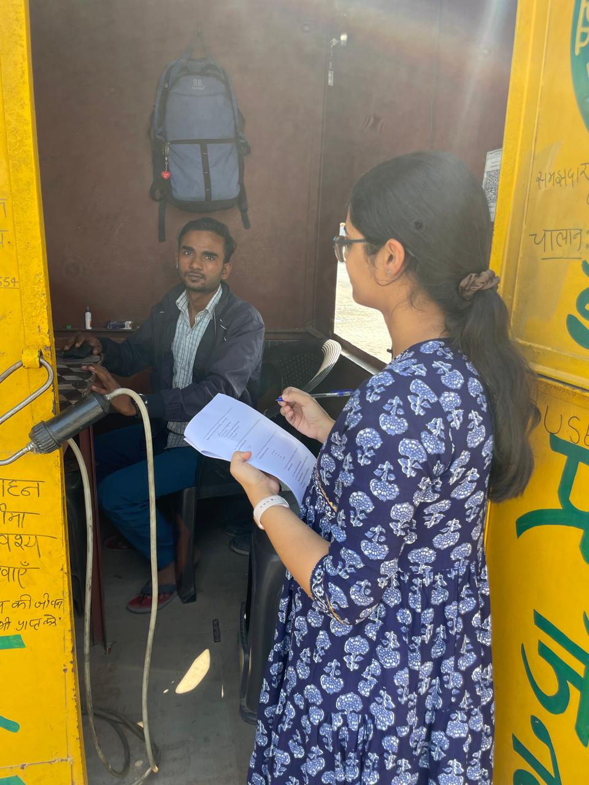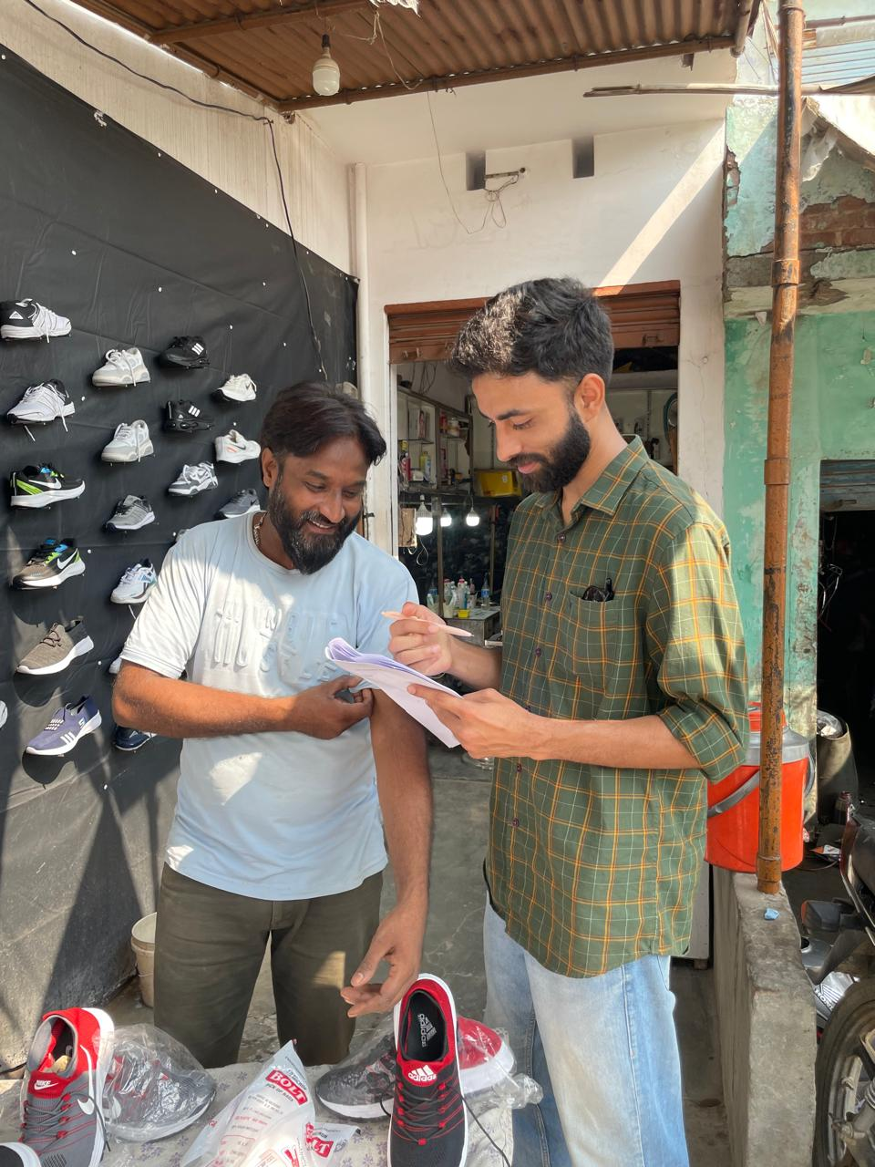

References
- Business Today Desk. (2024, April 18). Supreme Court orders ECI to address EVM malfunctioning in Kerala. Business Today. https://www.businesstoday.in/india/story/supreme-court-orders-eci-to-address-evm-malfunctioning-in-kerala-425960-2024-04-18
- Debnath, S. (2016). Impact of Electronic Voting Machines on Electoral Frauds. Ideas for India.
- In 140+ LS seats, more EVM votes were counted than EVM votes polled. What’s going on? (n.d.). The Wire. https://thewire.in/government/in-140-ls-seats-more-evm-votes-were-counted-than-evm-votes-polled-whats-going-on
- India, S. (2024, July 24). “Vote for Democracy” report on conduct of General Election 2024 raises concerns over ‘Discrepancies.’ NewsClick. https://www.newsclick.in/vote-democracy-report-conduct-general-election-2024-raises-concerns-over-discrepancies
- Kallmer, B. (2024). Why India’s Democracy Is Dying. Journal of Democracy.
- Parth, V. (2024). Electoral Bond Scheme and Free Elections. IACL-IADC Blog.

