**Steps for Data Preparation in Power BI (Using Only Remove Column Method)**

1. **Import Data**: Load the sustainable supply chain dataset (CSV files) into Power BI.
2. **Open Power Query**: Go to **Home** > **Transform Data** to open Query Editor.
3. **Create Duplicate Tables**:
   * Right-click on the main dataset and select **Duplicate** for each required table.
   * Rename each duplicated table (e.g., Inventory Table, Manufacturing Table, etc.).

**Process for Each Duplicate Table (Using Remove Column Method):**

**Inventory Table**:

* **Columns to Keep**: Product Type, SKU, Availability, Number of Products Sold, Customer Demographics, Stock Levels, Lead Times, Order Quantities, Revenue Generated.
* **Steps**:
  + Select irrelevant columns (those not in the list above).
  + Use **Remove Columns** to delete unnecessary data.

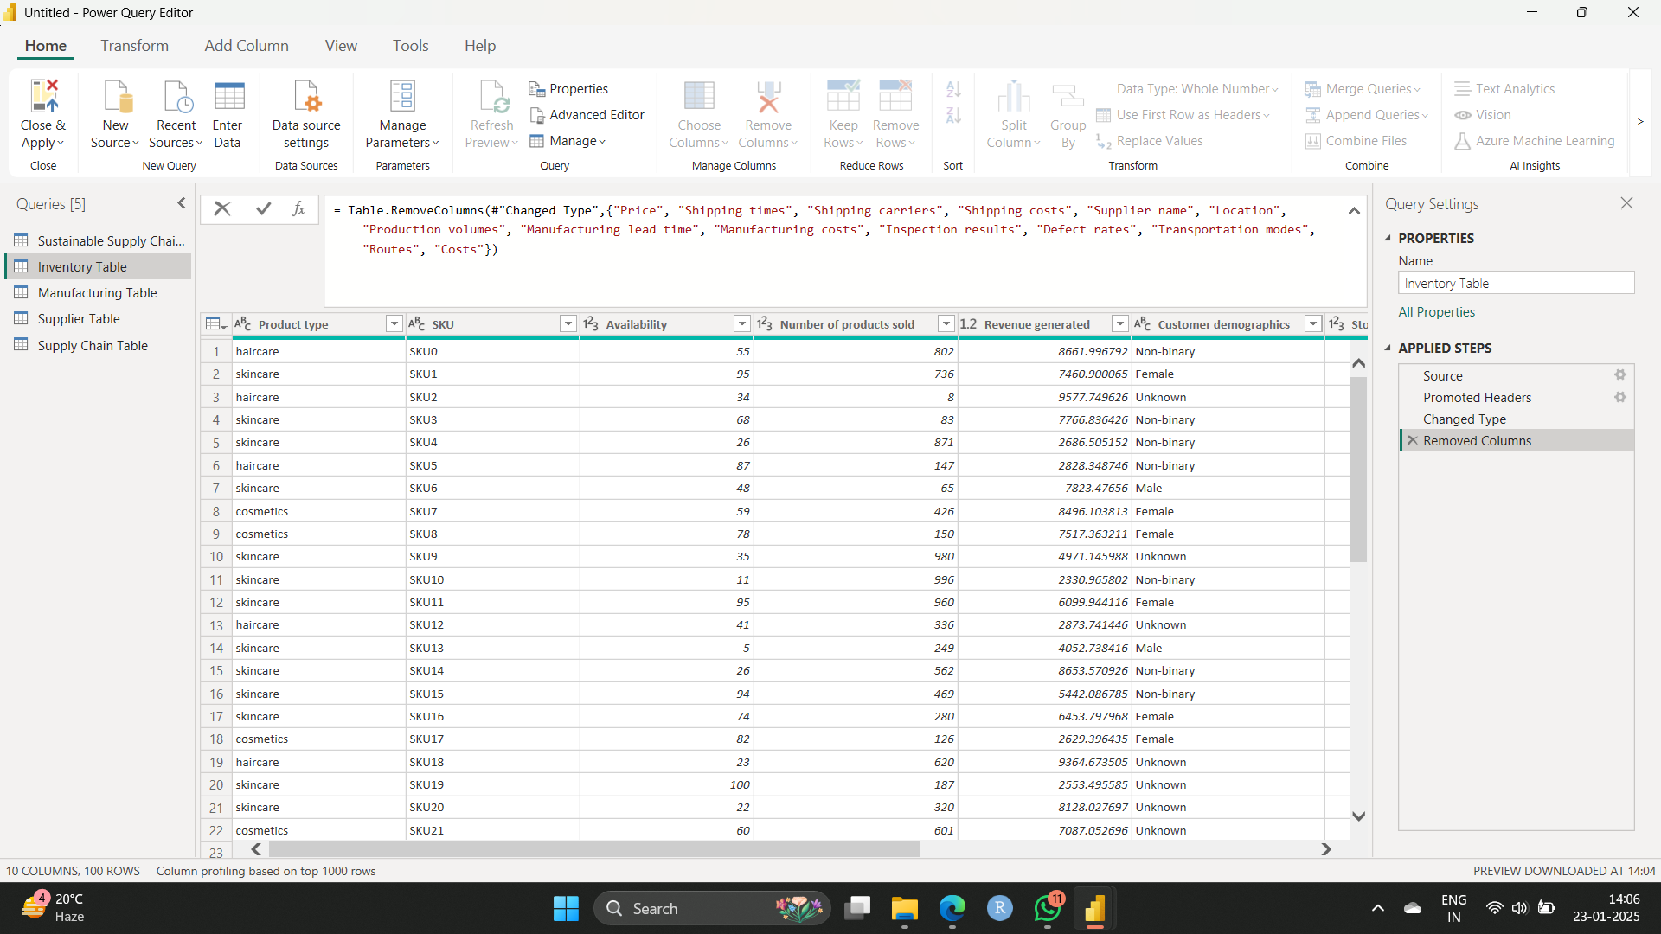

**Manufacturing Table**:

* **Columns to Keep**: Product Type, SKU, Production Volumes, Manufacturing Lead Time, Manufacturing Costs, Inspection Results, Defect Rates.
* **Steps**:
  + Remove all columns except the required ones.

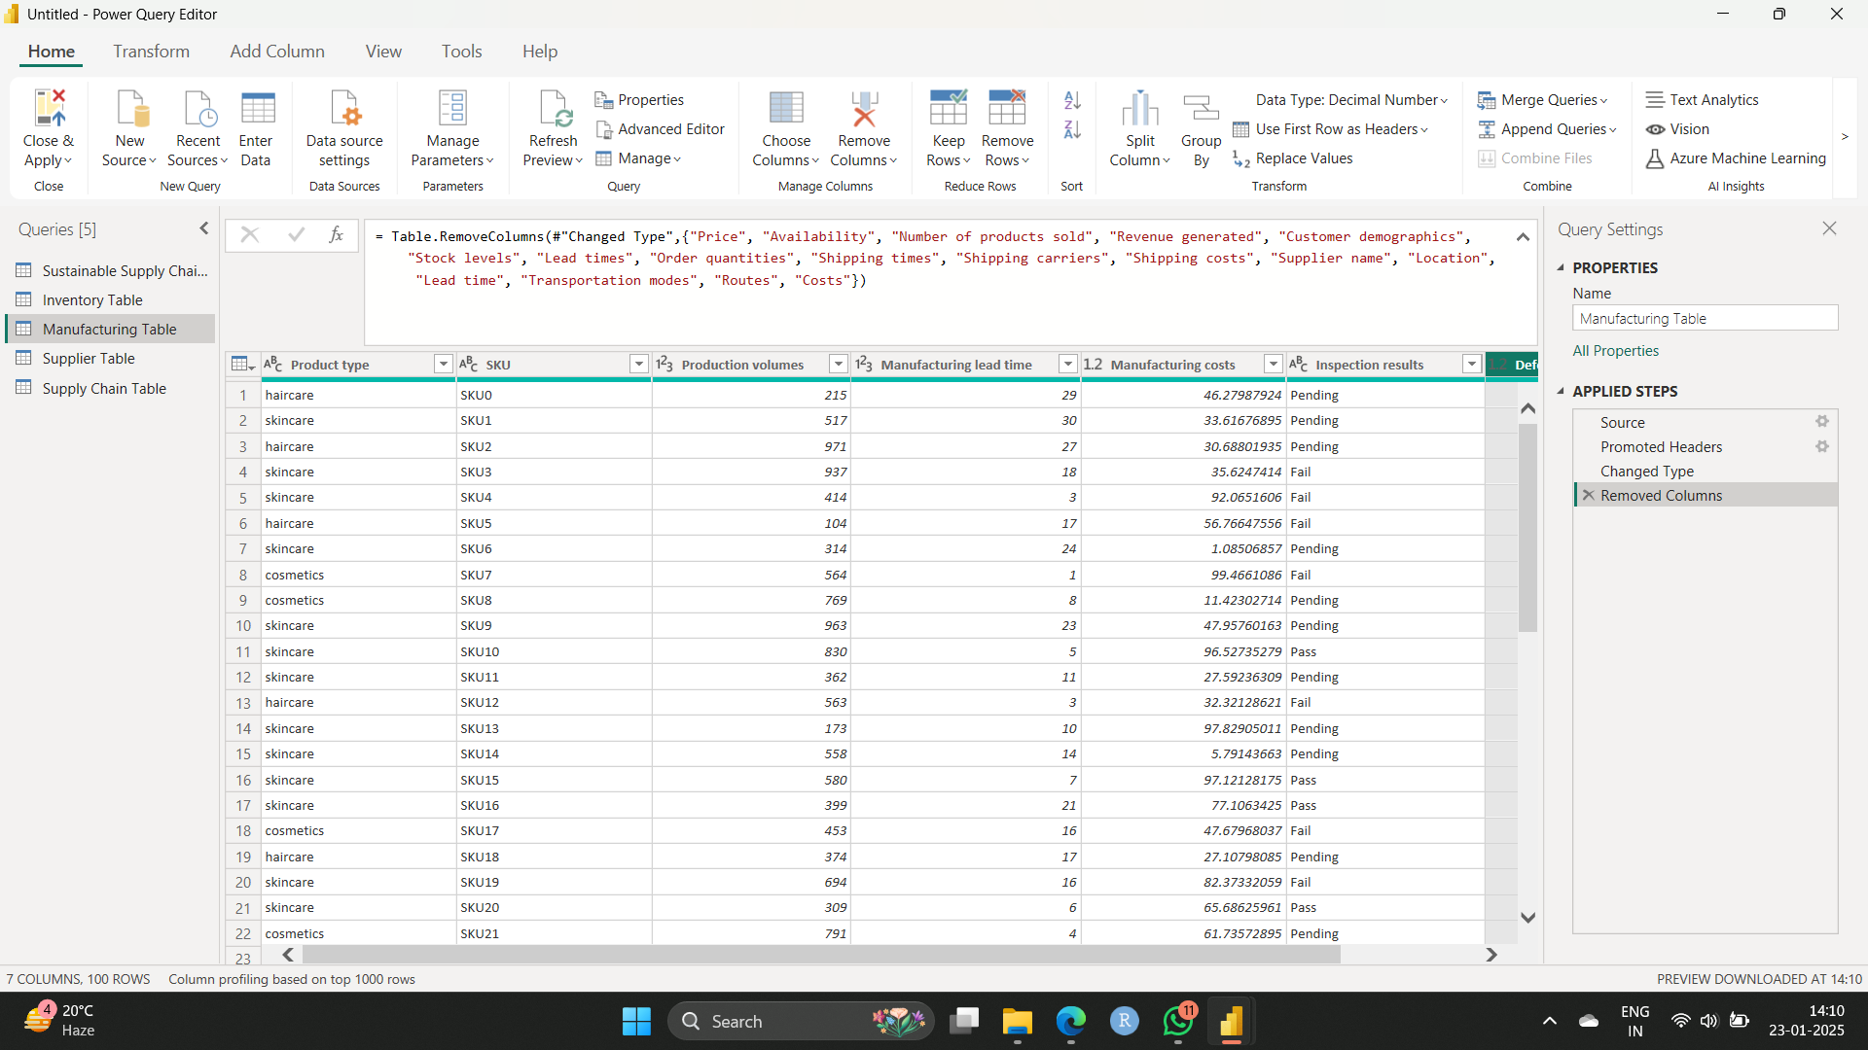

**Supplier Table**:

* **Columns to Keep**: Supplier Name, Location, Lead Time, Transportation Modes, Routes.
* **Steps**:
  + Use **Remove Columns** to delete all unrelated fields

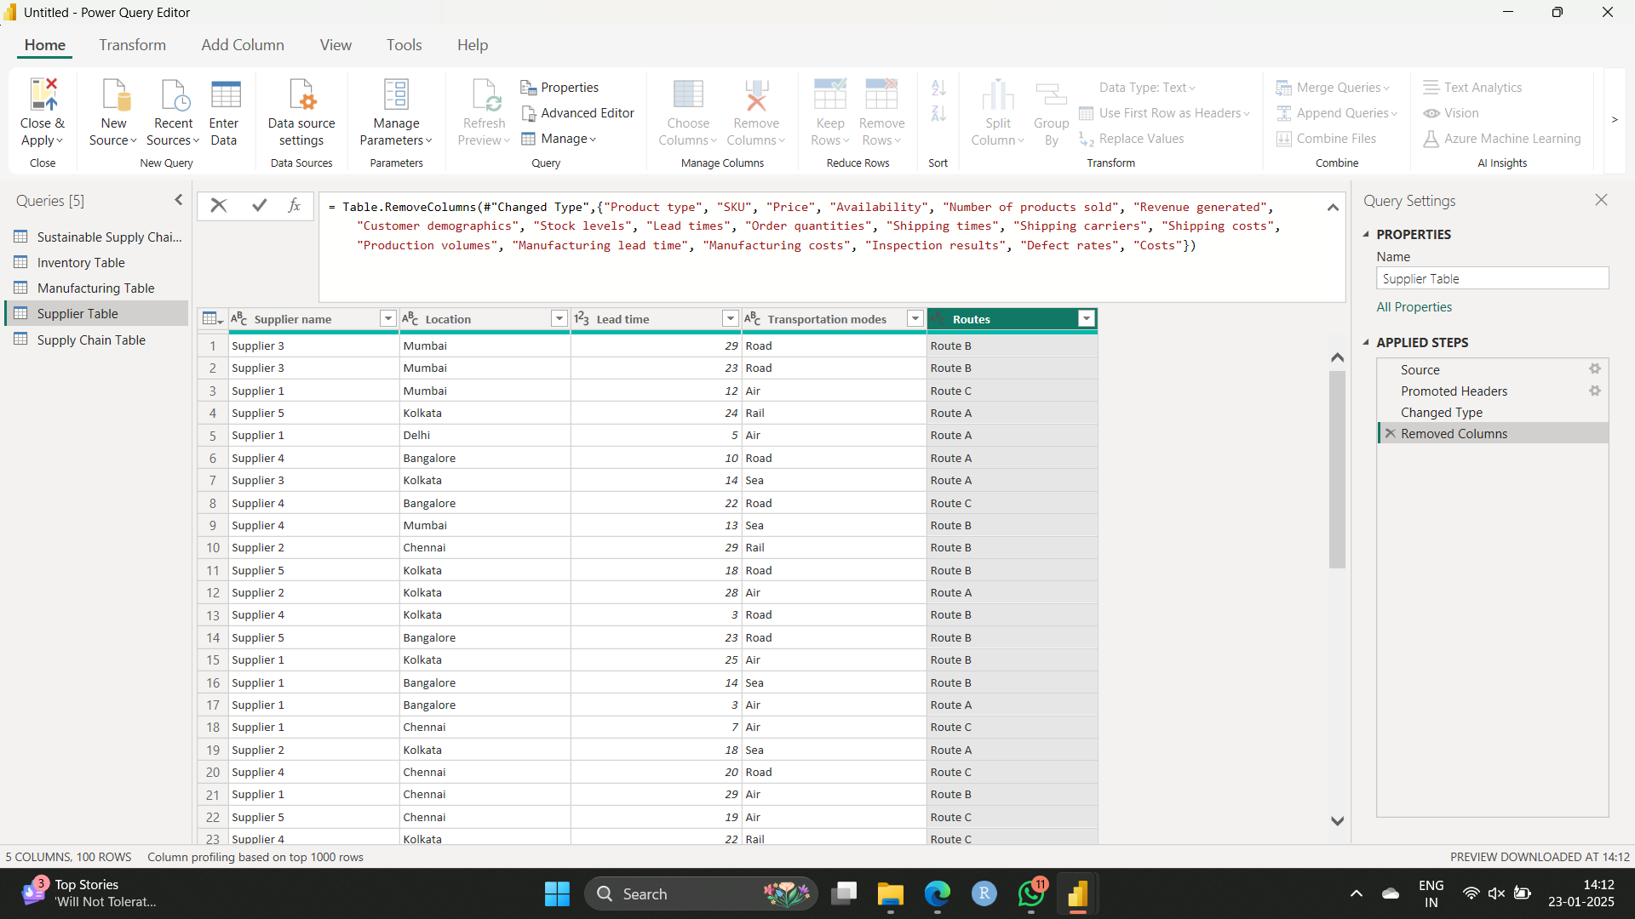

**Supply Chain Table**:

* **Columns to Keep**: Product Type, SKU, Price, Availability, Number of Products Sold, Revenue Generated, Customer Demographics, Stock Levels, Lead Times, Order Quantities, Shipping Times, Shipping Carriers, Shipping Costs, Supplier Name, Location, Transportation Modes, Routes.
* **Steps**:
  + Retain only the specified columns by removing all others.

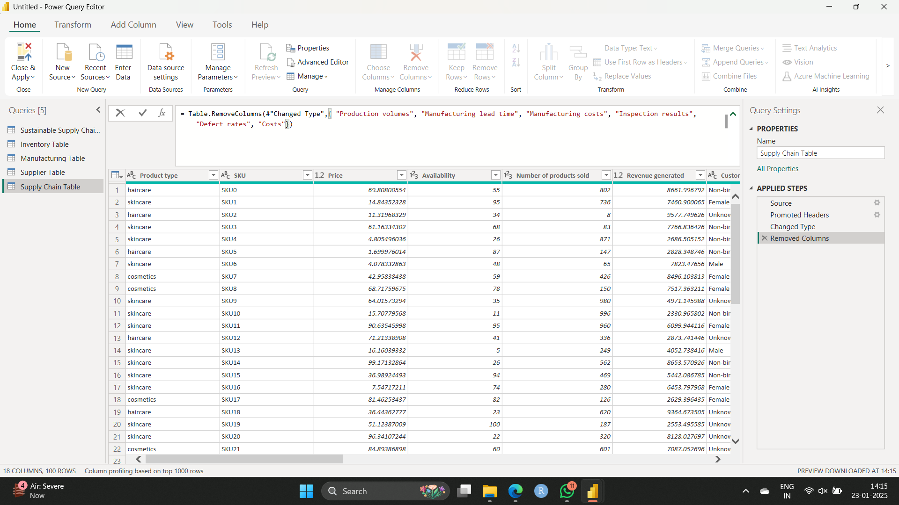

1. **Save Changes**: After cleaning each table, click **Close & Apply** to load the updated tables into Power BI.