TASK 1 REPORT

Student Performance Dataset Analysis

WeIntern Internship Program

Objective:
The objective of this task is to analyze the Student Performance dataset using Python. The goal is to understand the data, check for missing values and duplicate records, create graphs, and find useful insights about student performance.

Dataset Information:

Total Rows: 1000
Total Columns: 8

Columns:
- Gender
- Race/Ethnicity
- Parental Level of Education
- Lunch
- Test Preparation Course
- Math Score
- Reading Score
- Writing Score

Categorical Columns:
- Gender
- Race/Ethnicity
- Parental Level of Education
- Lunch
- Test Preparation Course

Numerical Columns:
- Math Score
- Reading Score
- Writing Score

Data Quality Checks:

Missing Values:
No missing values were found in the dataset.

Duplicate Rows:
No duplicate rows were found in the dataset.
The dataset was clean and ready for analysis.

Key Findings:
- Average Math Score: 66.09
- Average Reading Score: 69.17
- Average Writing Score: 68.05
Reading has the highest average score among all subjects.

Visualization- Graph 1:-Gender Distribution
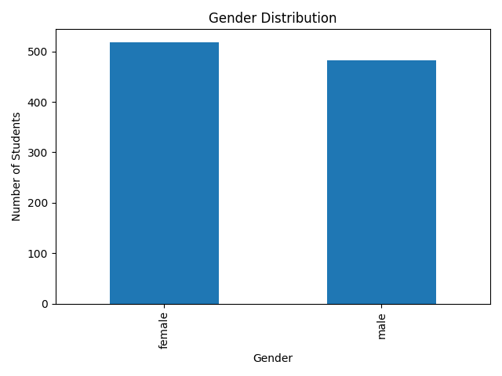

Graph 2:- Test Preparation Course Distribution
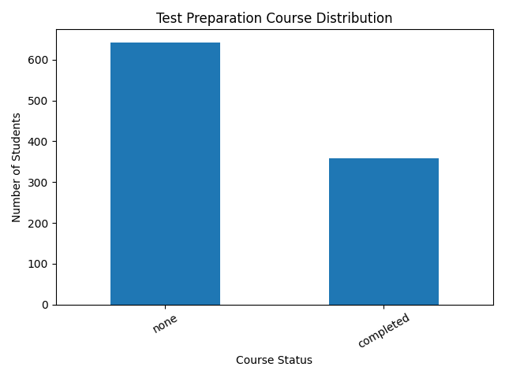

Graph 3:- Average Scores by Test Preparation Course
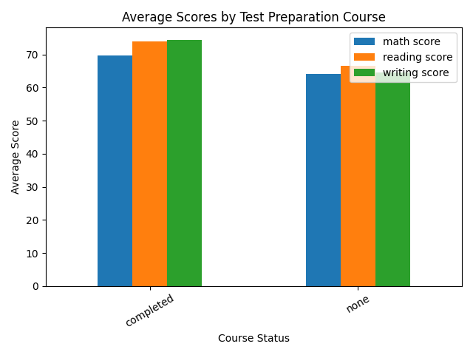

Graph 4:- Average Scores by Lunch Type
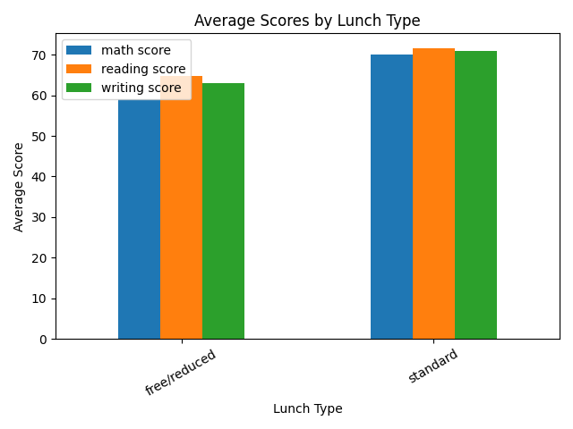

Observations:-

- The dataset contains 1000 students and 8 columns.
- No missing values were found in the dataset.
- No duplicate rows were found in the dataset.
- Female students (518) are slightly more than male students (482).
- Students who completed the test preparation course scored higher on average.
- Students with standard lunch scored better than students with free/reduced lunch.
- Reading score has the highest average among all subjects.

Conclusion:-
The dataset was successfully analyzed using Python. The data was clean and contained no missing values or duplicate records. The analysis showed that test preparation and lunch type have a positive impact on student performance. Students who completed the test preparation course and received standard lunch generally achieved better scores.

