TASK 2 REPORT
Student Performance Data Visualization
WeIntern Internship Program
Objective:-
The objective of this task is to create visualizations from the student performance dataset and identify important patterns, relationships, and trends using graphs.
Dataset Used
Cleaned Student Performance Dataset
Total Rows: 1000
Total Columns: 9
Visualizations Created
- Histogram of Math Scores
- Box Plot of Math Scores by Gender
- Scatter Plot of Math Score vs Reading Score
- Correlation Heatmap
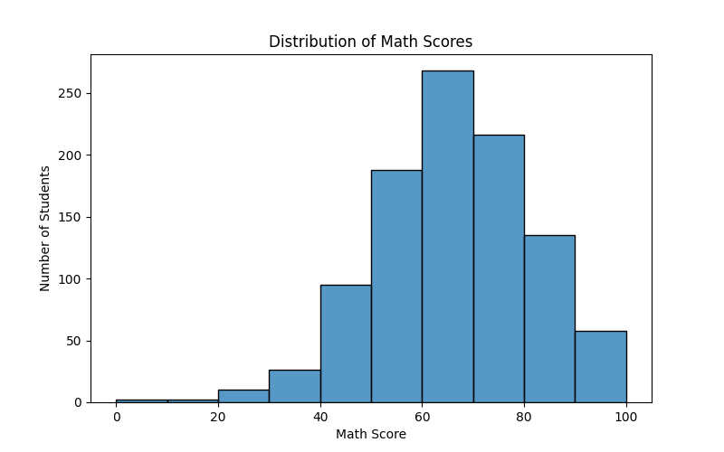
Graph 1: Histogram of Math Scores

Purpose:
To understand the distribution of math scores.
Observation:
Most students scored in the middle score ranges. The distribution appears reasonably balanced, with fewer students at extremely low or extremely high scores.
Interpretation:
Student performance in mathematics is concentrated around average score ranges, indicating a normal distribution pattern.

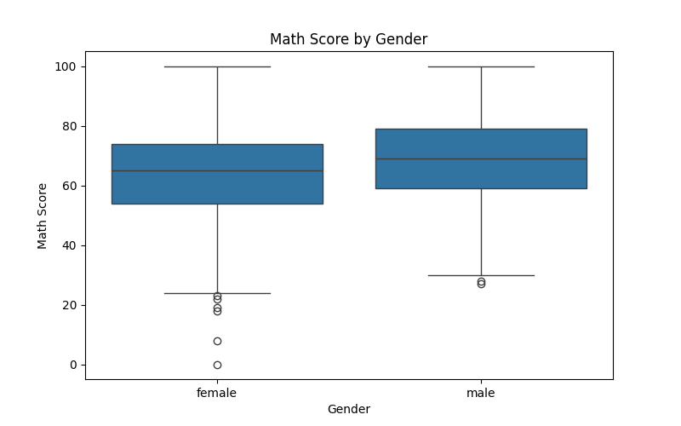
Graph 2: Math Score by Gender (Box Plot)

Purpose:
To compare math score distributions between male and female students.
Observation:
Male and female students show similar score distributions.
Interpretation:
Gender does not appear to have a strong influence on math performance in this dataset.
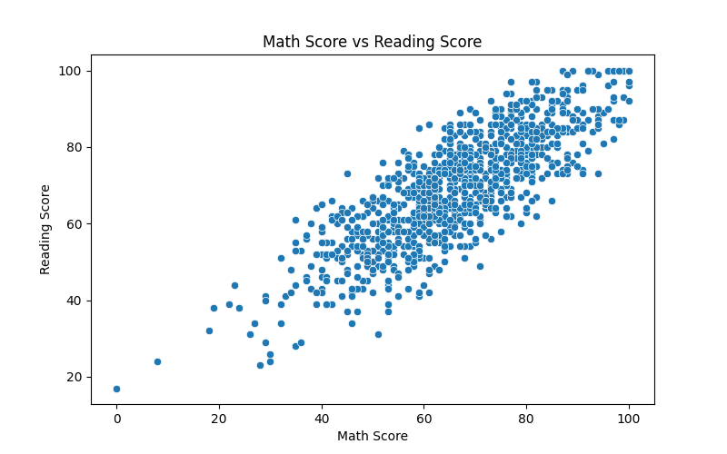
Graph 3: Math Score vs Reading Score (Scatter Plot)

Purpose:
To examine the relationship between math and reading scores.
Observation:
Students with higher math scores generally also have higher reading scores.
Interpretation:
A positive relationship exists between math and reading performance.

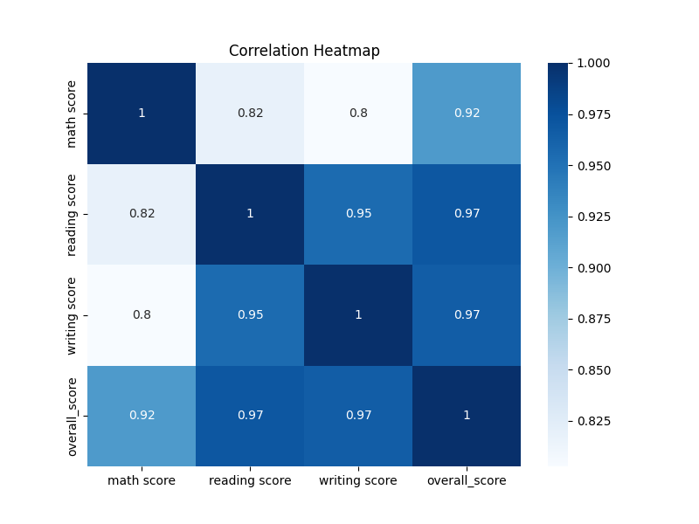
Graph 4: Correlation Heatmap

Purpose:
To analyze correlations among numerical variables.
Observation:
Math, reading, writing, and overall scores are strongly positively correlated.
Interpretation:
Students who perform well in one subject often perform well in other subjects.

Correlation Analysis
Strongest Positive Correlations:
- Reading Score and Writing Score
- Overall Score and Subject Scores
Weak Correlations:
- No major weak relationships among score-related variables.
Negative Correlations:
- No significant negative correlations were observed.
Important Note:
Correlation indicates association between variables but does not prove that one variable causes another.

Summary of Findings:
The analysis showed positive relationships among student scores and revealed useful patterns through visualizations.

Conclusion
The visualizations successfully revealed important patterns within the dataset. Student scores across subjects are positively related, and overall performance tends to remain consistent across different academic areas. The dataset provides useful insights into student achievement and performance trends.

