Game Design Document

Fill up the following document

1. Write the title of your project.

Space Shooter Game.

1. What is the goal of the game?

To shoot the asteriods.

1. Write a brief story of your game.

Suzie wants to be astronaut in future, but she wants to experience

the things she will do in future. So, she decides to create a game in

which she will be creating a spaceship shooting the asteriods coming

towards the earth. In which she will be shooting asteriods to save the

earth.

1. Which are the playing characters of this game?

* Playing characters are the ones who respond to the user based on the input from the user.
* Cars, monkeys, dinos, wizards, etc., are the playing characters in the game.

|  |  |  |
| --- | --- | --- |
| Number | Character Name | What can this character do? |
| 1 | spaceship | It will shoot the asteriods |
| 2 |  |  |
| 3 |  |  |
| 4 |  |  |
| 5 |  |  |
| 6 |  |  |
| 7 |  |  |
| 8 |  |  |

1. Which are the Non-Playing Characters of this game?

* Non-Playing characters are the ones that don't have an action or behavior when the user interacts with the game.
* Hurdles, stones, bananas, coins, etc., are non-playing characters in the game.

|  |  |  |
| --- | --- | --- |
| Number | Character Name | What can this character do? |
| 1 | asteriods | It will be coming towads the earth to destroy it |
| 2 | Bullets of spaceship | It will destroy the asteriod |
| 3 |  |  |
| 4 |  |  |
| 5 |  |  |
| 6 |  |  |
| 7 |  |  |
| 8 |  |  |

Draw your imagination of this game. What does this game look like?

* Draw the game either on your computer or on paper.
* Add images of the game scenes to show each of the playing and non-playing characters at least once.

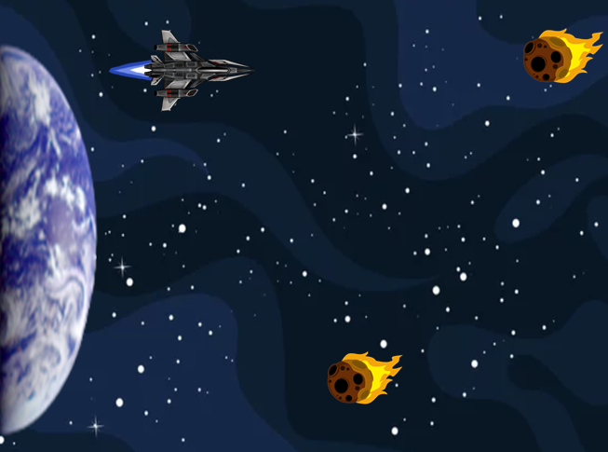

How do you plan to make your game engaging?

By creating asteriods too randomly with fast velocity.