A Project Report On

EVENT MANAGEMENT SYSTEM

Submitted in partial fulfillment of the requirement for the BCA Semester-4 Python Programming Subject Final Examination.
BACHELOR OF COMPUTER APPLICATIONS
(B.C.A.)

Academic Year 2025 – 26

Vanshi Modi- (92400527097)

Internal Guide
Prof. Amit Gohel



Rajkot-Morbi Road, At & PO : Gauridad, Rajkot 360 003. Gujarat. India.

Chapters | Particulars | Page No.
1 | SYNOPSIS
2  2.1  2.2  2.3  2.4 | PREAMBLE  General Introduction  Statement of Problem  Objective and Scope of the Study  Module Description with functionality
3  3.1  3.2  3.3  3.4 | SYSTEM DESIGN AND DEVELOPMENT  Data Flow Diagram (DFD)  Table Structure  Screen Design (Screen shots with short description)  Menu Design
4 | CONCLUSION
5 | LEARNING DURING PROJECT WORK
6  6.1  6.2 | BIBLIOGRAPHY  Online References  Offline References

CONTENTS

*SYNOPSIS:

The Event Management System is a desktop application developed using the Python programming language. The system is built using Tkinter for the graphical interface and Matplotlib for data visualization. The system assists users in managing events efficiently by performing various operations such as adding, updating, deleting, and displaying events.

The system stores information related to events such as the name of the event, the duration of the event (from day to day), the location of the event, the number of attendees, and the budget allocated for the event. The system also facilitates graphical representations using bar charts for the number of attendees and pie charts for the budget allocation.

The project is useful in managing events efficiently and provides a simple interface for managing multiple events.

PREAMBLE

2.1 General Introduction:

Managing events is a critical function in many organizations, colleges, and businesses. Manual management of events may result in loss of information and inefficiencies.

The system is intended to automate the management of events using Python programming. The system will have a simple graphical interface where a user will be able to input the events and display important information using graphs.

2.2 Statement of Problem:

The manual systems of managing events are accompanied by a number of problems, including:
The difficulties of keeping records
The tedious nature of the work
The absence of proper visualization of the information
The errors associated with calculation (budget, no. of attendees)

The problems are addressed by this project by introducing an automated solution.

2.3 Objective and Scope of the Study

Objectives:

Design a GUI-based event management system
Design a system for CRUD (Add, Update, Delete) operations
Design a system for displaying graphs
Design a user-friendly system
Scope:
It is applicable for small organizations, colleges
It helps in managing events easily
It helps in decision-making with graphical information display.

2.4 Module Description with Functionality

Modules:

- Add Event Module
Add new details for an event
Validate input from users
- Update Event Module
Update details for a selected event
- Delete Event Module
Delete a selected event
- Display Module
Display all events in list view
- Graph Module
Bar graph for attendees
Pie chart for budget distribution

*SYSTEM DESIGN AND DEVELOPMENT

3.1 Data Flow Diagram (DFD)

Level 0:

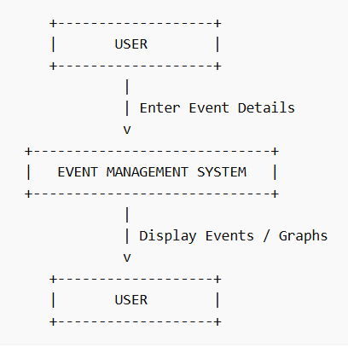

Level 1:

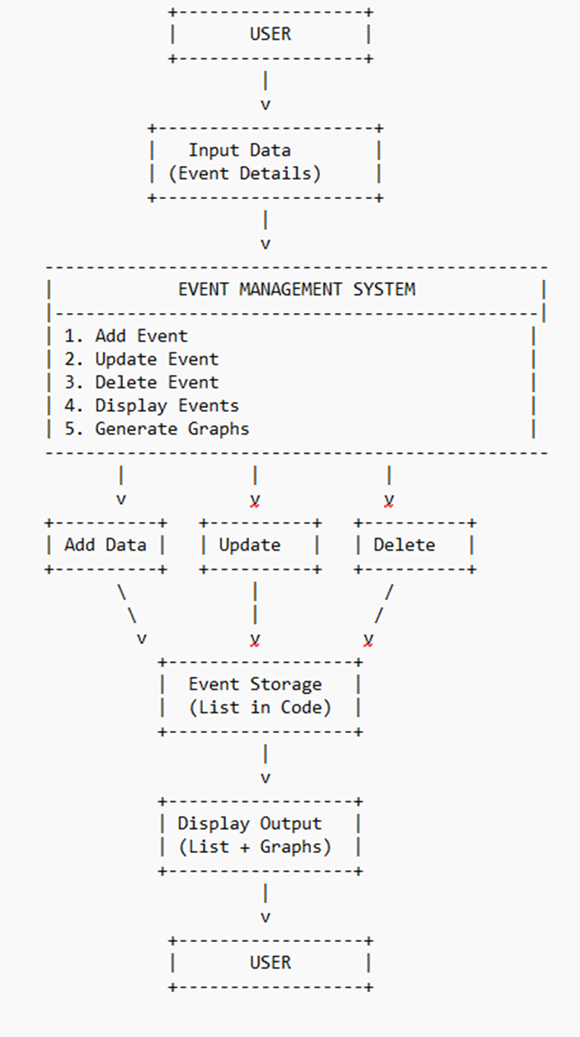

3.2 Table Structure:

Field Name | Data Type | Description
Name | String | Event Name
From Day | String | Start Day
To Day | String | End Day
Location | String | Event Location
Attendees | Integer | Number of people
Budget | Float | Event Budget

3.3 Screen Design (Screen shots with short description)

3.3.1] Add event: Used to insert new event details into the system.

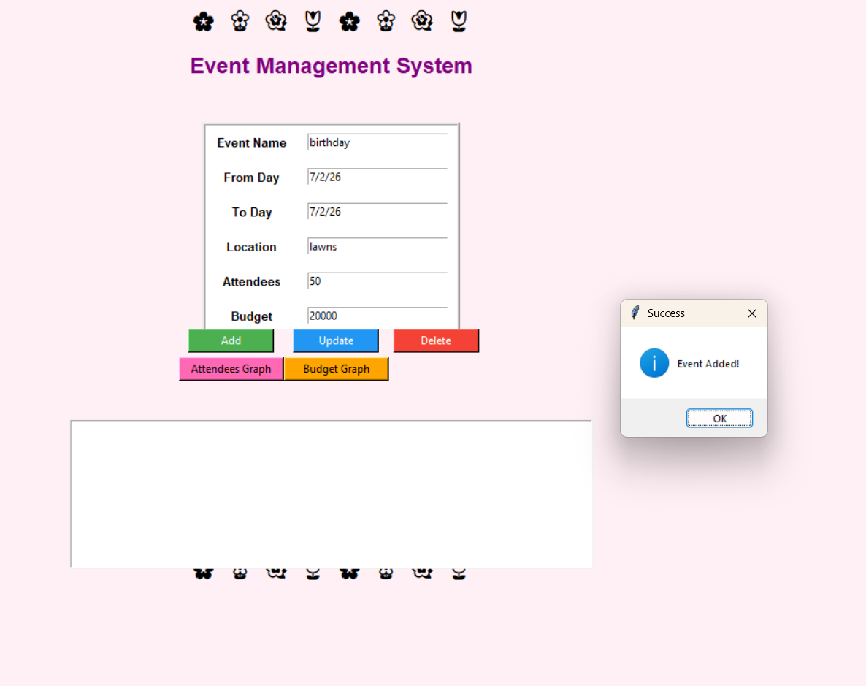

3.3.2] Update event: Used to modify existing event information.

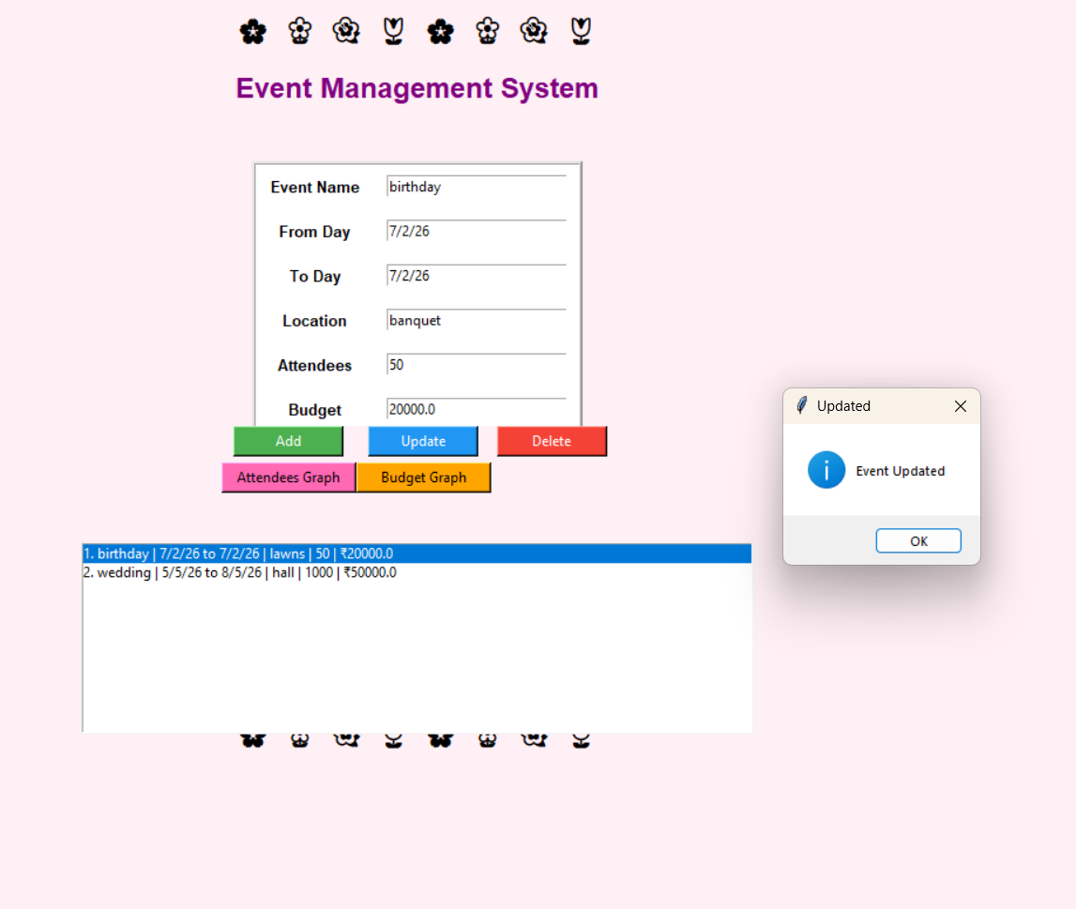

3.3.3] Delete event: Used to remove selected event records from the system.

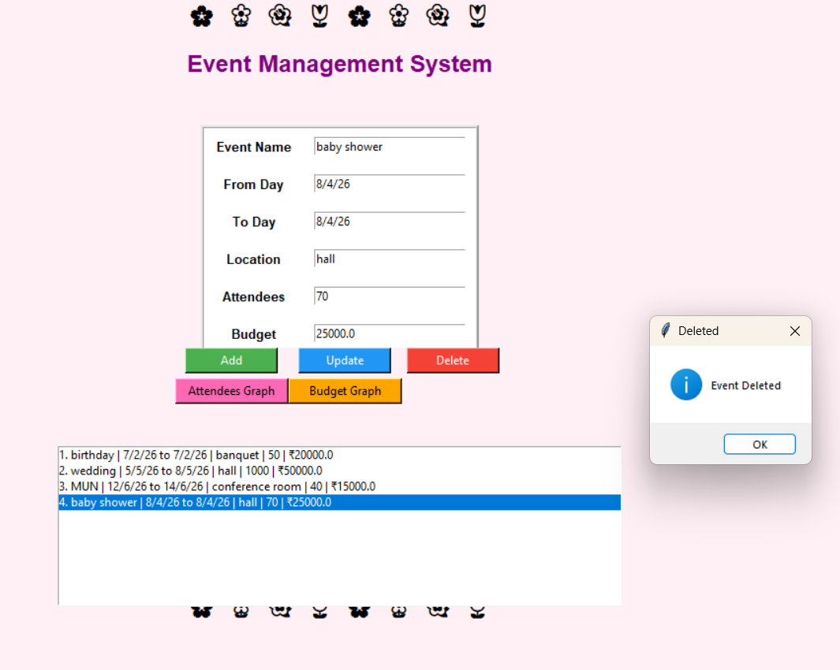

3.3.4] Attendees graph : Displays the number of attendees for each event for easy comparison.

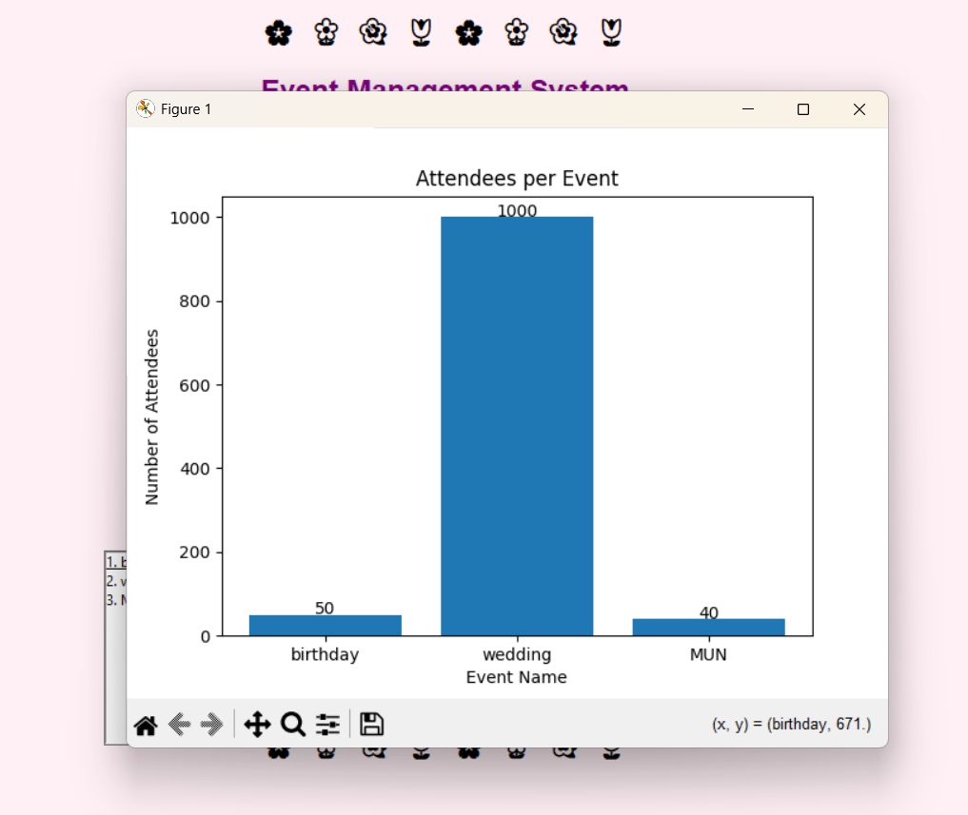

3.3.5] Budget graph: Shows the distribution of budget among different events in percentage form.

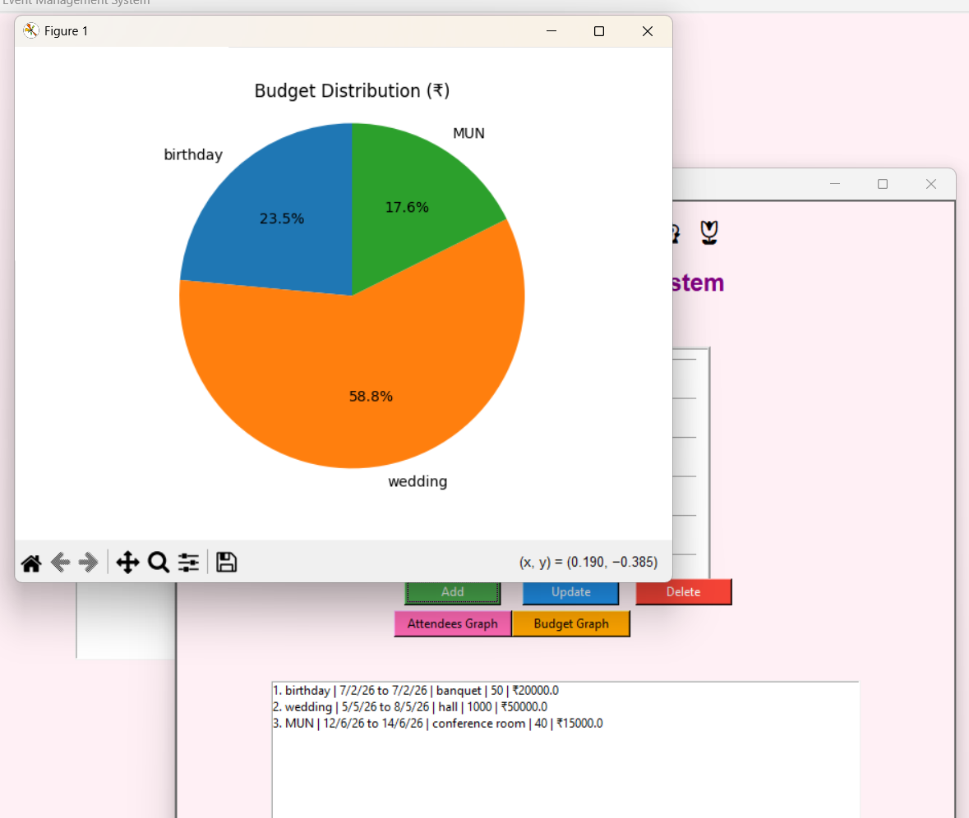

3.4 Menu Design: Main screen which displays after the program runs.

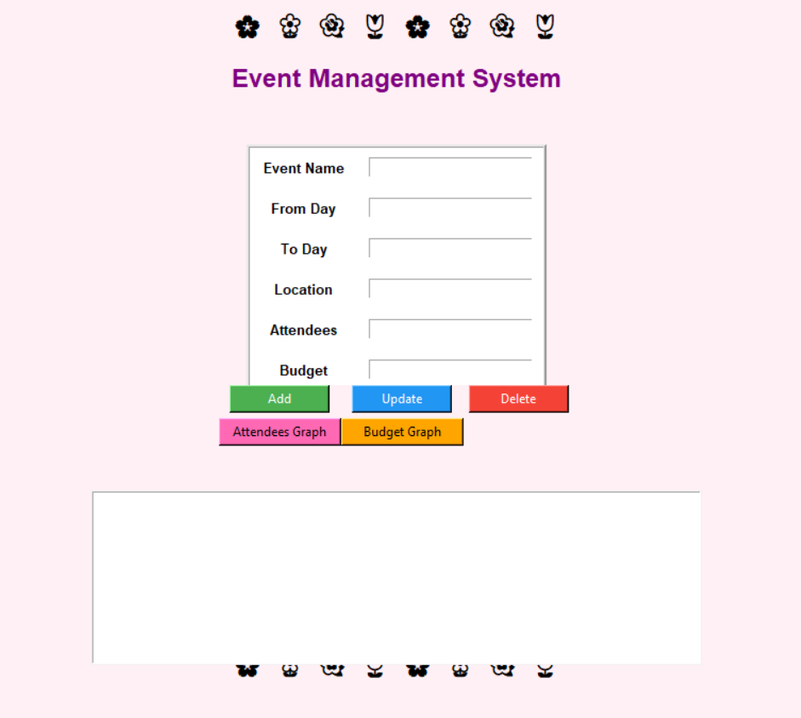

CONCLUSION:

The Event Management System successfully demonstrates the use of Python for developing GUI-based applications. It simplifies event handling and provides better visualization using graphs.
The system is efficient, user-friendly, and reduces manual effort significantly. It can be further enhanced with database integration and advanced features.

LEARNING DURING PROJECT WORK:

During the development of this project, I learned:

- Python GUI development using Tkinter
- Data handling using lists and dictionaries
- Error handling using try-except
- Graph plotting using Matplotlib
- Event-driven programming concepts
- Importance of user interface design

*BIBLIOGRAPHY:

6.1 Online References:

- https://www.python.org
- https://www.w3schools.com/python
- https://matplotlib.org

6.2 Offline References:

- Python Programming Books
- College Notes and Study Material

