Climate Change: It’s High Time We Get Serious About It

*A time series analysis*

*by*

*Aashi Agarwal*

*Divya Jain*

*Mohak Batra*

*Vanshi Thanai*

**ABSTRACT**

Climate change and variability is perhaps one of the major challenge’s world is facing today. There is an equivocal agreement that climate change is not only a threat to the economies of developing world, but also to the developed countries. One of the key drivers of global warming are Carbon Dioxide (CO2) emissions, a greenhouse gas. Using Autoregressive Integrated Moving Average (ARIMA) modelling, the study analyses time series data ranging from the year 2000 to 2017. This study is an attempt to determine the CO2 emission pattern over time and consequently forecast the trend in global CO2 emissions. The key findings of the study indicate that emissions will continue in an upward trend if no mitigation measure is put in place to revert the status quo. Averting the current state of affairs requires policies aimed at reducing the levels of CO2 in the atmosphere, such as strict enforcement of the initiatives taken by the government and increasing awareness among the masses.

**Objective of Study:**

* To predict the pattern of global monthly CO2 emissions since 2000s
* To forecast the level of global monthly CO2 emissions for the next 10 years

**INTRODUCTION**

U.N. reported a warning on the usage of land recently. Increasing emissions of Carbon Dioxide has been a threat to land. Also, climate change can imperil how we use land, negatively affecting the food security and putting us in severe weather conditions. The two major causes of human-induced greenhouse emissions are logging and agricultural practices. Presently, the jungles and other balanced lands have helped stabilize the negative impact of the emissions.

It is high time that humans find nature-based solutions for using the land in the most appropriate way. Else, they will have to be ready to witness the harmful effect of climate change and global warming coming closer.

Climate change has already caused several disruptive incidents across the world. Rising carbon emissions are the major cause of global warming and climate change. It is necessary that the pattern of these emissions is studied so that actions can be taken to reduce them. We have collected monthly data on atmospheric CO­2 levels for a period of 18 years from 2000 to 2017. Through our analysis we wish to understand the change in global CO2 levels and make predictions for the future.

**ECONOMETRIC METHODOLOGY AND MODEL SPECIFICATION**

Monthly data from the year 2000 to 2017 has been collected. This will then be modelled to understand past trends of atmospheric CO2 levels, based on which CO2 emissions for the next 10 years will be forecasted. It is necessary that the pattern of these emissions is studied so that actions can be taken to reduce them.

Figure 1 shows the trend in monthly CO2 emissions since 2000. We can see an upward trend in CO2 emissions overtime and data is not stationary since mean is varying at different points of time.

Figure 1: CO2 levels over the years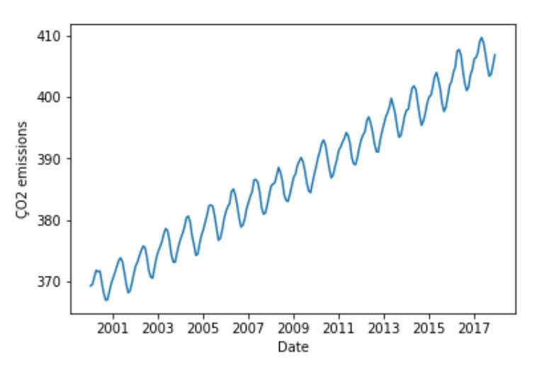

Then we conduct formal tests for checking stationarity. First, we plot the rolling mean as shown in Figure 2. Rolling means (or moving averages) are generally used to smooth out short-term fluctuations in time series data and highlight long-term trends. We see that rolling mean is not constant which indicates that data is not stationary.

Figure 2: Plotting the rolling mean 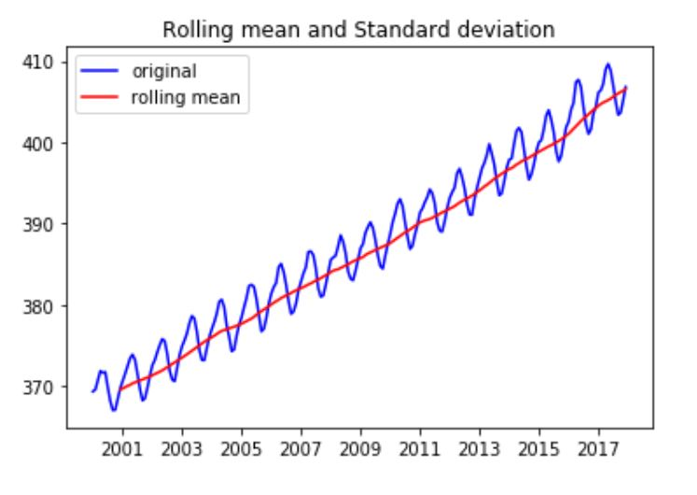

Then we perform the Dickey-Fuller test where

HO: unit root is present

H1: unit root is not present

We see that p-value is very high and thus we fail to reject null hypothesis and hence our model is non-stationary. Thus, we first need to remove non-stationarity to implement ARIMA model.

We have taken the log of CO2 emissions and plotted the rolling mean for the same. Again we see that still our data is not stationary as there still exist an upward trend.

To make the data stationary, two methods were used:

*1. Demeaning/Detrending*

We subtracted the moving average from log transformed values of CO2 emissions and performed Dicky-Fuller test again. Our p-value was very low and thus we rejected the null hypothesis. Now, our data has become stationary.

*2. Differencing*

We did first differencing by subtracting preceding log transformed values of CO2 emissions.

Generic formula is Yt = Yt - Yt-1

We found that first differencing gives us the best results with very low p-value and almost removes all the stationarity in the data.

Hence, we used log differenced data to forecast CO2 emissions using ARIMA model.

In order to calculate value of p and q for ARIMA model, we constructed PACF and ACF graphs respectively as shown in figure 3.

* ‘p’ is the number of autoregressive lags of dependent variable which is ascertained where PACF graph first drops to zero.
* ‘q’ is the order of moving average model which is ascertained where ACF graph first drops to zero.
* ‘d’ is the degree of differencing.

Figure 3: ACF and PACF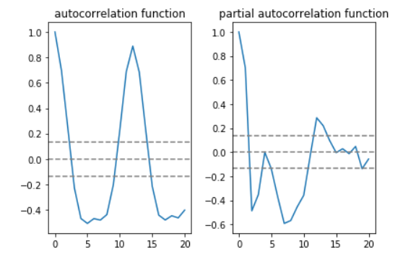

Value of p and q is determined where the graph drops to zero for the first time. This gives p=2, d=1 and q=3.

We then fitted the ARIMA model with the above parameter values and saw that fitted values and actual values both are very close as shown in figure 4. Orange line is the model that we have fitted, and blue line is the prediction. They both follow the same pattern but differ in magnitude.

Figure 4: Actual values and fitted values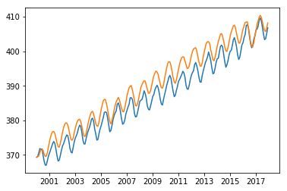

The forecast function was used to predict monthly CO2 emissions for the next 10 years with 95% confidence interval, as shown in figure 5. The results need a serious attention. We see a continuing upward trend in monthly CO2 emissions leading to a level as high as 429 parts per million on average in the year 2027.

Figure 5: Forecast for the next 10 years with 95% confidence interval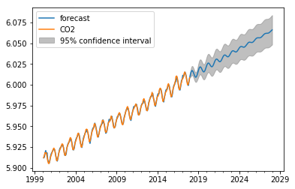

**LIMITATIONS**

The empirical question is not addressed by many and therefore there is a crunch of existing literature on this topic.

**RESULTS AND FORECAST**

The carbon dioxide emission in 2017 was approximately 406 parts per million as can be seen from the given data. According to our predictions, this value will shoot up to more than 429 parts per million by 2027. It is high time that the gravity of the situation is understood, and appropriate steps are taken in the right direction. We are living in an incredibly exciting time of the human history. We need to optimally utilize environmental resources at the global level, along with the with the “atmospheric garbage dump” that we use for our greenhouse gas waste, not just for ourselves but also for the future generations.

**WAY FORWARD**

To solve this problem, CO2 emissions need to be reduced. We can contribute to offset climate change by:

1. Using cleaner fuels and renewable sources of energy such as electricity, solar and wind energy.  
2. Using public transport and carpooling instead of private vehicles  
3. Reuse, Reduce and Recycle