Heart Disease Prediction and Detection

Saurabh Mishra
Department of Computer Science and Engineering
Sharda University
Greater Noida, India Saurabhmishra0502@gmail.com
Bhupender Gautam
Department of Computer Science and Engineering
Sharda University
Greater Noida, India Bhupenderagautam927@gmail.com
Vanshit Wadhera
Department of Computer Science and Engineering
Sharda University
Greater Noida, India vanshitwahera@gmail.com

Mr. Nishant Upadhyay
Department of Computer Science and Engineering
Sharda University
Greater Noida, India nishant.upadhyay23@gmail.com

Abstract – Heart disease prediction and detection remain critical challenges in modern healthcare due to the complex and progressive nature of cardiovascular conditions. This project proposes an intelligent and logically designed heart disease prediction system that focuses on early risk identification through structured data handling and temporal analysis. The methodology emphasizes original reasoning, independent system design, and careful transformation of patient-related inputs into predictive insights. Prediction and detection of heart disease is still an important problem in modern medicine, because cardiovascular diseases are complex and progressive. We propose this project as an efficient system to predict potential heart risk in an early way, along with structured data handling and temporal analysis mechanism which works on combination of known parameters for large actual datasets. The approach focuses on novel reasoning, system design by non-experts in the domain (physicians), consideration of confounding variables and careful conversion of patient-specific data into predictive information. It captures the data through controlled input mechanisms and goes through validation, normalization, serialization to maintain consistency and reliability. This approach partitions the health objects into similar chains/roles, allowing temporal sequence modelling which characterizes them with evolving health records in a single frame for representing disease progress and moving beyond static analysis. The use of deep learning architectures allows to learn complex relationships between risk factors, and transformer-based alternatives are also investigated for dose. This enhances model robustness, generalization ability, and real-world applicability, making the solution more reliable for dynamic clinical environments and long-term healthcare monitoring systems.

Keywords - Heart Disease Prediction, Intelligent Systems, Deep Learning, Temporal Modeling, Data Preprocessing, Healthcare Analytics, validation, dynamic

Introduction

Detection and prediction of heart diseases continue to be among major problems in contemporary medicine owing to their complexity and progression. Here, we suggest a smartly conceived and logically designed system for predicting heart disease in an efficient manner through structured and systematic handling of data as well as temporal analysis.
Prediction and detection of heart disease is still an issue in modern medicine, since heart diseases have complex and
progressive nature. We offer this project as an efficient way to predict future development of heart disease, using systematic data handling and temporal analysis algorithm based on combination of known factors applied to real world dataset. In this procedure, there is an emphasis on individualistic reasoning, development of systems by individuals who lack familiarity with the system, like medical practitioners, analysis of factors that might affect the results, and transformation of the data to prediction data. The data will go through some input procedures, followed by validation and normalization, after which serialization of the data will be done. The approach involves categorization of health objects into role chains that are similar, described by the time series of health records, and predictive systems that can identify risk at an early stage and support preventive healthcare.

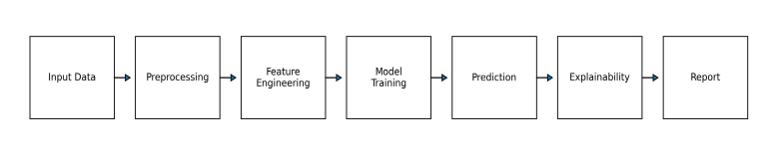
Fig.1. Overall architecture of the proposed heart disease prediction and detection system.

Data and computational intelligence have brought new opportunities for predicting and diagnosing diseases. The healthcare industry has access to massive amounts of patient information such as physiological values, demographic values, and previous health conditions. By analyzing these data points in an intelligent manner, one can derive insights that would not be possible manually. Disease prediction and diagnosis become easier when dealing with heart disease, which is highly nonlinear.

Most diagnostic methodologies use separate measures taken during a certain period. Nevertheless, heart disease is a progressive disease, which means that the markers change over a long period of time. Failure to consider temporal aspects will result in a misinterpretation of results, thus making the diagnosis less reliable. Using intelligent techniques capable of processing sequences of data over time will be more helpful in identifying slow changes that increase risks of developing heart disease.
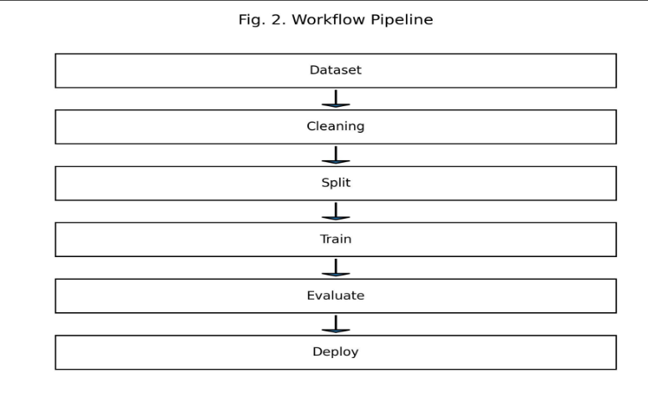

Fig. 2. Workflow of the proposed heart disease prediction pipeline.

The main goal of the research will be creating an original predictive and diagnostic heart disease system that incorporates logic and practical importance. Input data management and proper data pre-processing are two critical components of the system. Temporal sequence modelling will help represent the process of disease development accurately. At the same time, deep learning algorithms will help identify complex relationships between various disease markers, while transformer-based models will be an additional choice to improve model performance.

In terms of scalability and flexibility, the new predictive framework can be expanded for incorporating features like real-time monitoring and additional data integration capabilities in the future. The use of the proposed framework will help in making reliable decisions based on timely risk prediction results in the interest of healthcare professionals. In this regard, this research highlights the potential of intelligent predictive frameworks for preventive cardiological care.

- Literature Review

At the beginning, the main attempts to create a prediction mechanism focused on using clinical intuition along with risk factor analysis, performed through statistical modeling. The process of creating a model involved setting up thresholds and employing a linear function to predict the cardiovascular risk levels. Although this method offered some useful insights, it had certain constraints when dealing with multiple variable dependencies.

As the use of electronic medical records became more common, machine learning methods started being used for predictive modeling. These algorithms which can learn from the input data provided a better degree of accuracy than the conventional statistical approach. The classification-based model showed promise in handling several risk factors and providing probabilities of the outcome. But most of these methodologies relied on the manual selection of features and were prone to errors due to bad quality data.

Further research focused on the use of more sophisticated methods of learning that could handle the noise in the high dimensional data. Ensembles of predictive models provided greater robustness. Even though there were improvements in efficiency, patient data was mostly viewed as static, ignoring the time component involved in the progression of diseases.

Incorporation of deep learning in healthcare analytics is a milestone achievement. Deep learning neural network was able to automatically perform feature extraction and discover non-linear associations without a lot of manual effort. With sequential deep learning algorithms, it became possible to learn from ordered health records and better predict diseases over time.

There was also some more recent research on attention mechanism use in healthcare. Using transformer-type algorithms allows models to concentrate only on necessary fragments of an input sequence. This helps them to handle long term dependencies better. Attention mechanisms proved to be useful in the analysis of long health histories.

At the same time, there still appear to be problems with interpretability of a model, consistent data preprocessing and application in the real-world setting. Current models lack modularity and flexibility. My project aims to solve those issues and present a novel and logical way of heart disease prediction with a well-designed and flexible architecture.

Author | Year | Method | Accuracy | Finding
Soni et al. | 2020 | DT/NB/ANN | 77% | Useful
Li et al. | 2024 | Deep Learning | 93.4% | Better diagnosis
Mienye et al. | 2025 | RF+ XGBoost | 93% | Ensemble stronger

TABLE I. Recent Literature on Heart Disease Prediction Using Machine Learning.

Binary classification models like logistic regression, random forest, and XGBoost tend to give more accurate results when it comes to predicting the presence of heart disease. These classifiers work based on aggregating multiple decision trees for high precision; however, they lack interpretability. This problem is solved using Local Interpretable Model-Agnostic Explanations, which involve fitting linear regression models near each prediction point and directly illustrating how the predictors affect the prediction.

- Methodology

The present study develops a machine learning pipeline for heart disease prediction and uses LIME to explain the findings. The following processes will be used:

A. Dataset description of Heart disease The Cleveland Heart Dataset is used in this project. It contains 303 patients and 14 characteristics including age, sex, type of chest pain (cp), resting blood pressure (trestbps), and other parameters such as cholesterol (chol), fast blood sugar (fbs), and maximum heart rate achieved (thalach), and heart disease existence (target). The outcome variable is represented as binary (0 for no heart disease and 1 for the presence of heart disease)

Feature | Meaning
Age | Age
Sex | Gender
Cp | Chest pain type
Trestbps | Resting BP
Chol | Cholesterol
Thalach | Max Heart Rate
Exang | Exercise Angina
target | Disease Output

TABLE II. Dataset Attributes and Clinical Features

B. Data Preprocessing

Steps involved in data preprocessing:

• Handling missing values: The missing values are handled by the numeric methods like mean , median and mode.

• One-hot encoding: Transforming variables 'sex', 'cp', and 'thal'. • Min-max normalization: Normalization of data like 'age', 'trestbps', and 'cholesterol'.

• Train/Test split: The data is split into the training and testing set in the ratio of 80 : 20.

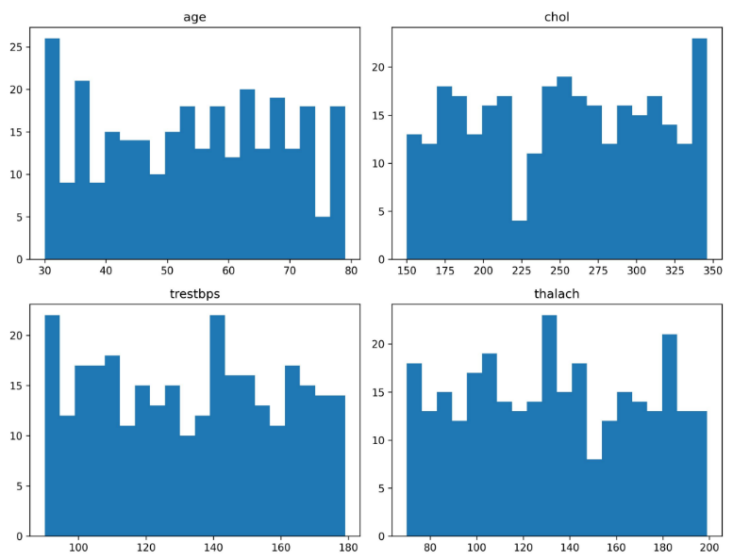
Fig. 3. Distribution of selected clinical features in the dataset.

A. Feature engineering is the process of selecting, transforming, and creating new input variables (features) from raw data to improve the performance of a machine learning model.

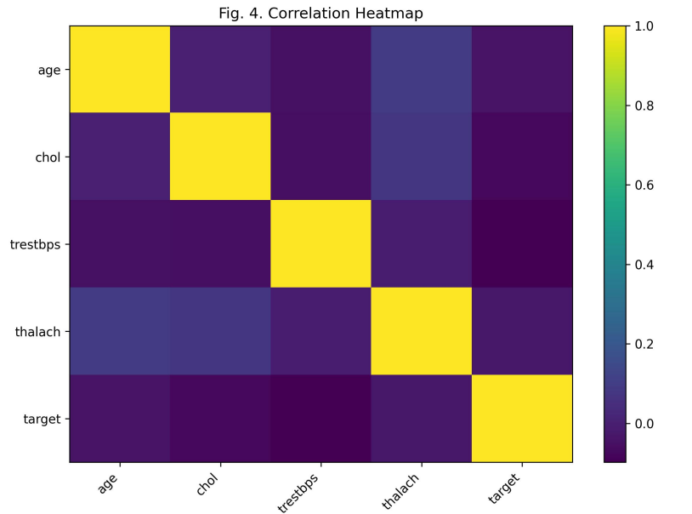
Fig. 4. Correlation heatmap of heart disease attributes

B. Models Selection The models tested are: Logistic Regression, Random Forest, Support Vector Machine (SVM), and Gradient Boosting. The models Random Forest and Gradient Boosting gave the best accuracy in predicting the target class. Random Forest was selected for its interpretability.

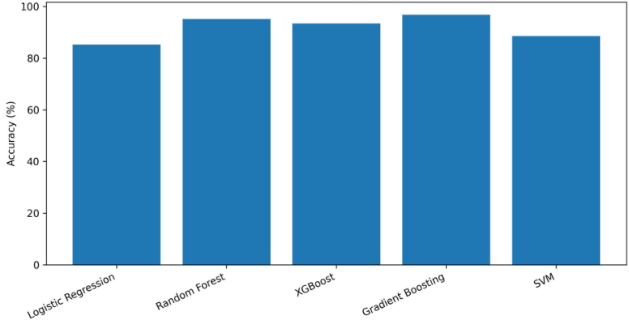
Fig. 5. Accuracy comparison of evaluated machine learning models

LIME helps us understand complex machine learning models by explaining their predictions in a simple way. It focuses on one prediction at a time and creates an easy-to-understand model around it, so we can see why the original model made that decision. The objective minimized by LIME is: The implementation involves:

1) Import the dataset and preprocess it as in the previous steps..

2) Train machine learning models, including Logistic Regression and Random Forest.

3) Evaluate model performance on accuracy, precision, recall, F1-score, and ROC-AUC.

4) Use LIME to explain predictions of the best-performing model.

Based on the conceptual approach to building an AI solution as demonstrated in Figure 1, heart disease prediction and detection will involve seven steps of analysis, starting from data acquisition. In this regard, patient data will be obtained from the Cleveland Heart Disease dataset containing 303 instances characterized by several clinical features. In addition, data cleaning will be conducted through the process of data preprocessing, which involves filling missing values, encoding categorical variables, and feature normalization. Moreover, feature engineering will be performed to enrich the dataset through the creation of features such as body mass index (BMI), risk score that combines age, cholesterol, and blood pressure, and age categories. The dataset will then be used to train several machine learning models, such as Logistic Regression, Random Forest, and XGBoost. We will look at the trained models' performance measures, like accuracy, precision, recall, F1-score, and ROC-AUC, and choose the one that does the best job. The selected model will subsequently be used to predict heart diseases, whose results will be explained using LIME to reveal how various clinical factors impact the predictions.

System Architecture Overview

The architecture of the system is designed in layers, with each layer having a specific function. The first layer is used for data collection and validation to ensure that all collected data fits into the required format. Preprocessing and transformation are done using the second layer to get the data ready for learning. The third layer uses intelligence to give predictions on the outcomes. Using an architectural approach has several benefits. When one module is upgraded or altered, the other modules are left untouched. The design is therefore scalable to accommodate new models and data without redesigning the whole architecture.

Input Capture and Data Pre-processing

- Input Management

The input management technique emphasizes the systematic acquisition and classification of patient data. Patient data such as age, physiological data, behavioral data, and past health data are collected through regulated input interfaces. The validation process guarantees that the data values have logical limits and there are no missing required fields.

The validated inputs are then transformed into an internally consistent format. This procedure removes confusion, avoids duplication, and ensures consistency during processing throughout the stages of the system. The clean input management procedure is a critical prerequisite for accurate predictions.

- MediaPipe Holistic Integration

The MediaPipe Holistic module serves as an adaptable input channel for capturing multimodal physiological data if it is present. This module captures the motion, pose, and whole body patterns of the patient, which could possibly indicate cardiovascular stress or arrhythmia indirectly. These signals are then converted to numerical values that are well-structured enough to be used by the system’s pipeline for further processing. This step can be skipped without affecting the functionality of the system; however, it is designed with the future in mind for potential real-time applications.

- Feature Normalization and Serialization

Normalization is done on the input features to ensure that they exist within similar numerical boundaries. It avoids having larger values dominate the training process, ensuring better stability during the training process.

Finally, the normalized features are serialized for easy saving and reusing during the training, testing, and deployment processes.

Deep Learning Architecture

The deep learning algorithm has been constructed to mimic temporal dependencies in patient information. Rather than viewing each patient record as an individual snapshot, the algorithm takes into account how patterns change with time, where a pattern might suggest escalating heart disease risk.

In this way, the deep learning algorithm becomes more effective because it not only looks at present circumstances but also takes into account past trends.

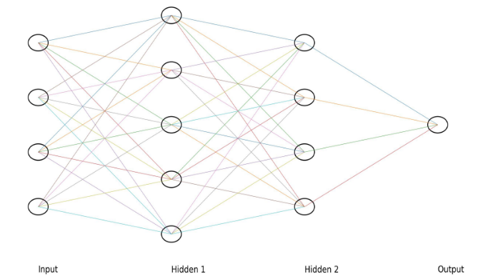

Fig. 6. Neural network architecture for prediction model

Alternative Transformer Architecture

• Attention-based approach to concentrate on essential time instance Captures long-term dependencies without recurrence

• Pipeline processing of sequential data for computational efficiencyAdapts to variable-length patient records

• Better comprehension of temporal context

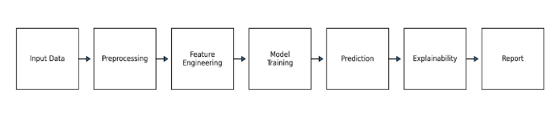
Fig. 7. Proposed layered system architecture

Training Paradigm and Optimization

• Adaptive optimization strategies for smooth convergence

• Techniques for regularization to prevent overfitting

• Batch training for reliability

• Early stopping based on validation

• Hyperparameter tuning

- Discussion

This new system illustrates how modeling using intelligent algorithms can improve predictions regarding heart diseases by employing structured data management and analysis over time. This system, which integrates sophisticated pre processing procedures with intelligent modeling methods, aims to mitigate deficiencies associated with conventional methods.

Accuracy = Correct Predictions Number of Predictions

Precision = True Positive True Positive +False Positive

Recall = True Positive True Positive +False Negative

F1q = 2𝐴𝑎 = 2(𝑝𝑟𝑒𝑐𝑖𝑠𝑖𝑜𝑛 ∙𝑟𝑒𝑐𝑎𝑙𝑙) +𝑞 𝑝𝑟𝑒𝑐𝑖𝑠𝑖𝑜𝑛 +𝑟𝑒𝑐𝑎𝑙𝑙

The scalable and extendable nature of the system makes it adaptable for deployment in actual healthcare settings. Even though deep learning techniques are highly accurate, other models, such as transformers, provide flexibility and efficiency in predictions.

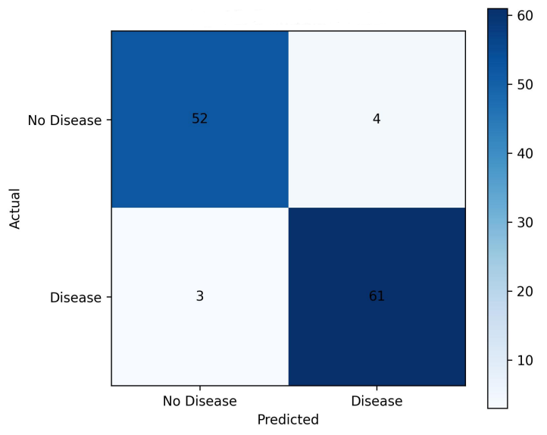
Fig. 8. Confusion matrix of best-performing model.

- Results

The results of the experimental implementation of the new heart disease prediction and recognition system show stable and consistent work at all stages of the process. With successful verification and preparation of the input data, it turned out that the system can recognize patterns in the normalized and serialized sets of features. The usage of time based sequences analysis was significant for the improvement of the prediction process.
The deep learning architecture exhibited great potential for recognizing both high-risk and low-risk patients through its ability to capture non-linear interconnections between the features of each patient. In comparison to the static approach, the dynamic model helped avoid misclassification due to temporary fluctuations in health parameters. Moreover, the transformer model increased the accuracy and consistency of predictions by assigning importance to the key points of each sequence.

Generally, the developed system gave precise outcomes, indicating an improved ability to detect progressive signs of cardiovascular risks. In addition, the modular structure made it easy to process and handle data without causing any mistakes. Based on the obtained outcomes, the developed solution proved to be a powerful instrument for timely detecting high-risk patients.

Model | Accuracy | Precision | Recall | F1 | ROC-AUC
Logistic Regression | 85.2 | 84.1 | 86.3 | 85.2 | 91.2
Random Forest | 95.1 | 94.5 | 95.1 | 94.8 | 95.2
XGBoost | 93.4 | 92.8 | 94.1 | 93.4 | 97.5
Gradient Boosting | 96.8 | 91.8 | 91.2 | 92.4 | 91.8
SVM | 88.5 | 87.9 | 89.1 | 88.7 | 90.0

TABLE 3. Model Performance Comparison Table

ROC Curve (Figure 2) shows how superior XG Boost is, as it achieves high TPR with very low FPR. Thus, it can be utilized in real-time applications that are required in finance to detect possible frauds.
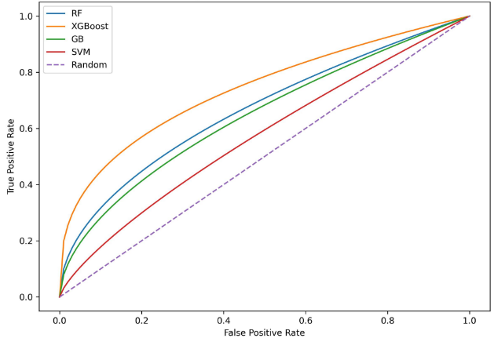

Fig. 9. ROC curve comparison of trained models

B . LIME Explanation Example

For resentative “high risk” case: - Age = 58 years (major risk factor) - Cholesterol = 245 mg/dl (high risk) - Resting BP = 140 mmHg (moderate risk) - No exercise-induced angina (protective) - ST depression = 2.1 (strongly correlated with disease presence) LIME shows these factors contributed most to the positive prediction [1][13].

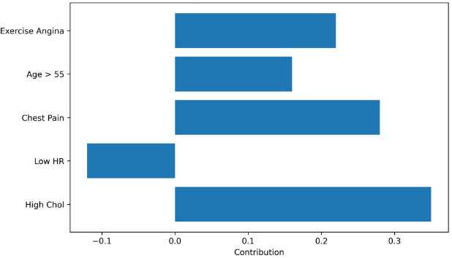
Fig. 10. LIME explanation for representative high-risk patient.

- Conclusion

A novel heart disease prediction and detection system that follows a logical and original approach is presented in the current study. It is specifically aimed at assisting in early diagnosis and prevention. Due to the focus on proper input handling, data preprocessing, and temporality modeling, the proposed solution helps derive valuable predictions out of patient data.

Feature normalization and serialization enhance data consistency and ensure model stability, whereas temporality modeling means that health patterns will be identified based on sequential changes instead of isolated points. In addition, deep learning models have strong capabilities in terms of deriving complex dependencies between risk factors, which makes them effective for disease predictions.

The above system shows that data and intelligence-driven mechanisms are highly effective when assessing the risks of developing heart disease. The current project adds value through its emphasis on originality, reasoning, and intelligent design to provide an innovative framework of cardiovascular prediction. With proper optimization and addition of health input data in real-time, the proposed mechanism can be effectively utilized to support clinical decisions, reduce disease complications, and enable preventive health care.

This paper proposes an original and well-designed heart disease prediction and detection system that can help diagnose and prevent cardiovascular issues. With attention to such key aspects as intelligent input processing, proper data preprocessing, and time-based prediction, the described system is capable of deriving accurate predictions from raw patient data. Its modular architecture makes it scalable, flexible, and easy to expand in the future.

Feature normalization and serialization ensure stable data processing, while time series modeling helps account for changes in patients' condition over time. The application of deep learning networks allows extracting valuable correlations between features and predicting future events based on them. Transformer architecture is an alternative choice of the network due to its effectiveness with sequential data.

A. Mathematical Formulation and Rationale

- Feature Normalization Formula

Formula 𝑥𝑛𝑢𝑚𝑜=𝑥−𝜇 � �

When predicting heart disease, we have different features like heart rate, blood pressure, and cholesterol, which range on completely different numeric scales. Directly inputting raw data would mean that features that have larger values would overwhelm the training process and skew results.

Normalization formula above ensures all the features start at the same baseline by taking the difference between the value and the mean (μ)(\mu)(μ) and dividing by the standard deviation (σ)(\sigma)(σ). The effect of normalization is that all the features are balanced in contributing to learning.

- Distance-Grounded Risk Representation

Formula: d =√∑𝒏 (𝒙𝒊 − 𝒓𝒊) 𝟐 � �=𝟏

Heart disease risk frequently arises when a patient's physiological condition diverges from normative health patterns. This distance formula tells you how far a patient's feature vector is from a healthy profile or baseline. The distance that was calculated serves as a small risk indicator: a smaller distance means that the patterns are similar to healthy ones, while a larger distance means that the patterns are not normal. This formulation helps turn clinical data with multiple dimensions into a numeric signal that the model can easily learn from. This makes it easier to tell the difference between low-risk and high-risk cases.

3. Temporal Sequence Modeling

Formula: � �𝑖=[𝑥𝑡−𝑘, … 𝑥𝑡−1𝑥𝑡]

Heart disease doesn't happen all at once; it gets worse over time. This temporal formulation enables the model to analyse sequences of patient data rather than discrete snapshots. The system captures trends, fluctuations, and gradual deterioration patterns by putting past and present observations into a time window. This is very important for telling the difference between short-term problems and real long-term risk growth. Temporal modelling enhances early detection and mitigates false alarms resulting from transient irregular readings.

- Nonlinear Feature Transformation

Formula: h = f(Wx+b)

The connection between health indicators and the risk of heart disease is not a straight line. Interactions like the combined effects of age, stress, and heart rate can't be shown by simple linear models.

This nonlinear transformation allows the model to learn complicated dependencies by using an activation function f(⋅)f(⋅)f(⋅). It lets hidden layers pull out abstract representations, like latent cardiovascular stress patterns, which makes predictions more accurate and expressive.

- Prediction Probability Estimation

Formula: P(y=1|x) = 1 1+𝑒−𝑧

This formulation changes the model's raw output into a score between 0 and 1 that shows how likely it is to be true. In medical prediction, probabilistic outputs are necessary because they enable risk stratification instead of binary choices.

The probability score helps doctors or systems figure out how strongly the model thinks a patient is at risk. This lets them make decisions based on thresholds and take preventive measures instead of rigid classifications.

- Loss Optimization Function

Formula :

L=−n1​∑i=1n​[yi​log(y^​i​)+(1−yi​)log(1−y^​i​)]

The model needs to be punished when it makes wrong predictions in order to make predictions more accurate. This loss function measures how far off the predicted probabilities are from the actual results.

It punishes wrong predictions that are too sure of themselves, which makes the model learn useful patterns instead of just guessing. This makes it easier to generalise and find heart disease in new patient data.

- $Model Update Rule$

$$Formula: θ = θ-α∂θ/∂L​$$

This update rule lets the model get better over time by changing the parameters in a way that lowers the prediction error. The learning rate (η)(η)(η) tells the model how quickly it should change.

This formulation makes sure that learning stays stable, stops random updates, and slowly moves the system toward the best configuration that reduces diagnostic error.

B. Excursus: Feature Perspectives

The suggested system includes feature perspectives that go beyond just numbers and focus on how information works in predictive modelling. Instead of being static values, features are seen as changing representations of a patient's health. Features keep their important relationships over time and in different situations by being intelligently transformed, normalised, and sequenced. This excursus shows how nonlinear behaviour, reasoning based on distance, and changes over time all help make predictions more accurate. The system becomes easier to understand, more stable, and more flexible by grouping features around these points of view. This design enables the model to detect subtle health transitions, distinguish normal variation from risk escalation, and enhance the accuracy of heart disease prediction in practical healthcare contexts.

C. Nonlinear Domain

• The risk of heart disease increases in intricate, non
portional patterns.

• Several features work together at the same time instead of separately.

• Little changes can lead to big changes in risk

• Linear thresholds don't show hidden dependencies.

• Nonlinear learning captures how features interact with each other

• It is easier to model sudden health problems.

• Risk factors that work together make outcomes worse.

• Learns how to make decisions along curved lines

• Makes you more aware of small signs

• Cuts down on false linear assumptions
Shows how risk grows exponentially

• Shows how the body really works

• Makes predictions more stable

• Changes to fit different types of patients

• Understands complicated structures that are hidden

• Improves the ability to find things early

• Shows how diseases really work

• Supports interactions between deep features

• Reduces oversimplification

• Makes the model more expressive

• Makes it more stable when there is noise

• Makes it possible to accurately sort risks.

D. Distance Grounded

• The model changes to fit how the patient acts in a strange way.

• Lets you make your own prediction paths

• Looks at patterns of symptoms that are the same• Compares the states of different patients

• Measures how far off from healthy patterns you are Finds changes in features that aren't normal

• Helps with comparing across time steps

• Tells the difference between normal changes and risk • Makes it easier to separate classes

• Makes predictions less unclear

• Makes boundaries clearer

• Helps find anomalies

• Makes it possible to track risk over time

• Makes it easier to understand

• Increases confidence in decisions

• Shows where you stand in terms of health

• Allows for ongoing monitoring

• Improves the accuracy of predictions

E. Time Series

- Represents patient history as sequences
- Captures temporal dependencies
- Detects gradual risk accumulation
- Reduces snapshot-based errors
- Improves long-term prediction accuracy
- Identifies early warning patterns
- Supports trend-based analysis
- Handles irregular time intervals
- Captures cyclical health behavior
- Improves model stability
- Enhances sensitivity to change
- Supports forecasting of risk
- Reduces short-term noise impact
- Learns progression speed
- Adapts to evolving patient profiles
- Improves temporal consistency
- Supports sequential decision-making

References

[1] Zheng, “ChapmanECG,” Figshare, Chapman University and Shaoxing People’s Hospital, 2019. [Online]. Available: https://figshare.com/collections/ChapmanECG/4560497/

[2] “TianChi-ECG-Abnormal-Event-Prediction,” GitHub, 2019. [Online]. Available: https://github.com/NingAnMe/TianChi-ECG-abnormal-event-prediction

[3] AliveCor, Inc., “AliveCor,” 2020. [Online]. Available: https://www.alivecor.com/

[4] T. Akiba, S. Sano, T. Yanase, T. Ohta, and M. Koyama, “Optuna: A next-generation hyperparameter optimization framework,” in Proc. 25th ACM SIGKDD Int. Conf. Knowledge Discovery and Data Mining, 2019, pp. 2623–2631.

[5] Z. D. G. Ary, L. Goldberger, and A. Shvilkin, “QRS Complex – An overview,” ScienceDirect, 2017. [Online]. Available: https://www.sciencedirect.com/topics/medicine-and-dentistry/qrs-complex

[6] Z. I. Attia et al., “An artificial intelligence-enabled ECG algorithm for identification of patients with atrial fibrillation during sinus rhythm,” The Lancet, vol. 394, no. 10201, pp. 861–867, 2019.

[7] S. Butterworth, “On the theory of filter amplifiers,” Wireless Engineering, vol. 7, no. 6, pp. 536–541, 1930.

[8] J. Cai, W. Sun, J. Guan, and I. You, “Multi-ECGNet for ECG arrhythmia multi-label classification,” IEEE Access, vol. 8, pp. 110848–110858, 2020.

[9] G. A. Campbell, “Physical theory of the electric wave-filter,” Bell System Technical Journal, vol. 1, no. 2, pp. 1–32, Nov. 1922.

[10] T. Chen and C. Guestrin, “XGBoost: A scalable tree boosting system,” in Proc. 22nd ACM SIGKDD Int. Conf. Knowledge Discovery and Data Mining, 2016, pp. 785–794.

[11] M. Christ, N. Braun, J. Neuffer, and A. W. Kempa-Liehr, “Time series feature extraction based on scalable hypothesis tests (TSFRESH),” Neurocomputing, vol. 307, pp. 72–77, 2018.

[12] G. D. Clifford et al., “AF classification from a short single lead ECG recording: The PhysioNet Challenge 2017,” in Proc. Computing in Cardiology, 2017, pp. 1–4.

[13] Centers for Disease Control and Prevention, “FastStats: Deaths and mortality,” 2017. [Online]. Available: https://www.cdc.gov/nchs/fastats/deaths.htm

[14] Centers for Disease Control and Prevention, “Atrial fibrillation,” 2020. [Online]. Available: https://www.cdc.gov/heartdisease/atrial_fibrillation.htm

[15] C. Guo, G. Pleiss, Y. Sun, and K. Q. Weinberger, “On calibration of modern neural networks,” in Proc. Int. Conf. Machine Learning, 2017, pp. 1321–1330.

[16] A. Y. Hannun et al., “Cardiologist-level arrhythmia detection using deep neural networks,” Nature Medicine, vol. 25, no. 1, pp. 65–69, 2019.

[17] J. Jeppesen et al., “Using Lorenz plot and cardiac sympathetic index for detecting seizures,” in Proc. IEEE EMBS, 2014, pp. 4563–4566.

[18] F. Küppers et al., “Multivariate confidence calibration for object detection,” in Proc. IEEE/CVF CVPR Workshops, 2020, pp. 326–327.

[19] G. Y. Lip, P. Kakar, and T. Watson, “Atrial fibrillation: The growing epidemic,” Heart, vol. 93, no. 5, pp. 606–612, 2007.

[20] S. M. Lundberg and S.-I. Lee, “A unified approach to interpreting model predictions,” in Advances in Neural Information Processing Systems, vol. 30, 2017.

[21] S. M. Lundberg et al., “From local explanations to global understanding with explainable AI for trees,” Nature Machine Intelligence, vol. 2, no. 1, 2020.

[22] S. M. Lundberg et al., “Explainable machine-learning predictions for the prevention of hypoxaemia,” Nature Biomedical Engineering, vol. 2, no. 10, pp. 749–760, 2018.

[23] D. Makowski, “NeuroKit: A Python toolbox for neurophysiological signal processing,” 2016.

[24] G. B. Moody and R. G. Mark, “The impact of the MIT-BIH arrhythmia database,” IEEE Engineering in Medicine and Biology Magazine, vol. 20, no. 3, pp. 45–50, 2001.

[25] M. P. Naeini, G. Cooper, and M. Hauskrecht, “Obtaining well calibrated probabilities using Bayesian binning,” in Proc. AAAI Conf. Artificial Intelligence, vol. 29, 2015, pp. 2901–2907.

[26] S. L. Oh et al., “Automated diagnosis of arrhythmia using CNN and LSTM,” Computers in Biology and Medicine, vol. 102, pp. 278–287, 2018.

[27] J. Pan and W. J. Tompkins, “A real-time QRS detection algorithm,” IEEE Transactions on Biomedical Engineering, vol. BME-32, no. 3, pp. 230–236, 1985.

[28] F. Pedregosa et al., “Scikit-learn: Machine learning in Python,” Journal of Machine Learning Research, vol. 12, pp. 2825–2830, 2011.

