ASSIGNMENT 1

MATH5425 Graph Theory

Q1.

Let P denote a set of two adjacent edges:

We say that the graph G = (V, E) is P-splittable if there is a partition of E into disjoint copies of P. That is,

$$E=\bigcup_{j=1}^{t}{P_{j}}$$

where each Pj is a set of two adjacent edges, and P1,...,Pt are pairwise disjoint. If G is P-splittable as above, then we say that P = {P1,...,Pt} is a P-decomposition of G.

1. Write down a P-decomposition of K4. (Assume that the vertices of K4 are labelled 1,2,3,4.)



K4 is a complete graph with 6 edges.

E= {{1,2}, {1,3}, {1,4}, {2,3}, {2,4}, {3,4}}

A P-decomposition needs to have a set of two adjacent edges. Since there are 6 edges and P has 2 edges, the decomposition will be split into three parts where each Pt contains 2 unique edges

A possible P-decomposition of K4​ is:

P1​={{2,1},{1,3}},

P2​={{1,4},{4,2}},

P3​={{2,3},{3,4}}

1. Let G be a graph with connected components G1,...,Gr. Briefly explain why G is P-splittable if and only if G1,...,Gr are all P-splittable.

Case 1: If G is P-splittable then G1,...,Gr are all P-splittable

Assuming G is P-splittable, and for contradiction Gi is not P-splittable. Since Gi is a graph made of edges from G, a P-decomposition of G must cover all the edges of Gi because the edges of Gi can’t be paired with edges from another component since they are disconnected.

From P we infer that each part of a decomposition must have two adjacent edges, if Gi were not P-splittable that is it had an odd number of edges, it would mean that the graph G would also have an odd number of edges assuming other components had an even number. To be P-splittable, it is required to have an even number of edges which G doesn’t have meaning G is not P-splittable. But this contradicts the fact that G is P-splittable meaning every component Gi of G must have an even number of edges

Hence every G1,...,Gr must be P-splittable.

Case 2: If all G₁,...,Gr are P-splittable, then G is P-splittable

A component is a subgraph of graph G containing a subset of E(G). If all G₁,...,Gr are P-splittable and we were to take a union of every P- decomposition from every component, it would result in P-decomposition of G.

Hence G is P-splittable.

1. Find a graph G with an even number of edges which is not P-splittable. Briefly explain your answer.

Let G = (V, E) where V = {1,2,3,4} and E = {{1,2}, {3,4}}

Number of edges = 2

Each edge in the graph forms its own component and no two edges are adjacent to each other. So from part (b) we can infer that G is not P-splittable neither are its components.

Given a connected graph G = (V, E) and distinct edges e,f ∈ E, define the distance between e and f in G, denoted dG(e,f), to be the minimum length of a path in G from an endvertex of e to an endvertex of f.

1. Suppose G = (V, E) is a connected graph with distinct edges e,f ∈ E such that G−{e,f} is P-splittable. Prove that if dG(e,f) > 0 then there is an edge h ∈ E−{e,f} such that is P-splittable and dG(h,f) < dG(e,f).

Consider the shortest path P between edge *e* and *f*, dG(e,f) = x edges which is greater than zero because they are not adjacent. If the edge adjacent to *e* is labelled *h*, then, dG(h,f) = x-1>0.

In the P-decomposition of G−{e,f}, the edge *h* would be paired with another edge *h0*. Assuming the edge *e* had its vertices named *a* and *b* and the edge *h* shares the vertex *b*.

Case 1: h0 shares the vertex *b* along with *h*

Assuming all the edges *e*, *h*, and *h0* are adjacent to each other since they share the vertex *b*. Now consider the P-decomposition of G−{h,f}, *h* has been removed and then the edge *e* will pair up with *h0*. This means that G−{h,f} is P-splittable, and dG(h,f)=dG(e,f)−1.

e

h

*A*

*b*

f

h0

Case 2: *h0* is part of the path adjacent to *h*

In this case *h0* is not sharing the vertex *b* and is not adjacent to edge *e*. Now, if we remove the edge *h*, we have to pair up edge *e* with *h0* This means that G−{h,f} is P-splittable, and dG(h,f)=dG(e,f)−1.

e

h

*A*

*b*

f

h0

By selecting the edge *h* adjacent to *e* along the shortest path to *f*, we’ve proved G−{e,f}is P-splittable and dG(h,f) < dG(e,f).

1. Hence, or otherwise, prove that if G is a connected graph with an even number of edges, then G is P-splittable.

Consider a connected graph G that has 2 edges as a base case for a proof by induction. Since consists of two adjacent edges, it is P-splittable.

Now, assume every connected graph that has 2k edges is P-splittable. Take a connected graph G with edges 2k +2 edges which has at least 2 edges if k=0. If two edges were to be removed,

Case 1: Graph G will split into different connected components

Since every component will have an even number of edges if there an even number of components.

Thus, each component of G with edges (2k+2) -2 is P-splittable.

Case 2: Graph G doesn’t split into components

The total number of edges will edges reduce to 2k after removing two edges which we have already proved to be P-splittable.

By induction, every connected graph with an even number of edges is P-splittable.

Q2.

1. Let G be a graph with 2r vertices and minimum degree δ(G) ≥ r, where r ≥1. Prove that G has a perfect matching.

Case 1: r ≥1

Since G already has two connected vertices with minimum degree δ(G) = 1. The single edge is the only possible matching thus being a perfect matching.

Case 2: r ≥2

If r ≥2, means that graph G has 4 or more vertices. Using Dirac’s Theorem with states that every graph with n ≥ 3 vertices and with minimum degree at least n/2 has a Hamilton cycle, in this case, n= 2r and n/2 = r, we can say that G has a Hamilton cycle.

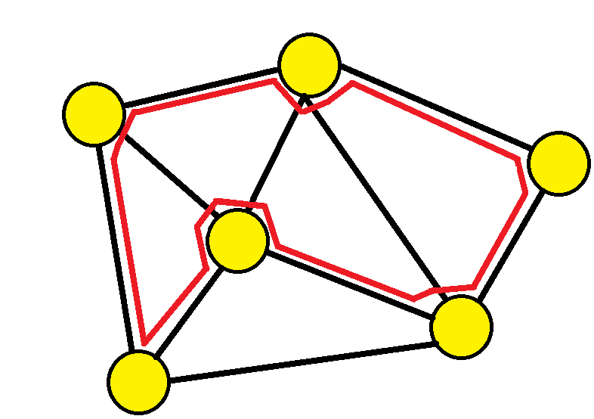By definition, a Hamilton cycle is a cycle which includes every vertex. The Hamilton cycle will have 2r vertices connected 2r edges but my selecting every other edge, it adds to r edges forming a maximum perfect matching.



1. Let G be a graph with minimum degree δ(G) ≥ 1 and maximum degree ∆ = ∆(G). Let F be a maximum matching in G. Say that a vertex is covered by F if it is the end vertex of an edge in F.
2. Let x be a vertex not covered by F. Show that every neighbour of x is covered by F.

Assuming *x* is a vertex not covered by F and has a neighbour *y* of *x* which is also not covered by F. Since both *x* and *y* are adjacent vertices not covered by F, the edge *xy*∈*E*(*G*) is not part of the set F.

Creating a new matching F’=F∪{*xy*}. *x* and *y* are not the end vertex of any other edge present in F making F’ a valid matching. However, this contradicts the assumption that F is a maximum matching means there is no larger matching existing in G. Thus, our initial assumption must be false. Therefore, every neighbour must be covered by F.

1. Let x, y be two distinct vertices not covered by F. Show that if xa,yb ∈ E then ab ̸∈ F.

Assuming for contradiction, the edge ab∈F where F is the maximum matching of G and a, b are matched to each other.

Since xa,yb ∈ E, we can create a new matching: F’ =(F-{ab})∪{xa, yb} by replacing ab with xa and yb. However, this contradicts the assumption that F is the maximum matching of G since F’ has one more edge than F. This must mean that our original assumption of ab∈F was false and ab∉F if xa,yb ∈ E.

1. Hence show that the number of vertices not covered by F is at most (∆−1) |F|.

From part (i), we can infer an uncovered vertex has δ(G)≥1 where all of its neighbours are covered by the maximum matching F. The maximum degree of any vertex in G is Δ, this includes any covered vertex belonging to F. If a covered vertex *a* has a maximum number of neighbours Δ, then it can have at most Δ-1 uncovered neighbours vertices because one of the vertices *b* will be matched to vertex *a*. This means that there can be at most Δ-1 uncovered vertices for any covered vertex.

If we consider one edge consisting of two covered vertices from F, together they both have Δ-1 uncovered neighbour vertices, why? Some uncovered vertices may be a neighbour of both *a* and *b*. Since every vertex pair of F has at most Δ-1 uncovered neighbour vertices, the total number of vertices not covered by F is at most (∆−1) x |F|

1. Prove that |F| ≥ n/(∆+1), where n = |G|.

Assuming,

U = as set of vertices not covered by F

Each edge in the matching F covers two vertices, so the number of covered vertices in F is 2∣F∣.

So, we can say that 2|F| + |U| = n,

From part (iii), |U| ≤ (∆−1) |F|

Replacing it in total vertex count, 2|F| + (∆−1) |F| ≥ n,

|F| (2 + (∆−1)) = |F| (1 + ∆) ≥ n

Hence,

|F| ≥ n/ (1 + ∆).