2023UCM2385
DBMS
EXERCISE6

Q1. A)
All functional dependencies
3NF
Tables in xampp

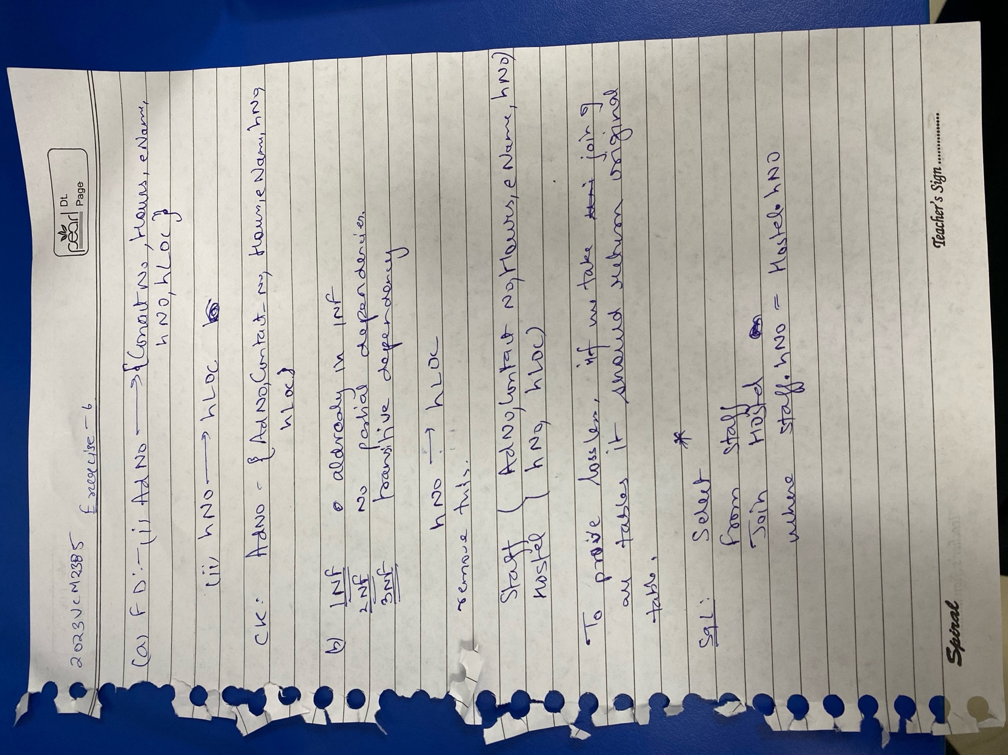
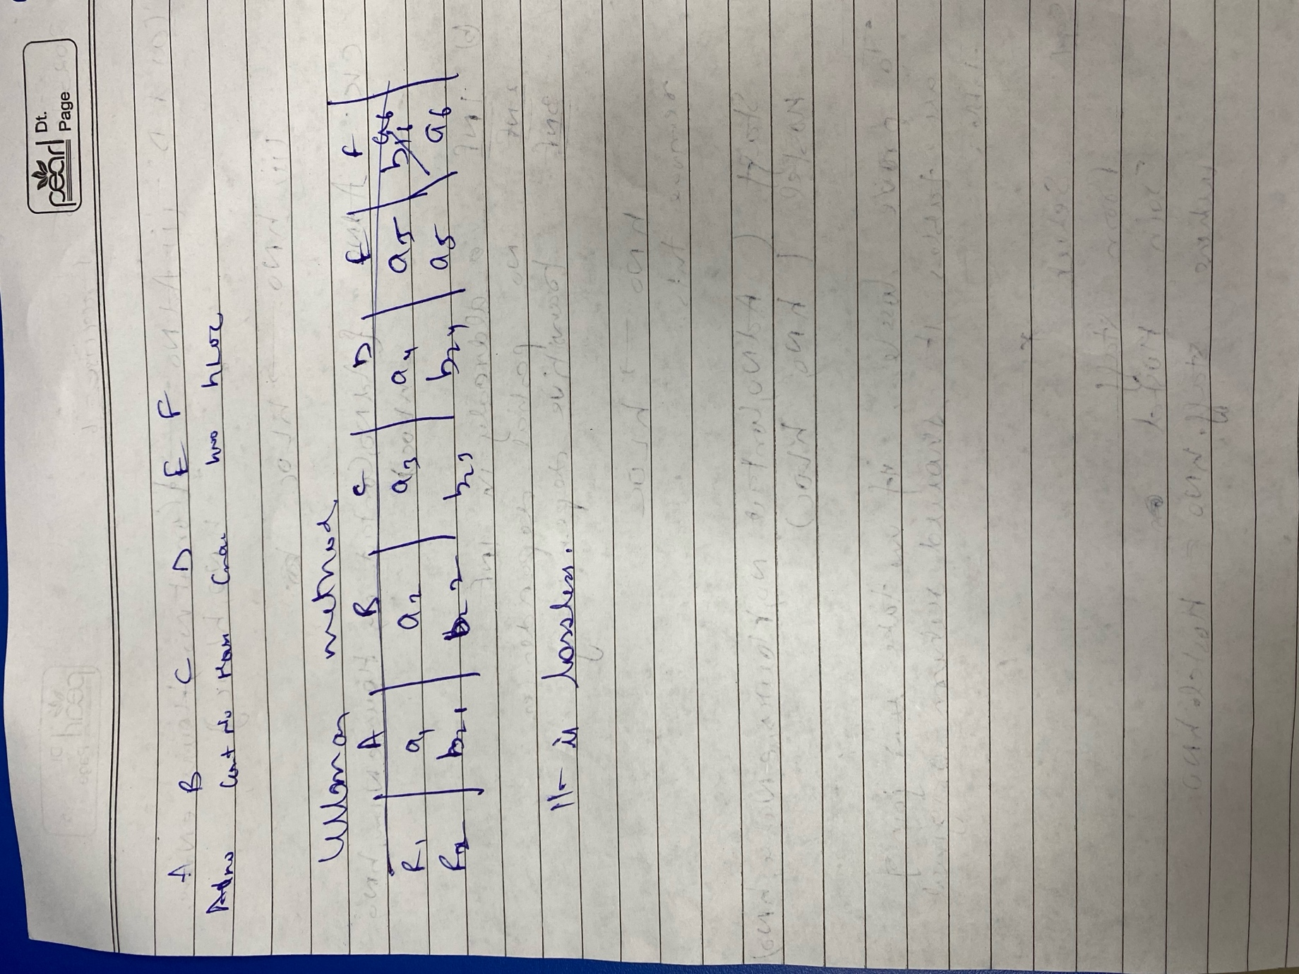

Table 1 hostelInfo
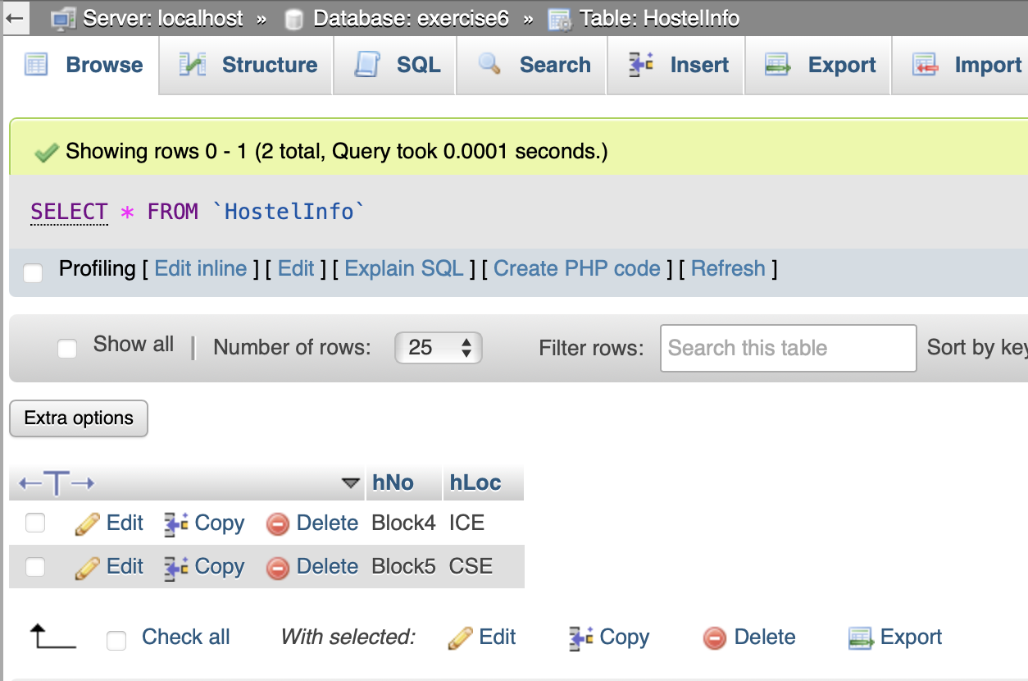
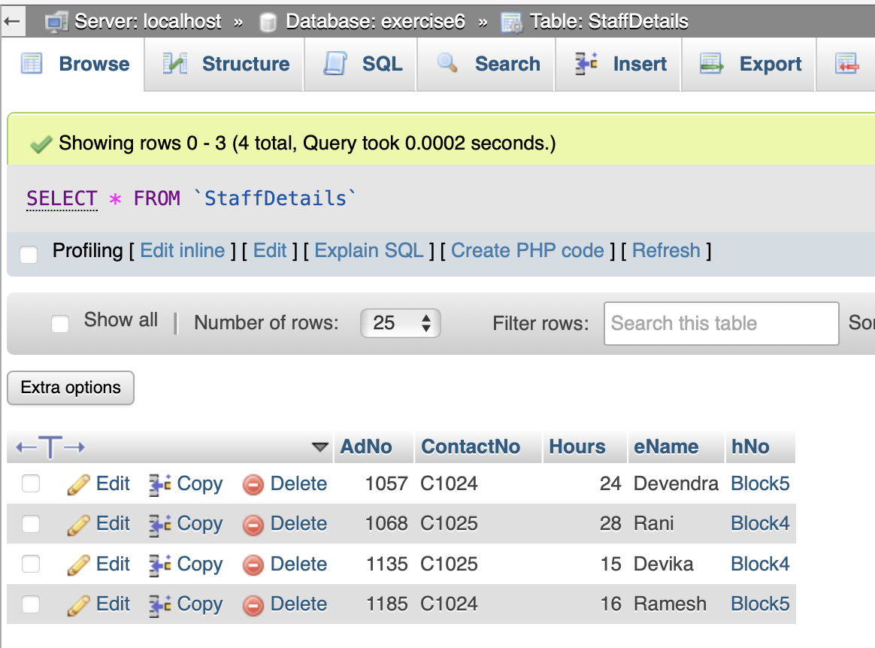
table 2 staff details

Designer ( relation )
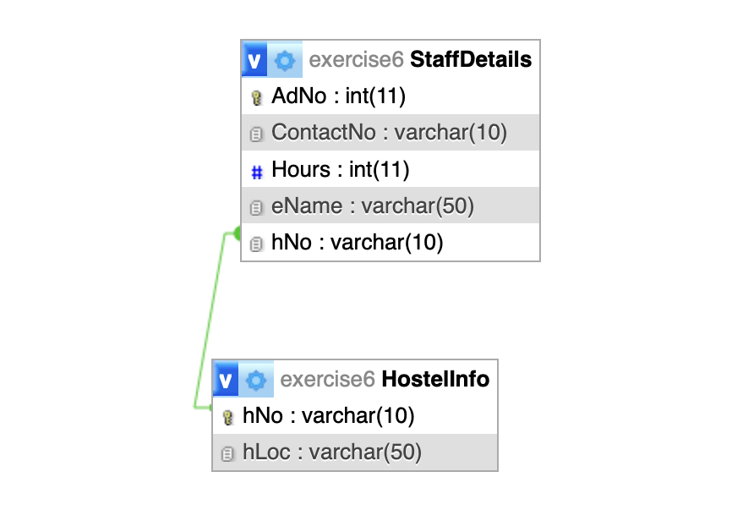

Q2. Python queries
Connection build code :
mydb = mysql.connector.connect(
host = 'localhost',
user = 'root',
password = '',
database = 'exercise6'

)

if mydb.is_connected():
print("Connected")

print(mydb)

mycursor = mydb.cursor()

a)
List out eName hNo wise.
cur.execute('''
SELECT eName, hNo FROM StaffDetails ORDER BY hNo;
''')
result = cur.fetchall()
print(result)

output:
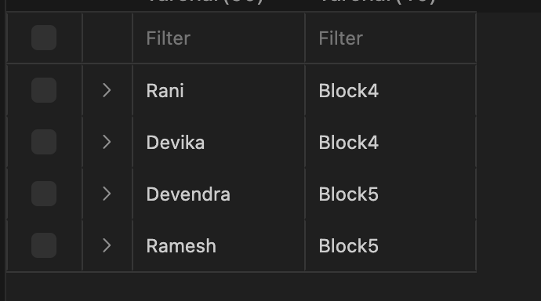

b) List AdNo with increasing order of their hours worked.

cur.execute('''
SELECT AdNo FROM StaffDetails ORDER BY Hours;
''')
result = cur.fetchall()
print(result)

output:

