CONTENTS

Sr. No. | CHAPTER | Page No
 | ABSTRACT | I
 | LIST OF FIGURES | II
 | LIST OF TABLES | III
1 | BRIEF REVIEW OF THE PROJECT
 | 1.1 TITLE | 1
 | 1.2 INTRODUCTION / OBJECTIVE | 2
 | 1.3 PRELIMINARY INVESTIGATION | 3
 | 1.4 FLAWS IN PRESENT SYSTEM | 4
 | 1.5 NEED OF NEW SYSTEM | 5
2 | DETAILED SYSTEM DESIGN
 | 2.1 SYSTEM FLOW CHART | 6
 | 2.2 DETAILS OF LOGIC DEVELOPED | 7
 | 2.3 STRUCTURE DIAGRAM OF EACH MODULE | 9
 | 2.4 DATA DICTIONARY | 10
 | 2.5 DATA FLOW DIAGRAMS | 12
3 | SOFTWARE/ HARDWARE DETAILS
 | 3.1 CHOICE OF A LANGUAGE USED | 14
 | 3.2 HARDWARE/ SOFTWARE SPECIFICATION | 15
4 | SYSTEM DESIGN
 | 4.1 PROGRAM LISTING | 16
 | 4.2 INPUT SCREENS | 18
 | 4.3 OUTPUT SCREENS / REPORTS | 22
5 | USER DOCUMENTATION
 | 5.1 IMPLEMENTATION, PROGRAM EXECUTION & MAINTENANCE | 26
6 | CONCLUSION
 | 6.1 LIMITATIONS OF THE SYSTEM | 28
 | 6.2 SCOPE AND FUTURE MODIFICATION | 29
7 | REFERENCES / BIBLIOGRAPHY | 30

ABSTRACT
The modern job market has become increasingly competitive, with employers relying heavily on Applicant Tracking Systems (ATS). AI Resume Studio is an advanced cloud-based Resume Maker platform configured with ATS Scoring & AI-Powered features which help candidates generate a professional and short-listed CV.

LIST OF FIGURES
Figure 1: System Flow Chart
Figure 2: Data Flow Diagram
Figure 3: Login Input Screen
Figure 4: Dashboard Output Screen
Figure 5: Resume Builder Interface
Figure 6: Templates Selection

LIST OF TABLES
Table 1: Data Dictionary - Users
Table 2: Data Dictionary - Resumes
Table 3: Hardware / Software Requirements

1. BRIEF REVIEW OF THE PROJECT

1.1 TITLE
AI Resume Studio — Resume Maker with ATS Scoring & AI-Powered Features

1.2 INTRODUCTION / OBJECTIVE
The main objective of AI Resume Studio is to provide job seekers with a powerful AI-driven platform to build professional, ATS-optimized resumes. It provides real-time ATS scoring, smart AI suggestions for bullet points, and dynamic generation of professional summaries.

1.3 PRELIMINARY INVESTIGATION
Preliminary investigation revealed that over 75% of resumes are rejected by ATS software blindly because of poor formatting, lack of keywords, or unstructured designs. Job seekers face high rejection rates despite being qualified.

1.4 FLAWS IN PRESENT SYSTEM
• Traditional generic tools lack ATS-friendly formatting.
• Existing systems do not offer detailed analytics or pinpoint exact keyword gaps.
• No contextual AI assistance that adapts to the specific job descriptions.

1.5 NEED OF NEW SYSTEM
• To bridge the gap between job applicant qualifications and recruiter expectations.
• To automate resume formatting so users focus purely on content.
• To use LLMs effectively in evaluating and refining professional vocabulary.

2. DETAILED SYSTEM DESIGN

2.1 SYSTEM FLOW CHART
User Authentication -> Dashboard -> Create/Edit Resume -> AI Optimization -> ATS Score Check -> Download PDF.
[Placeholder for System Flow Chart Diagram]

2.2 DETAILS OF LOGIC DEVELOPED
The core logic entails fetching user section (Experience, Education, Skills) and running it through a sophisticated scoring algorithm. The API queries OpenRouter/Claude 3 Opus for intelligent recommendations based on TF-IDF logic of the provided Job descriptions.

2.3 STRUCTURE DIAGRAM OF EACH MODULE
Modules Include:
1. Auth Module
2. Resume CRUD Module
3. AI Analysis Module
4. Export/PDF Module
[Placeholder for Structure Diagram]

2.4 DATA DICTIONARY
Table: Users
Columns: id (UUID), email (VARCHAR), created_at (TIMESTAMP), subscription_tier (VARCHAR).
Table: Resumes
Columns: id (UUID), user_id (UUID), content (JSONB), ats_score (INTEGER).

2.5 DATA FLOW DIAGRAMS
DFD Level 0: User -> System -> Job Ready Output.
DFD Level 1: Expand into Sub-processes like Validation, Formatting, and Download.
[Placeholder for DFD Diagram]

3. SOFTWARE/ HARDWARE DETAILS

3.1 CHOICE OF A LANGUAGE USED
• Frontend: HTML5, CSS3/Tailwind, React 18, TypeScript.
• Backend Logic: Supabase Edge Functions (Deno/TypeScript), Node.js.
• Database: PostgreSQL (via Supabase).

3.2 HARDWARE/ SOFTWARE SPECIFICATION
Hardware Requirements (Client Side):
- Any modern operating system (Windows, Linux, macOS).
- 4GB RAM minimum, 2-core processor.
Software Requirements:
- Node.js (v18+)
- Modern Web Browser (Chrome, Edge, Firefox) with JS enabled.

4. SYSTEM DESIGN

4.1 PROGRAM LISTING
The program consists of modular components in React (`src/components`), hooks for data fetching (`src/hooks/useResume.ts`), pages (`src/pages`), and serverless Edge Functions linked to Supabase PostgreSQL.

4.2 INPUT SCREENS
The input screens capture user interactions such as logging in, selecting templates, and inputting resume details into the Builder module.
Screen: Landing Page (System Entry)
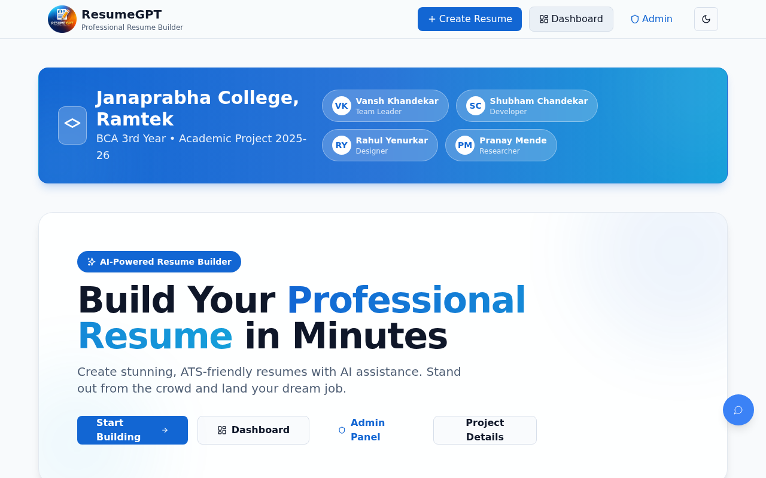

Screen: Template Selection Screen
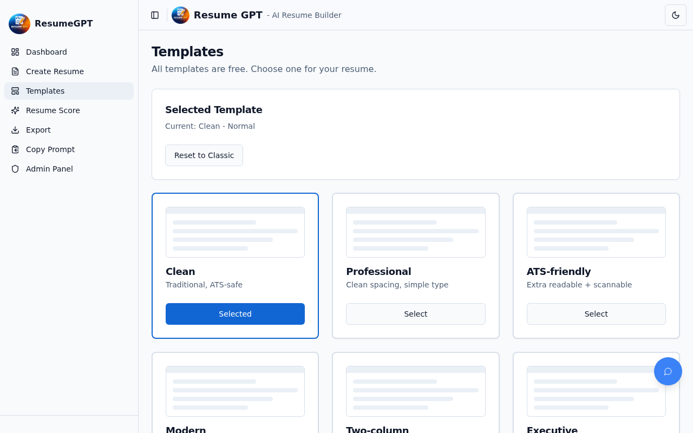

4.3 OUTPUT SCREENS / REPORTS
The output screens show the final rendered layout, the analytics dashboard, and the administrative reports.
Screen: Resume Builder Interface (Output View)
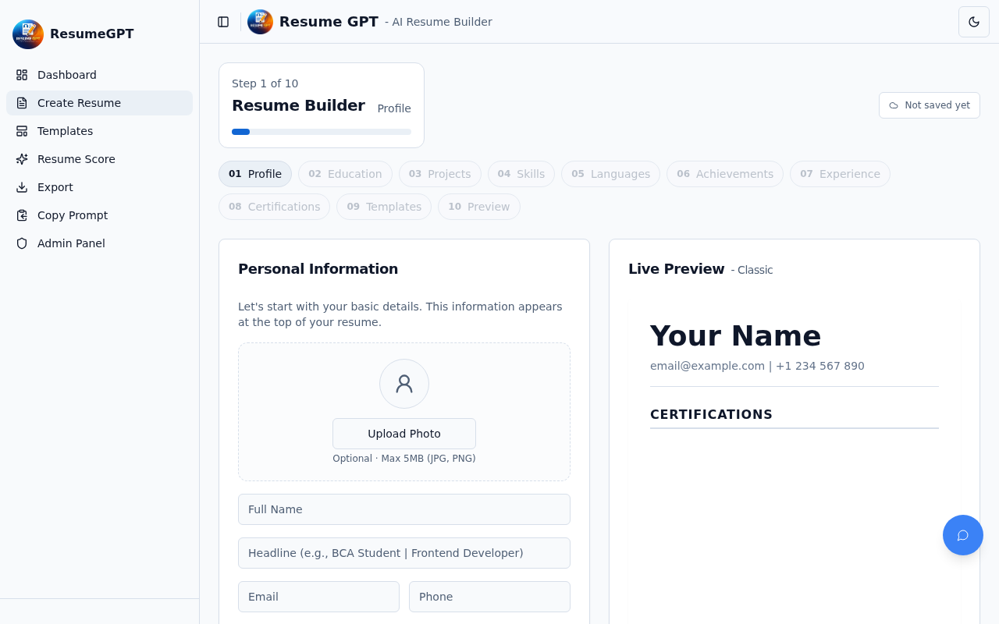

Screen: User Dashboard (Analytics and Management)
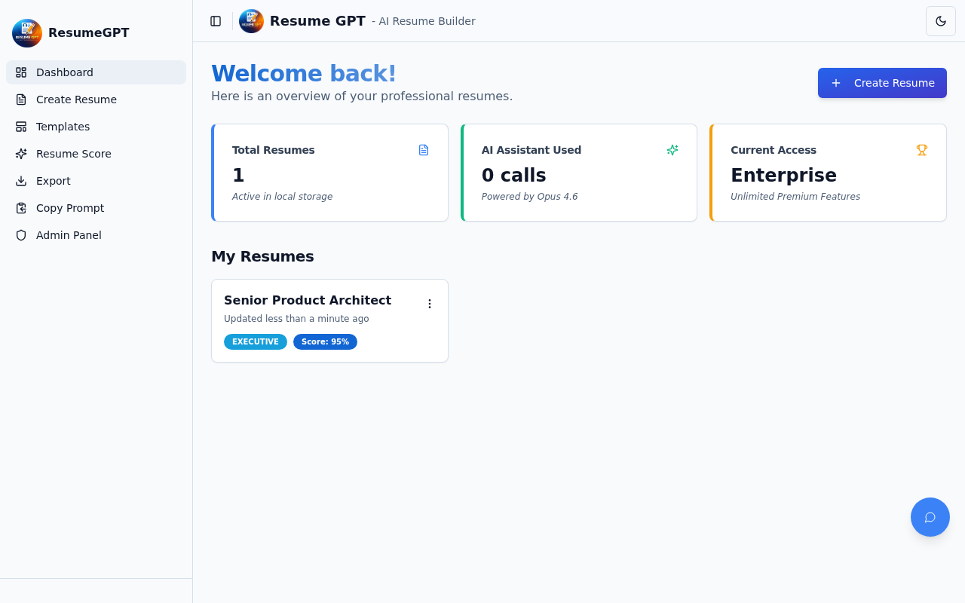

Screen: Admin Reporting Dashboard
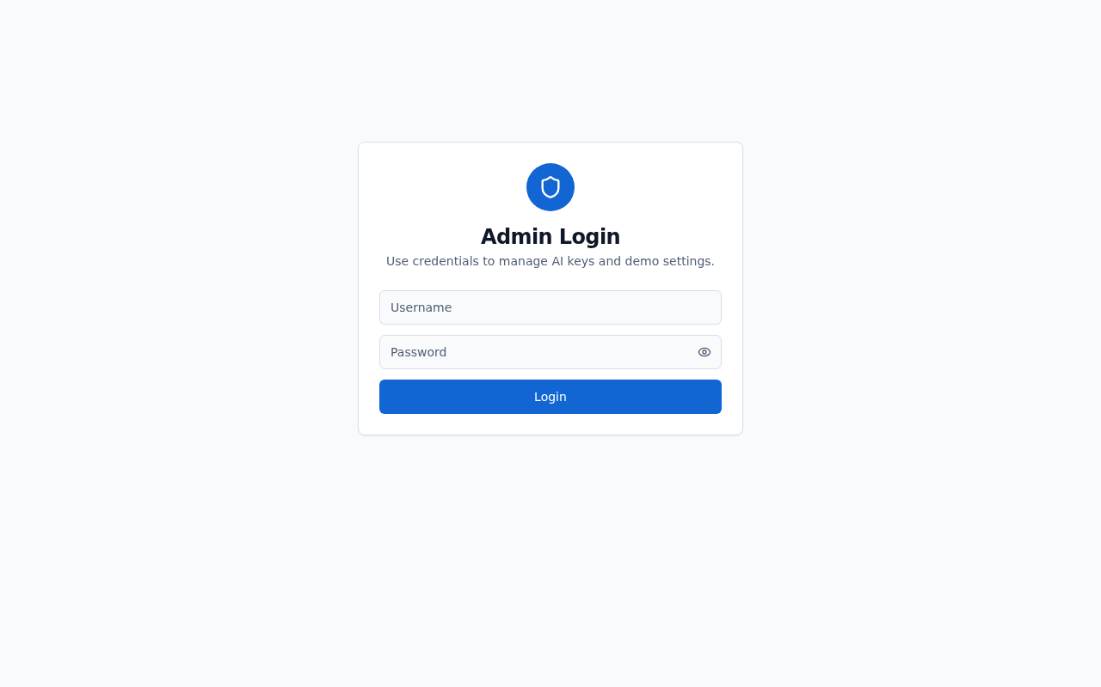

5. USER DOCUMENTATION

5.1 IMPLEMENTATION, PROGRAM EXECUTION & MAINTENANCE
Implementation Details:
1. The system is deployed via Vercel for the frontend and Supabase for the backend infrastructure.
2. Program execution requires a user to sign-up via OAuth or Email links.
3. Maintenance consists of periodic updates to AI system prompts and updating the ATS algorithms inline with current industry trends.

6. CONCLUSION

6.1 LIMITATIONS OF THE SYSTEM
• Requires active high-speed internet connection for real-time AI suggestions.
• Contextual limits in LLMs might miss highly specialized niche terminology natively unencountered.
• Strict PDF parsing formatting limitations when downloading in raw environments.

6.2 SCOPE AND FUTURE MODIFICATION
• Integration with LinkedIn for direct 1-click importing of user profiles.
• Support for multiple file exports like proper DOCX conversion.
• Mobile App implementation for resume management on-the-go.

7. REFERENCES / BIBLIOGRAPHY
1. React Documentation: https://reactjs.org/docs
2. Supabase Documentation: https://supabase.com/docs
3. OpenAI / Anthropic APIs Context Guides.
4. Modern Systems Analysis and Design by Hoffer et al.
5. Applicant Tracking Algorithms and Implementation Guidelines, 2025.

