Assignment 2 — Menu-Driven Calculator
Tutedude | Python

1. Objective
Create a menu-driven Python calculator with separate functions for addition, subtraction, multiplication, and division. The program must continue running until the user exits and must safely handle division by zero.

2. Code Explanation

2.1 Separate Mathematical Functions
Four separate functions perform the required mathematical operations. Each function accepts two numbers and returns the calculated result.

2.2 Division-by-Zero Handling
The division function checks the divisor before performing division. If the divisor is zero, the program returns a clear error message instead of attempting an invalid operation.
def divide(x, y):
if y == 0:
return "Error: Cannot divide by zero."
return x / y

2.3 Repeated Execution
A while loop keeps the calculator running after each operation. Selecting option 5 breaks the loop and exits the program.

2.4 Operation Selection
The user's menu choice is evaluated using if-elif-else statements. The corresponding function is called, and its return value is stored in the result variable.

3. Program Demonstration

3.1 Addition
Enter your choice: 1
Enter first number: 20
Enter second number: 10
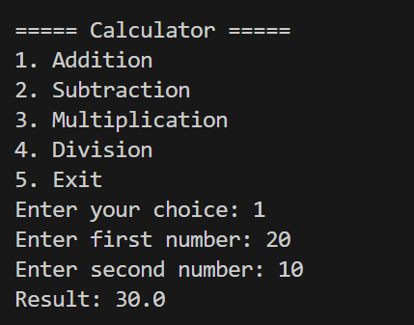
Result: 30.0

3.2 Subtraction
Enter your choice: 2
Enter first number: 20
Enter second number: 10
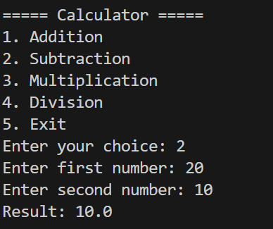
Result: 10.0

3.3 Multiplication
Enter your choice: 3
Enter first number: 20
Enter second number: 10
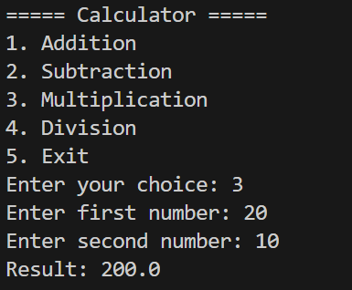
Result: 200.0

3.4 Division
Enter your choice: 4
Enter first number: 20
Enter second number: 10
Result: 2.0
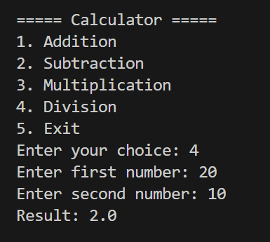

3.5 Division by Zero
Enter your choice: 4
Enter first number: 20
Enter second number: 0
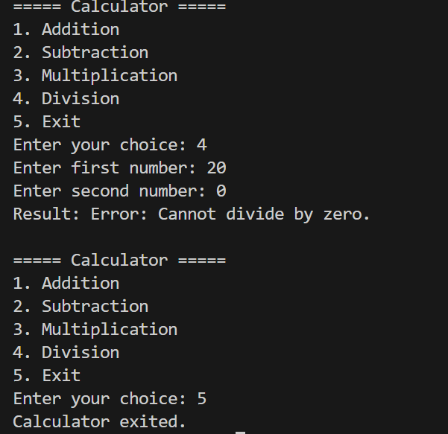
Result: Error: Cannot divide by zero.

4. GitHub Repository
Repository: Assignment-2(https://github.com/vanshkumar31/tutedude/tree/main/Assignment-2)

