Assignment 3 — Flask API and MongoDB Atlas
Tutedude Assignment

Overview
This assignment demonstrates Flask API development, reading backend data from a JSON file, returning JSON responses, frontend form submission, and MongoDB Atlas integration.

1. Flask Application with an /api Route

Objective
Create a Flask application with an /api route. The route reads a JSON list from a backend file and returns the data as a JSON response.

Implementation
- Create a Flask application.
- Store the data in a backend JSON file.
- Read the JSON file using Python.
- Return the data through the /api route as a JSON list.

Explanation
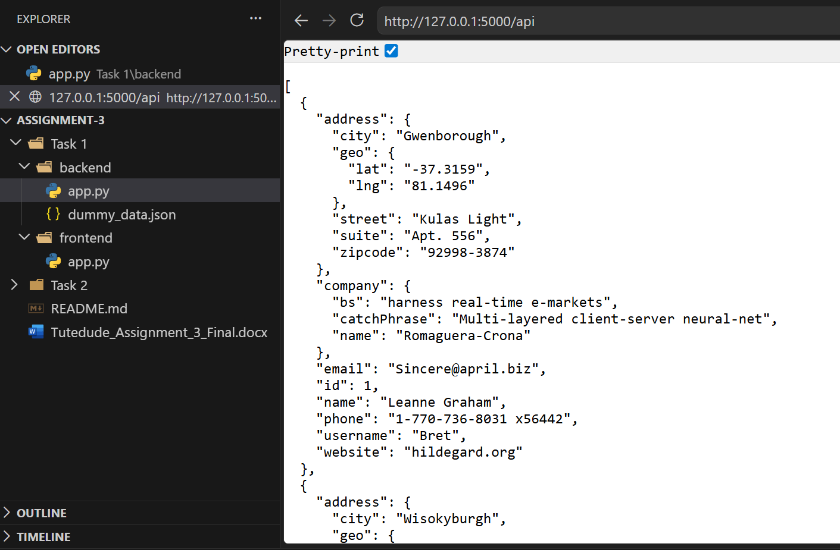
The /api route opens dummy_data.json in read mode, loads the JSON data using json.load(), and returns the data using Flask's jsonify() function.

2. Frontend Form with MongoDB Atlas

Objective
Create a frontend form that submits user data to a Flask backend. The backend inserts the data into MongoDB Atlas. After successful submission, the user is redirected to another page displaying "Data submitted successfully". If an error occurs, the error is displayed on the same form page.

Application Flow
Frontend Form
|
v
Frontend Flask Application
|
v
Backend Flask API
|
v
MongoDB Atlas
|
+--+----------------+
| |
Success Error
| |
v v
Success Page Same Form Page
"Data submitted Error Message
successfully" displayed

Implementation
- Create the frontend form.
- Receive the submitted form data.
- Send the data to the backend.
- Insert the data into MongoDB Atlas.
- Redirect to a separate success page after successful insertion.
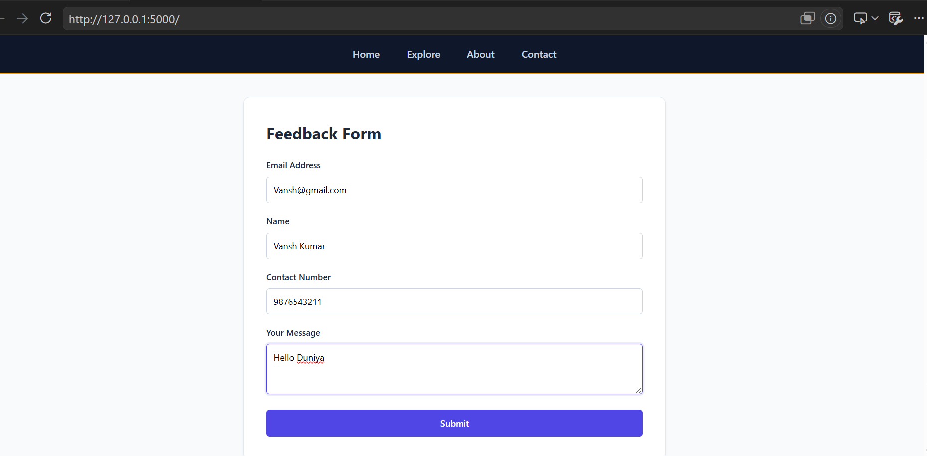
- Display the error on the original form page when submission fails.

MongoDB Atlas
The backend uses MongoDB Atlas to store the submitted form data. The database connection should use an environment variable for the MongoDB connection URI rather than hard-coding credentials.

Success Response
{
"success": true,
"message": "Data submitted successfully"
}
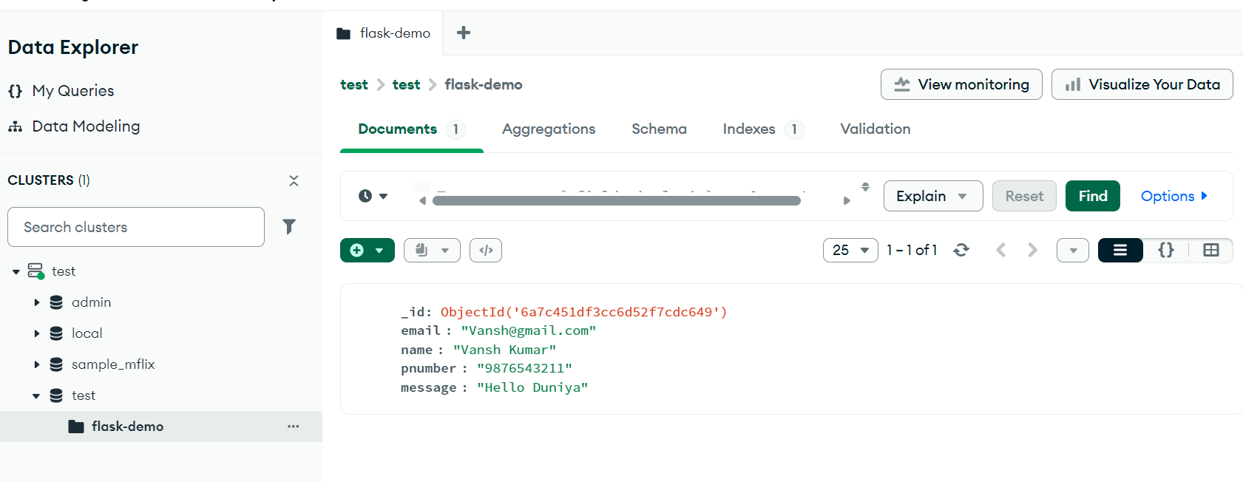
The required success message is exactly: "Data submitted successfully".
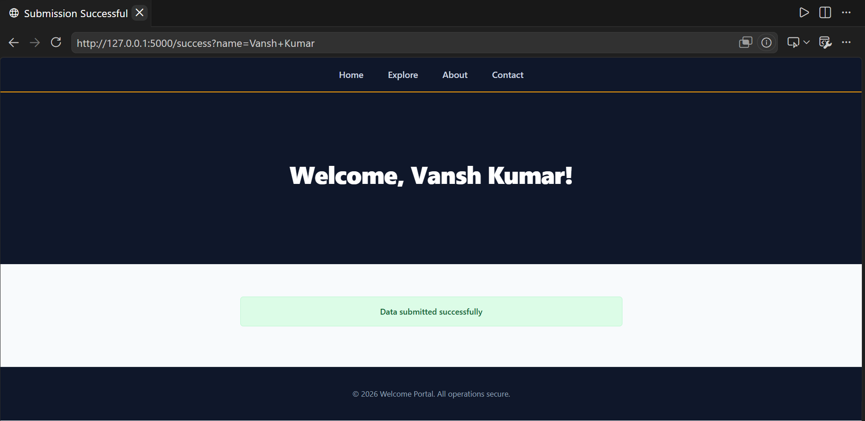
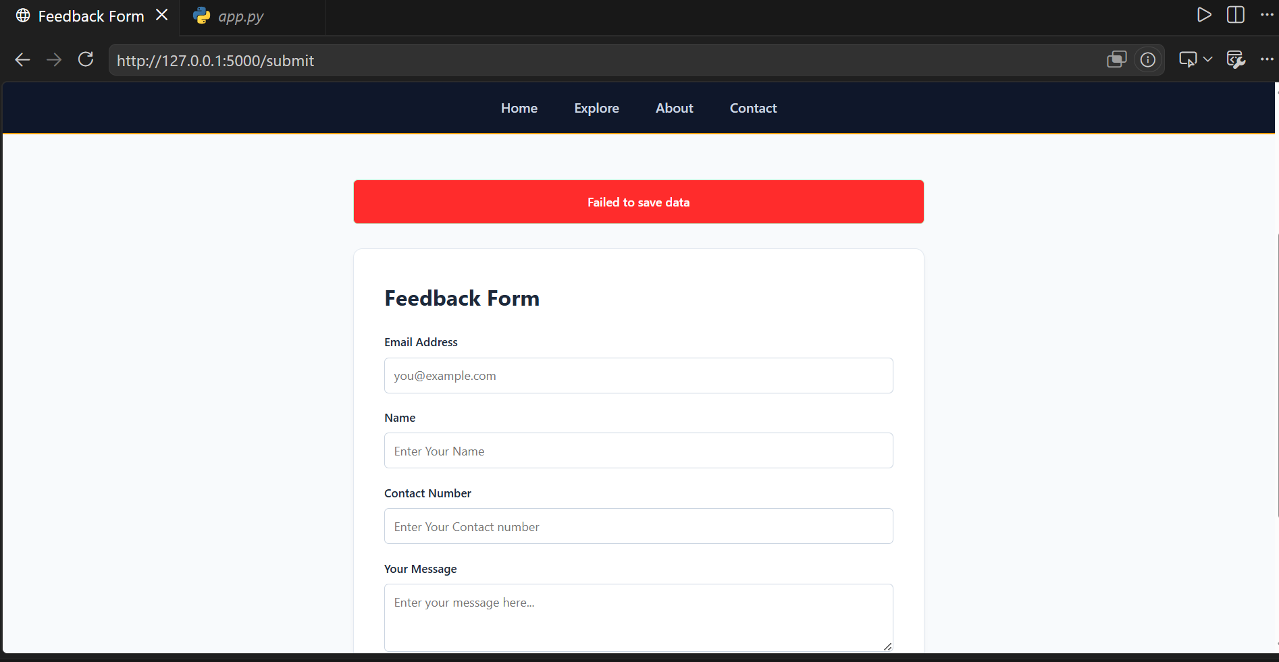

GitHub Repository
Repository: Assignment-3

Conclusion
This assignment demonstrates the integration of Flask, JSON data, frontend forms, backend APIs, and MongoDB Atlas with both successful submission and error-handling flows.

