EXPERIMENT – 7

Name: Vansh Madaan

Batch – 4

Sap Id - 500123857

- In a 3D modeling application, define an abstract class named Solid that declares an abstract method calculateVolume(). Then, derive two concrete classes—Cuboid and Sphere—from the Solid class. Each subclass should override calculateVolume() to compute its volume using the appropriate geometric formula. Finally, in your main method, create objects of Cuboid and Sphere and call their calculateVolume() methods to display the computed volumes.
// Abstract class Solid
abstract class Solid {
// Abstract method to be implemented by subclasses
abstract double calculateVolume();
}

// Cuboid class extending Solid
class Cuboid extends Solid {
private double length;
private double width;
private double height;

// Constructor
public Cuboid(double length, double width, double height) {
this.length = length;
this.width = width;
this.height = height;
}

// Overriding calculateVolume method
@Override
double calculateVolume() {
return length * width * height;
}
}

// Sphere class extending Solid
class Sphere extends Solid {
private double radius;

// Constructor
public Sphere(double radius) {
this.radius = radius;
}

// Overriding calculateVolume method
@Override
double calculateVolume() {
return (4.0 / 3.0) * Math.PI * Math.pow(radius, 3);
}
}

// Main class to test the implementation
public class Main {
public static void main(String[] args) {
// Create Cuboid object
Solid cuboid = new Cuboid(4.0, 3.0, 2.0);
System.out.println("Volume of Cuboid: " + cuboid.calculateVolume());

// Create Sphere object
Solid sphere = new Sphere(5.0);
System.out.println("Volume of Sphere: " + sphere.calculateVolume());
}
}

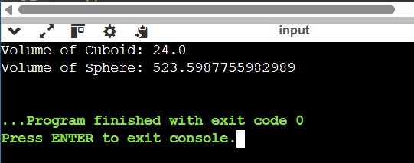

- Consider an automotive application where you need to manage different types of vehicles. Create an interface called Vehicle with methods start(), stop(), and getFuelLevel(). Implement this interface in two classes, Car and Motorcycle, each providing its own implementation of the methods. Then write a main method that uses a Vehicle reference to hold objects of both Car and Motorcycle and calls the methods to demonstrate runtime polymorphism.
// Vehicle interface
interface Vehicle {
void start();
void stop();
double getFuelLevel();
}

// Car class implementing Vehicle
class Car implements Vehicle {
private double fuelLevel;

public Car(double fuelLevel) {
this.fuelLevel = fuelLevel;
}

public void start() {
System.out.println("Car is starting...");
}

public void stop() {
System.out.println("Car is stopping...");
}

public double getFuelLevel() {
return fuelLevel;
}
}

// Motorcycle class implementing Vehicle
class Motorcycle implements Vehicle {
private double fuelLevel;

public Motorcycle(double fuelLevel) {
this.fuelLevel = fuelLevel;
}

public void start() {
System.out.println("Motorcycle is starting...");
}

public void stop() {
System.out.println("Motorcycle is stopping...");
}

public double getFuelLevel() {
return fuelLevel;
}
}

// Main class to demonstrate runtime polymorphism
public class Main {
public static void main(String[] args) {
// Vehicle reference holding a Car object
Vehicle vehicle = new Car(50.5);
vehicle.start();
System.out.println("Car Fuel Level: " + vehicle.getFuelLevel());
vehicle.stop();

System.out.println();

// Vehicle reference holding a Motorcycle object
vehicle = new Motorcycle(15.0);
vehicle.start();
System.out.println("Motorcycle Fuel Level: " + vehicle.getFuelLevel());
vehicle.stop();
}
}

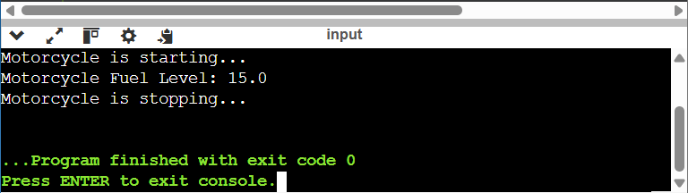

- Design an interface called Wallet that declares two methods: addFunds(double amount) and spendFunds(double amount). Implement this interface in a class named DigitalWallet that maintains a private balance variable. Ensure that the class provides controlled access to update the balance only through the interface methods. Then, write a separate class with a main method that creates a DigitalWallet object, performs a series of fund additions and expenditures, and prints the updated balance to verify that external classes cannot directly manipulate the wallet’s internal data.

interface Wallet {
void addFunds(double amount);
void spendFunds(double amount);
}

class DigitalWallet implements Wallet {

private double balance;

public DigitalWallet() {
balance = 0.0;
}

// Implements addFunds method
@Override
public void addFunds(double amount) {
if (amount > 0) {
balance += amount;
System.out.println("Added: $" + amount);
} else {
System.out.println("Invalid amount. Cannot add funds.");
}
}

// Implements spendFunds method
@Override
public void spendFunds(double amount) {
if (amount > 0 && amount <= balance) {
balance -= amount;
System.out.println("Spent: $" + amount);
} else {
System.out.println("Transaction failed. Insufficient balance or invalid amount.");
}
}

// Public method to get current balance (read-only)
public double getBalance() {
return balance;
}
}

// Separate class with main method
public class Main {
public static void main(String[] args) {
DigitalWallet myWallet = new DigitalWallet();

// Perform wallet operations
myWallet.addFunds(100.0);
myWallet.spendFunds(30.0);
myWallet.addFunds(50.0);
myWallet.spendFunds(150.0); // Should fail

// Print final balance
System.out.println("Final Balance: $" + myWallet.getBalance());

}
}

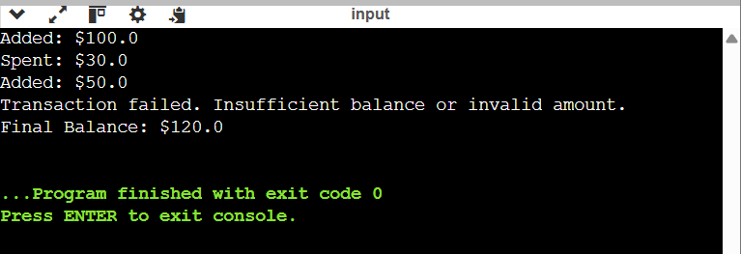

- Create an interface named Remote with methods powerOn(), powerOff(), and changeChannel(int channel). Next, implement this interface in a class called Television, where each method prints a message indicating its action (e.g., "TV is now on", "TV is off", "Channel changed to X"). Finally, develop a class with a main method that instantiates a Television object and uses a Remote reference to call the methods, thereby demonstrating how polymorphism and interface abstraction allow you to control a device through a common interface.
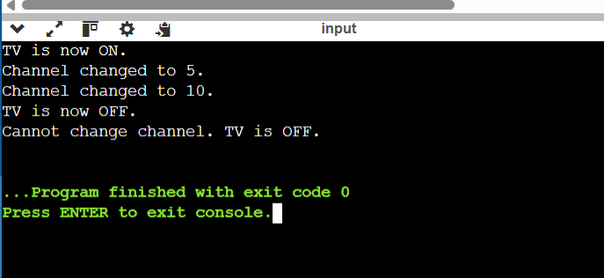

interface Remote {
void powerOn();
void powerOff();
void changeChannel(int channel);
}

class Television implements Remote {
private boolean isOn = false;
private int currentChannel = 1;

@Override
public void powerOn() {
if (!isOn) {
isOn = true;
System.out.println("TV is now ON.");
} else {
System.out.println("TV is already ON.");
}
}

@Override
public void powerOff() {
if (isOn) {
isOn = false;
System.out.println("TV is now OFF.");
} else {
System.out.println("TV is already OFF.");
}
}

@Override
public void changeChannel(int channel) {
if (isOn) {
currentChannel = channel;
System.out.println("Channel changed to " + channel + ".");
} else {
System.out.println("Cannot change channel. TV is OFF.");
}
}
}

public class Main {
public static void main(String[] args) {

Remote remote = new Television();

remote.powerOn();
remote.changeChannel(5);
remote.changeChannel(10);
remote.powerOff();
remote.changeChannel(3);
}
}

