A PROJECT REPORT ON
FOOD ORDERING BEHAVIOUR AND CONSUMER TRENDS
Submitted in partial fulfillment of the requirements for the degree of
Bachelor of Technology (B.Tech)
in
Artificial Intelligence and Data Science (AI&DS)
Submitted by:
VANSH JAISINGHANI
INDIRA COLLEGE OF ENGINEERING AND MANAGEMENT (ICEM), PUNE
Academic Year: 2025-2026

ABSTRACT

In the rapidly evolving digital landscape, food delivery platforms have become a cornerstone of the modern urban lifestyle. Cloud kitchens, restaurant aggregators, and logistics networks generate massive volumes of transactional data daily. However, extracting actionable business intelligence from this raw data remains a challenge for many stakeholders. This project, titled 'Food Ordering Behaviour and Consumer Trends', aims to bridge this gap by applying advanced data analytics and visualization techniques to a comprehensive dataset of 50,000 food delivery records.
The project methodology encompasses the entire data analytics life cycle: data collection, rigorous data preprocessing, feature engineering (such as age and time binning), visual analytics using Tableau Public, and full-stack web integration. By utilizing Tableau's powerful visual encoding capabilities, this study uncovers hidden patterns in consumer demographics, regional cuisine preferences, order timing distributions, and social eating behaviors. Key findings reveal specific age groups driving mid-range restaurant sales, dominant geographical markets (Mumbai and Pune), and highly consistent delivery performancecurves.
To ensure the accessibility of these insights for non-technical business decision-makers, the interactive Tableau Dashboards and Tableau Data Stories were successfully embedded into a lightweight Python Flask web application. The resulting portal provides a centralized, interactive environment for exploring real-time business intelligence, ultimately enabling smarter, data-driven strategies for inventory management, targeted marketing, and logistics optimization.

CHAPTER 1: INTRODUCTION

1.1 Background of the Study
The food delivery industry has experienced exponential growth over the past decade. With the advent of smartphones and high-speed internet, consumers expect seamless, rapid, and personalized food delivery services. For businesses operating in this space—ranging from multinational aggregators to local cloud kitchens—data is the most valuable asset. Analyzing how, when, and what consumers order provides a crucial competitive edge. This project explores a dataset of 50,000 orders to understand these precise dynamics.

1.2 Problem Statement
Food delivery platforms and cloud kitchens frequently struggle with operational inefficiencies and misaligned marketing strategies due to a lack of clear consumer insights. Specifically, businesses face challenges in predicting peak demand periods, mapping regional cuisine preferences accurately, tailoring restaurant tiers to specific age demographics, and monitoring delivery logistics. There is a pressing need for an interactive, centralized dashboard that transforms raw transactional rows into clear, actionable visual insights for business stakeholders.

1.3 Objectives of the Project
The primary objectives of this project are as follows:
- 1. To clean, preprocess, and structure a large-scale dataset of 50,000 food delivery records.
- 2. To engineer new analytical features, such as demographic age bins and delivery time intervals.
- 3. To design and develop an interactive Business Intelligence (BI) dashboard using Tableau.
- 4. To extract and document key business insights regarding geographical dominance, cuisine popularity, and operational efficiency.
- 5. To deploy the visual analytics securely within a Python Flask web application for seamless stakeholder access.

1.4 Scope of the Project
The scope of this project spans from raw data ingestion to web deployment. It includes data preparation (type casting, aggregation, handling missing values if any), visualization (building charts, KPIs, and heatmaps), storytelling (creating a Tableau Story for sequential presentation), and web development (creating HTML/CSS templates and routing via Flask). The analysis is limited to the provided dataset's historical constraints and focuses heavily on Indian metropolitan markets.

CHAPTER 2: LITERATURE REVIEW & TECHNOLOGY STACK

2.1 Industry Context: Food Analytics

Modern food delivery relies heavily on predictive analytics and descriptive statistics. Aggregators use data to determine surge pricing, estimated time of arrival (ETA), and personalized recommendations. Understanding 'Consumer Trends' involves tracking multi-dimensional variables: what time of day a meal is ordered, the mood or social context of the customer, and their demographic profile. Analyzing these factors allows platforms to optimize their supply chain, reducing food wastage and improving delivery fleet utilization.

2.2 Technology Stack Selection

This project utilizes a modern data analytics and web development stack chosen for its robust integration capabilities, industry relevance, and performance.

2.2.1 Tableau Public

Tableau was selected as the primary Business Intelligence tool due to its industry-leading visualization capabilities. Unlike programmatic plotting libraries (like Matplotlib or Seaborn), Tableau allows for rapid dashboard prototyping, highly interactive cross-filtering, and the ability to combine multiple worksheets into cohesive 'Stories'. Tableau Public provides free cloud hosting for visualizations, generating embed codes essential for web integration.

2.2.2 Python & Flask

Python is the de-facto language for data science and backend web development. Flask, a micro web framework written in Python, was chosen for the deployment phase. Flask is lightweight, highly customizable, and perfectly suited for serving HTML templates that host embedded third-party APIs (such as the Tableau Web Component).

2.2.3 HTML5 & CSS3

The frontend of the web portal was constructed using standard web technologies. HTML5 provides the semantic structure required to host the Tableau iframe and Web Components, while custom CSS3 ensures the application is visually appealing, responsive, and aligned with modern corporate dashboard designs.

CHAPTER 3: DATASET DESCRIPTION & PREPARATION

3.1 Data Source and Overview

The project utilizes a static historical dataset named 'food_ordering_behavior_dataset.csv'. This file comprises 50,000 distinct order records, capturing a comprehensive view of customer interactions with a food delivery platform.

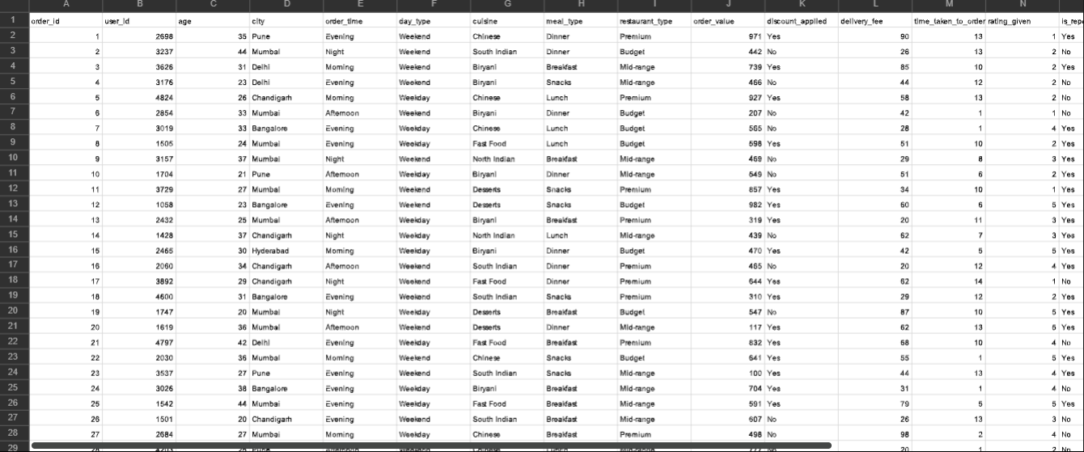

3.2 Data Dictionary

The dataset contains several key attributes, categorized into transactional, demographic, operational, and performance metrics:
- • Order ID: A unique numerical identifier for each transaction.
- • Order Value: The total monetary value of the food ordered (in INR).
- • City: The geographical location of the order (e.g., Mumbai, Pune, Bangalore).
- • Cuisine: The category of food ordered (e.g., Biryani, Chinese, Fast Food).
- • Meal Type: The time-of-day category (Breakfast, Lunch, Dinner, Snacks).
- • Day Type: Indicates whether the order was placed on a Weekday or Weekend.
- • Age: The numerical age of the customer.
- • Company: The social context of the meal (Alone, Partner, Friends, Family).
- • Restaurant Type: The economic tier of the restaurant (Budget, Mid-range, Premium).
- • Rating Given: The customer satisfaction score out of 5.
- • Time Taken to Order: The logistical duration from order placement to fulfillment.

3.3 Feature Engineering and Binning

Raw numerical data often contains too much variance to visualize effectively in bar charts. To resolve this, data binning techniques were applied within Tableau:
Age Binning: Customer ages were grouped into bins of size 10. This transformed a continuous variable (e.g., 22, 27, 29) into discrete generational cohorts (20s, 30s). This is crucial for demographic targeting.
Delivery Time Binning: The fulfillment time was grouped into 5-minute increments (0, 5, 10, 15). This enabled the creation of a delivery distribution histogram, allowing logistics teams to identify the median delivery time and spot statistical outliers (extremely late deliveries).

CHAPTER 4: VISUALIZATION & DASHBOARD DESIGN

4.1 System Architecture

The visual analytics architecture was designed in three distinct layers: Data Layer (CSV extraction), Visualization Layer (Tableau Worksheets), and Presentation Layer (Tableau Dashboards and Stories).

4.2 Design of KPI Cards

Key Performance Indicators (KPIs) act as the executive summary of the dashboard. Four distinct cards were designed to sit at the top of the interface:
- 1. Total Orders: Calculated using COUNT(Order Id), resulting in 50,000.
- 2. Total Revenue: Calculated using SUM(Order Value), resulting in ₹2,73,86,555.
- 3. Average Order Value (AOV): Calculated using AVG(Order Value), resulting in ₹547.7.
- 4. Average Rating: Calculated using AVG(Rating Given), resulting in 2.994.

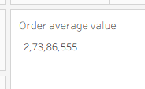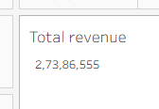

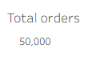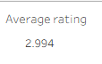

4.3 Worksheet Development

Seven primary visual worksheets were developed to address specific business questions. Below are the configurations for key visuals:

4.3.1 Flavours Across Cities (Stacked Bar Chart)

This chart maps Cuisine on the Columns shelf and SUM(Order Value) on the Rows shelf. The 'City' dimension is placed on the Color mark, creating a stacked bar that immediately illustrates which cities contribute the most revenue to specific food categories.

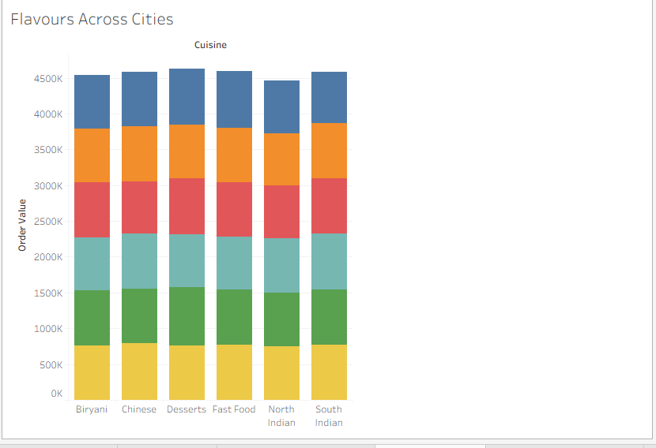

4.3.2 Order Distribution by Age Group and Restaurant Segment

This visual utilizes the engineered 'Age (bin)' on the Columns shelf and COUNT(Order Id) on the Rows shelf. 'Restaurant Type' serves as the color distinction. It effectively demonstrates demographic purchasing power across Budget and Premium tiers.
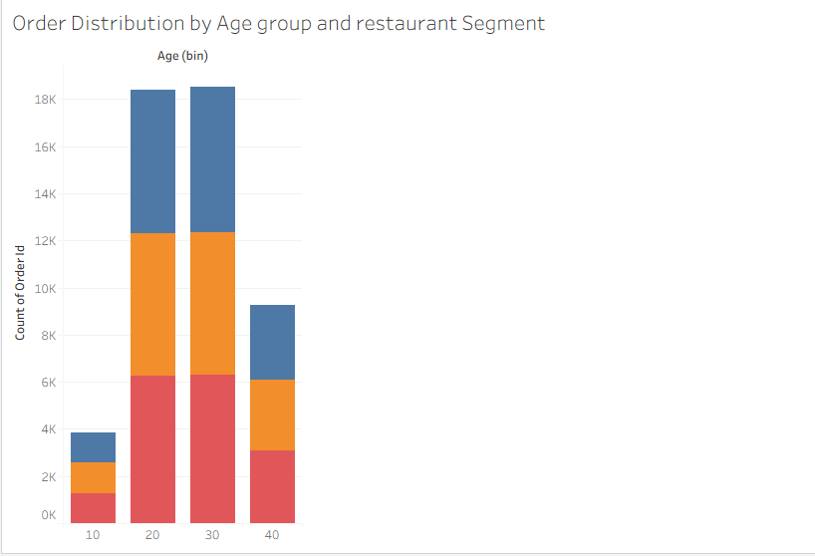

4.3.3 Analysis of Orders Across Company Type and Meal Type

A detailed cross-tab (pivot table) was constructed with 'Company' (Alone, Family, etc.) on the Columns and 'Meal Type' on the Rows, displaying the absolute count of orders in the text mark. This highlights behavioral patterns regarding when people eat together versus alone.
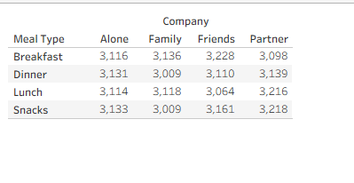

4.4 Dashboard Layout and Interactivity

The individual worksheets were assembled into a fixed-size (1400x900px) dashboard. The layout follows a strict top-down hierarchy: KPIs at the top, primary regional/demographic charts in the middle, and detailed operational metrics at the bottom. Crucially, interactive filtering actions were enabled. Clicking on a specific city in the 'Cities by Order Volume' chart dynamically filters every other chart on the dashboard to reflect only data for that specific city.
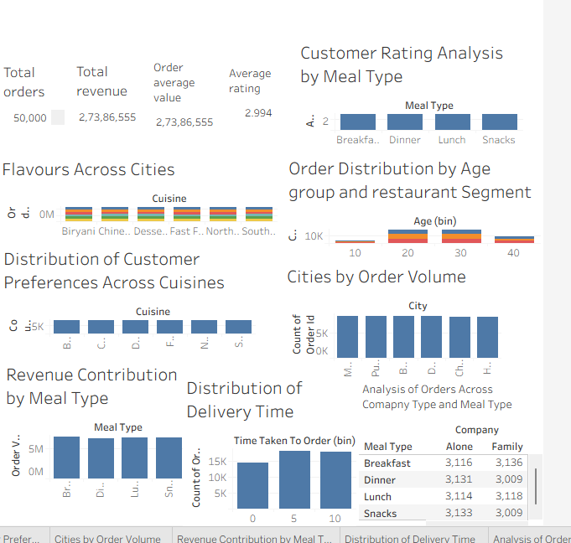

4.5 Tableau Story Construction

To present the findings sequentially, a Tableau Story was authored. This includes a prominent Heatmap titled 'City vs Cuisine', utilizing a color gradient (Orange-Gold) to map order intensity across a matrix of cities and cuisines. Navigation tabs were added to guide stakeholders through the narrative of the data.

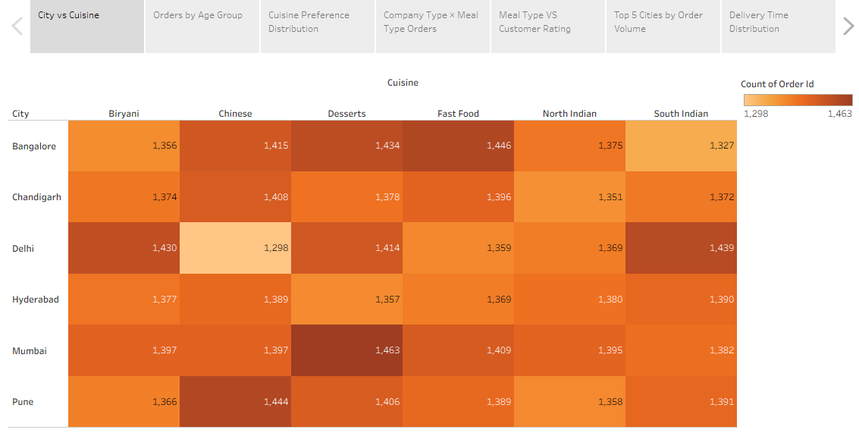

CHAPTER 5: WEB INTEGRATION & FLASK DEPLOYMENT

5.1 The Need for Web Integration

While Tableau is a powerful tool, expecting all business stakeholders to install Tableau Desktop or navigate Tableau Public directly is impractical. Embedding the analytics into a custom web portal ensures centralized, brand-compliant, and easy access for end-users.

5.2 Flask Application Architecture

A Python Flask application was established with a standard routing structure. The application consists of a backend script (app.py) and a 'templates' directory containing three HTML files: index.html (landing page), dashboard.html, and story.html.

5.3 Backend Code Implementation (app.py)

The following Python code initializes the Flask server and defines the routing logic:
from flask import Flask, render_template
app = Flask(__name__)
@app.route('/')
def home():
return render_template('index.html')
@app.route('/dashboard')
def dashboard():
return render_template('dashboard.html')
@app.route('/story')
def story():
return render_template('story.html')
if __name__ == '__main__':
app.run(debug=True)

5.4 Frontend Code Implementation (HTML & Embedded Component)

To securely embed the Tableau visualizations bypassing standard iframe restrictions, the official Tableau Web Component API was utilized. Below is the code snippet for 'story.html', demonstrating the integration:
<!DOCTYPE html>
<html lang="en">
<head>
<meta charset="UTF-8">
<title>Live Dashboard | Food Ordering Analytics</title>
<style>
body { margin: 0; padding: 0; font-family: sans-serif; background-color: #f4f6f8; }
header { background: #1a1a1a; padding: 15px 30px; display: flex; justify-content: space-between; align-items: center; }
header a { color: #fff; text-decoration: none; margin-right: 20px; font-size: 15px; }
.container { max-width: 1400px; margin: 20px auto; padding: 0 15px; }
h2 { margin-bottom: 15px; color: #333; }
</style>
</head>
<body>
<header>
<a href="/" style="font-weight:bold; color: #ff5252;">← Back to Home</a>
<div>
<a href="/dashboard">Dashboard</a>
<a href="/story">Story</a>
</div>
</header>
<div class="container">
<h2>Interactive Food Ordering Dashboard</h2>

<div class='tableauPlaceholder' id='viz1791292502376' style='position: relative'><noscript><a href='#'><img alt='Dashboard 1 ' src='https:&#47;&#47;public.tableau.com&#47;static&#47;images&#47;Fo&#47;FoodOrderingBehaviourandConsumerTrend&#47;Dashboard1&#47;1_rss.png' style='border: none' /></a></noscript><object class='tableauViz' style='display:none;'><param name='host_url' value='https%3A%2F%2Fpublic.tableau.com%2F' /> <param name='embed_code_version' value='3' /> <param name='site_root' value='' /><param name='name' value='FoodOrderingBehaviourandConsumerTrend&#47;Dashboard1' /><param name='tabs' value='no' /><param name='toolbar' value='yes' /><param name='static_image' value='https:&#47;&#47;public.tableau.com&#47;static&#47;images&#47;Fo&#47;FoodOrderingBehaviourandConsumerTrend&#47;Dashboard1&#47;1.png' /> <param name='animate_transition' value='yes' /><param name='display_static_image' value='yes' /><param name='display_spinner' value='yes' /><param name='display_overlay' value='yes' /><param name='display_count' value='yes' /><param name='language' value='en-US' /><param name='filter' value='publish=yes' /></object></div> <script type='text/javascript'> var divElement = document.getElementById('viz1791292502376'); var vizElement = divElement.getElementsByTagName('object')[0]; if ( divElement.offsetWidth > 800 ) { vizElement.style.minWidth='420px';vizElement.style.maxWidth='650px';vizElement.style.width='100%';vizElement.style.minHeight='587px';vizElement.style.maxHeight='887px';vizElement.style.height=(divElement.offsetWidth*0.75)+'px';} else if ( divElement.offsetWidth > 500 ) { vizElement.style.minWidth='420px';vizElement.style.maxWidth='650px';vizElement.style.width='100%';vizElement.style.minHeight='587px';vizElement.style.maxHeight='887px';vizElement.style.height=(divElement.offsetWidth*0.75)+'px';} else { vizElement.style.width='100%';vizElement.style.height='2177px';} var scriptElement = document.createElement('script'); scriptElement.src = 'https://public.tableau.com/javascripts/api/viz_v1.js'; vizElement.parentNode.insertBefore(scriptElement, vizElement); </script>
</div>
</body>
</html>

CHAPTER 6: RESULTS, ANALYSIS & BUSINESS INSIGHTS

6.1 Regional Market Dominance

Analysis of the 'Cities by Order Volume' and the geographic heatmaps reveals that Mumbai (8,443 orders) and Pune (8,354 orders) are the highest-performing markets. This indicates a highly successful operational footprint in Maharashtra. Conversely, emerging markets like Chandigarh require targeted promotions to elevate their order volumes to match tier-1 cities.

6.2 Cuisine Preferences and Revenue Drivers

The dataset highlights that Desserts (8,452 orders) and Fast Food (8,368 orders) command the highest overall order frequencies. However, traditional meals like Biryani show highly consistent, high-value order volumes across all top-tier cities. The recommendation is to ensure cloud kitchen supply chains are heavily stocked with Fast Food and Dessert inventory during peak weekend hours.

6.3 Demographic Targeting Insights

The 'Order Distribution by Age Group and Restaurant Segment' chart provides profound marketing insights. The 20s and 30s age brackets are the absolute primary drivers of the Mid-range and Budget restaurant segments. Premium restaurant orders form a minority across all age groups but see a slight proportional increase in the 30s and 40s brackets. Marketing spend for budget-friendly fast food should therefore be aggressively targeted at the 18-29 demographic via social media channels.

6.4 Operational Consistency and Satisfaction

Customer ratings remain remarkably consistent across all meal types, averaging between 2.98 and 3.00 out of 5. While this consistency implies stable food quality regardless of the time of day, a baseline rating of ~3.0 suggests significant room for platform-wide improvement in customer satisfaction. The delivery time distribution reveals a standard bell curve, indicating predictable logistics, but identifying the outliers on the higher end of the delivery time bins will be crucial to improving the average rating.

6.5 Social Context of Dining

The cross-tab analysis examining 'Company Type vs. Meal Type' uncovers that order volumes are relatively evenly distributed whether a customer is eating Alone, with a Partner, or with Family (ranging consistently around 3,000 - 3,200 orders per category). This suggests that time-of-day (Meal Type) is a far stronger predictor of order volume than the social context or party size.

CHAPTER 7: CONCLUSION & FUTURE SCOPE

7.1 Conclusion

The 'Food Ordering Behaviour and Consumer Trends' project successfully demonstrates the transformative power of data analytics in the food delivery sector. By systematically processing 50,000 raw transactional records, engineering demographic and time-based features, and designing an interactive Tableau dashboard, this study provides a clear window into the operational realities of a food delivery platform. The deployment of these insights via a secure, easily accessible Python Flask web application ensures that business stakeholders can interact with real-time intelligence without requiring specialized technical software. The project achieved all its initial objectives, yielding actionable strategies for targeted marketing, regional expansion, and logistics optimization.

7.2 Future Scope

While this project provides a robust foundation for descriptive analytics, several avenues for future enhancement exist:
- 1. Predictive Machine Learning: Implementing algorithms (like Random Forest or XGBoost) to predict future order volumes based on weather, holidays, and historical trends.

- 2. Real-time Data Streaming: Transitioning from a static CSV dataset to a live database connection (e.g., PostgreSQL or MongoDB) to feed real-time transaction data into the Tableau dashboard.

- 3. Sentiment Analysis: If text reviews are collected in the future, Natural Language Processing (NLP) could be applied to categorize exactly why customers are giving an average rating of 3.0, isolating complaints regarding food quality versus delivery delays.

REFERENCES
1. Tableau Software. (2024). Tableau Public Embedding API v3 Documentation. Retrieved from https://help.tableau.com/current/api/embedding_api/en-us/index.html
2. Pallets Projects. (2024). Flask Web Development Framework Documentation. Retrieved from https://flask.palletsprojects.com/
3. McKinney, W. (2017). Python for Data Analysis: Data Wrangling with Pandas, NumPy, and IPython. O'Reilly Media.
4. Skill Wallet AI Platform. Data Analytics with Tableau Course Curriculum and Project Prompt.
5. Dataset: 'food_ordering_behavior_dataset.csv' (Synthesized/Provided for academic evaluation).

