

SHRI RAM MURTI SMARAK CET&R

MINI-PROJECT

"PORTFOLIO WEBSITE"

COURSE:- B.Tech

BRANCH:- CSE

BATCH:- 2020

3rd SEMESTER

**SUBMITTED TO: SUBMITTED BY:**

**SACHIN RAJ SAXENA VANSHPREET SINGH**

**ROLL NO -2004500100057**

**OUTLINE**

* CERTIFICATE
* ACKNOWLEDGEMENT
* SOURCE CODE
* OUTPUTS
* DECLARATION
* BIBILIOGRAPHY

**CERTIFICATE**

This is to certify that VANSHPREET SINGH of BTech 2nd year 3rd Sem has successfully completed his project on the topic Portfolio Website as prescribed by Sachin Raj Saxena during the academic year 2021-2022 as per the guidelines given by AKTU.

**ACKNOWLEDGEMENT**

I express my gratitude towards my teacher for his extended guidance & support for completion of this project.

I would give my special thanks to my teacher for his great support by motivating and encouraging in every endeavors of project. I want to thanks my friend for their contribution & cooperation.

I offers special thanks to AKTU for the scheme of project introduction to make students discover their inbuilt abilities.

Thanks & regards

VANSHPREET SINGH

BTech CSE

2nd year 3rd Sem

PAGE-1 SOURCE CODE

<!DOCTYPE html>

<html>

<head>

    <title>Portfolio website</title>

    <link rel="stylesheet" type="text/css" href="css/style.css">

    <link rel="preconnect" href="https://fonts.gstatic.com">

  <link href="https://fonts.googleapis.com/css2?family=Josefin+Sans:ital,wght@0,100;0,200;0,300;0,400;0,500;0,600;0,700;1,100;1,200;1,300;1,400;1,500;1,600;1,700&display=swap" rel="stylesheet">

  <link rel="stylesheet" href="https://cdnjs.cloudflare.com/ajax/libs/font-awesome/5.15.3/css/all.min.css" integrity="sha512-iBBXm8fW90+nuLcSKlbmrPcLa0OT92xO1BIsZ+ywDWZCvqsWgccV3gFoRBv0z+8dLJgyAHIhR35VZc2oM/gI1w==" crossorigin="anonymous" referrerpolicy="no-referrer" />

</head>

<body>

    <!----hero Section start---->

    <div class="hero">

        <nav>

            <h2 class="logo">Portfo<span>lio</span></h2>

            <ul>

                <li><a href="#">Home</a></li>

                <li><a href="#about">About Us</a></li>

                <li><a href="#service">Services</a></li>

                <li><a href="#">Skills</a></li>

                <li><a href="#contact">Contact Us</a></li>

            </ul>

            <a href="#" class="btn">Subscribe</a>

        </nav>

        <div class="content">

            <h4>Hello, my name is</h4>

            <h1>Vanshpreet <span>Singh</span></h1>

            <h3>I'am a Web Developer.</h3>

            <div class="newslatter">

                <form>

                    <input type="email" name="email" id="mail" placeholder="Enter Your Email">

                    <input type="submit" name="submit" value="Lets Start">

                </form>

            </div>

        </div>

    </div>

    <!----About section start---->

    <section class="about" id="about">

        <div class="main">

            <img src="vps88.jfif">

            <div class="about-text">

                <h2>About Me</h2>

                <h5>Developer <span>& Designer</span></h5>

                <p>I am a front-end web developer. I can provide clean code and pixel perfect design. I also make the website more & more interactive with web animations.I can provide clean code and pixel perfect design. I also make the website more & more interactive with web animations.A responsive design makes your website accessible to all users, regardless of their device.</p>

                <button type="button">Let's Talk</button>

            </div>

        </div>

    </section>

    <!-----service section start----------->

    <div class="service" id="service">

        <div class="title">

            <h2>Our Services</h2>

        </div>

        <div class="box">

            <div class="card">

                <i class="fas fa-bars"></i>

                <h5>Web Development</h5>

                <div class="pra">

                    <p>Every website should be built with two primary goals: Firstly, it needs to work across all devices. Secondly, it needs to be fast as possible.</p>

                    <p style="text-align: center;">

                        <a class="button" href="#">Read More</a>

                    </p>

                </div>

            </div>

            <div class="card">

                <i class="far fa-user"></i>

                <h5>Web Development</h5>

                <div class="pra">

                    <p>Every website should be built with two primary goals: Firstly, it needs to work across all devices. Secondly, it needs to be fast as possible.</p>

                    <p style="text-align: center;">

                        <a class="button" href="#">Read More</a>

                    </p>

                </div>

            </div>

            <div class="card">

                <i class="far fa-bell"></i>

                <h5>Web Development</h5>

                <div class="pra">

                    <p>Every website should be built with two primary goals: Firstly, it needs to work across all devices. Secondly, it needs to be fast as possible.</p>

                    <p style="text-align: center;">

                        <a class="button" href="#">Read More</a>

                    </p>

                </div>

            </div>

        </div>

    </div>

    <!------Contact Me------>

    <div class="contact-me" id="contact">

        <p>Let Me Get You A Beautiful Website.</p>

        <a class="button-two" href="#">Hire Me</a>

    </div>

    <!------footer start--------->

    <footer>

        <p>Vanshpreet Singh</p>

        <p> Connect with me on </p>

        <div class="social">

            <a href="#"><i class="fab fa-facebook-f"></i></a>

            <a href="#"><i class="fab fa-instagram"></i></a>

            <a href="#"><i class="fab fa-dribbble"></i></a>

        </div>

        <p class="end">CopyRight By Vanshpreet Singh</p>

    </footer>

</body>

</html>

PAGE-2 SOURCE CODE

*{

    padding: 0;

    margin: 0;

    font-family: 'Josefin Sans', sans-serif;

    box-sizing: border-box;

}

.hero{

    height: 110vh;

    width: 100%;

    background-image: url(../img/vps5.jfif);

    background-size: cover;

    background-position: center;

}

nav{

    display: flex;

    align-items: center;

    justify-content: space-between;

    padding-top: 45px;

    padding-left: 8%;

    padding-right: 8%;

}

.logo{

    color: white;

    font-size: 35px;

    letter-spacing: 1px;

    cursor: pointer;

}

span{

    color: #f9004d;

}

nav ul li{

    list-style-type: none;

    display: inline-block;

    padding: 10px  25px;

}

nav ul li a{

    color: white;

    text-decoration: none;

    font-weight: bold;

    text-transform: capitalize;

}

nav ul li a:hover{

    color: #f9004d;

    transition: .4s;

}

.btn{

    background-color:#f9004d;

    color: white;

    text-decoration: none;

    border: 2px solid transparent;

    font-weight: bold;

    padding: 10px 25px;

    border-radius: 30px;

    transition: transform .4s;

}

.btn:hover{

    transform: scale(1.2);

}

.content{

    position: absolute;

    top: 50%;

    left:8%;

    transform: translateY(-50%);

}

h1{

    color: white;

    margin: 20px 0px 20px;

    font-size: 75px;

}

h3{

    color: white;

    font-size: 25px;

    margin-bottom: 50px;

}

h4{

    color: #fcfc;

    letter-spacing: 2px;

    font-size: 20px;

}

.newslatter form{

    width: 380px;

    max-width: 100%;

    position: relative;

}

.newslatter form input:first-child{

    display: inline-block;

    width: 100%;

    padding: 14px 130px 14px 15px;

    border: 2px solid #f9004d;

    outline: none;

    border-radius: 30px;

}

.newslatter form input:last-child{

    position: absolute;

    display: inline-block;

    outline: none;

    border: none;

    padding: 10px 30px;

    border-radius: 30px;

    background-color:#f9004d;

    color: white;

    box-shadow: 0px 0px 5px #000, 0px 0px 15px #858585;

    top: 6px;

    right: 6px;

}

.about{

    width: 100%;

    padding: 100px 0px;

    background-color: #191919;

}

.about img{

    height: auto;

    width: 430px;

}

.about-text{

    width: 550px;

}

.main{

    width: 1130px;

    max-width: 95%;

    margin: 0 auto;

    display: flex;

    align-items: center;

    justify-content: space-around;

}

.about-text h2{

    color: white;

    font-size: 75px;

    text-transform: capitalize;

    margin-bottom: 20px;

}

.about-text h5{

    color: white;

    letter-spacing: 2px;

    font-size: 22px;

    margin-bottom: 25px;

    text-transform: capitalize;

}

.about-text p{

    color: #fcfc;

    letter-spacing: 1px;

    line-height: 28px;

    font-size: 18px;

    margin-bottom: 45px;

}

button{

    background-color:#f9004d;

    color: white;

    text-decoration: none;

    border: 2px solid transparent;

    font-weight: bold;

    padding: 13px 30px;

    border-radius: 30px;

    transition: .4s;

}

button:hover{

    background-color: transparent;

    border: 2px solid #f9004d;

    cursor: pointer;

}

.service{

    background: #101010;

    width: 100%;

    padding: 100px 0px;

}

.title h2{

    color: white;

    font-size: 75px;

    width: 1130px;

    margin: 30px auto;

    text-align: center;

}

.box{

    display: flex;

    justify-content: center;

    align-items: center;

    min-height: 400px;

}

.card{

    height: 365px;

    width: 335px;

    padding: 20px 35px;

    background: #191919;

    border-radius: 20px;

    margin: 15px;

    position: relative;

    overflow: hidden;

    text-align: center;

}

.card i{

    font-size: 50px;

    display: block;

    text-align: center;

    margin: 25px 0px;

    color: #f9004d;

}

h5{

    color: white;

    font-size: 23px;

    margin-bottom: 15px;

}

.pra p{

    color: #fcfc;

    font-size: 16px;

    line-height: 27px;

    margin-bottom: 25px;

}

.card .button{

    background-color:#f9004d;

    color: white;

    text-decoration: none;

    border: 2px solid transparent;

    font-weight: bold;

    padding: 9px 22px;

    border-radius: 30px;

    transition: .4s;

}

.card .button:hover{

    background-color: transparent;

    border: 2px solid #f9004d;

    cursor: pointer;

}

.contact-me{

    width: 100%;

    height: 290px;

    background: #191919;

    display: flex;

    align-items: center;

    flex-direction: column;

    justify-content: center;

}

.contact-me p{

    color: white;

    font-size: 30px;

    font-weight: bold;

    margin-bottom: 25px;

}

.contact-me .button-two{

    background-color:#f9004d;

    color: white;

    text-decoration: none;

    border: 2px solid transparent;

    font-weight: bold;

    padding: 13px 30px;

    border-radius: 30px;

    transition: .4s;

}

.contact-me .button-two:hover{

    background-color: transparent;

    border: 2px solid #f9004d;

    cursor: pointer;

}

footer{

    position: relative;

    width: 100%;

    height: 400px;

    background: #101010;

    display: flex;

    flex-direction: column;

    align-items: center;

    justify-content: center;

}

footer p:nth-child(1){

    font-size: 30px;

    color: white;

    margin-bottom: 20px;

    font-weight: bold;

}

footer p:nth-child(2){

    color: white;

    font-size: 17px;

    width: 500px;

    text-align: center;

    line-height: 26px;

}

.social{

    display: flex;

}

.social a{

    width: 45px;

    height: 45px;

    display: flex;

    align-items: center;

    justify-content: center;

    background:  #f9004d;

    border-radius: 50%;

    margin: 22px 10px;

    color: white;

    text-decoration: none;

    font-size: 20px;

}

.social a:hover{

    transform: scale(1.3);

    transition: .3s;

}

.end{

    position: absolute;

    color:#f9004d;

    bottom: 35px;

    font-size: 14px;

}

**Outputs**

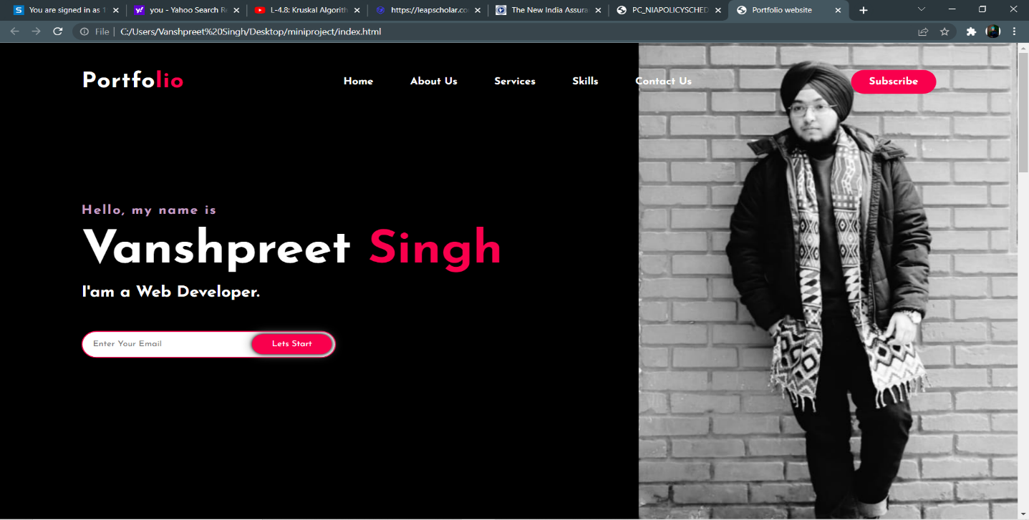

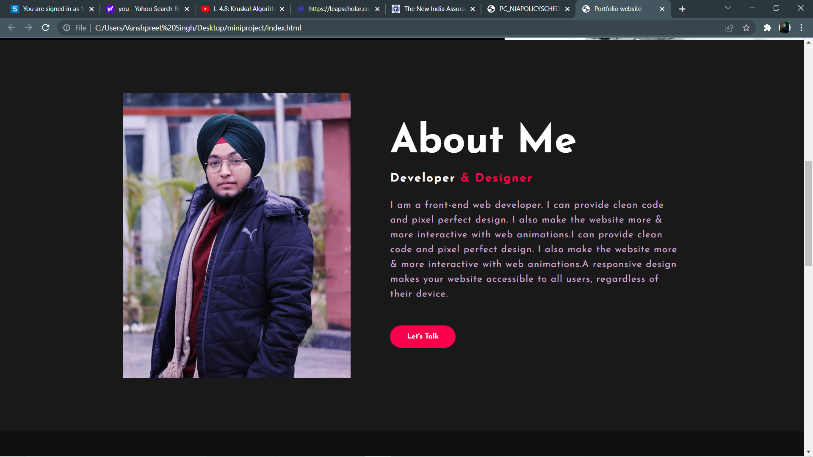

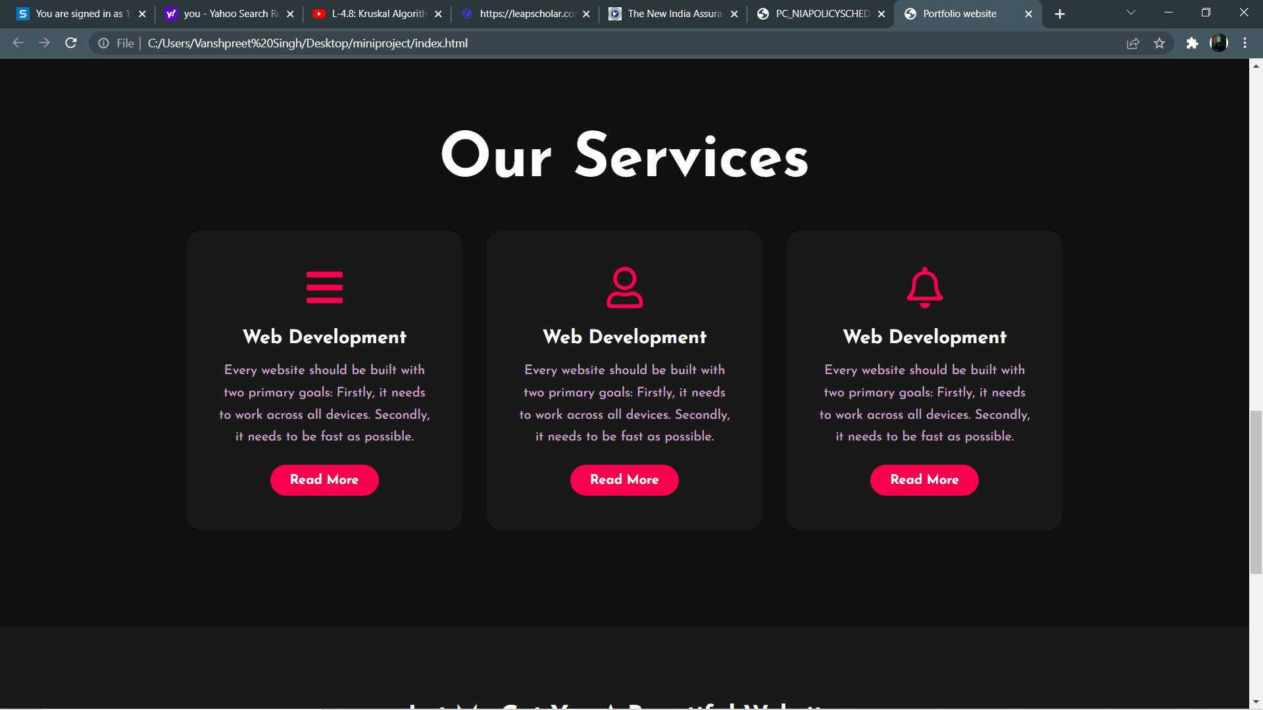

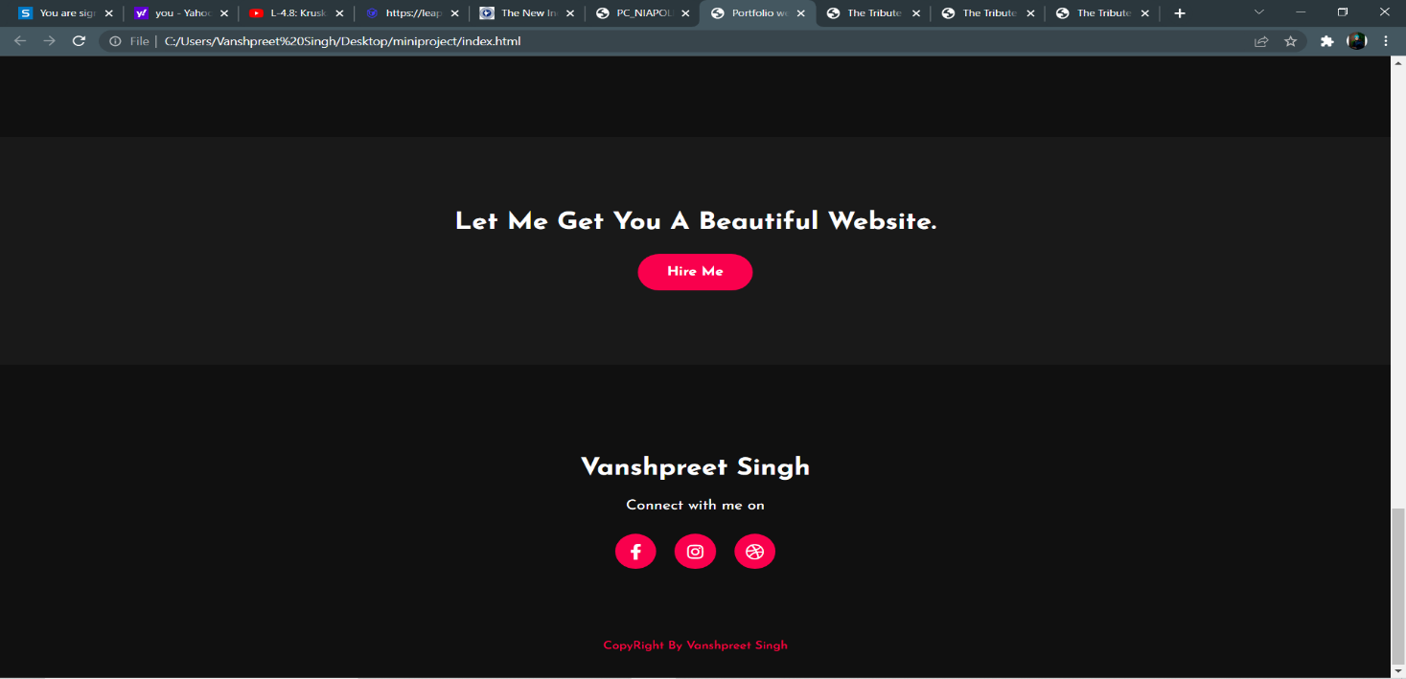

**DECLARATION**

This work is a presentation of my original research work.

Wherever contribution of others is involved, every effect is made to indicate this clearly.

With due respect and reference to literature and acknowledgement of collaborative research and discussions.

BIBLIOGRAPHY

* <https://dev.to/kunaal438/how-to-make-an-e-commerce-website-with-html-css-and-js-3aon>
* <https://www.w3schools.com/>
* <https://www.javatpoint.com/html-tutorial>