**BE-CSE (Artificial Intelligence)**

**PROJECT SYNOPSIS**

**ON**

**Next Word Predictor**

**SUBMITTED BY:**

**Divanshu Goyal (2110993885)**

**Guided by**

**Mr. Rahul Dogra**

**PROBLEM STATEMENT**

Around the world, people are spending an increasing amount of time on their mobile devices for email, social networking, banking and a whole range of other activities. Typing on mobile devices can be easier if you are presented option for what the next word might be. In this project we will be creating a model which will predict the next word of a sentence given its previous words and a corpus for training the model. We will train neural models and n-gram language models to predict the next word of a sequence.

**INTRODUCTION**

Natural Language Processing (NLP) is a signiﬁcant part of

artiﬁcial Intelligence, which incorporates AI, which con-

tributes to ﬁnding productive approaches to speak with

people and gain from the associations with them. One

such commitment is to give portable clients anticipated

”next words,” as they type along within applications, with

an end goal to assist message conveyance by having the

client select a proposed word as opposed to composing it.

As LSTM is Long short time memory it will understand

the past text and predict the words which may be helpful

for the user to frame sentences and this technique uses a

letter to letter prediction means it predicts a character to

create a word. As writing an essay and framing a big para-

graph are time-consuming it will help end-users to frame

important parts of the paragraph and help users to focus

on the topic instead of wasting time on what to type next.

Natural Language Processing (NLP) is a signiﬁcant part of

artiﬁcial Intelligence, which incorporates AI, which con-

tributes to ﬁnding productive approaches to speak with

people and gain from the associations with them. One

such commitment is to give portable clients anticipated

”next words,” as they type along within applications, with

an end goal to assist message conveyance by having the

client select a proposed word as opposed to composing it.

As LSTM is Long short time memory it will understand

the past text and predict the words which may be helpful

for the user to frame sentences and this technique uses a

letter to letter prediction means it predicts a character to

create a word. As writing an essay and framing a big para-

graph are time-consuming it will help end-users to frame

important parts of the paragraph and help users to focus

on the topic instead of wasting time on what to type next.

Natural Language Processing (NLP) is a signiﬁcant part of

artiﬁcial Intelligence, which incorporates AI, which con-

tributes to ﬁnding productive approaches to speak with

people and gain from the associations with them. One

such commitment is to give portable clients anticipated

”next words,” as they type along within applications, with

an end goal to assist message conveyance by having the

client select a proposed word as opposed to composing it.

As LSTM is Long short time memory it will understand

the past text and predict the words which may be helpful

for the user to frame sentences and this technique uses a

letter to letter prediction means it predicts a character to

create a word. As writing an essay and framing a big para-

graph are time-consuming it will help end-users to frame

important parts of the paragraph and help users to focus

on the topic instead of wasting time on what to type next

Natural Language Processing (NLP) is a signiﬁcant part of

artiﬁcial Intelligence, which incorporates AI, which con-

tributes to ﬁnding productive approaches to speak with

people and gain from the associations with them. One

such commitment is to give portable clients anticipated

”next words,” as they type along within applications, with

an end goal to assist message conveyance by having the

client select a proposed word as opposed to composing it.

As LSTM is Long short time memory it will understand

the past text and predict the words which may be helpful

for the user to frame sentences and this technique uses a

letter to letter prediction means it predicts a character to

create a word. As writing an essay and framing a big para-

graph are time-consuming it will help end-users to frame

important parts of the paragraph and help users to focus

on the topic instead of wasting time on what to type next

Natural Language Processing (NLP) is a signiﬁcant part of artiﬁcial Intelligence, which incorporates AI, which contributes to ﬁnding productive approaches to speak with people and gain from the associations with them. One such commitment is to give clients anticipated “next words,” as they type along within applications, with an end goal to assist message conveyance by having the client select a proposed word as opposed to composing it. As LSTM is Long short time memory it will understand the past text and predict the words which may be helpful for the user to frame sentences and this technique uses a letter-to-letter prediction means it predicts a character to create a word. As writing an essay and framing a big paragraph are time consuming it will help end users to frame important parts of the paragraph and help users to focus on the topic instead of wasting time on what to type next.

**FLOWCHART**

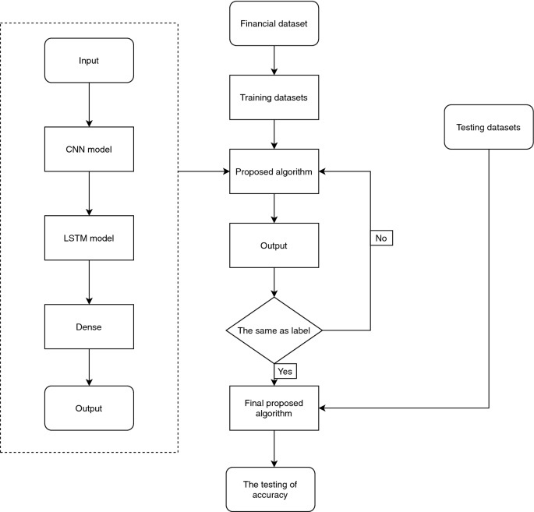

**PICTORIAL REPRESENTATION**

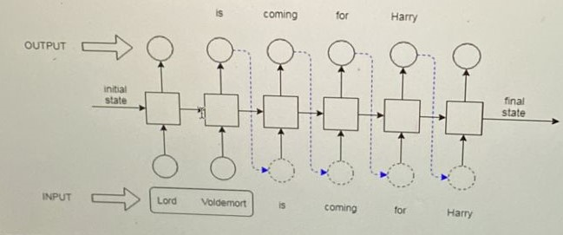

**TECHNOLOGY**

* Python
* TensorFlow
* NLTK
* Spacy

**CONCLUSION**

Our task in this project is to train and try an algorithm

that best ﬁt this task and mostly we are looking forward to

implementing an LSTM to get good accuracy as this task is

quite complex because we have to predict the user’s future

text which he will be thinking

At present we manage to understand the problem state-

ment as this problem is unique, we created a 3d vector

layer of input and a 2d vector layer for output and feed

through to the LSTM layer having 128 hidden layers and

manage to get accuracy to around 56% during 5 epochs

This paper presents how the system is predicting and

correcting the next/target words using some mechanisms

and using TensorFlow closed-loop system, the scalability

of a trained system can be increased and using the perplex-

ity concept the the system will decide that the sentence is

having more misspelled and the performance of the system

can be increased

Our task in this project is to train and try an algorithm

that best ﬁt this task and mostly we are looking forward to

implementing an LSTM to get good accuracy as this task is

quite complex because we have to predict the user’s future

text which he will be thinking

At present we manage to understand the problem state-

ment as this problem is unique, we created a 3d vector

layer of input and a 2d vector layer for output and feed

through to the LSTM layer having 128 hidden layers and

manage to get accuracy to around 56% during 5 epochs

This paper presents how the system is predicting and

correcting the next/target words using some mechanisms

and using TensorFlow closed-loop system, the scalability

of a trained system can be increased and using the perplex-

ity concept the the system will decide that the sentence is

having more misspelled and the performance of the system

can be increased

Our task in this project is to train and try an algorithm that best ﬁt this task and mostly we are looking forward to implementing an LSTM to get good accuracy as this task is quite complex because we have to predict the user’s future text which he will be thinking. This model presents how the system is predicting words using some mechanisms and using TensorFlow, the scalability of a trained system can be increased and using the perplexity concept the model will decide that the sentence is having more misspelled and the performance of the system can be increased.

**REFERENCES**

* Kaggle, YouTube etc.