UNIT – I
DIGITAL ELECTRONICS
Electronic Devices
Semiconductors · PN Junction Diodes · Rectifiers · Special Diodes
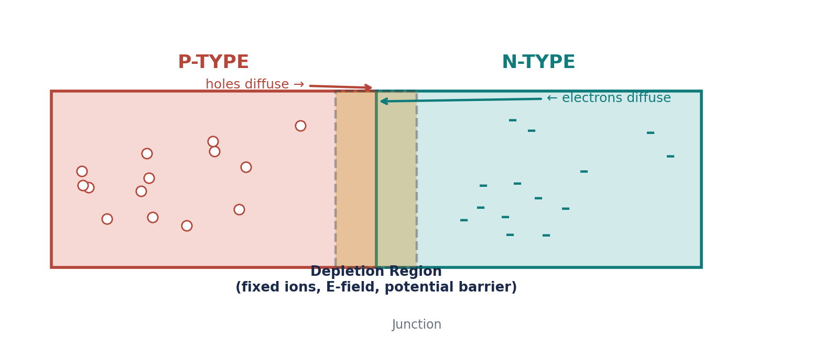
Beautified Revision Notes | Compiled with diagrams for quick visual recall
Prepared for: Vansh Garg | United University, Prayagraj

1 · Semiconductors — The Foundation
A semiconductor is a material whose electrical conductivity lies between that of a good conductor and a good insulator. Its conductivity can be controlled by temperature, light, electric field, and — most importantly — by adding a controlled amount of impurity.
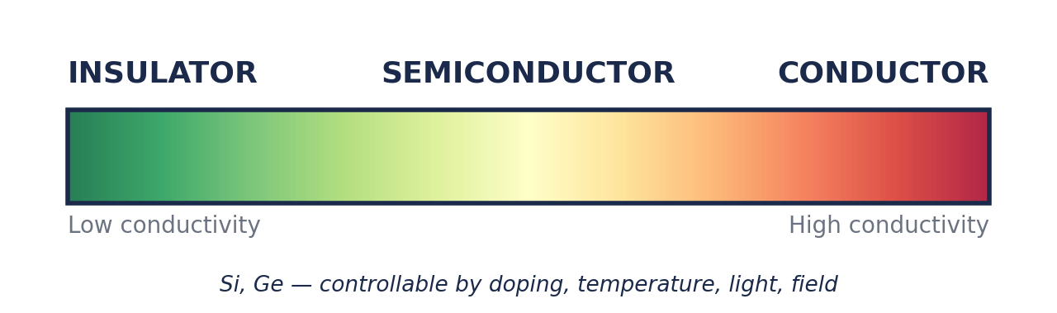

Common semiconductor materials
- Silicon (Si) — most widely used in practical electronics
- Germanium (Ge)

Used to manufacture
- Diodes, Transistors, Integrated circuits
- LEDs, Solar cells, Sensors, Switching devices
💡 Key idea
A semiconductor is not simply a “weak conductor” — its special value is that its electrical properties can be controlled.

Properties of semiconductors
- Conductivity lies between conductors and insulators
- Conductivity increases with temperature
- Conductivity can be greatly increased by doping
- Both electrons and holes carry current
- Conductivity is controllable → makes semiconductor devices possible
n = p = nᵢ (intrinsic semiconductor: electrons = holes = intrinsic concentration)

2 · Intrinsic vs. Extrinsic Semiconductors
An intrinsic semiconductor is pure — no intentional impurity added (e.g. pure Si or Ge). When thermal energy breaks a covalent bond, it produces one free electron and one hole — an electron-hole pair.
An extrinsic semiconductor has its conductivity increased by deliberately adding impurity — a process called doping. Extrinsic semiconductors are of two types: P-type and N-type.
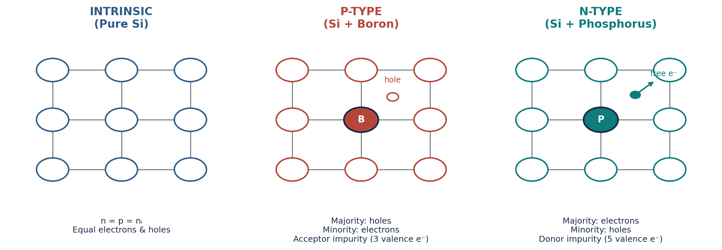
Intrinsic silicon vs. P-type (trivalent doping) vs. N-type (pentavalent doping)

Doping impurities
Impurity Type | Valence e⁻ | Produces | Examples
Trivalent (Acceptor) | 3 | P-type | Boron, Aluminium, Gallium, Indium
Pentavalent (Donor) | 5 | N-type | Phosphorus, Arsenic, Antimony

💡 Don't confuse
Doping = adding impurity. Diffusion = movement of carriers from high to low concentration.

3 · P-type vs. N-type Semiconductors
P-type | N-type
Trivalent impurity | Pentavalent impurity
Majority carriers: holes | Majority carriers: electrons
Minority carriers: electrons | Minority carriers: holes
Acceptor impurity | Donor impurity
Common: Boron | Common: Phosphorus

💡 Memory aid
P-type → P → “Positive” → holes (memory aid only — the material as a whole is electrically neutral). N-type → electrons are majority carriers.

4 · Charge Carriers & the Mass-Action Law
The two mobile charge carriers are electrons (charge −q) and holes (charge +q), where q = 1.6 × 10⁻¹⁹ C.
ρₙ = −qn ρₚ = +qp n·p = nᵢ² (Mass-Action Law)
Material | Carrier relation
Intrinsic | n = p
N-type | n > p
P-type | p > n

5 · Formation of the PN Junction
When a P-type semiconductor is joined to an N-type semiconductor, a PN junction is formed. Before contact, the P-side is rich in holes and the N-side is rich in electrons. After contact, concentration differences drive diffusion: electrons move N→P and holes move P→N. Near the junction they recombine, leaving behind fixed charged ions that establish an electric field — creating a carrier-depleted zone.
Diffusion of carriers across the junction creates the depletion region

Depletion region
Region around the junction depleted of mobile carriers, containing mainly fixed ionized atoms. It produces an electric field that acts as a barrier to further diffusion — also called the space-charge region.
Bias condition | Effect on depletion region
Forward bias | Becomes narrower
Reverse bias | Becomes wider

Potential barrier (built-in potential)
The fixed ions create a built-in potential difference across the junction.
Silicon ≈ 0.7 V Germanium ≈ 0.3 V
💡 Don't confuse
Potential barrier = built-in junction voltage. PIV = maximum reverse voltage a diode must withstand in a circuit.

6 · Diffusion Current vs. Drift Current
Diffusion Current | Drift Current
Caused by concentration gradient | Caused by electric field
High → low concentration movement | Field-driven carrier motion
e⁻ diffuse N→P, holes diffuse P→N | Opposes diffusion at equilibrium

At thermal equilibrium the two currents balance: |I_diffusion| = |I_drift|, so the net current I_net = 0. Individual carrier motion continues — only the net current cancels.

7 · Biasing — Forward & Reverse
Biasing means applying an external voltage across the PN junction, in one of two ways:
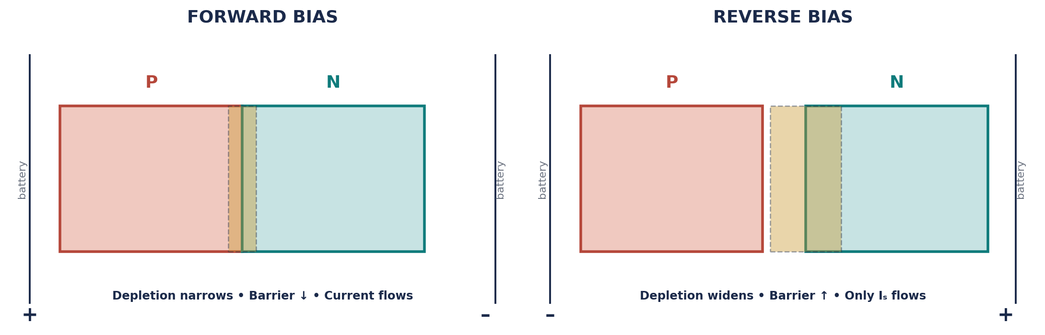
Forward Bias | Reverse Bias
P → (+), N → (−) | P → (−), N → (+)
Opposes built-in barrier | Supports junction field
Depletion region narrows | Depletion region widens
Barrier decreases | Barrier increases
Significant current flows (Si ≈ 0.7V drop) | Only small Iₛ flows until breakdown

💡 Memory
Forward bias → P to Positive → conducts. Reverse bias → P to Negative → blocks.

8 · V-I Characteristics & Reverse Saturation Current
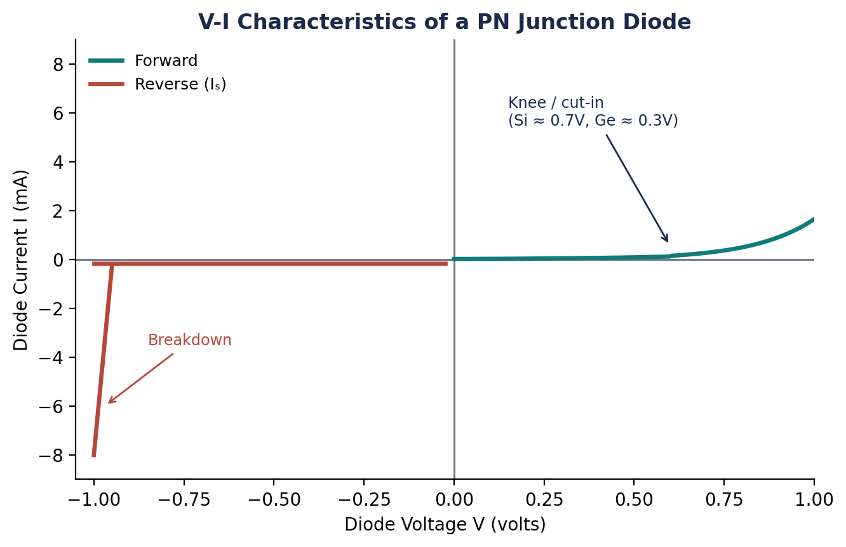
Forward: at small voltage, current is tiny; past the knee/cut-in point current rises rapidly (Si ≈ 0.7 V, Ge ≈ 0.3 V). Reverse: only the small reverse saturation current Iₛ (mainly minority carriers) flows — until breakdown, when reverse current increases sharply.

9 · Breakdown of a PN Junction
Excessive reverse voltage drives the junction into breakdown, via two distinct mechanisms:
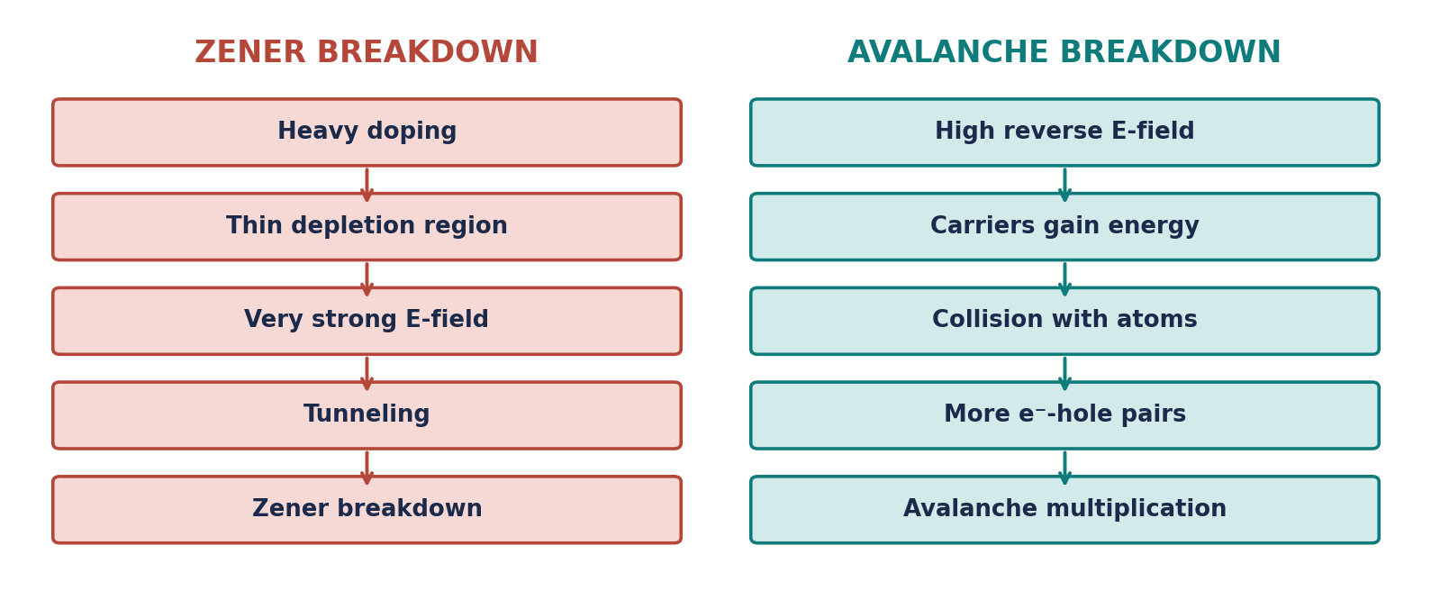
Zener Breakdown | Avalanche Breakdown
Tunneling (quantum-mechanical) | Impact ionization
Heavily doped junction | Relatively lightly doped
Very thin depletion region | Wider depletion region
Strong electric field | High-energy carrier collisions

10 · Rectifiers — Converting AC to DC
A rectifier converts AC into pulsating DC, exploiting the diode's one-directional conduction. Three main types: half-wave, full-wave center-tapped, and bridge.
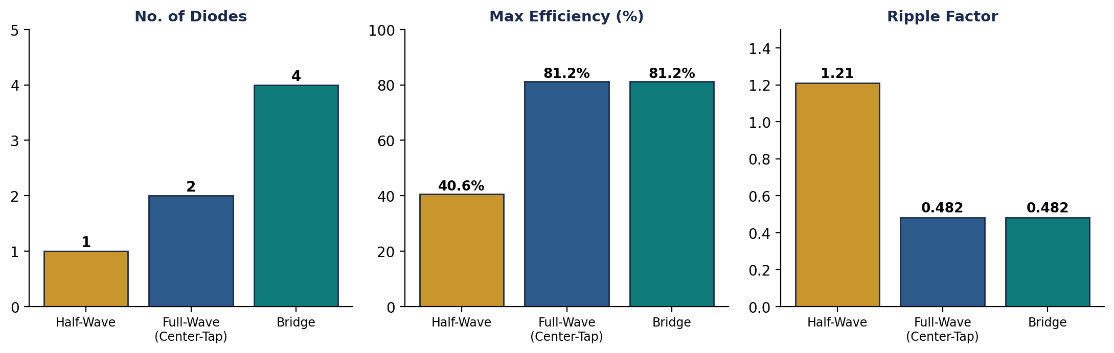
Quantity | Half-Wave | Full-Wave (Center-Tap) | Bridge
Diodes | 1 | 2 | 4
Uses both half-cycles | No | Yes | Yes
Max efficiency | 40.6% | 81.2% | 81.2%
Ripple factor | 1.21 | 0.482 | 0.482
Ripple frequency | f | 2f | 2f
PIV / diode | Vₘ | 2Vₘ | Vₘ
Center-tap needed | No | Yes | No

💡 Common exam trap
Center-tapped full-wave PIV = 2Vₘ — Bridge PIV = Vₘ. Do not mix these up.

Bridge rectifier — practical note
Two diodes conduct in series each half-cycle, so total drop ≈ 2 × 0.7 V = 1.4 V for silicon. Advantage: no center-tapped transformer needed, and lower PIV per diode.

11 · Ripple Factor, PIV & Efficiency
r = √((Vrms/Vdc)² − 1) PIV(half-wave) = Vₘ η = (DC output power / AC input power) × 100%
Parameter | Half-Wave | Full-Wave
Ripple factor | 1.21 | 0.482
Max efficiency | 40.6% | 81.2%
Ripple frequency | f | 2f

Lower ripple factor = smoother DC output. A filter capacitor further reduces ripple. Full-wave output is smoother and more efficient than half-wave.

12 · Clipper vs. Clamper vs. Voltage Doubler
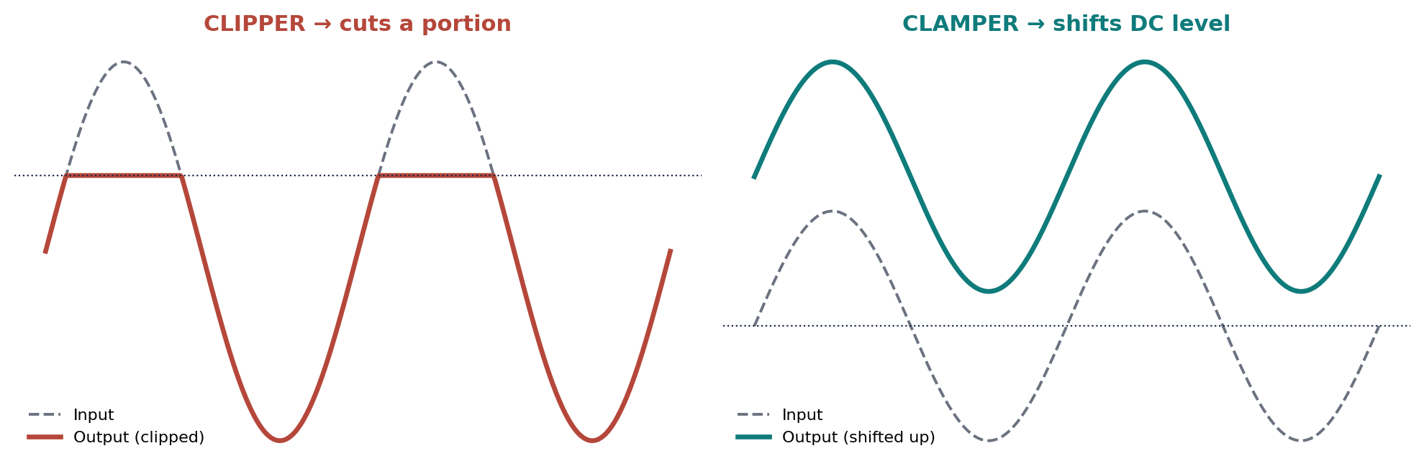
Clipper | Clamper
Cuts a portion of the waveform | Shifts the entire waveform up/down
Waveform limiting / protection | Adds a DC level
Think: CUT | Think: SHIFT

A voltage doubler is a diode-capacitor circuit producing output ≈ 2Vₘ under ideal, no-load conditions. Practical output is lower due to diode drops, capacitor losses, and load current.
Vout ≈ 2Vₘ (Voltage Doubler)

13 · Special Diodes — Zener, Tunnel, Varactor

Zener diode
Designed to operate in reverse breakdown, where voltage stays approximately constant (Vz) over a range of currents — used for voltage regulation and reference. In a simple regulator with a series resistor, Vout ≈ Vz across the normal operating range.

Tunnel diode
Very heavily doped → extremely thin depletion region → quantum tunneling → a unique negative resistance region (current decreases as voltage increases). Used in high-speed switching, oscillators, and high-frequency circuits.

Varactor diode
Operated in reverse bias; behaves as a voltage-controlled capacitor. As reverse voltage increases, depletion widens and junction capacitance decreases. Used for electronic tuning, VCOs, and RF circuits.
Tunnel Diode | Varactor Diode
Heavily doped, thin depletion region | Reverse-biased variable-capacitance junction
Tunneling → negative resistance | Voltage-controlled capacitance
High-speed switching, oscillators | Tuning, VCOs, RF circuits

14 · Formula Sheet — Quick Reference
q = 1.6 × 10⁻¹⁹ C n = p = nᵢ (intrinsic) n·p = nᵢ²
Silicon barrier/forward drop ≈ 0.7 V Germanium ≈ 0.3 V
Half-wave: η = 40.6%, r = 1.21, PIV = Vₘ, fᵣ = f
Full-wave: η = 81.2%, r = 0.482, fᵣ = 2f | Center-tap PIV = 2Vₘ | Bridge PIV = Vₘ
Voltage doubler: Vout ≈ 2Vₘ Capacitor: C = Q/V

15 · The Big-Picture Chain
The professor's key advice: understand the causal chain rather than memorizing disconnected facts.
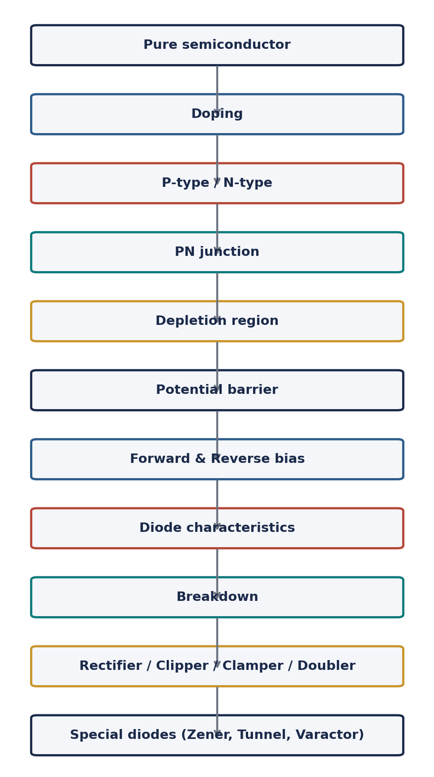
💡 Before any numerical problem, ask
1. What circuit is this? 2. Forward or reverse biased? 3. Which quantity is asked? 4. Efficiency, ripple, PIV, voltage, current, or frequency? 5. Which standard formula applies?

UNIT – I COMPLETE · Study. Revise. Solve. Repeat.

