Practical - 3
Practical Title: Responsive UI Design using CSS2.0/CSS3.0, CSS Grid and Flexbox

Problem Definition: Design responsive layouts for Home, About, Registration, Dashboard, and Events pages using CSS Grid and Flexbox. Optional to use a CSS framework such as Bootstrap or Tailwind. Ensure mobile-first responsiveness.

Theory

1. How does the layout adapt for mobile, tablet, and desktop screens?
Answer: A mobile-first approach was used - base CSS is written for small screens first (single column, stacked navigation), then media queries such as @media (min-width: 768px) for tablet and @media (min-width: 1024px) for desktop add multi-column layouts as the screen grows. Flexbox is used on the navbar so menu items wrap into a stacked/hamburger style on mobile and a horizontal row on desktop. CSS Grid is used on the Events and Dashboard cards so they rearrange from 1 column on mobile to 3-4 columns on desktop.

2. Which layout technique is used and why?
Answer: Flexbox is used for one-dimensional layouts like the navbar, button groups, and form rows since it is simplest for aligning items in a single row or column. CSS Grid is used for two-dimensional layouts like the Events and Dashboard cards since it controls rows and columns together with grid-template-columns, which is harder to do cleanly with Flexbox alone.

3. Are typography, spacing, colors, and contrast readable?
Answer: A consistent type scale using rem units keeps text readable and lets it scale with the user's browser settings, with enough line-height for body text. Spacing follows a consistent scale (multiples of 8px) using CSS variables. Text and background colors were checked for sufficient contrast so content stays readable in bright light and for users with low vision.

4. Is the framework used consistently without unnecessary inline CSS?
Answer: All styling is written in the external style.css file (with Bootstrap utility classes where used) - no inline style="" attributes were added to any element, so the design can be changed from one place without touching the HTML.

Implementation/ Output/Result
Flexbox was used for the navbar and Grid for the card-based sections, with mobile-first media queries. Sample CSS:
nav {
display: flex;
justify-content: space-between;
flex-wrap: wrap;
}

.event-grid {
display: grid;
grid-template-columns: repeat(auto-fit, minmax(220px, 1fr));
gap: 16px;
}

nav a {
color: #222222;
margin-left: 20px;
text-decoration: none;
}

Evidence of Work (Screenshots)
Home page :
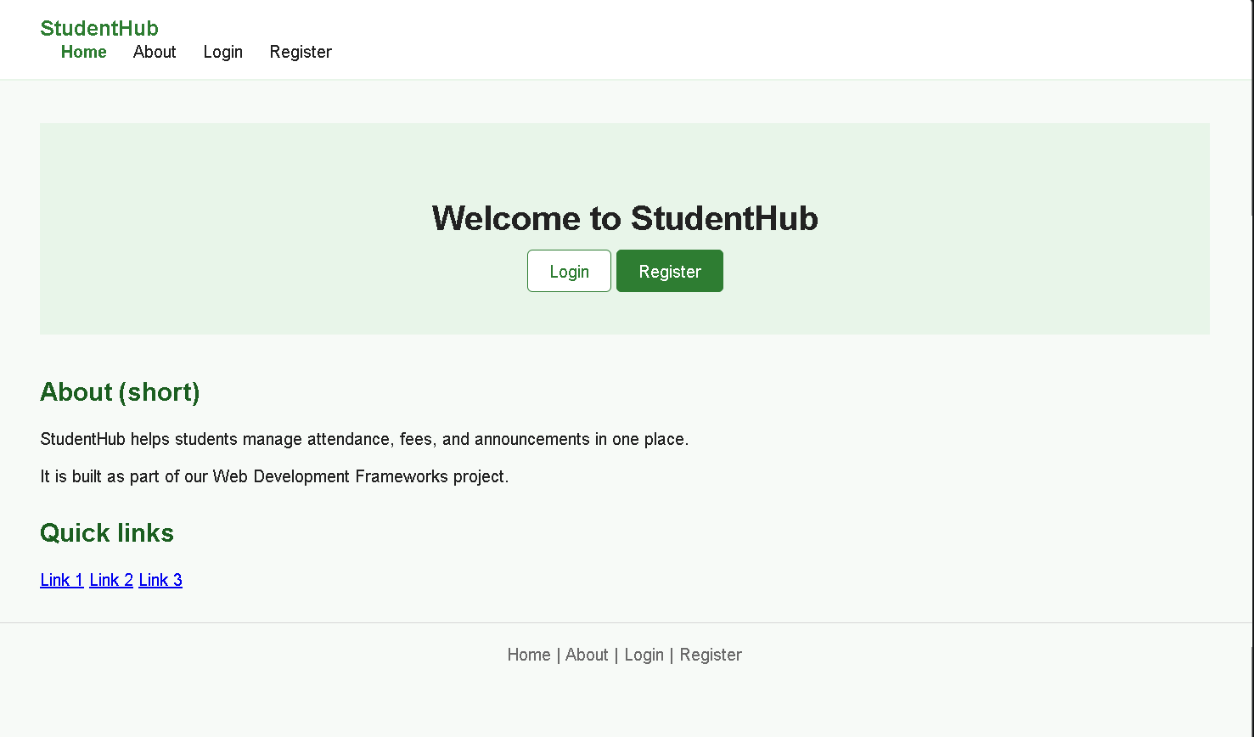

Login page :
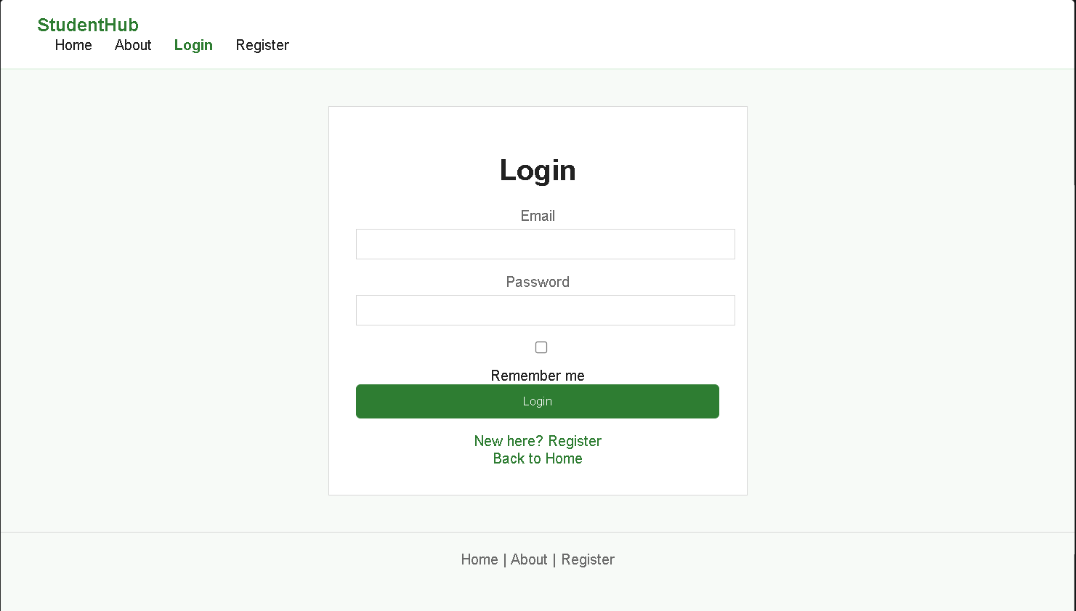

Register page :
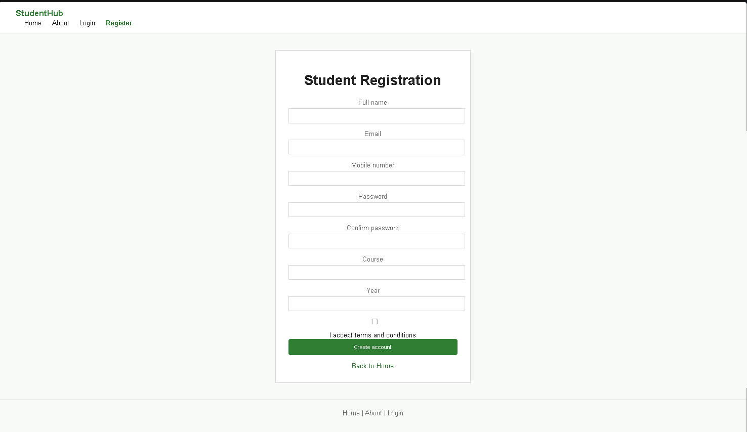

About page

Attendance page :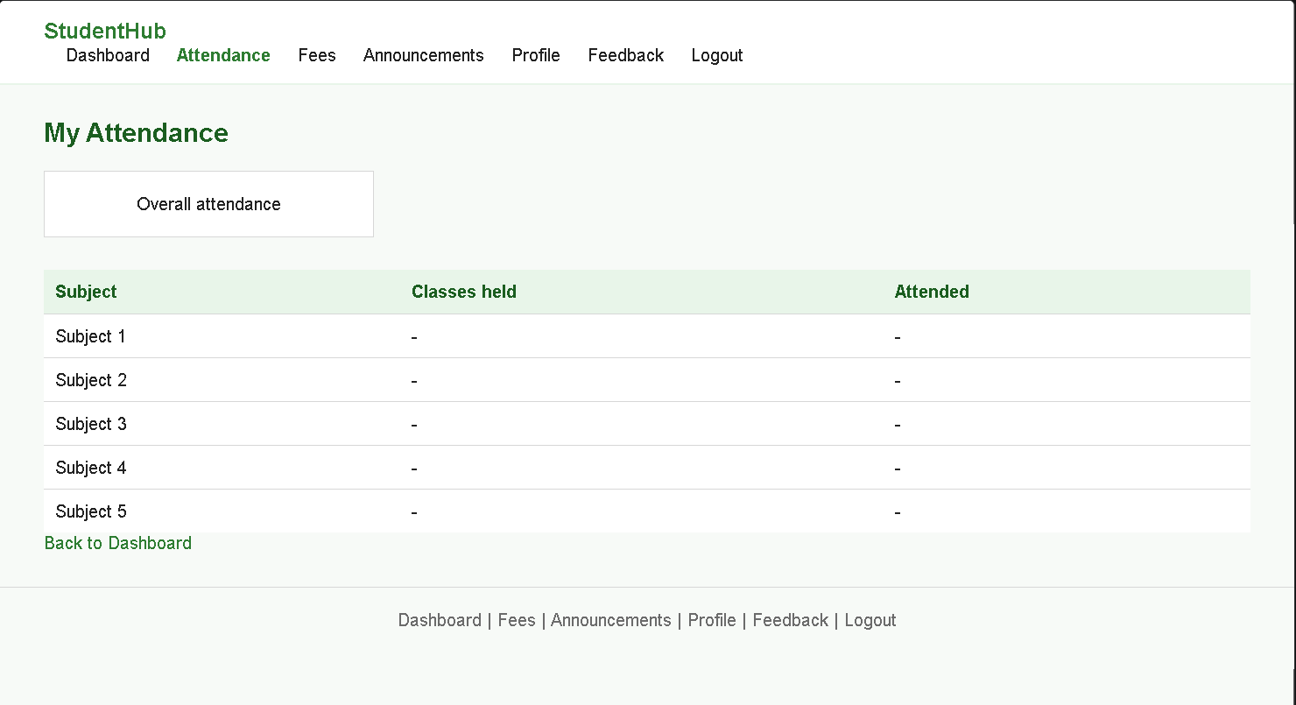

Fees page :

Announcements page :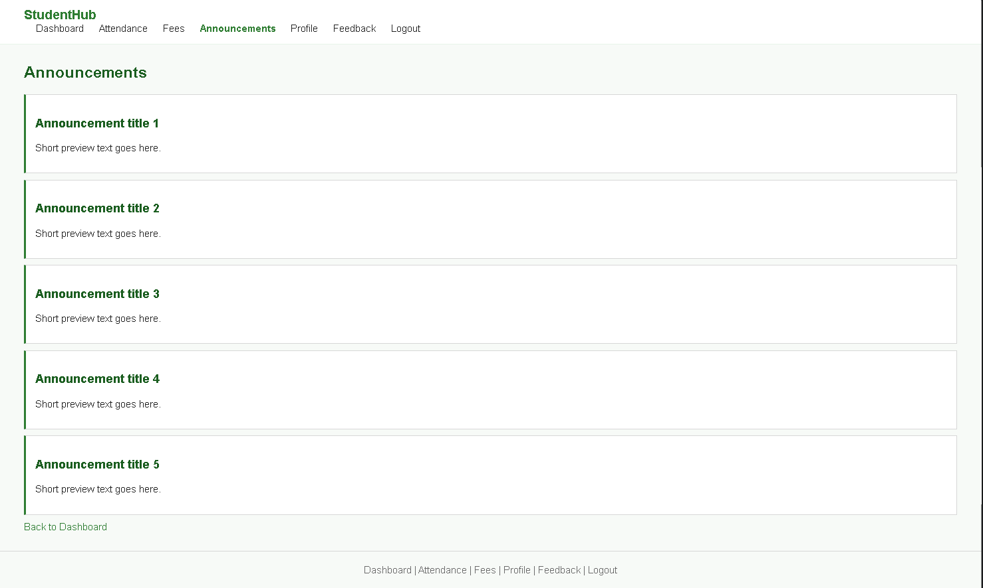

Profile page :
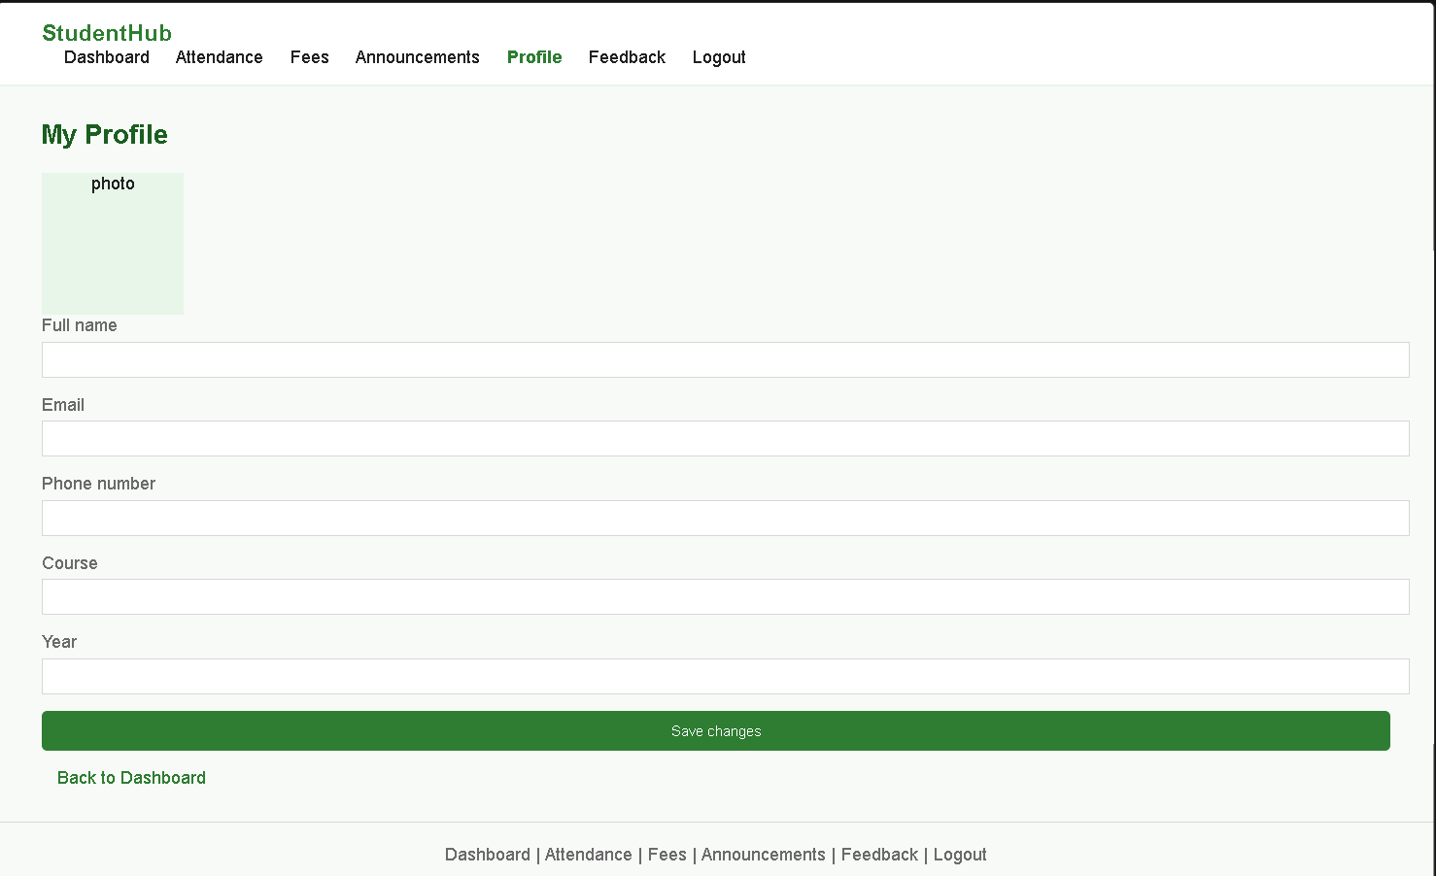

Feedback Page :
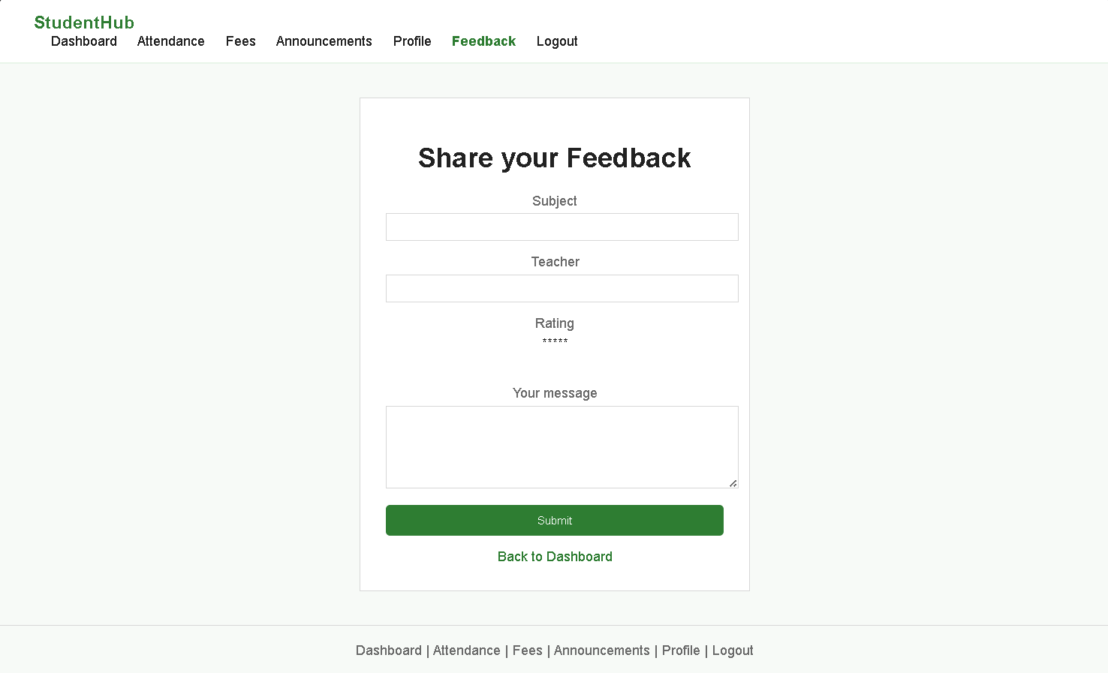

GitHub Repository Link:
https://github.com/vanshsavaliya-bit/WEB-DEVELOPMENT

Challenges Faced:

Getting the Events card grid to look right on both a small phone and a wide monitor took a few tries - using a fixed number of columns instead of auto-fit/minmax caused broken layouts at odd screen widths. Switching to grid-template-columns: repeat(auto-fit, minmax(220px, 1fr)) fixed it.

Learning Outcomes:

Learned the practical difference between Flexbox and Grid and when to use each. Understood mobile-first responsive design using media queries, and practiced testing layouts with the browser's device toolbar.

Faculty Remarks:

