BCSE497J Project-I
Review 2

PLANT PULSE

22BCE0251 OM PRAKASH BHAGAT
22BCE0759 VANSH SEHGAL
22BCE2690 DIVYANSH KUMAWAT

Under the Supervision of
ANISHA M. LAL

Designation
School of Computer Science and Engineering (SCOPE)

B.Tech.
in
Computer Science and Engineering

School of Computer Science and Engineering



September 2025
ABSTRACT

The rapid emergence and spread of plant diseases pose a serious challenge to global agricultural sustainability, often leading to significant crop losses and economic damage. In recent years, plant diseases have increasingly constrained agricultural productivity, with traditional detection and management methods relying on manual inspection, which is slow, labor-intensive, and prone to human error.

This work presents a deep learning-based approach using Convolutional Neural Networks (CNNs) for accurate plant disease detection. The model is trained on a large dataset of more than 65,000 images across 37 disease categories, employing data augmentation and the Adam optimizer to improve the efficiency and accuracy of training. The architecture consists of multiple convolutional layers for extracting features, pooling layers for dimensionality reduction, and a softmax classifier to identify specific diseases. To support users further, the system includes an FAQ chatbot powered by sentence embedding methods, allowing queries related to detected diseases and serving as both a diagnostic and educational tool for farmers and agricultural experts.

The model applies the Rectified Linear Unit (ReLU) activation function to capture complex features, while the Adam optimizer ensures rapid convergence. Data augmentation techniques are utilized to increase robustness and minimize overfitting. Experimental results show that the model reaches a 95% accuracy rate, confirming its reliability in recognizing diverse plant diseases. By integrating advanced deep learning models with conversational AI, this research provides both accurate detection and interactive guidance, offering practical support for disease management in resource-constrained agricultural environments.

Keywords: Plant Disease Detection, Convolutional Neural Networks, Deep Learning, Agricultural Technology, Chatbot, Artificial Intelligence

TABLE OF CONTENTS

Sl.No | Contents | Page No.
 | Abstract | 1
1. | INTRODUCTION | 4
 | 1.1 Background | 4
 | 1.2 Motivations | 4
 | 1.3 Scope of the Project | 5
2. | PROJECT DESCRIPTION AND GOALS | 6
 | 2.1 Literature Review | 6
 | 2.2 Gaps Identified | 8
 | 2.3 Objectives | 9
 | 2.4 Problem Statement | 9
 | 2.5 Project Plan | 10
3. | REQUIREMENT ANALYSIS * | 11
 | 3.1 Functional Requirements | 11
 | 3.2 Non-Functional Requirements | 12
4. | SYSTEM DESIGN* | 13
 | 4.1 System Architecture | 13
 | 4.2 Data Flow Diagram | 13
 | 4.3 Use Case Diagram | 14
 | 4.4 Sequence Diagram | 14
 | 4.5 Class Diagram | 15
5. | REFERENCES

1. INTRODUCTION
1.1 Background
Plants are fundamental to life on Earth, serving as sources of food, oxygen, and essential raw materials for human survival. However, plant health is consistently endangered by diseases caused by pathogens such as fungi, bacteria, and viruses. These diseases can result in major agricultural losses, reduced yields, and threats to food security. Timely and accurate identification of plant diseases is therefore crucial for maintaining productivity and achieving sustainable agriculture.
Plant diseases can generally be grouped into three types based on their origin: (i) fungal diseases, such as rust and powdery mildew, (ii) bacterial diseases, including bacterial spots and blight, and (iii) viral diseases, such as the yellow leaf curl virus. These diseases produce visible symptoms such as spots on leaves, discoloration, or deformities, which hinder processes like photosynthesis, nutrient uptake, and overall plant growth. Without prompt detection and management, they can spread quickly, leading to widespread damage and financial losses.
Conventional diagnosis of plant diseases typically relies on expert visual inspection, which is labor-intensive, slow, and susceptible to human error. In places with limited agricultural resources, where expert assistance is not readily available, disease identification becomes even more difficult. Technological progress, especially in fields like artificial intelligence and deep learning, provides new opportunities to overcome these barriers.

1.2 Motivation
This project is driven by the pressing need to improve the accuracy and efficiency of plant disease detection in agriculture. Diagnosing diseases is often challenging, as many symptoms overlap with nutrient deficiencies or environmental stress factors, making correct identification difficult. Incorrect or delayed diagnoses can result in extensive crop loss, lower productivity, and financial strain for farmers. Accurate and timely detection is therefore essential for food security and sustainable farming.
The inspiration behind this work comes from the potential of technology to reduce the gap in agricultural diagnostics. Farmers in remote or resource-limited areas often lack access to experts and instead rely on assumptions or late interventions, which worsen the severity of the damage. With advancements in artificial intelligence, deep learning in particular provides an opportunity to automate diagnosis and supply farmers with meaningful, accurate, and immediate insights.

1.3 Scope of the Project
This project focuses on applying deep learning and artificial intelligence to plant disease detection with the aim of improving productivity, minimizing crop losses, and supporting food security. Traditional disease diagnosis, often based on manual inspection, is slow, error-prone, and inaccessible in many rural or resource-limited settings. Hence, an automated, accurate, and user-friendly system is essential for early identification and effective disease management.
To achieve this, a Convolutional Neural Network (CNN) is developed to identify and classify plant diseases from leaf images. The model employs convolutional and pooling layers for feature extraction, along with data augmentation for robustness and generalization. A Softmax classifier enables accurate categorization across multiple disease classes, making it adaptable to diverse crops.
The project also integrates an FAQ chatbot powered by sentence embeddings, enabling farmers to query the system and receive tailored information and guidance. Trained on over 65,000 images spanning 37 disease categories, the system is rigorously evaluated for accuracy, efficiency, and usability. Designed to operate even on low-resource devices, the project offers a scalable, accessible, and farmer-friendly tool to support sustainable and technology-driven agriculture.
2. PROJECTDESCRIPTIONANDGOALS
2.1 Literature Review
Ref No. | Paper Title | Year | Techniques Used | Dataset Details | Accuracy | Features | Limitations | Observations
1 | Semantic segmentation for plant leaf disease detection and segmentation | 2024 | CNN, U-Net, Otsu’s Thresholding, Edge Detection & Pixel Counting | Plant Village dataset | 96.97% | Image segmentation, Severity estimation, Remedy prediction | Computational resources, Overfitting, Limited generalization, Dataset dependency | Focuses on disease detection and severity classification
2 | Innovative deep learning approach for cross-crop plant disease detection | 2024 | Small Inception model | PlantVillage dataset | 94.04% | Small leaf region disease detection, architecture enhances performance | Limited generalization on crops not in training | Efficient across multiple crops
3 | Improving deep learning-based plant disease classification with attention mechanism | 2024 | CBAM with CNN + Transfer Learning (EfficientNetB0, ResNet50, etc.) | DiaMOS Plant dataset (pear leaves) | 86.89% | Attention mechanism improves classification | Computational complexity, model dependency | EfficientNetB0 with CBAM performed best
4 | Shuffled Shepherd Social optimization-based deep learning for rice leaf disease classification | 2023 | Shuffled Shepherd Social Optimization, Deep Learning, Deep LSTM, Maxout Networks | Rice leaf dataset | 92.60% | Severity prediction, Classification | High complexity, Model dependency | Outperformed BLSNet and RSW-based methods
5 | Construction of deep learning-based disease detection model in plants | 2023 | CNN with five pre-trained models | Diseased-healthy paired dataset | 97.09% | Three-step classification | Low accuracy for non-model crops | Potential application in smart farming
6 | CPD-CCNN: classification of pepper disease | 2023 | Concatenated CNN (VGG16 + AlexNet) | Pepper dataset | 95.82% | Concatenation of features improves accuracy | Model complexity | High accuracy with concatenated features
7 | Image processing & transfer learning for rust disease detection | 2023 | CNN (Xception, ResNet50, EfficientNetB4, MobileNet) | 857 positive + 907 negative samples | 94.29% | Rust detection | Variability with optimizers | EfficientNetB4 performed best
8 | DeepCrop: deep learning-based crop disease prediction with web application | 2023 | CNN, VGG-16, VGG-19, ResNet-50 | PlantVillage (10,000 images) | 98.98% | Web application built, Crop disease prediction | Limited to dataset | ResNet-50 best, applied to real-life via web app
9 | Cotton leaf segmentation with composite backbone | 2023 | CoAtNet, Xception | Cotton leaf dataset | 94% | Leaf segmentation | Requires extensive resources | Outperformed benchmark models
10 | Comparative study on plant disease detection using ML | 2023 | Random Forest, XGBoost, CNN | Multi-crop dataset (15,000 images) | 95.20% | Multi-class detection | High computation | Hybrid models improve accuracy
11 | Automatic detection and severity analysis of grape black measles disease | 2022 | ResNet50-based DeepLabV3+, fuzzy logic | Grape disease images | 97.75% | Severity analysis | Complexity in fuzzy logic implementation | Combines deep learning with fuzzy logic
12 | Plant leaf disease recognition using CNN | 2022 | CNN, AlexNet | 20,000 images (multi-species) | 95.80% | Fast classification | Limited species | Suitable for small/medium datasets

2.2 Gaps Identified
Despite extensive progress in leveraging deep learning for plant disease detection, critical gaps still persist that limit the broader applicability and scalability of current solutions. A significant issue lies in the overreliance on small and homogeneous datasets, such as the PlantVillage dataset, which dominate the research landscape. While they provide a controlled environment for benchmarking, these datasets fail to reflect the diverse conditions of real-world agricultural settings. In practice, factors such as inconsistent lighting, variation in leaf orientation, complex background noise, and mixed disease severity levels lead to performance degradation when models trained in laboratory settings are deployed on farms. This lack of data diversity directly impacts the generalization capabilities of otherwise high-performing architectures.
Another noticeable research gap is the challenge of early and subtle disease symptom identification. Most models are tuned to detect well-developed disease characteristics but struggle when symptoms are faint, small in size, or in their incubation stages. This issue is compounded by inadequate utilization of advanced data augmentation techniques and insufficient experimentation with underrepresented crops or rare disease classes. Consequently, models tend to perform unevenly across different crops, excelling in one species while underperforming in others. While some studies explore transfer learning and ensemble strategies to broaden generalization, their computational demands remain a barrier for low-cost or edge-based solutions required in farming environments.
Equally important is the concern of computational efficiency and deployment feasibility. High-performing architectures, including ensembles or sophisticated attention-based CNNs, often involve high complexity, which limits their real-time applicability on portable devices. This creates a gap between research outcomes and practical field use, where connectivity, processing power, and storage are constrained. The design of lightweight yet accurate models suited for mobile or edge environments has not received sufficient attention, especially considering the urgency of providing farmers with timely and accessible disease detection.
Furthermore, most current studies predominantly focus on classification or segmentation tasks without extending their contributions towards user-friendly applications. While some initiatives propose mobile-based systems and web platforms, the integration of more interactive and decision-support oriented tools such as chatbots, voice-assisted advisors, or predictive recommendation engines remains underexplored. Farmers ultimately require actionable insights that guide them toward treatment methods, prevention strategies, and yield optimization, not merely classification outputs. The narrow scope of existing solutions represents a major research-to-practice gap that must be addressed for large-scale agricultural adoption.

2.3 Objectives
The objective of this research is to develop and validate a deep learning-based model for plant disease detection and classification from images. The model aims to achieve an accuracy of over 95% across 10 different crop types, covering 37 disease classes. To ensure reliable performance, the system will incorporate preprocessing techniques such as data augmentation and normalization and employ Convolutional Neural Networks (CNNs) for effective feature extraction. In addition, a user-friendly chatbot interface will be integrated to provide farmers with real-time, actionable information about the detected diseases. The model’s performance will be evaluated on diverse plant disease datasets to test its robustness and applicability, particularly in resource-constrained regions. This research seeks to make disease detection more accessible for farmers, enabling timely management, improved yield, and better agricultural practices.

2.4 Problem Statement
Plant diseases can severely affect crop health, leading to reduced yields, financial losses for farmers, and food insecurity. Early and accurate detection is essential for effective disease management and sustainable agriculture. However, current diagnostic methods rely heavily on visual inspections and manual analysis by farmers or experts, which are time-consuming, prone to human error, and inaccessible in many resource-limited regions. The challenge is that plant diseases vary widely in appearance, with symptoms often resemble those of other diseases or environmental stresses. Moreover, the presence of multiple diseases on a single plant or across different crops further complicates diagnosis, making it difficult for farmers to take timely and accurate decisions. This underscores the need for an automated, reliable, and efficient system that can accurately detect plant diseases from images, reducing farmers’ burden and enabling faster, more precise decisions, especially in areas lacking agricultural expertise. By applying deep learning techniques like Convolutional Neural Networks (CNNs) and integrating a user-friendly FAQ chatbot for disease-related queries, the proposed system aims to enhance detection efficiency, robustness, and accessibility. This approach can support farmers in resource-constrained settings, improve crop health, and boost agricultural productivity, addressing critical challenges in global food security and sustainable farming practices.

2.5 Project Plan
Week | Activities and Milestones | Deliverables
Week 1-2: Data Collection & Preprocessing | Identify reliable data sources for plant disease images, ensuring diversity in plant species, diseases, and environments. | Data Collection Report detailing sources, image types, formats, and preprocessing methods such as augmentation and normalization.
 | Collect and consolidate multiple datasets to build a comprehensive dataset with properly labeled disease types and attributes. | Preprocessed Dataset composed of cleaned, normalized, and augmented images, ready for training.
 | Clean data by normalizing images (resizing, scaling pixel intensities), augmenting images (rotation, flipping, scaling, color jitter), and removing corrupted or irrelevant files. | Documentation describing all preprocessing steps including data cleaning, normalization, augmentation, and other transformations.
 | Correct inconsistencies in labels and annotations and resize images to fit model input requirements.
Week 3-4: Model System Architecture Design | Research and evaluate suitable architectures for plant disease classification (CNN, ResNet, VGG, etc.), considering dataset size and multiclass capability. | Model Architecture Design Document outlining the selected model, layer configuration, and reasoning.
 | Design the system architecture including the number of layers (convolutional, pooling, fully connected), activation functions (ReLU, Softmax), and multiclass output structure. | Flow Diagrams illustrating data flow through the model layers and component interactions.
 | Define the input pipeline detailing how images will be fed and preprocessed during training (resizing, augmentation). | Decision Rationale explaining the selection factors such as model complexity, performance, and scalability.
Week 5-6: Model Training | Prepare the training environment, including software (TensorFlow, Keras, PyTorch) and hardware (GPUs, TPUs). | Training Logs and Metrics documenting accuracy, loss, and other performance indicators during epochs.
 | Train the initial model on the preprocessed dataset, setting hyperparameters like learning rate, batch size, and optimizer (Adam, SGD). | Initial Model Checkpoints saved periodically for recovery or fine-tuning.
 | Monitor training metrics and adjust procedures to avoid overfitting. | Documentation of training configurations specifying all parameters and settings.
Week 7-8: Model Testing & Validation | Develop testing and validation strategies including metrics such as accuracy, precision, recall, F1-score, and confusion matrix. | Validation Report outlining performance results with all relevant metrics.
 | Evaluate the trained model on an unseen validation dataset to assess generalization. | Analysis of Model Performance describing errors, misclassifications, and areas for improvement.
 | Analyze test results to identify shortcomings and suggest improvements. | Recommendations for modifications in architecture, preprocessing, or training methods.
Week 9-10: Performance Analysis & Fine-Tuning | Fine-tune hyperparameters and adjust model architecture based on test feedback (learning rate, layer number, activation functions). | Final Performance Report showing accuracy, precision, recall, and F1-score after fine-tuning.
 | Conduct additional experiments such as transfer learning, dropout, or regularization to enhance performance. | Summary of conducted experiments and their effects on model improvement.
 | Compile and document final model performance metrics. | Recommendations for future work or further enhancements.
Final Stage: Report & Presentation Preparation | Compile all findings, methodologies, and results into a comprehensive final project report. | Final Report documenting project workflow, data, model design, training, testing, tuning, and results.
 | Prepare presentation materials including slides, charts, graphs, and code samples. | Polished Presentation Slides summarizing key project points with visuals.
 | Rehearse the delivery of the final presentation focusing on clear communication of research outcomes. | Feedback from project guide on presentation content with suggestions for refinement.

3. Requirements Analysis
3.1 Functional Requirements
1. Data Preprocessing
- The system must be capable of loading and preprocessing images, including operations such as resizing, normalization, and augmentation (e.g., flips, rotations, and color changes).
- It should provide multiple augmentation techniques such as cropping, zooming, and color shifting to increase robustness.
- Missing or corrupted data should be automatically managed, either by exclusion or imputation using mean or median values.
- Dataset splitting should be configurable into training, validation, and testing sets, with the option for stratified splits.
2. Model Training
- The system should support CNN model training on preprocessed data, offering both batch and stochastic training modes.
- Metrics (loss, accuracy, and validation accuracy) should be displayed in real time for every epoch to monitor performance.
- An early stopping mechanism should be implemented to prevent overfitting by tracking validation results.
- Training should be resumable from specific checkpoints or epochs.
3. Model Architecture
- Users should be able to modify the CNN by adding or removing layers (convolutional, pooling, dropout).
- Key hyperparameters such as learning rate, batch size, filter size, and activation functions (e.g., ReLU, Sigmoid) should be customizable.
- Support for layer-specific settings like dropout rate and batch normalization should be available to optimize performance.
4. Model Evaluation
- A confusion matrix must be generated to visualize performance across categories.
- Core metrics (accuracy, precision, recall, F1-score) should be presented for evaluation.
- A classification report should summarize detailed results for each class and overall model performance.
5. Prediction
- The system should accept single or batch image inputs for prediction.
- Predictions must include both the identified class and associated confidence scores.
- Visual outputs should display images with prediction overlays for better interpretability.
- For multi-class use cases, the system should support top-k predictions, highlighting the most probable k classes.
6. Model Saving and Loading
- Trained models should be saved with architecture, weights, and training metadata for reuse.
- Version control should be maintained to allow access to specific saved models.
- Model configuration details and hyperparameters must be exportable for replication.
- The system should enable loading of models for continued training or fine-tuning on new tasks.

3.2 Non-Functional Requirements
1. Performance
- Image classification must execute within seconds, providing near-real-time results.
- Training should leverage GPU acceleration and parallel computation to minimize time.
- The system must optimize both training and inference for low latency.
- For large-batch predictions, CPU and GPU workloads should be balanced for stable throughput.
2. Scalability
- The system should handle large datasets without memory failures, using techniques like streaming or mini-batching.
- High-resolution images must be processed efficiently, even with deeper CNN architectures.
- Horizontal scaling should allow deployment on distributed or cloud environments.
- The system must handle increasing concurrent users and requests without degradation.
3. Usability
- A user-friendly interface should provide clear instructions and tooltips for guidance.
- Visual indicators such as progress bars must be shown during processing or predictions.
- Documentation, tutorials, and troubleshooting support should be available.
- The interface should be responsive across devices (desktop, tablet, and mobile).
4. Reliability
- Missing/corrupted data should be handled gracefully through exclusion or simple repairs.
- Robust error-handling should prevent crashes and allow uninterrupted operation.
- Regular backups of model checkpoints and logs must ensure recovery from failures.
- Edge cases must be tested to maintain consistent performance.
5. Maintainability
- The system should allow easy integration of new datasets for retraining and fine-tuning.
- Modular code with separate configuration files should be maintained for easier updates.
- Automated testing and monitoring should ensure system stability after updates.
- Documentation should be maintained clearly for efficient handover to developers.
6. Security
- Authentication and authorization must restrict unauthorized system or data access.
- All inputs should be sanitized to prevent attacks, such as injections or data leaks.
- Sensitive data must be encrypted during storage and transmission.
- Regular updates and audits should maintain protection against threats.
7. Efficiency
- CPU and GPU utilization must be optimized to reduce idle resource time.
- Resource throttling should ensure fair usage in multi-user setups.
- The system should implement memory optimization and garbage collection to prevent leaks.
- Caching mechanisms should be used wherever possible to cut redundant computation.

4. DESIGN APPROACHANDDETAILS

4.1 System Architecture

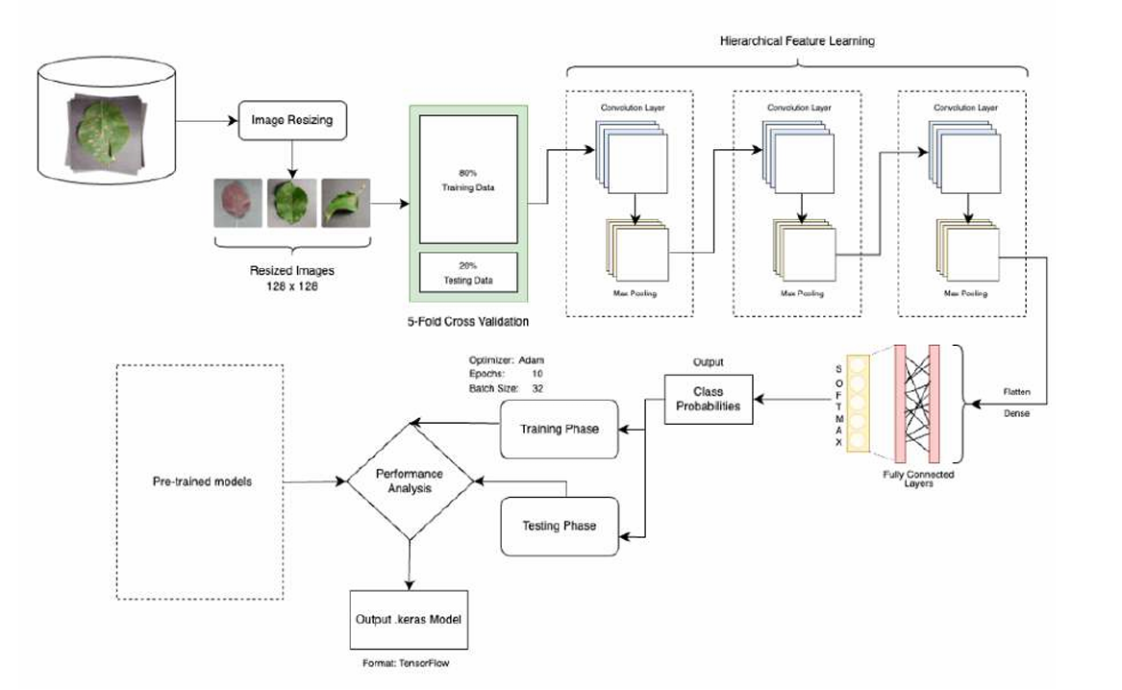

4.2 Data Flow Diagram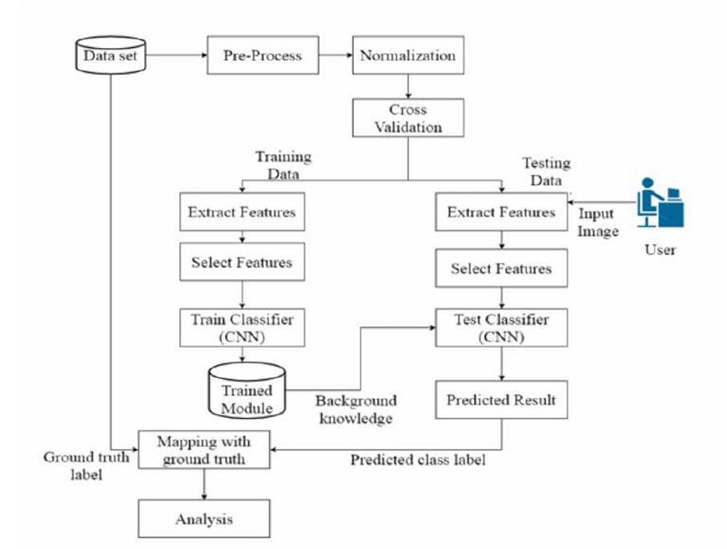

4.3 Use Case Diagram 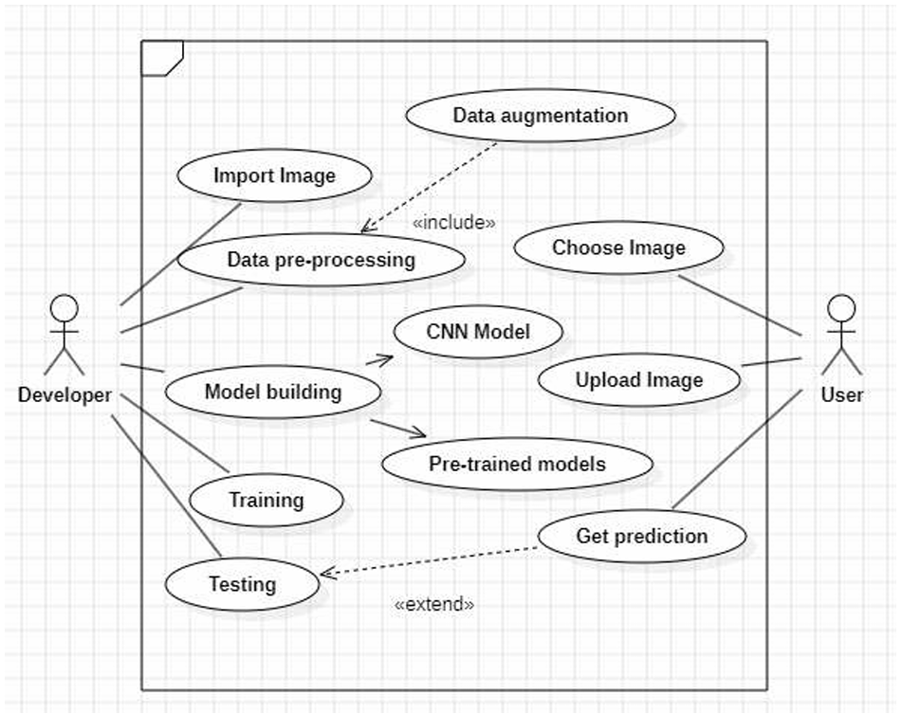

4.4 Sequence Diagram 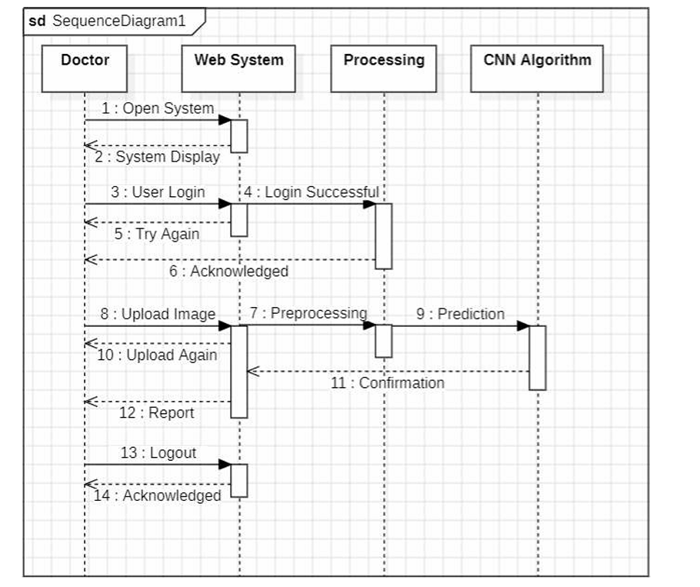

4.5 Class Diagram 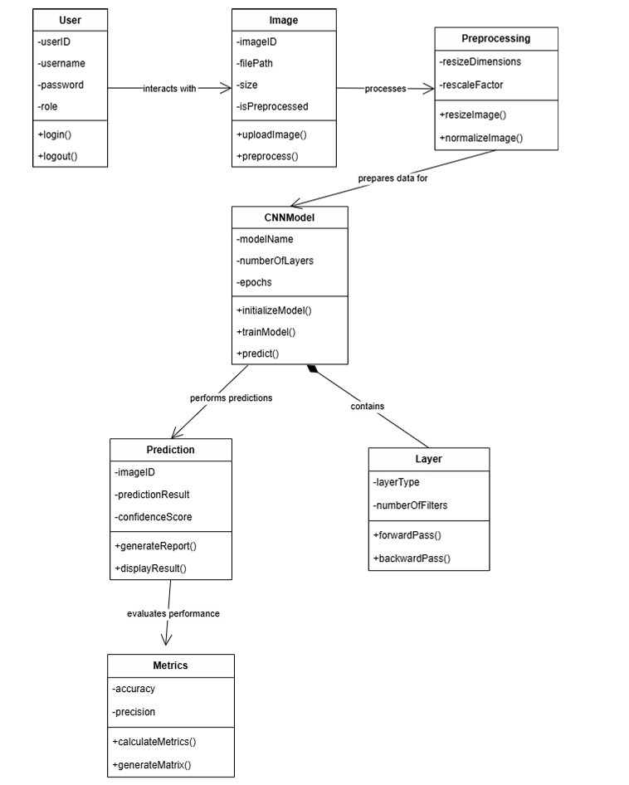

REFERENCES

[1] Polly, R. and Devi, E.A., 2024. Semantic segmentation for plant leaf disease classification and damage detection: A deep learning approach. Smart Agricultural Technology, 9, p.100526.

[2] Bouacida, I., Farou, B., Djakhdjakha, L., Seridi, H., & Kurulay, M. (2024). Innovative deep learning approach for cross-crop plant disease detection: A generalized method for identifying unhealthy leaves. Information Processing in Agriculture.

[3] Alirezazadeh, P., Schirrmann, M., & Stolzenburg, F. (2023). Improving deep learning-based plant disease classification with attention mechanism. Gesunde Pflanzen, 75(1), 49-59.
[4] Daniya, T., & Srinivasan, V. (2023). Shuffled shepherd social optimization based deep learning for rice leaf disease classification and severity percentage prediction. Concurrency and Computation: Practice and Experience, 35(4), e7523.

[5] Jung, M., Song, J. S., Shin, A. Y., Choi, B., Go, S., Kwon, S. Y., ... & Kim, Y. M. (2023). Construction of deep learning-based disease detection model in plants. Scientific reports, 13(1), 7331.

[6] Bezabh, Y. A., Salau, A. O., Abuhayi, B. M., Mussa, A. A., & Ayalew, A. M. (2023). CPD-CCNN: classification of pepper disease using a concatenation of convolutional neural network models. Scientific Reports, 13(1), 15581.

[7] Shahoveisi, F., Taheri Gorji, H., Shahabi, S., Hosseinirad, S., Markell, S., & Vasefi, F. (2023). Application of image processing and transfer learning for the detection of rust disease. Scientific Reports, 13(1), 5133.

[8] Islam, M. M., Adil, M. A. A., Talukder, M. A., Ahamed, M. K. U., Uddin, M. A., Hasan, M. K., ... & Debnath, S. K. (2023). DeepCrop: Deep learning-based crop disease prediction with web application. Journal of Agriculture and Food Research, 14, 100764.

[9] Yan, J., Yan, T., Ye, W., Lv, X., Gao, P., & Xu, W. (2023). Cotton leaf segmentation with composite backbone architecture combining convolution and attention. Frontiers in Plant Science, 14, 1111175.

[10] Kadir, M.S. and Anuar, S., 2022. A Comparative Study on Plant Disease Detection Using Machine Learning Algorithm. Open International Journal of Informatics, 10(2), pp.117-123.

[11] Ji, M., & Wu, Z. (2022). Automatic detection and severity analysis of grape black measles disease based on deep learning and fuzzy logic. Computers and Electronics in Agriculture, 193, 106718.

