

**Department of Computer Science and Engineering,**

**Institute of Technology, Nirma University,**

**Ahmedabad**

Full Stack Web Developement

**Assignment Done By:**

Vansh Shah (23BTM059)

Sujal Lohar (23BCE334)

**Topic :**

Music streaming website

**Submitted to :**

Mr. Sunil Gautam

**Objective:**

The objective of the "Purple Player" website is to provide users with a music streaming experience similar to Spotify, offering curated playlists and music playback functionality. The site aims to offer a user-friendly interface with a focus on easy navigation and music discovery.

**Tech Stack:**

* HTML: For structuring the content and layout of the website.
* CSS: For styling the website, including colors, fonts, and responsive design.
* JavaScript: For adding interactivity, handling music playback, and managing the user interface.
* Tailwind CSS: A CSS framework used for rapid UI development, providing pre-designed CSS classes for styling.
* React: Not explicitly used in the code provided.
* Node: Not explicitly used in the code provided.

**Creating Process**

1. **HTML Structure:** The HTML file sets up the basic structure of the website, including the header, sidebar, main content area, and music player footer. It includes links to external CSS stylesheets, JavaScript files, and font libraries.
2. **CSS Styling:** CSS is used to style the different elements of the website, including the layout, colors, fonts, and responsive design. Tailwind CSS classes are used extensively for styling.
3. **JavaScript Functionality:** JavaScript is used to add interactivity to the website, such as handling music playback, updating the UI, and managing user interactions. The provided code includes JavaScript for controlling the audio player, handling play/pause functionality, and managing the playlist.
4. **Layout and Components:**
   * **Sidebar:** Provides navigation links to Home, Search, and Library pages.
   * **Main Content:** Displays curated playlists and trending music.
   * **Music Player:** A fixed footer that provides controls for music playback, volume adjustment, and track information.

**Screen of the major website weebpages:**

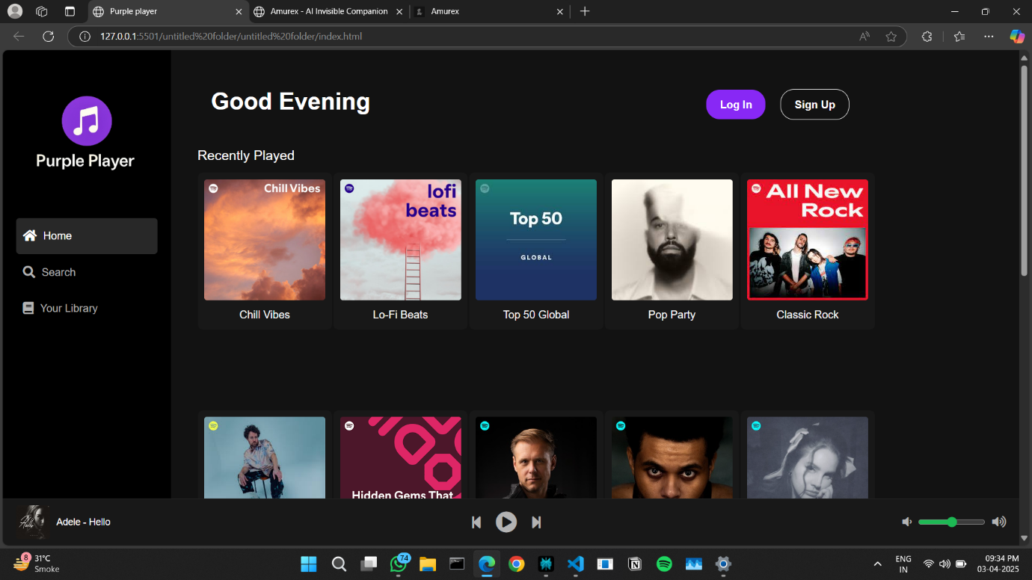

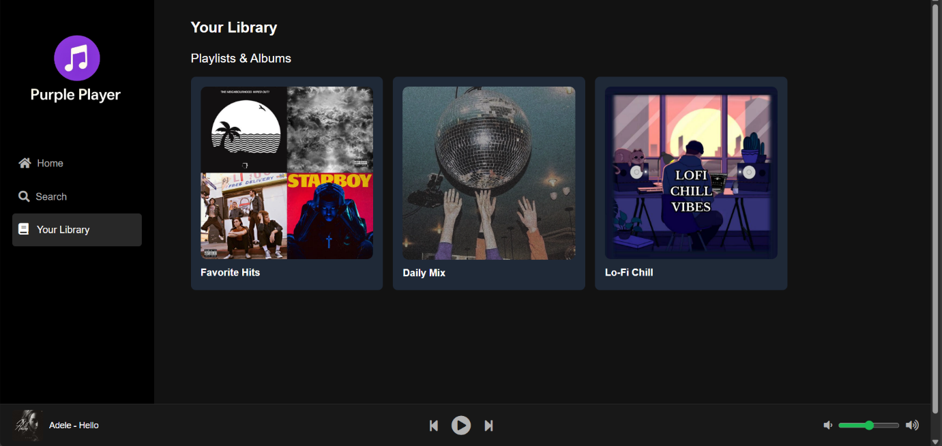

**Creating Process**

1. **HTML Structure:** The HTML file sets up the basic structure of the website, including the header, sidebar, main content area, and music player footer. It includes links to external CSS stylesheets, JavaScript files, and font libraries.
2. **CSS Styling:** CSS is used to style the different elements of the website, including the layout, colors, fonts, and responsive design. Tailwind CSS classes are used extensively for styling.
3. **JavaScript Functionality:** JavaScript is used to add interactivity to the website, such as handling music playback, updating the UI, and managing user interactions. The provided code includes JavaScript for controlling the audio player, handling play/pause functionality, and managing the playlist.
4. **Layout and Components:**
   * **Sidebar:** Provides navigation links to Home, Search, and Library pages.
   * **Main Content:** Displays curated playlists and trending music.
   * **Music Player:** A fixed footer that provides controls for music playback, volume adjustment, and track information.

**Result**

The "Purple Player" website presents a basic music streaming interface with the following features:

* **Homepage:** Displays curated playlists ("Recently Played," "Trending Now") with clickable images that navigate to a music page.
* **Sidebar Navigation:** Allows users to navigate to different sections of the website (Home, Search, Your Library).
* **Music Player:** A fixed footer with controls for playing, pausing, skipping tracks, and adjusting the volume. It also displays the current track's information.
* **Responsive Design:** The website is designed to be responsive and adapt to different screen sizes.

**Conclusion**

The "Purple Player" website is a functional music streaming interface with a clean design and basic music playback capabilities. While the website provides a foundation for a music streaming platform, it could be expanded to include features such as user authentication, search functionality, and a more comprehensive music library.