Project Information Report - Godrej Woods

Project Summary
Sales Status: Sustenance
Construction Status: Excavation is currently in progress for Towers A, B, and C. For Tower D onwards, excavation has been completed and foundation work has commenced.

Configurations (all of them) & Pricing (in crs.)
Configuration | SBU Size  (sq. ft.) | Pricing Range  (Agreement  Value) | Pricing  Range  (Agreement  Value + GST) | Pricing Range  (Agreement  Value + GST +  SDR)
2 BHK | 1193-1242 | 1.65 Cr | 1.65 Cr + 5% | 1.65 Cr + 5% +  7.6%
3 BHK premium | 1888 | 2.45 Cr | 2.45 Cr + 5% | 2.45 Cr + 5% +  7.6%
3 BHK luxe | 2143-2305 | 2.80 Cr | 2.80 Cr + 5% | 2.80 Cr + 5% +  7.6%

RERA: Possession & OC Timelines
- RERA Number: PRM/KA/RERA/1251/472/PR/121125/008248
- RERA Certificate Link: https://rera.karnataka.gov.in/certificate?CER_NO=PRM/KA/RERA/1251/472/PR/121 125/008248
- Possession Timeline As Per RERA (Month and Year): Nov 2030 • Possession Timeline Target As Per GPL (Month and Year): Dec 2029
- OC Timeline As Per RERA (Month and Year):
- OC Timeline Target As Per GPL (Month and Year):

1% Payment Plan
- Payment Plan - 1% Payment Plan
- How it will work for this project (with demo illustration of the calculation):

2 BHK Sample Calculation
Total Cost For Customer 1,75,83,831.25
Total Agreement Value 1,65,48,330

Milestone - 1% Payment Plan | % | 2BHK - 844  sqft | Logic
On Booking | 5% | 868787.33 | 5% Of Agreement Value + additional  5% GST of that value
Within 15 days from the Date of  Booking | 5% | 868787.33 | 5% Of Agreement Value + additional  5% GST of that value
Within 60 days or Before 30th June 2026, whichever is earlier | 10% | 1737574.65 | 10% Of Agreement Value + additional 5% GST of that value
On or before 5th July 2026 | 1% | 173757.47 | 1% Of Agreement Value + additional  5% GST of that value
On or before 5th August 2026 | 1% | 173757.47 | 1% Of Agreement Value + additional  5% GST of that value
On or before 5th Sept 2026 | 1% | 173757.47 | 1% Of Agreement Value + additional  5% GST of that value
On or before 5th Oct 2026 | 1% | 173757.47 | 1% Of Agreement Value + additional  5% GST of that value
On or before 5th Nov 2026 | 1% | 173757.47 | 1% Of Agreement Value + additional  5% GST of that value
On or before 5th Dec 2026 | 1% | 173757.47 | 1% Of Agreement Value + additional  5% GST of that value
On or before 5th Jan 2027 | 1% | 173757.47 | 1% Of Agreement Value + additional  5% GST of that value
On or before 5th Feb 2027 | 1% | 173757.47 | 1% Of Agreement Value + additional  5% GST of that value
On or before 5th March 2027 | 21% | 3648906.77 | 21% Of Agreement Value + additional 5% GST of that value
On or before 5th April 2027 | 1% | 173757.47 | 1% Of Agreement Value + additional  5% GST of that value
On or before 5th May 2027 | 1% | 173757.47 | 1% Of Agreement Value + additional  5% GST of that value
On or before 5th June 2027 | 1% | 173757.47 | 1% Of Agreement Value + additional  5% GST of that value
On or before 5th July 2027 | 1% | 173757.47 | 1% Of Agreement Value + additional  5% GST of that value
On or before 5th Aug 2027 | 1% | 173757.47 | 1% Of Agreement Value + additional  5% GST of that value
On or before 5th Sept 2027 | 1% | 173757.47 | 1% Of Agreement Value + additional  5% GST of that value
On Receipt of OC | 35% | 6081511.28 | 35% Of Agreement Value + additional 5% GST of that value
On Notice of Possession | 10% | 1737574.65 | 10% Of Agreement Value + additional 5% GST of that value
On Notice of Possession - Advance  Maintenance & Sinking Fund Charges | 0% | 208084.75
Total Cost | 100% | 17583831.25

Additional SDR Charges of 7.6% at the time of possession

* This illustration is for representation purposes only. The actual calculation and monthly payout may vary depending on the (i) unit selected (ii) associated charges for that unit and (iii) the offers available at project marketing office.

Floor Plans
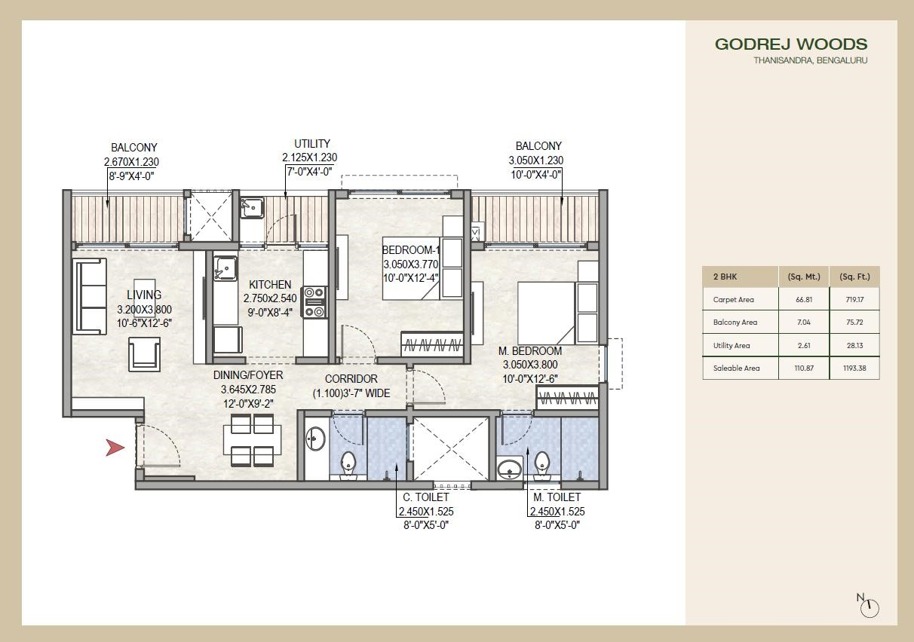

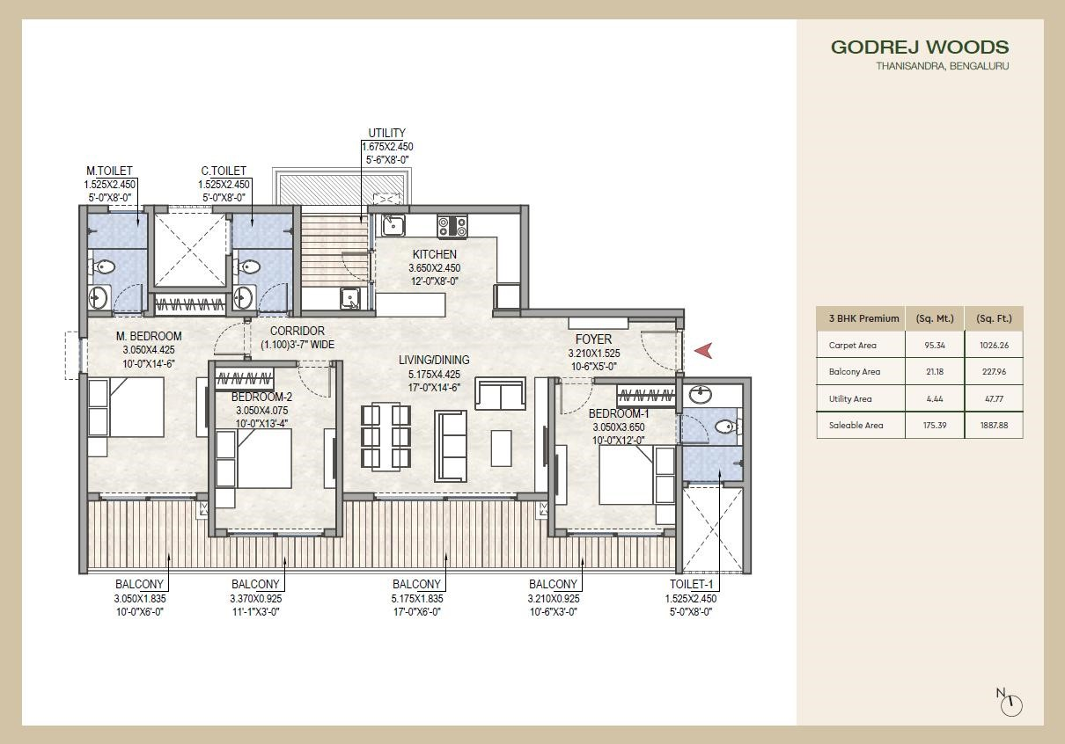
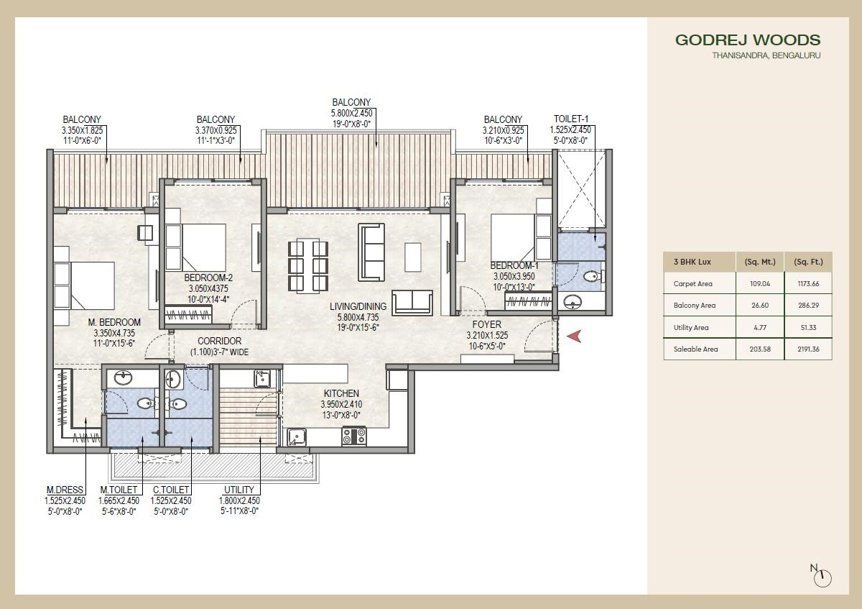

Location Advantages

- Educational Institutes o REVA University 2 minutes
  - EuroSchool North Campus 6 minutes o Delhi Public School 7 minutes o Canadian International School 10 minutes o Mallya Aditi 12 minutes o CMR University 12 minutes o Stonehill International School 18 minutes
  - Vidyashilp University 22 minutes

- Hospitals o Cytecare Hospital 7 minutes o Sparsh Hospital Yelahanka 9 minutes o Cratis Hospital 16 minutes o Aster CMI Hospital 16 minutes
  - Manipal Hospital, Hebbal 30 minutes

- IT & Tech Parks o Bhartiya Centre of Information Technology 7 minutes o Manyata Tech Park 12 minutes o L&T Tech Park 12 minutes o KIADB Aerospace Park 15 minutes
  - Kirloskar Business Park 18 minutes

- Entertainment & Leisure o Bhartiya Mall Of Bengaluru 8 minutes o Oia 10 minutes o Byg Brewski 12 minutes o Elements Mall 12 minutes o Decathlon 12 minutes o The Galleria Mall 14 minutes o Phoenix Mall Of Asia 15 minutes
  - Padukone-Dravid Centre For Sports Excellence 18 minutes

Micro Marketing Understanding

Location Overview
Thanisandra is one of North Bengaluru’s fastest-growing residential corridors, driven by:
- Proximity to Manyata Tech Park
- Connectivity to Hebbal, Airport Road & Outer Ring Road
- Rapid infrastructure growth
- Demand from IT professionals and investors
- Emergence of premium residential developments
It has evolved from a peripheral location into a mid-to-premium housing market.

Employment Catchment
Major demand comes from employees working in:
- Manyata Tech Park
- Kirloskar Tech Park
- Hebbal business district
- Airport corridor offices
- Upcoming tech and commercial hubs in North Bengaluru

Infrastructure Growth
- Wider roads and flyover developments
- Retail growth (malls, supermarkets, entertainment)
- International schools and hospitals nearby
- Strong social infrastructure supporting family buyers

FAQs Used By Sales & Pre-Sales Teams
Total land area except the buffer zone ? | 6 acres & 37 Gunthas
Total number of towers | 9
Total number of units | 800+
Number of basement | 2 or 3
Type of parking | Basement
What is the open space ratio ? | 76%
Construction area we are using in the project ? | 6099 sqmt
UDS of the project ? | ~26%
What is the civic amenities area? | 5% of plot area
Theme of the project ? | Forest Theme
List of amenities ? | Clubhouse, Swimming pool, Kids play area
Clubhouse area space ? | 20000 sq ft
We have seen the number of the trees , how many trees we have overall ? | ~350 fully grown trees
how many entry and exit we are planning ? | Single entry/exit portal
What is the main road width? | 24 m proposed to be widened to 30 m
Which khata it is? | A khata
What is the land zoned for (residential, commercial, mixed-use)? | Residential
Are there any restrictions on construction height, FSI (Floor Space Index), or usage? | Tower Height- 41.45/44.4 metres, FSI  -2.98
gap between unit to unit ? | Differs as per tower layout
Gap betweeen two towers ? | Differs as per tower layout
What is the type of construction used? (RCC frame structure, precast, etc.) | RCC Frame structure
what is the water source here? | Borewell, BWSSB
What makes this project unique compared to others in the market? | Limited appartments, lavish balconies, forest themed development
Are there smart home features (e.g., video door phone, home automation)? | No
Is additional parking or storage space available for purchase? | No
Numbers of visitor parking? | 60
Where is the provision fo the stp , type of the stp plan? | SBR
What is the electric backup ? | 2 BHK- 0.8 Kw, 3 BHK - 1 KW
What is the strength and grade of concrete used? | Foundation-M35, Column- M45
What type and grade of steel is used for reinforcement? | Fe 550
Authority | BDA & BBMP
If customer asks what is ODU in floor plans? | Outdoor units
Free hold or lease hold | Freehold
Are solar panels, rainwater harvesting, or waste management systems included? | Yes

Legal Disclaimers

The project is registered as “GODREJ WOODS” with Karnataka RERA bearing Registration No. PRM/KA/RERA/1251/472/PR/121125/008248 at https://rera.karnataka.gov.in/. The Developer of the projects is Godrej Properties Limited. Site Address: GODREJ WOODS, KHATA NO. 323/106/9&10, E PID NO.
2254233335, SY NO 106/9 & 106/10 KOGILU VILLAGE, YELAHANKA HOBLI,
YELAHANKA, BENGALURU URBAN, KARNATAKA – 560064.The official website of Godrej Properties Ltd. is www.godrejproperties.com. Please do not rely on the information provided on any other website. The sale will be subject to the terms of the application form, allotment letter and Agreement for Sale. The specifications/amenities mentioned in the Agreement for Sale and/or uploaded on Karnataka RERA website shall be final and binding on the Developer and Purchaser. Recipients are advised to apprise themselves of the necessary and relevant information of the Project prior to making any purchase decisions. *This refers to the payment plan offer. Please refer to payment terms as mentioned in the AFS. Basis sole discretion of the developer. Limited time period offer. Date of publication 14th April, 2026

