Project Information Report - Godrej
Azure

Project Summary
Sales Status: Sustenance
Construction Status: Under Construction, Basement Stage

Configurations (all of them) & Pricing (in crs.)
Configuration | SBU Size (sq. ft.) | Pricing Range (Agreement Value) | Pricing Range  (Agreement Value + GST) | Pricing Range  (Agreement Value + GST + SDR)
2 BHK ROYALE | 1020-50 | 78L - 88L | 78L + 5% | 78L + 5% + 7%
3 BHK ELITE | 1250 | 96L - 1.04 Cr | 96L + 5% | 96L + 5% + 7%
3 BHK ROYALE | 1470 | 1.13 Cr -1.26 Cr | 1.13 Cr + 5% | 1.13 Cr + 5% + 7%
3 BHK GRANDEUR | 1950 | 1.47 Cr -1.65 Cr | 1.47 Cr + 5% | 1.47 Cr + 5% + 7%
4 BHK DUPLEX | 2722 | 2.09 Cr -2.34 Cr | 2.09 Cr + 5% | 2.09 Cr + 5% + 7%

RERA: Possession & OC Timelines
- RERA Number: TNRERA/35/BLG/0354/2025
- RERA Certificate Link: https://rera.tn.gov.in/formcqr/f0bc5860-6641-11f0-82dc1ff5a34f029d
- Possession Timeline As Per RERA (Month and Year): May 2030
- Possession Timeline Target As Per GPL (Month and Year): December 2027
- OC Timeline As Per RERA (Month and Year): December 2027
- OC Timeline Target As Per GPL (Month and Year): December 2027

1% Payment Plan
- Payment Plan - 1% Payment Plan
- How it will work for this project (with demo illustration of the calculation):

2 BHK Sample Calculation
Total Cost For Customer 8414000.75
Total Agreement Value 7904115

Milestone - 1% Payment Plan | % | 2BHK - 1020 sqft | Logic
Advance towards booking amount | 5% | 414966.0 | 5% Of Agreement Value + additional 5% GST of that value
Balance booking amount payable within 15 days | 5% | 414966.0 | 5% Of Agreement Value + additional 5% GST of that value
Within 60 days of booking or before 30th June whichever is earlier | 10% | 829932.1 | 10% Of Agreement Value + additional 5% GST of that value
On or before 5th July 2026 | 1% | 82993.2 | 1% Of Agreement Value + additional 5% GST of that value
On or before 5th August 2026 | 1% | 82993.2 | 1% Of Agreement Value + additional 5% GST of that value
On or before 5th Sept 2026 | 1% | 82993.2 | 1% Of Agreement Value + additional 5% GST of that value
On or before 5th Oct 2026 | 1% | 82993.2 | 1% Of Agreement Value + additional 5% GST of that value
On or before 5th Nov 2026 | 1% | 82993.2 | 1% Of Agreement Value + additional 5% GST of that value
On or before 5th Dec 2026 | 1% | 82993.2 | 1% Of Agreement Value + additional 5% GST of that value
On or before 5th Jan 2027 | 1% | 82993.2 | 1% Of Agreement Value + additional 5% GST of that value
On or before 5th Feb 2027 | 1% | 82993.2 | 1% Of Agreement Value + additional 5% GST of that value
On or before 5th March 2027 | 21% | 1742857.4 | 21% Of Agreement Value + additional 5% GST of that value
On or before 5th April 2027 | 1% | 82993.2 | 1% Of Agreement Value + additional 5% GST of that value
On or before 5th May 2027 | 1% | 82993.2 | 1% Of Agreement Value + additional 5% GST of that value
On or before 5th June 2027 | 1% | 82993.2 | 1% Of Agreement Value + additional 5% GST of that value
On or before 5th July 2027 | 1% | 82993.2 | 1% Of Agreement Value + additional 5% GST of that value
On or before 5th Aug 2027 | 1% | 82993.2 | 1% Of Agreement Value + additional 5% GST of that value
On or before 5th Sept 2027 | 1% | 82993.2 | 1% Of Agreement Value + additional 5% GST of that value
On Receipt of Completion Certificate | 35% | 2904762.3 | 35% Of Agreement Value + additional 5% GST of that value
On Notice of Possession | 10% | 829932.1 | 10% Of Agreement Value + additional 5% GST of that value
Advance Maintenance & Sinking Fund Charges | 0% | 114680.0
Total Cost | 100% | 8414000.75
Additional SDR Charges of 7% at the
time of possession

* This illustration is for representation purposes only. The actual calculation and monthly payout may vary depending on the (i) unit selected (ii) associated charges for that unit and (iii) the offers available at project marketing office.

Floor Plans
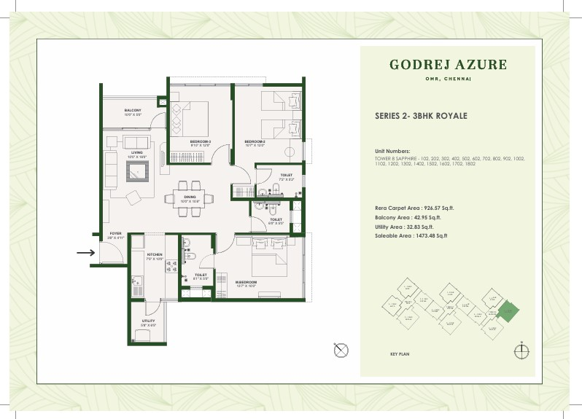

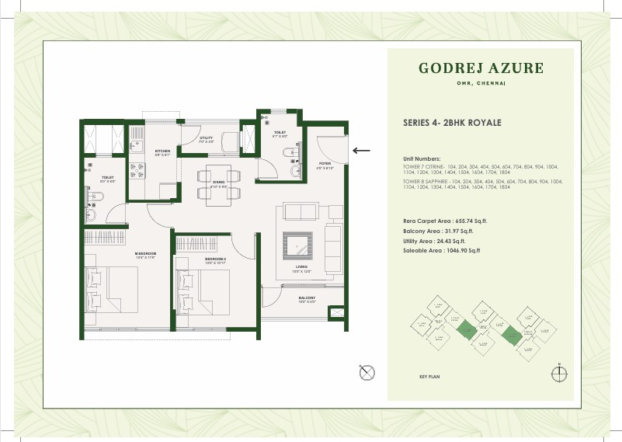

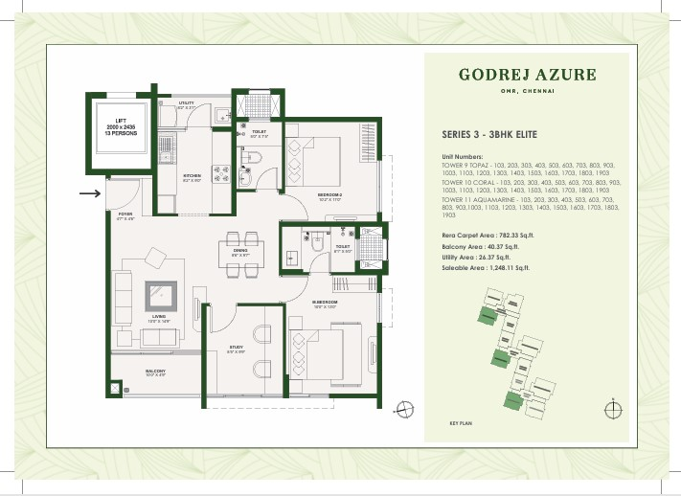
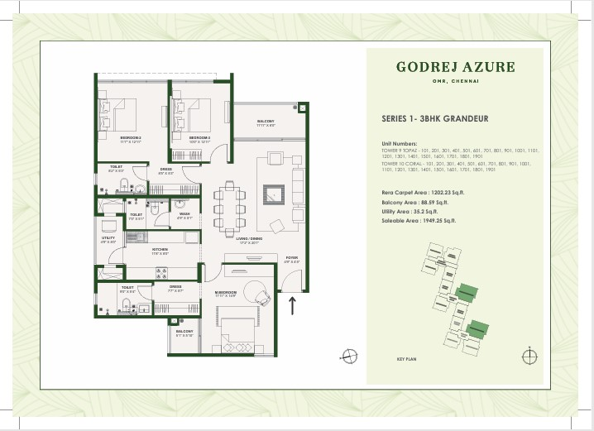
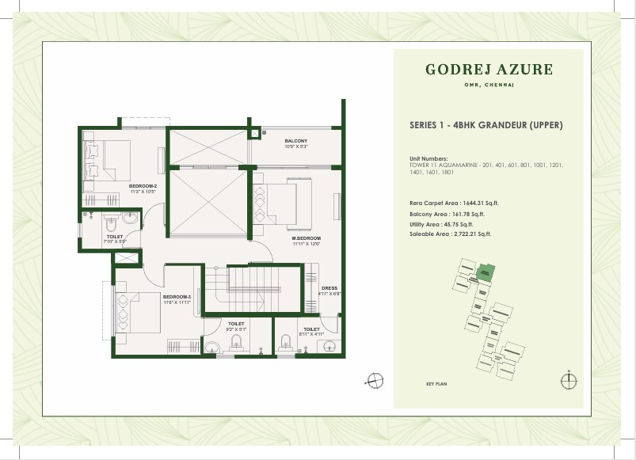
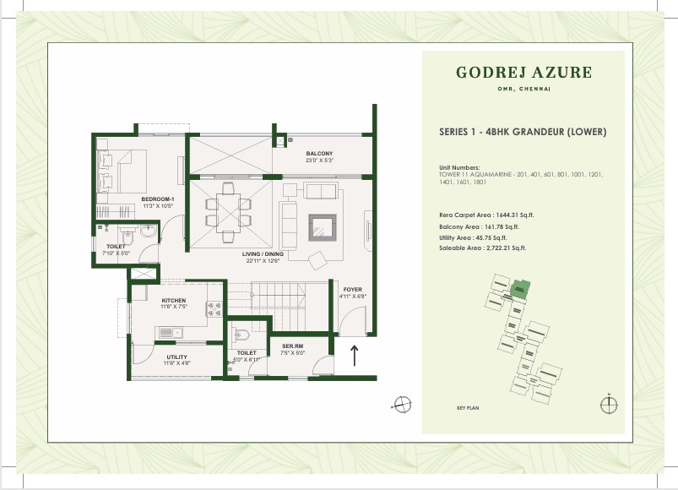

Location Advantages
- SCHOOLS & COLLEGES -
Hindustan University (0.95 Km) | 4 Min Drive
Sri Chaitanya School (1.9 Km) | 5 Min Drive
Gateway International School (1.4 Km) | 6 Min Drive
Hindustan International School (2 Km) | 6 Min Drive
Chettinad Sarvalokaa International School (3.9 Km) | 11 Min Drive
Jeppiaar Engineering College (7.3 Km) | 16 Min Drive
Satyabhama University (8.3 Km) | 17 Min Drive

- Hospital –
Supreme Specialty Hospital (0.5 Km) | 2 Min Drive
Unittas Hospital OMR (1.5 Km) | 5 Min Drive
Dr. Kamakshi Memorial Hospital (3.0 Km) | 6 Min Drive
Chettinad Hospital (3.8 Km) | 16 Min Drive
Rainbow Children's Hospital (15.4 Km) | 36 Min Drive
Apollo Specialty Hospital (20.5 Km) | 45 Min Drive

- OFFICES / IT HUBS -
FL Smith Private Limited (2.9 Km) | 6 Min Drive
SIPCOT IT Park (3 Km) | 6 Min Drive
Virtusa Consulting Services Private Limited (4.4 Km) | 10 Min Drive
Pacifica Tech Park (4.6 Km) | 10 Min Drive
ETA Techno Park (5.1 Km) | 11 Min Drive
HCL Technologies (5.4 Km) | 12 Min Drive
The Times of India (7.5 Km) | 14 Min Drive
TCS (9.3 Km) | 20 Min Drive

- MALLS / SUPERMARKETS –
Reliance Smart Bazaar (0.3 Km) | 3 Min Walk
Aysha Hypermart (0.3 Km) | 3 Min Walk
Nilgiris Supermarket (0.8 Km) | 5 Min Drive
KPN (Kovai Pazhamuthir Nilayam) (1.3 Km) | 5 Min Drive
Grand Marina Mall (2.3 Km) | 7 Min Drive
Decathlon (3.5 Km) | 8 Min Drive
OMR Food Street (5.8 Km) | 12 Min Drive
Vivira Mall (6.9 Km) | 14 Min Drive
PVR Cinemas ECR (14 Km) | 20 Min Drive

Micro Marketing Understanding
- Phase 1 for the project, launched at 2015, has seen appreciation of ~100%, owing to infrastructure developments and rapid establishment of IT corridor for Chennai city on OMR, with major developments in Siruseri and ELCOT, former of which is roughly 2.5 Kms from our project location.
- Influx of cosmopolitan crowd, ranging from IT professionals to students pursuing higher studies from across the country, has ensured the consistent need for group housing for accommodation as well as investment opportunities.
- Upcoming Phase 2 Corridor 3 metro line which will run parallel to OMR ensures connectivity to key locations inside Chennai city.

FAQs Used By Sales & Pre-Sales Teams
• | Godrej Azure - FAQ
• | Question | • | Answer
• | What is the distance from metro station? | • | 2.5 Km (Siruseri metro station)
• | What is the OSR (Open Space Reserved)? | • | 1 Acre
• | What is the size of ODU space and the entrance of it? | • | ODU will have shaft size of 1525x750mm, and the opening size will be 750x1500mm.

• | What is the staircases measurement? | • | Staircases have a width of 1250mm.
• | What is the elevator capacity and who is the service provider? | • | 10pax Jhonson
• | What type of doors are we using? | • | Engg door
• | Door width and height? | • | Doors will have dimensions of 1100x2100mm.
• | Is there any provision for mosquito mesh? | • | No
• | Types of tiles used in clubhouse, lobby and reception. | • | Vertified tiles
• | Are the doors facing each other? | • | Yes
• | Lift lobby and corridor width | • | 6ft
• | Number of Lifts? | • | 2Nos
• | Is there a glass partition in the toilet? | • | No
• | What is the source of water  ? | • | Ground water & Tanker
• | Water Supply ? How many borewells are already functional and planned with depth. | • | 3 Borewells
• | Any concierge service to offer the residents | • | No
• | Is rainwater harvesting  Provided in the project? | • | Yes
• | Width of the roads in the project | • | 12m
• | Distance between two blocks? | • | Block to block, tentatively 13-16 metres distance. One block consists of 3 towers merged.
• | What is the paint finish provided in the apartment? | • | Texture Paint

• | What is the size of the clubhouses and the bifurcation of each ? | • | 11330 sq. ft.
• | Can a customer pay 100% down payment upfront? If yes, what is the benefit he can get ? | • | PACE interest rebate will be passed to the customer at  7.5% per annum
• | How many changing rooms will be there near the swimming pool ? | • | 6Nos
• | Charges of third party for the agreement | •
• | What is the size of the guest rooms? | • | No Guest Rooms
• | How many entry points are there for the clubhouse? | • | 2
• | Does the club house have centralised AC? | • | Yes
• | What is the size & depth of the swimming pools? | • | 17 m x 11 m x 4ft
• | Whether it will be a heated swimming pool? | • | No
• | What Type of parking do we provide? | • | Open/Closed
• | What is the size of each parking we provide? | • | 8ft/16ft
• | What is the process of Parking alotment? | • | 2 BHk - Open Parking, 2,5 BHk/3 BHk/3 BHK Large -  Covered Parking, 4 BHK - Tandom Parking (1:1 for all )
• | What is the scope of EV charging points and how many points will be there? | • | Yes, In the designated spaces we have EV points
• | How many parking? | • | Single
• | What is the total number of open parking ? | • | All 2BHKs have open parking, and 3 and 4 BHKs will have covered parking.
• | Can a customer buy additional car parking? | • | No

• | Can two flats be bought and combined into one flat? As a duplex ? | • | No
• | Are modifications permitted in the apartments? | • | No
• | Can buyer choose the flooring/finishing in case he wants ? | • | No
• | Ground level | • | No need to disclose, but 6.37 metres Average Mean Sea Level.
• | Is the title of the property clear? | • | Yes
• | Is the property freehold or leasehold ? | • | Freehold
• | Is there any legal cases pending and how will they affect the buyers decision ? | • | No
• | What is the UDS percentage  ? | • | 27%
• | Under which development authority does the location comes in ? | • | DTCP
• | Where will the registration take place? | • | Navallur
• | Any previous litigation | • | No
• | Previous land owners (title history) | • | Yes
• | Height restrictions and building height | • | In Phase-3, the three towers will be Basement+Stilt+18 floors, and in Phase 4, the towers will be  Basement+Stilt+19 floors, with the Basement and Stilt area used solely for parking.
• | Which banks are we planning on/timelines? | • | All Major Banks (Godrej Capital, ICICI, HDFC, Tata  Capital, Axis Etc..,)
 |  | • | Registration
• | Franking or registration?

• | Stamp charges | • | At Actuals (7 plus 2 )
• | When can we share the legal set of documents? | • | After 10%
• | How deep is the excavation for basements | • | No Need to disclose, just mention basement floor height
• | How many trees and what kind? | • | Total no. of trees in project- 120; OSR- 58, total shrubs in OSR-2532, Variants in shrubs- 27
• | Property tax payable by customer post handover | • | Yes
• | FSI | • | 2.3
• | Zone | • | Sesmic Zone -3
• | Guideline values/ Composite  Value | • | 5500
• | Documents for purchase in company name | • | As per registration Process
• | HUF purchase | • | Yes
• | Construction partner | • | Not Decided
• | Modfications (wiring, AC core cutting, power backup) | • | No
• | Construction type | • | Maivan (No Block work)
• | Glass thickness - balcony and windows | • | Balcony will have MS Railing. The windows will have SGU 4mm and 6mm thickness.
• | Wall thickness of external and internal walls | • | External walls will have 160mm thickness and internal walls will have 90mm thickness.
• | Common walls between towers/units | • | No
• | Sale agreement process for NRI or outstation clients? | • | NRI as well as outstation clients will have to visit the site in-person to complete the registration.
 |  | • | Design Tree Consultancy
• | Engineering consultant

• | Structural consultant/MEP consultant | • | Design Tree Consultancy
• | Height of boundary walls | • | Boundary walls will have a height of 2.1 metres.
• | The theme of the project | • | Not Decided
• | Floor to ceiling height | • | All units will have a floor to ceiling height of 2950mm.
• | Architect | • | RSP
• | Flood issue resolution | • | YES
• | Fire Extinguisher | • | Yes
• | Grade of concrete | • | M30/M40
• | Electricals | • | All the wiring will be concealed copper FRLS(Fire resistant and Low Smoke) wiring, and all units will receive modular switches. In terms of power backup you will get DG power backup for your lift and common areas.
• | Lifts | • | All towers will be having two lifts, with one being passenger lift, and the bigger one being service lift.
• | Vitrified tile | • | In all units, the Living, Dining, Study, Bedrooms and Kitchen will have Vitrified Tiles. All Washrooms and Dado will have Anti-Skid Vitrified Tiles upto 2100 MM. Similarly, the Balcony and Utility space will also be having Anti-Skid Vitrified Tiles.
• | Bathroom fittings | • | All your sanitary fittings will be from American Standard.
• | Paint | • | Living, Dining, Study and Bedrooms along with the Kitchen, Utility and Balcony will have walls with Emulsion and Ceiling with OBD.
• | Kitchen slab | • | No
 |  | • | Yes
• | Balcony

• | Are we providing Intercom in the apartment door? | • | No
• | Do we provide AC points? | • | Yes
• | Do we have a gas leak detector in the kitchen? | • | Yes
• | Where is the STP located? | • | Basement
• | Who will maintain the property ? | • | Registered Association
• | What type of security alignment do we provide ? | • | The community will have MyGate application for security purposes.
• | Water storage Capacity | •
• | Will there be 100% percent power backup/ Capacity ? | • | Yes
• | Do we have WTP in the project? | • | Yes
• | Are solar options provided in project? | • | Yes - Top most 2 floors in each tower
• | What type of door locks will be provided at main door ? | • | It will be an engineered door frame and flush panel door with Veneer on both sides.
• | Is there a provision for piped gas? | • | NO
• | Who will provide the electricity? | • | TNEB
• | What is the delay /outstanding payment penalty? | • | After 15 days of defualt intreset payment 16th day basis on SBI MCLR rate + 2% on the outstanding amount
• | Does the customer have an option to customise the location of the electrical points ? | • | No
• | What is the size of the banquet hall ? | • | 150
 |  | • | Yes
• | Garbage chute

• | When is the construction starting at site? | • | Oct-25
• | What is the booking cancellation clause ? | • | 10% Deduction
• | What is the loading percentage ? | • | 68%
• | What cheque name has to be favoured for EOI ? | • | GSSPDLGAPL collection account for Godrej Azure phase  3 & 4
• | Can a customer buy multiple apartments? | • | Not more than 2 units
• | What is the mode of payment? | • | DD/RTGS./NEFT/Card Swipe/UPI
• | What is the society office location? | • | Block 1
• | What’s the Electricity load? | • | 4 BHK EB - 86 kW & DG - 3 kW  3 BHK & 3 BHK L EB - 6 kW & DG -– 1.53 kW  Compact 3 BHK EB - 5 kW & DG - 1.5 kW  2 BHK EB - 5 kW & DG - 1 kW
• | Is payment schedule flexible and whether it is construction linked or time linked ? | • | CLP
• | SBA to Carpet Ratio. | • | 68%
• | Which brand of electrical fittings will be provided and who will be the service provider | • | Brand: Panasonic Roma, Service provider not confirmed
• | Basement Floor height | • | 3.7 metres/12.1 Feet
• | Provision for Borewell | • | Yes
• | Bathtub Space | • | No
• | Wiring Brand | •
 |  | •
• | Floor to Concrete height
• | Antiflooding Provisions | • | Yes
• | Water Connection Pipes | • | CPVC/UPVC Pipes
• | Floor to Celling height | • | 9.6 Feet
 |  | • | Tata Steel or reputed brand - Primary steel
• | Steel Brand

Legal Disclaimers
RERA Registered. RERA No: TNRERA/35/BLG/0354/2025; Project: Godrej Azure,
Survey Nos. 282, 283/1, 284/1, 284/2A, 281/1B1A, 281/1B2, 283/2 and 284/2B Padur
Village, Tiruporur Taluk, Kancheepuram District and survey Nos. 222/2, 224/1, 224/2, 227/1A, 227/1B, 227/1C, 227/2A, 227/2B, 227/2C, 227/3, 225/1, 225/2, 226/1 and 226/2 Kazhipattur Village, Muttukadu Panchayat Union, Kancheepuram District. Website: https://rera.tn.gov.in. The official website of Godrej Properties Ltd. is www.godrejproperties.com. Please do not rely on the information provided on any other website. The sale will be subject to the terms of the application form, allotment letter and Agreement for Sale. The specifications/amenities mentioned in the Agreement for Sale and/or uploaded on Karnataka RERA website shall be final and binding on the Developer and Purchaser. Recipients are advised to apprise themselves of the necessary and relevant information of the Project prior to making any purchase decisions. *This refers to the payment plan offer. Please refer to payment terms as mentioned in the AFS. Basis sole discretion of the developer. Limited time period offer.
Date of publication 14th April, 2026.

