Project Information Report - Godrej
Lakeside Orchard

Project Summary
Sales Status: Sustenance
Construction Status: Under – Construction (All towers are in between 3rd floor -7th floor construction stage)

Configurations (all of them) & Pricing (in Crs.)
Configuration | SBU Size  (sq. ft.) | Pricing Range  (Agreement  Value) | Pricing Range  (Agreement  Value + GST) | Pricing Range  (Agreement  Value + GST +  SDR)
3BHK+2T | 1579 | 1,99,55,094 | 1,99,55,094 +  5% | 1,99,55,094 + 5% +  7.6%
3BHK+3T | 1790 | 2,25,90,097 | 2,25,90,097 +  5% | 2,25,90,097 + 5% +  7.6%
 | 1943 | 2,44,72,144 | 2,44,72,144 +  5% | 2,44,72,144 + 5% +  7.6%
 | 2100 | 2,64,47,578 | 2,64,47,578 +  5% | 2,64,47,578 + 5% +  7.6%
 | 2260 | 2,81,38,977 | 2,81,38,977 +  5% | 2,81,38,977 + 5% +  7.6%
3.5BHK+4T | 2163 | 2,72,02,001 | 2,72,02,001 +  5% | 2,72,02,001 + 5% +  7.6%
 | 2257 | 2,86,15,193 | 2,86,15,193 +  5% | 2,86,15,193 + 5% +  7.6%
 | 2217 | 2,74,79,402 | 2,74,79,402 +  5% | 2,74,79,402 + 5% +  7.6%
 | 2244 | 2,78,55,734 | 2,78,55,734 +  5% | 2,78,55,734 + 5% +  7.6%
 | 2214 | 2,74,79,402 | 2,74,79,402 +  5% | 2,74,79,402 + 5% +  7.6%

RERA: Possession & OC Timelines
- RERA Number: PRM/KA/RERA/1251/446/PR/300924/007105
- RERA Certificate Link: RERA GLO.pdf

- Possession Timeline As Per RERA (Month and Year): SEP 2030
- Possession Timeline Target As Per GPL (Month and Year): APRIL-JUNE 2028
- OC Timeline As Per RERA (Month and Year): Not Applicable
- OC Timeline Target As Per GPL (Month and Year): FEB-MARCH 2028

1% Payment Plan
- Payment Plan - 1% Payment Plan
- How it will work for this project (with demo illustration of the calculation):

3 BHK Sample Calculation
Total Cost For Customer 26000806.00
Total Agreement Value 24472144

Milestone - 1% Payment Plan | % | 3 BHK - 1943 sqft | Logic
On Booking | 10% | 2569575.12 | 10% Of Agreement Value + additional 5% GST of that value
Within 45 days or Before  30th June 2026, whichever is earlier | 10% | 2569575.12 | 10% Of Agreement Value + additional 5% GST of that value
On or before 5th July 2026 | 1% | 256957.51 | 1% Of Agreement Value + additional 5% GST of that value
On or before 5th August 2026 | 1% | 256957.51 | 1% Of Agreement Value + additional 5% GST of that value
On or before 5th Sept 2026 | 1% | 256957.51 | 1% Of Agreement Value + additional 5% GST of that value
On or before 5th Oct 2026 | 1% | 256957.51 | 1% Of Agreement Value + additional 5% GST of that value
On or before 5th Nov 2026 | 1% | 256957.51 | 1% Of Agreement Value + additional 5% GST of that value
On or before 5th Dec 2026 | 1% | 256957.51 | 1% Of Agreement Value + additional 5% GST of that value
On or before 5th Jan 2027 | 1% | 256957.51 | 1% Of Agreement Value + additional 5% GST of that value
On or before 5th Feb 2027 | 1% | 256957.51 | 1% Of Agreement Value + additional 5% GST of that value
On or before 5th March 2027 | 21% | 5396107.75 | 21% Of Agreement Value + additional 5% GST of that value
On or before 5th April 2027 | 1% | 256957.51 | 1% Of Agreement Value + additional 5% GST of that value
On or before 5th May 2027 | 1% | 256957.51 | 1% Of Agreement Value + additional 5% GST of that value
On or before 5th June 2027 | 1% | 256957.51 | 1% Of Agreement Value + additional 5% GST of that value
On or before 5th July 2027 | 1% | 256957.51 | 1% Of Agreement Value + additional 5% GST of that value
On or before 5th Aug 2027 | 1% | 256957.51 | 1% Of Agreement Value + additional 5% GST of that value
On or before 5th Sept 2027 | 1% | 256957.51 | 1% Of Agreement Value + additional 5% GST of that value
On Receipt of OC | 35% | 8993512.92 | 35% Of Agreement Value + additional 5% GST of that value
On Notice of Possession | 10% | 2569575.12 | 10% Of Agreement Value + additional 5% GST of that value
Advance Maintenance & Sinking Fund Charges | 0% | 305054.9
Total Cost | 100% | 26000806.07
Additional SDR Charges of 7.6% at the
time of possession

* This illustration is for representation purposes only. The actual calculation and monthly payout may vary depending on the (i) unit selected (ii) associated charges for that unit and (iii) the offers available at project marketing office.

Floor Plans-

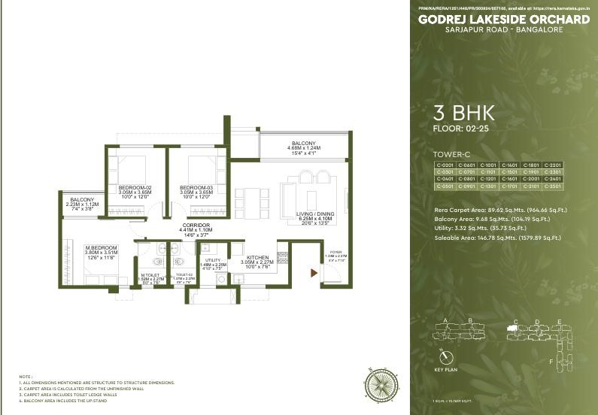
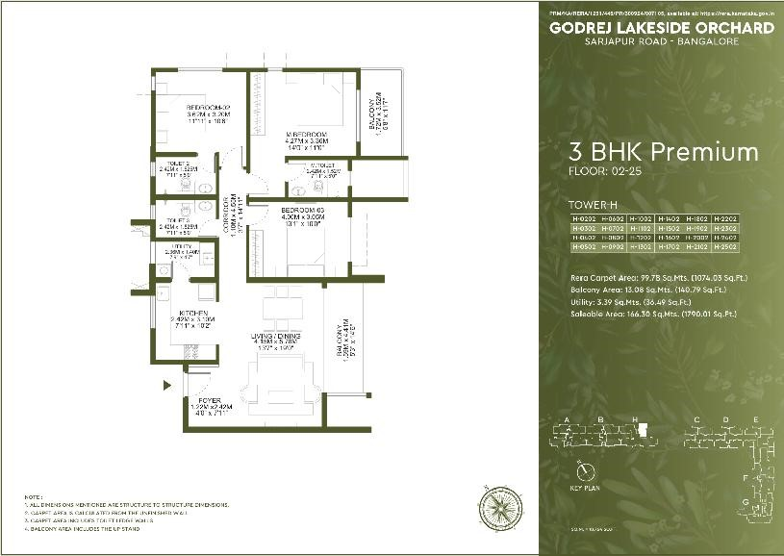
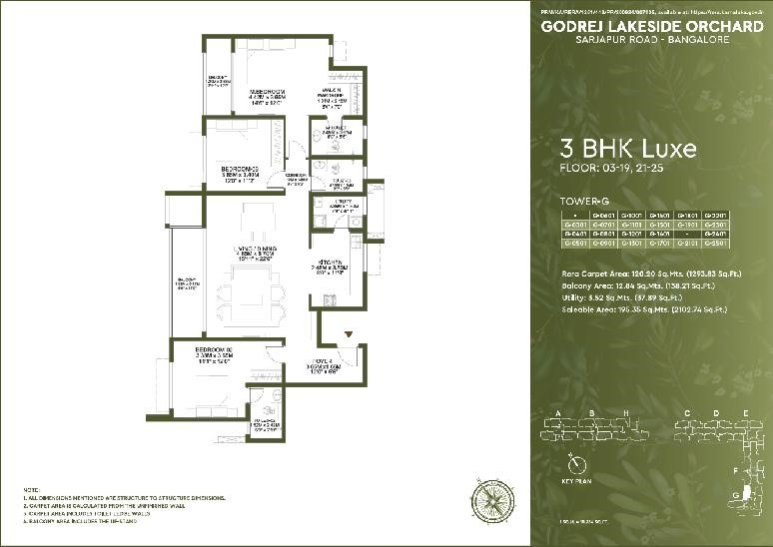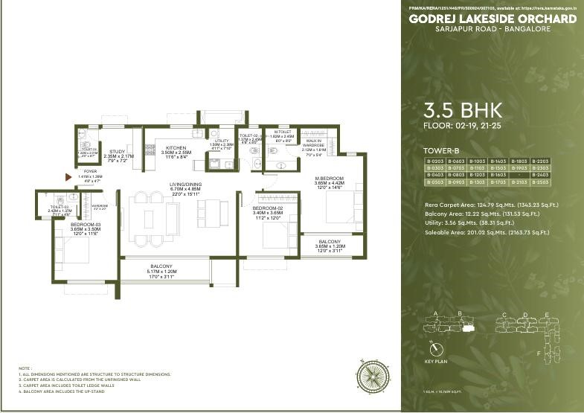

Location Advantages

- CONNECTIVITY :
Proposed Carmelaram Metro Station (6 Min Drive)
Carmelaram Railway Station (7 Min Drive)
Proposed Iblur Metro Station (15 Min Drive)
S.H. 35 (12 Min Drive)
Outer Ring Road (15 Min Drive)

- Hotel & Mall:
DoubleTree Suites by Hilton Hotel (13 Min Drive)
Soul Space Spirit Centro Mall (15 Min Drive)
Fairfield by Marriott (16 Min Drive)
Rural Blues (8 Min Drive)
Byg Brewski (10 Min Drive)
Bier Library (8 Min Drive)

- IT Hubs :
Global Technology Park (16 Min Drive)
Wipro (8 Min Drive)
Embassy Tech Village (20 Min Drive)
RMZ Ecospace (15 Min Drive)
Cessna Business Park (20 Min Drive)
RGA Tech Park (6 Min Drive)

- Schools :
The International School, Bangalore (14 Min Drive)
CMR Gandhi Public School (4 Min Drive)
Harvest International School (5 Min Drive)
GEAR Innovative International School (14 Min Drive)
DPS EAST (8 Min Drive)
Oakridge International School (13 Min Drive)
Inventure Academy (14 Min Drive)
Primus Public School (12 Min Drive)

- Hospital :
Belenus Champion Hospital (7 Min Drive)
Natus Women & Children Hospital (7 Min Drive)
Manipal Hospital (15 Min Drive)
Sakra World Hospital (18 Min Drive) Cloudnine Hospital (10 Min Drive)
Motherhood Hospital (11 Min Drive)

Micro Marketing Understanding
- Location advantage for customers & Investors
- Easily connected to multiple corners of the city, making it central point in east Bengaluru.
- New projects are coming in far exterior from the city center & ORR, hence GLO can be a better choice.

FAQs Used By Sales & Pre-Sales Teams
Objection Handling
If customer is looking for RTMI / Early possession property | May I know what possession time line you're expecting? I do understand your concern however if you go for early  possession / RTMI property very limited options would be available for you our  project has recently been launched / is in pre launch multiple options would be  available for you wherein you can choose  your choice of inventory. I'm not telling you to come and book the property however  what I would suggest as you're comfortable with our project's location you might be  exploring other projects as well in the same locality come and explore our project as  well wherein you'll get a fair idea and post that you can take a tentative decision of yours post that.
Also, Godrej being a brand we've delivered projects prior to the RERA timeline in 3-
3.5yrs, we've many projects as example such as Godrej Ananda Phase 1 ( RERA - 2026, Godrej - 2024 ) Godrej Royale Woods & Woodland ( RERA - 2025, Godrej - 2023 )
; Godrej Park Retreat (RERA - 2027, Godrej - 2024)

If customer is not comfortable with our dimension | I do understand your concern it may sound small to you over the call however Godrej being a Brand we always create Smartly Designed Apartments wherein we keep  Complete Utilization of Carpet Area and  Zero Wastage of space, even our walls are less space consuming. So if you look it from inside you may find our apartment  Spacious enough. You can figure it out once you visit our Site we have sample flat  available wherein you'll get a fair idea. So would you be able to consider this Dimension?
If customer says pricing is high / Comparing with Competiters | I do understand your concern however these are market competitive rates and  Godrej being a Brand we never compromise on Construction Quality, also  in our Project we have amenities for all age group and lot of Open Space & Greenery.  Also the Construction technology which we use is Mivan, which is one of the best. You  may find it value for money
If customer's budget is less | That’s a really healthy budget. If you like the property is it possible for you to stretch your budget?
 | Is it all self funding / including loan? How much will be your self funding?
 | Suggest finance options available.
Details | If  customer asks  details  prior discussion | I'll definitely ask my sales manager to share you the  details however it'll contain  limited details wherein pricing  details won't be mentioned.  It'll take hardly 3-5mins of your time so shall I continue?
 | If  customer asks  details  post discussion | I'll definitely ask my sales manager to share you the  details however it'll contain limited details which I've  already shared to you over the  call why don’t you plan a visit along with your family I'll  arrange an on table discussion  for you with my sales manager wherein you'll get a fair idea  regarding what exactly we're coming up with along with locality.
 | If sharing upfront | Post call you'll receive details over your mail I'd from my  sales manager Miss Shivani  Pandey you can revert on that mail if you have any queries  also a two way communication number will be mentioned you can reach out to us on that as well. The details which I'll be sharing will be containing 2  links one would be of location and another would be of Digital Collateral wherein you'll get master plan and floor plan.
 | If  customer  asks to share | I'll definitely ask my sales manager to share you the  details post call over your mail ID, his name would be Mr. Ajit  Shindey you can revert on that mail if you have any queries  also a two way communication number will be mentioned you can reach out to us on that as well. The details which I'll be sharing will be containing 2  links one would be of location and another would be of Digital Collateral wherein you'll get master plan and floor plan.
 | If  customer  asks to share  details for pre  launch property | I'll definitely ask my sales manager to share you the  details post call over your mail I'd her name would be Miss  Shivani Pandey you can revert on that mail if you have any queries also a two way  communication number will be mentioned you can reach  out to us on that as well. The details which I'll be sharing  will be containing 2 links one would be of location and  another would be of Digital  Collateral wherein you'll get master plan and floor plan.

Question | Ans
What is salable area? | Salable area is basically super built up area. (Super Built  Up area includes your thickness of internal walls & ceilings, carpet & common area.
What is built up area? | Built Up area includes your thickness of internal walls & ceilings and carpet area.
What is carpet area? | Carpet area is your usable area / area which you can use
What is sinking fund? | Its basically corpus fund. (Its emergency fund used when maintenance amount is not sufficient enough)
What is GST? | Goods and service tax its govt. charge (It'll be 5%)
What is SDR? | Stamp Duty and Registration its govt. charge (It'll be 7% approx together)
If customer is looking for RTMI? | Are you looking this property for self use / investment?
I do understand your concern however if you go for RTMI property very limited options would be available for you our project is in pre launch, multiple options would be
available for you wherein you can choose your choice of inventory. I'm not telling you to come and book the property however what I would suggest as you're
comfortable with our project's location you might be
exploring other projects as well in the same locality come
and explore our project as well wherein you'll get a fair
idea and post that you can take a tentative decision of yours post that. Also, Godrej being a brand we've
delivered projects prior to the RERA timeline in 3-3.5yrs,
we've many projects as example such as Godrej Ananda Phase 1 ( RERA - 2026, Godrej - 2024 ) Godrej Royale Woods & Woodland ( RERA - 2025, Godrej - 2023 ).
If customer is looking for early possession? | Are you looking this property for self use / investment?
 | May I know what possession time line you're expecting?
I do understand your concern however if you go for RTMI property very limited options would be available for you our project is in pre launch multiple options would be
available for you wherein you can choose your choice of inventory. I'm not telling you to come and book the property however what I would suggest as you're
comfortable with our project's location you might be
exploring other projects as well in the same locality come
and explore our project as well wherein you'll get a fair
idea and post that you can take a tentative decision of yours post that. Also, Godrej being a brand we've
delivered projects prior to the RERA timeline in 3-3.5yrs,
we've many projects as example such as Godrej Ananda Phase 1 ( RERA - 2026, Godrej - 2024 ) Godrej Royale Woods & Woodland ( RERA - 2025, Godrej - 2023 ).
Can you give developer's possession time to me in written ? | We'll give you RERA possession in written as they give same timeline to every developer. Its our legacy that we provide projects prior to timeline.
How can I assure then you'll give it prior to timeline? | We've delivered projects prior to the RERA timeline in 33.5yrs, we've many projects as example such as Godrej Ananda Phase 1 ( RERA - 2026, Godrej - 2024 ) Godrej Royale Woods & Woodland ( RERA - 2025, Godrej - 2023  ).
What if Pandemic Strikes again still you'll give in 3-3.5yrs? | Its government call, if govt. asks us to stop the construction then we've to stop it. However, we'll aim to give you at the earliest.
I already have a pre-approved loan, can I avail pre EMI offer?? | No, Sir/ Ma'am if you want to go ahead with that bank's loan you can however offer is only applicable with Godrej Captial.
Pre-Launch benefits | These are the pre launch pricings which we're offering right now, Once the project gets launched pricings will revise and hike.
Why are you taking booking amount if the project is in Pre-Launch? | We got a very good response for our project due to which 2bhks were oversubscribed hence, we started with allotment.

I’m not interested –
Fresh – Any specific reason Sir/Ma’am? We have just received your enquiry.

VDNB - Any specific reason Sir/Ma’am? You had visited our project earlier.
EDNV - Any specific reason Sir/Ma’am? We had expressed interest in our project/s earlier.
I don’t have any plans –
Fresh – Any specific reason Sir/Ma’am? We have just received your enquiry and we do have exciting offers.
VDNB - Any specific reason Sir/Ma’am? You had visited our project earlier and we do have exciting offers.
EDNV - Any specific reason Sir/Ma’am? We had expressed interest in our project/s earlier and we do have exciting offers.
I did not enquire -
We received an enquiry from this number, hence we called.
I am a Broker -
Sir, there is a specific team who caters brokers/channel partners. I’ll ask them to contact you.
Calling for Job opportunity –
Sir, we provide property details. For job, kindly visit our website.
Test Enquiry –
I’ll update the same.
Wrong Number –
We received an enquiry from this number, hence we called.
Irrelevant Enquiry (I’m a Carpenter, have a land for sale, wanted to share generic feedback etc)
Sir, we provide property details. For your query, kindly visit our website.
Call Back Later –
Fresh - You had placed an enquiry hence we called. I will need a few mins of your time. I will just quickly brief you on the project, etc
VDNB - You had visited our site earlier. I will need a few mins of your time. I will just quickly brief you on the project, etc
EDNV - You had expressed interest in our project earlier. I will need a few mins of your time. I will just quickly brief you on the project, etc
Already Purchased –
Are you looking for any other investment option?
Is anyone from your friend or family looking to invest?
Bought with Competitor –
Congratulations for the purchase!
Can you share any feedback as in what was the reason you chose other project over ours?
Language Barrier –
I’ll try to arrange a call in your preferred language.
Lost Budget/Inventory not Available/Location/Specification Amenities/Price/Possession/Size of Apartments
Rebuttals as per the script or cross pitch (If option).

Query | Answer
Customer went directly in Module flat | Ask the sales manager name who is assisting, if no SM is attending ask to go to reception and register in order to  get assign by a SM
Customer is getting irrated with too many calls | Firstly appologize and Inform customer that he is getting calls from CP, and give him assurity that he wont receive calls from our end and get his expected time of visit
Customer is not handing over the call to receptionist | Infor customer, in order to assign him with the SM he need to handover the call to the receptionist
Customer is not ready to register as he/she did not like the project location/module flat | Inform customer, that it’s a registeration process in order to track your visit and to keep you posted for future updates as and offers per his/her requirements
Customer wants to visit the site and site is not operational | Try to reschedule the appointment while informing SM got an emergency and no one is available at site

Rebuttals (If needed)
If client's budget is less - That is a very healthy budget sir however, thr price of our inventory is
XYZ, so I would like to know if you have a look at the location and the project and you find it value for money, would you like to extend your budget a little bit? ( Talk about funding source)
If client asks for details on mobile or denies to visit- Sir being from the pre sales department of
Godrej properties ,I can send you limited details which you already might have received since you placed the enquiry, however when it comes to the final deal/cost sheet/unit availabilty,
someone directly from the sales team at site can help you with it. The sooner you visit the better options you will have to choose from as we have received great response for the project, so may
I know when would be the suitable time where I can arrange a visit for you?

Legal Disclaimers
- RERA Registered. RERA No. PRM/KA/RERA/1251/446/PR/300924/007105 Project is registered as Godrej Lakeside Orchard, available at website:
http://rera.karnataka.gov.in.
- Site address: Godrej Lakeside Orchard, Survey Nos. 77, 174/1B, 175/P, 175/2A, 175/2B,
176/2A, 176/2B, 177, 73, 78/1A, 78/2A1(P), 78/2B, 78/3A, 78/4, 79/1C2, 178 of Kodathi Village Varthur Hobli, Bengaluru East, Bengaluru Urban, Karnataka – 560035. The official website of Godrej Properties Ltd. is www.godrejproperties.com. Please do not rely on the information provided on any other website. The sale will be subject to the terms of the application form, allotment letter and Agreement for Sale. The specifications/amenities mentioned in the Agreement for Sale and/or uploaded on Karnataka RERA website shall be final and binding on the Developer and Purchaser. Recipients are advised to apprise themselves of the necessary and relevant information of the Project prior to making any purchase decisions. *This refers to the payment plan offer. Please refer to payment terms as mentioned in the AFS. Basis sole discretion of the developer. Limited time period offer. Date of publication 14th April, 2026. T&C Apply.

