Project Information Report - Godrej
Regal Pavilion

Project Summary
Sales Status: Sustenance
Construction Status: Under Construction (Excavation done)

Configurations (all of them) & Pricing (in crs.)
Configuration | SBU Size  (sq. ft.) | Pricing Range  (Agreement  Value) | Pricing  Range  (Agreement  Value + GST) | Pricing Range  (Agreement  Value + GST +  SDR)
3 BHK Premium | 1679 - 1783 | 1.62 Cr - 1.75 Cr | 1.62 Cr + 5% | 1.62 Cr + 5% +  8.15%
3 BHK Luxe | 1873 - 2425 | 2.08 Cr - 2.51 Cr | 2.08 Cr + 5% | 2.08 Cr + 5% +  8.15%
3.5 BHK | 2673 | 2.39 Cr - 2.74 Cr | 2.39 Cr + 5% | 2.39 Cr + 5% +  8.15%
4 BHK Premium | 2885 - 2904 | 2.87 Cr - 3.01 Cr | 2.87 Cr + 5% | 2.87 Cr + 5% +  8.15%
4 BHK Luxe | 3444 - 3572 | 3.21 Cr - 3.56 Cr | 3.21 Cr + 5% | 3.21 Cr + 5% +  8.15%

RERA: Possession & OC Timelines
- RERA Number: P02400009910
- RERA Certificate Link: RERA Website
- Possession Timeline As Per RERA (Month and Year): 16 July 2030
- Possession Timeline Target As Per GPL (Month and Year): October 2029
- OC Timeline As Per RERA (Month and Year): January 2030
- OC Timeline Target As Per GPL (Month and Year): May 2029

1% Payment Plan
- Payment Plan - 1% Payment Plan
- How it will work for this project (with demo illustration of the calculation):

Tower 8 & Tower 9: 3 BHK Luxe Sample Calculation
Total Cost For Customer 2,18,31,042
Total Agreement Value 2,04,59,132

Milestone - 1% Payment Plan | % | 3 BHK Luxe -  2223 sqft | Logic
Advance towards Booking Amount | 5% | 1074104.43 | 5% Of Agreement  Value + additional 5% GST of that value
Balance booking amount payable within 15 days of booking | 5% | 1074104.43 | 5% Of Agreement  Value + additional 5% GST of that value
Within 60 days of booking or before 30th June 2026 whichever is earlier | 10% | 2148208.86 | 10% Of Agreement  Value + additional 5% GST of that value
On or before 5th July 2026 | 1% | 214820.886 | 1% Of Agreement  Value + additional 5% GST of that value
On or before 5th August 2026 | 1% | 214820.886 | 1% Of Agreement  Value + additional 5% GST of that value
On or before 5th Sept 2026 | 1% | 214820.886 | 1% Of Agreement  Value + additional 5% GST of that value
On or before 5th Oct 2026 | 1% | 214820.886 | 1% Of Agreement  Value + additional 5% GST of that value
On or before 5th Nov 2026 | 1% | 214820.886 | 1% Of Agreement  Value + additional 5% GST of that value

On or before 5th Dec 2026 | 1% | 214820.886 | 1% Of Agreement  Value + additional 5% GST of that value
On or before 5th Jan 2027 | 1% | 214820.886 | 1% Of Agreement  Value + additional 5% GST of that value
On or before 5th Feb 2027 | 1% | 214820.886 | 1% Of Agreement  Value + additional 5% GST of that value
On or before 5th March 2027 | 1% | 214820.886 | 1% Of Agreement  Value + additional 5% GST of that value
On or before 5th April 2027 | 1% | 214820.886 | 1% Of Agreement  Value + additional 5% GST of that value
On or before 5th May 2027 | 1% | 214820.886 | 1% Of Agreement  Value + additional 5% GST of that value
On or before 5th June 2027 | 1% | 214820.886 | 1% Of Agreement  Value + additional 5% GST of that value
On or before 5th July 2027 | 1% | 214820.886 | 1% Of Agreement  Value + additional 5% GST of that value
On or before 5th Aug 2027 | 1% | 214820.886 | 1% Of Agreement  Value + additional 5% GST of that value
On or before 5th Sept 2027 | 1% | 214820.886 | 1% Of Agreement  Value + additional 5% GST of that value
On or before 5th Oct 2027 | 1% | 214820.886 | 1% Of Agreement  Value + additional 5% GST of that value
On or before 5th Nov 2027 | 1% | 214820.886 | 1% Of Agreement  Value + additional 5% GST of that value
On or before 5th Dec 2027 | 1% | 214820.886 | 1% Of Agreement  Value + additional 5% GST of that value
On or before 5th Jan 2028 | 1% | 214820.886 | 1% Of Agreement Value + additional

 |  |  | 5% GST of that value
On or before 5th Feb 2028 | 1% | 214820.886 | 1% Of Agreement  Value + additional 5% GST of that value
On or before 5th Mar 2028 | 20% | 4296417.72 | 20% Of Agreement  Value + additional 5% GST of that value
On or before 5th Apr 2028 | 1% | 214820.886 | 1% Of Agreement  Value + additional 5% GST of that value
On or before 5th May 2028 | 1% | 214820.886 | 1% Of Agreement  Value + additional 5% GST of that value
On or before 5th Jun 2028 | 1% | 214820.886 | 1% Of Agreement  Value + additional 5% GST of that value
On or before 5th Jul 2028 | 1% | 214820.886 | 1% Of Agreement  Value + additional 5% GST of that value
On or before 5th Aug 2028 | 1% | 214820.886 | 1% Of Agreement  Value + additional 5% GST of that value
On or before 5th Sep 2028 | 1% | 214820.886 | 1% Of Agreement  Value + additional 5% GST of that value
On or before 5th Oct 2028 | 1% | 214820.886 | 1% Of Agreement  Value + additional 5% GST of that value
On or before 5th Nov 2028 | 1% | 214820.886 | 1% Of Agreement  Value + additional 5% GST of that value
Completion of Terrace floor slab for respective tower | 2% | 429641.772 | 2% Of Agreement  Value + additional 5% GST of that value
On Receipt of OC | 20% | 4296417.72 | 20% Of Agreement  Value + additional 5% GST of that value
On Notice of Possession | 10% | 2148208.86 | 10% Of Agreement  Value + additional 5% GST of that value
Advance Maintenance & Sinking Fund Charges | 0% | 3,48,953.47
Total Cost | 100% | 21831042.07
Additional 0.5% (Agreement of Sale) after initial 10% payment and additional 7.65% SDR later at the time of possession
- This illustration is for representation purposes only. The actual calculation and monthly payout may vary depending on the (i) unit selected in which tower (ii) associated charges for that unit and (iii) the offers available at project marketing office.

Tower 1 to Tower 7: 3 BHK Luxe Sample Calculation
Total Cost For Customer 2,19,95,982.12
Total Agreement Value 2,06,27,755.00

Milestone - 1% Payment Plan | % | 3 BHK Luxe -  2150 sqft | Logic
Advance towards booking amount | 5% | 1082957.138 | 5% Of Agreement Value + additional 5% GST of that value
Balance booking amount payable  within 15 days | 5% | 1082957.138 | 5% Of Agreement Value + additional 5% GST of that value
Within 60 days of booking or before 30th  June whichever is earlier | 10% | 2165914.275 | 10% Of Agreement Value + additional 5% GST of that value
On or before 5th July 2026 | 1% | 216591.4275 | 1% Of Agreement Value + additional 5% GST of that value
On or before 5th August 2026 | 1% | 216591.4275 | 1% Of Agreement Value + additional 5% GST of that value
On or before 5th Sept 2026 | 1% | 216591.4275 | 1% Of Agreement Value + additional 5% GST of that value
On or before 5th Oct 2026 | 1% | 216591.4275 | 1% Of Agreement Value + additional 5% GST of that value
On or before 5th Nov 2026 | 1% | 216591.4275 | 1% Of Agreement Value + additional 5% GST of that value
On or before 5th Dec 2026 | 1% | 216591.4275 | 1% Of Agreement Value + additional 5% GST of that value
On or before 5th Jan 2027 | 1% | 216591.4275 | 1% Of Agreement Value + additional 5% GST of that value
On or before 5th Feb 2027 | 1% | 216591.4275 | 1% Of Agreement Value + additional 5% GST of that value
On or before 5th March 2027 | 1% | 216591.4275 | 1% Of Agreement Value + additional 5% GST of that value
On or before 5th April 2027 | 1% | 216591.4275 | 1% Of Agreement Value + additional 5% GST of that value
On or before 5th May 2027 | 1% | 216591.4275 | 1% Of Agreement Value + additional 5% GST of that value
On or before 5th June 2027 | 1% | 216591.4275 | 1% Of Agreement Value + additional 5% GST of that value
On or before 5th July 2027 | 1% | 216591.4275 | 1% Of Agreement Value + additional 5% GST of that value
On or before 5th Aug 2027 | 1% | 216591.4275 | 1% Of Agreement Value + additional 5% GST of that value
On or before 5th Sept 2027 | 1% | 216591.4275 | 1% Of Agreement Value + additional 5% GST of that value
On or before 5th Oct 2027 | 1% | 216591.4275 | 1% Of Agreement Value + additional 5% GST of that value
On or before 5th Nov 2027 | 1% | 216591.4275 | 1% Of Agreement Value + additional 5% GST of that value
On or before 5th Dec 2027 | 1% | 216591.4275 | 1% Of Agreement Value + additional 5% GST of that value
On or before 5th Jan 2028 | 1% | 216591.4275 | 1% Of Agreement Value + additional 5% GST of that value
On or before 5th Feb 2028 | 1% | 216591.4275 | 1% Of Agreement Value + additional 5% GST of that value
On or before 5th Mar 2028 | 30% | 6497742.825 | 30% Of Agreement Value + additional 5% GST of that value
On Receipt of OC | 20% | 4331828.55 | 20% Of Agreement Value + additional 5% GST of that value
On Notice of Possession | 10% | 2165914.275 | 10% Of Agreement Value + additional 5% GST of that value
Advance Maintenance & Sinking Fund Charges | 0% | 3,36,839.30
Total Cost | 100% | 21995982.05
Additional 0.5% (Agreement of Sale) after initial 10% payment and additional 7.65%
SDR later at the time of possession

- This illustration is for representation purposes only. The actual calculation and monthly payout may vary depending on the (i) unit selected in which tower (ii) associated charges for that unit and (iii) the offers available at project marketing office.

Floor Plans
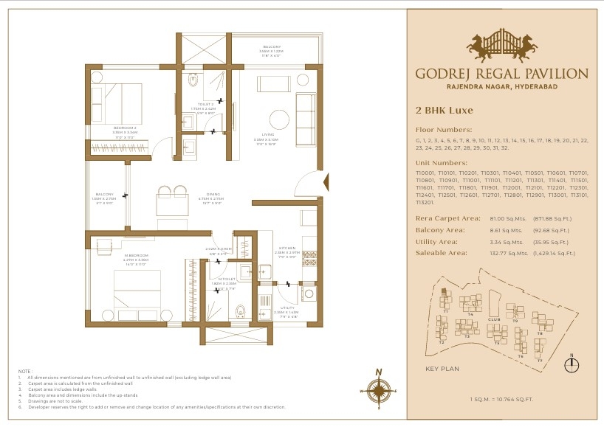

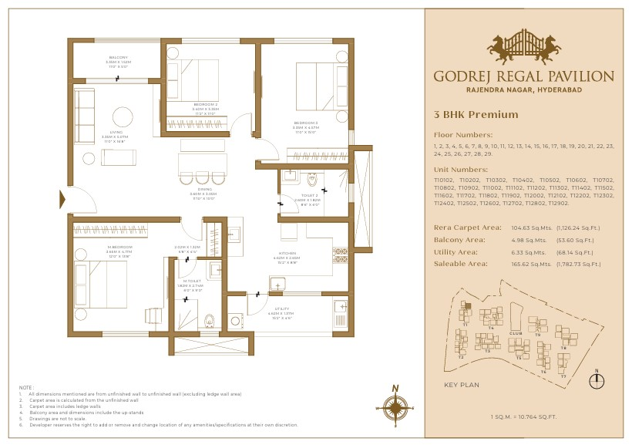
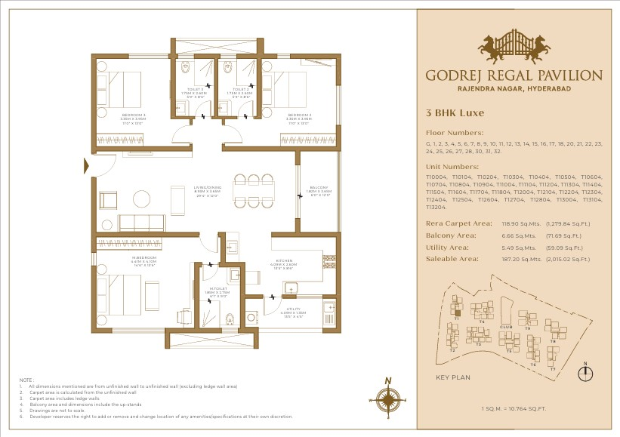
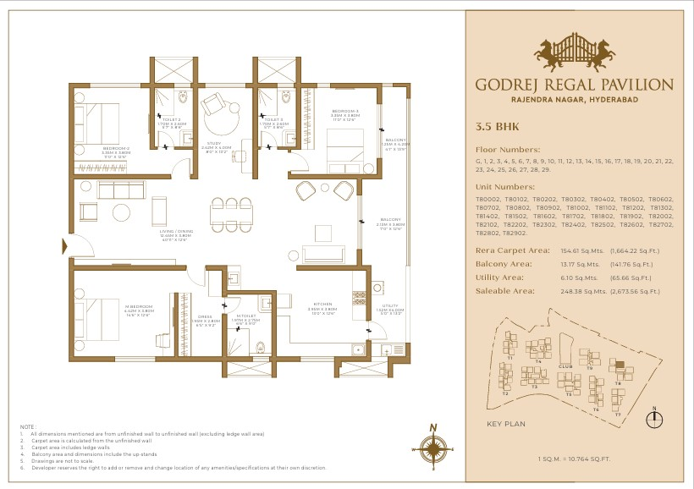
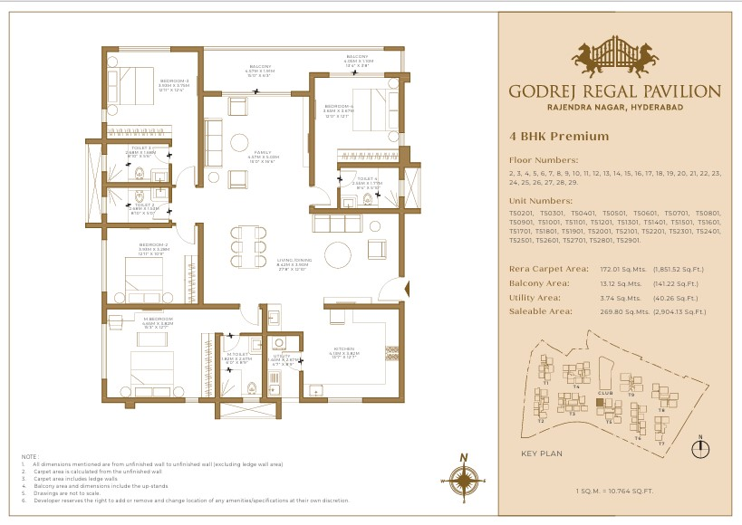

Location Advantages
- Godrej Rajendra Nagar, located near the Outer Ring Road (ORR) and the PV Narasimha Rao Expressway, provides easy access to popular destinations including Gachibowli, HITEC City, and the Financial District. The Rajiv Gandhi International Airport is just a 10- to 15-minute drive away, making travel simple for homeowners. The project's closeness to important roads, such as NH 65 and NH 44, improves access to various areas of Hyderabad.
- Surrounded by green zones and institutions like the Police Academy and Agricultural
University, it ensures a serene yet urban lifestyle.
The area has strong social infrastructure with top schools, hospitals, and retail options. 8–12% annual appreciation, it’s a high-potential investment corridor.
- Rajendra Nagar in Hyderabad is set for considerable infrastructure improvements, boosting its appeal as a residential and business hub. Notable impending developments include:
  - Development of IT Parks
The Telangana government has set up roughly 350 acres between Budvel and Kismatpur for the development of IT clusters. This plan seeks to house 28 IT firms, creating job opportunities and stimulating economic growth in the region. Also, we have GMR Aerocity which is 1500 acre land parcel near Airport.
  - Hyderabad Airport Metro Express.
The projected 31-kilometer Hyderabad Airport Metro Express will connect Raidurg to Rajiv Gandhi International Airport via Rajendra Nagar. This project is projected to drastically cut travel time to the airport while improving overall connectivity.
- Airport - 20Min (15Km)
Railway Station - Budvel railway station 7min (3.8km)
Outer Ring Road - 12min (9km)
NH44 - site is on NH44
IT Park - 22KM (40Min)

Micro Marketing Understanding
- The Rajendra Nagar micro market is one of the fastest-growing residential corridors in South Hyderabad, primarily driven by its strategic connectivity through NH-44, Outer Ring Road, and seamless access to the airport and major employment hubs. Connectivity remains the core strength of this location, making it highly accessible from key parts of the city.
- The micro market is currently in a developing-to-growth stage, where large-scale residential projects by reputed developers are shaping it into a structured residential zone. With improving infrastructure, upcoming metro connectivity, and continuous civic upgrades, the area is witnessing strong real estate activity and increasing buyer interest.
- Compared to already saturated locations like Gachibowli or Kokapet, Rajendra Nagar offers better entry pricing with higher appreciation potential, supported by consistent price growth and increasing demand from both end-users and investors.
- Overall, the micro market is transitioning from a peripheral location to a preferred residential destination, backed by connectivity, upcoming developments, and long-term growth prospects.

FAQs Used By Sales & Pre-Sales Teams
Attached in the mail
Questions | Answers
 | Location
Where is the proposed development? | Godrej Rajendra Nagar, located near the Outer Ring Road (ORR) and the PV Narasimha Rao Expressway, provides easy access to popular destinations including as Gachibowli, HITEC City, and the Financial District. The Rajiv Gandhi International Airport is just a 10- to 15-minute drive away, making travel simple for homeowners. The project's closeness to important roads, such as NH 65 and NH 44, improves access to various areas of Hyderabad.
What is the landmark ? | Professor Jayashankar Telangana Agricultural University

How far is the location from airport, railway station and bus terminus? | Airport - 20Min(15Km)  Railway Station - Budvel railway station 7min(3.8km)  Outer Ring Road - 12min(9km)  NH44 - site is on NH44  IT Park - 22KM(40Min)
Why is Rajendranagar a preferred location | Rajendra Nagar offers excellent connectivity to the Airport (15–20 mins) and Financial District (30–40 mins) via PVNR Expressway and ORR.  Surrounded by green zones and institutions like the Police Academy and Agricultural University, it ensures a serene yet urban lifestyle.  The area has strong social infrastructure with top schools, hospitals, and retail options.  8–12% annual appreciation, it’s a high-potential investment corridor.
How is this area connected to the Highways? | Site is located on NH-44
Is there a market/convenience store inside the project ? | No
Which is the nearest Mall/Shopping Complexes from the site? | Inorbit Mall Cyberabad(45Min), GVK One Mall(31Min), Forum mall Upcoming (2min).
Current Status | Approvals in Process
Approvals | Yet to obtained
Upcoming Infra? | Rajendra Nagar in Hyderabad is set for considerable infrastructure improvements, boosting its appeal as a residential and business hub. Notable impending developments include: 1. Development of IT Parks  The Telangana government has set up roughly 350 acres between Budvel and Kismatpur for the development of IT clusters. This plan seeks to house 28 IT firms, creating job opportunities and stimulating economic growth in the region.  2. Hyderabad Airport Metro Express.  The projected 31-kilometer Hyderabad Airport Metro Express will connect Raidurg to Rajiv Gandhi International Airport via Rajendra Nagar. This project is projected to drastically cut travel time to the airport while improving overall connectivity.
Likely launch month | To be updated
Property
Is the title of the property clear? | Yes
What is the current status of the litigations? | No Litigations
Is the property freehold (no encroachment)? | Yes

About the Project (Residential project)
How big is the overall project? | Site Area - 12.5 Acres
What are the different types of developments coming up? | High Rise Residential Development
How many Towers are there in | 9 Residential Towers + Clubhouse
How many floors are there in the each building? | 1 to 7 towers of G+32 floors,  8 & 9 towers of G+33 floors  Clubhouse of G+6 floors
How many 2 BHK are there | 365
How many 3 BHK + 2T are there | 334
How many 3 BHK + 3 T are there | 331
How many 4 BHK are there | 53
How many units per floor in T1 | 6 units in Typical floor
How many units per floor in T2 | 8 units in Typical floor
How many units per floor in T3 | 9 units in Typical floor
How many units per floor in T4 | 9 units in Typical floor
How many units per floor in T5 | 7 units in Typical floor
How many units per floor in T6 | 7 units in Typical floor
How many units per floor in T7 | 4 units in Typical floor
How many units per floor in T8 | 6 units in Typical floor
How many units per floor in T9 | 4 units in Typical floor
Total number of lift in T1 | 5 (4 Passenger + 1 Service)
Total number of lift in T2 | 6 (5 Passenger + 1 Service)
Total number of lift in T3 | 9 (8 Passenger + 1 Service)
Total number of lift in T4 | 9 (8 Passenger + 1 Service)
Total number of lift in T5 | 6 (5 Passenger + 1 Service)
Total number of lift in T6 | 8 (7 Passenger + 1 Service)
Total number of lift in T7 | 5 (4 Passenger + 1 Service)
Total number of lift in T8 | 5 (4 Passenger + 1 Service)
Total number of lift in T9 | 5 (4 Passenger + 1 Service)
Total number of stair case T1 | 2 Nos
Total number of stair case T2 | 2 Nos
Total number of stair case T3 | 2 Nos
Total number of stair case T4 | 2 Nos
Total number of stair case T5 | 2 Nos
Total number of stair case T6 | 2 Nos
Total number of stair case T7 | 2 Nos
Total number of stair case T8 | 2 Nos
Total number of stair case T9 | 2 Nos

Height of the building | 1 to 7 towers - 101.2m  8 & 9 towers - 104.25m  Clubhouse - 31.35m
Distance between T1 & T2 | 18m
Distance between T1 & T4 | 18m
Distance between T2 & T3 | 18m
Distance between T3 & T4 | 18m
Distance between T3 & T5 | 18m
Distance between T4 & Club House | 18m
Distance between T5 & Club House | 18m
Distance between T5 & T6 | 18m
Distance between T6 & T7 | 18m
Distance between T6 & T9 | 22m
Distance between T7 & T8 | 18m
Distance between T8 & T9 | 18m
Distance between T9 & Club House | 18m
Who are the architects? | RSP Design Consultants (India) Pvt Ltd
Tower T1 footprint- include core | 9651 Sft
Tower T2 footprint - include core | 12,302 sft
Tower T3 footprint - include core | 15,372 sft
Tower T4 footprint - include core | 15,635 sft
Tower T5 footprint - include core | 15,108 sft
Tower T6 footprint - include core | 13,709 sft
Tower T7 footprint - include core | 8,567 sft
Tower T8 footprint - include core | 13,458 sft
Tower T8 footprint - include core | 11,355 sft
Internal wall thickness | 100/200mm
External wall thickness | 200mm
USP, Club Amenities & Landscape Amenities
What is Project Level USP | Royal Retreat Designed after royal palace of India
What are the Ground level amenities | "BADMINTON COURTS  SQUASH COURT  MULTIPURPOSE ROOM "
What are the 1st Floor amenities | SPACE FOR CO-WORKING  SCAPE FOR CRECHE  SENIORS LOUNGE  GUEST ROOM + ATT. TOI - 2 nos

What are the 2nd Floor amenities | "INDOOR GAMES  BILLIARDS  MINI THEATRE  SPACE FOR LIBRARY
What are the 3rd Floor amenities | CONFERENCE
SPACE FOR SPA & SALON
SPACE FOR DANCE & MUSIC
SPACE FOR YOGA /AEROBICS"
What are the 4th Floor amenities | SPACE FOR RESTAURANT LOUNGE
What are the 5th Floor amenities | "SWIMMING POOL  KID’S POOL  PARTY HALL / LOUNGE  KITCHEN + STORE"
What are the 6th Floor amenities | GYM
Have approvals for the project come ? | Awaiting for approvals
Have Plans been approved by GHMC/ HMDA for the Project? | GHMC
When is the possession timeline? | May-30
How many floors are there in the building? | 1 to 7 towers of G+32 floors, 8 & 9 towers of G+33 floors
What is the Area of Club House of Godrej BEL? | 75000 sq.ft
RERA RELATED QUERIES
What is the project name as per RERA | Will be communicated on the day of RERA
RERA Number | Will be communicated on the day of RERA
What is Flat Carpet Area ? | Carpet Area means the net usable floor area of an apartment, excluding the area covered by the external walls, areas under services shafts, exclusive balcony or verandah area and exclusive open terrace area, but includes the area covered by the internal partition walls of the apartment.
What is Exclusive Area ? | Exclusive area or exclusive balcony/verandah/open terrace means the area of the balcony/verandah/open terrace which is appurtenant (connected/related) to the net usable floor area of an apartment and which is available for the exclusive use of the allottee.
What is Common Area ? | Common areas mean the common stair cases, lifts lobbies, common entrances and exits of the building, common basements, terraces, parks, play area, open parking areas, common storage areas and all other portion of the project in common use.
What is total flat area ? | Total Flat Area= Carpet Area+Exclusive Area of the Flat

Pricing and Payment
What is the payment schedule? Is it time bound? | Construction Linked (we will have bank tie-ups)
What is the booking amount? | Refer attached training deck or contact Site Head for booking related queries
What is the mode of payment? | Swipe / Online transfer through NEFT, RTGS or IMPS or Cheque payment or barcode scanning.
Can I pay 100% down payment? | Yes, post registration and avail benefit of PACE
What is my responsibility for disbursement of instalments through HFI’s? | Customer is entirely responsible
Is payment schedule flexible? | It will be construction linked.
What are the registration charges and stamp duty charges? | As per the governament Gudielines
Sales process
Electricity & STP & UGT & OHT
Who will provide the electricity? | TELANGANA SOUTHERN POWER DISTRIBUTION COMPANY LIMITED
Will there be DG back up | YES (100%)
Source of water | Municipal (HMWSSB)
DG capacity | 12250 KVA (1500x8 + 250x1)
STP capacity | 1604 KLD
UGT capacity at T1, T2, T3, T4, T5, T6, T7, T8,  T9 (Common) | UGT Capacity (Domestic Water) 1742 KLD  UGT Capacity (Fire) 500 KLD  UGT Capacity (Rainwater/Raw water) 607 KLD
OHT capacity | 880 KLD
Swimming Pool | YES
solar panel provision | Yes
Do we have invertor provision in flat | No
Do we have VRV in flats | No
What’s the extent of Power Back up? | 100%
How do I get Telecom/ Internet etc.  connectivity? | THROUGH ISP (LIKE AIRTEL/JIO/LOCAL)
Parking
What is the parking system? | Tandom Parking
Total number of parking | To be confirmed after Approvals
Is their sufficient parking of visitor | To be confirmed after Approvals
No. of Visitor Parking | To be confirmed after Approvals
Will there be EV provision of owner parking | To be confirmed after Approvals
Will there be EV provision in visitor parking | To be confirmed after Approvals
Width of open and approach drive way | 11M
Internal driveway in podium | 11 M
Can I take no parking or more parking per flat? | -
Construction
When does the development start? | As soon as all the approvals in place (excepted in July'25)
What is the type of construction | aluminium formwork
When can I expect to move into my new home? | RERA timeline is May'2030
Are modifications permitted in the apartments? | No
Is there a borewell? | No
Can the developer apply the flooring/finishing if I customise? | No
Can I buy Bare Flat ? | No
Launch FAQs
When is the construction starting at site? | As soon as all the approvals in place
What are the buildings that are being launched now? | Total of 5 towers are being launched with a invetory of 1083 units
In case I wish to cancel the unit after the application amount is paid? | 10% of monies is non refundable
What documents will I get after giving you the cheque/RTGS/NEFT/SWIPE? | Mail Confirmation from sales Person
What is the pricing? | To be confirmed after Approvals
What is the applicability of the current pricing? | They are subject to revision/withdrawal at any time without notice at the sole discretion of the Company
Final Ticket Size of apartments? (including GST but exclusive of SDR) | Will be shared by sales team
What is the loading %? | 42.85% loading on carpet area
General Questions
for how much time Godrej will maintain the property | Around 1 year, might get stretched to 2 years till society is formed
How the maintenance charges would be utilized? | Maintenance charges will be utilized for water, security, services and facility management services
What will be the approximate maintenance cost? | Will be communciated in final break up during allotment. But tentatively it will be at market rate
What is the floor to floor height? | 3.05M(10Ft)
What is the ceiling to floor height | 2.85M (9.8Ft)
Is project under GHMC/ HMDA? | GHMC

Legal Disclaimers
RERA Registered. RERA No: P02400009910; Project: Godrej Regal Pavilion, Survey No:
253/P, 254, 255, 256/P, 259/P, at Gagan pahad, Rajendranagar, Ranga Reddy, 500052; Website: https://rera.telangana.gov.in/
The official website of Godrej Properties Ltd. is www.godrejproperties.com. Please do not rely on the information provided on any other website. The sale will be subject to the terms of the application form, allotment letter and Agreement for Sale. The specifications/amenities mentioned in the Agreement for Sale and/or uploaded on
Karnataka RERA website shall be final and binding on the Developer and Purchaser. Recipients are advised to apprise themselves of the necessary and relevant information of the Project prior to making any purchase decisions. *This refers to the payment plan offer. Please refer to payment terms as mentioned in the AFS. Basis sole discretion of the developer. Limited time period offer. Date of publication 14th April, 2026. T&C Apply.

