Project Information Report - Godrej Parkshire

1. Project Summary
Sales Status: Sustenance
Construction Status: Under Construction , Basement Stage

2. Configurations (all of them) & Pricing (in crs.)
Configuration | SBU Size  (sq. ft.) | Pricing Range  (Agreement Value) | Pricing Range  (Agreement Value + GST) | Pricing Range (Agreement Value + GST + SDR)
2BHK  Premium | 1095 | 1.25CR - 1.40CR | 1.25CR + 5 % | 1.25CR + 5 % + 7.6%
2BHK Luxe | 1228 | 1.40CR-1.60CR | 1.40CR + 5 % | 1.40CR + 5 % + 7.6%
3 BHK  Premium | 1634 | 1.67CR-1.90CR | 1.67CR + 5 % | 1.67CR + 5 % + 7.6%
3 BHK Luxe | 1750 | 1.90CR-2.25CR | 1.90CR + 5 % | 1.90CR + 5 % + 7.6%

3. RERA: Possession & OC Timelines
- RERA Number: PRM/KA/RERA/1250/304/PR/090126/008393
- RERA Certificate Link: https://rera.karnataka.gov.in/certificate?CER_NO=PRM/KA/RERA/1250/304/PR/090126/008393
- Possession Timeline As Per RERA (Month and Year): 12/2030
- Possession Timeline Target As Per GPL (Month and Year):12/2029
- OC Timeline As Per RERA (Month and Year):
- OC Timeline Target As Per GPL (Month and Year):

4. 1% Payment Plan
• Payment Plan Calculations:

2 BHK Sample Calculation
Total Cost For Customer 13219005.00
Total Agreement Value 12337199.05

Milestone - 1% Payment Plan | % | 2BHK - 1095  sqft | Logic
On Booking | 5% | 647702.95 | 5% Of Agreement Value + additional 5% GST of  that value
Within 15 days of Booking | 5% | 647702.95 | 5% Of Agreement Value + additional 5% GST of  that value
Within 45 days or Before 30th June 2026, whichever is earlier | 10% | 1295405.9 | 10% Of Agreement  Value + additional 5%  GST of that value
On or before 5th July 2026 | 1% | 129540.59 | 1% Of Agreement Value + additional 5% GST of  that value
On or before 5th August 2026 | 1% | 129540.59 | 1% Of Agreement Value + additional 5% GST of  that value
On or before 5th Sept 2026 | 1% | 129540.59 | 1% Of Agreement Value + additional 5% GST of  that value
On or before 5th Oct 2026 | 1% | 129540.59 | 1% Of Agreement Value + additional 5% GST of  that value
On or before 5th Nov 2026 | 1% | 129540.59 | 1% Of Agreement Value + additional 5% GST of  that value
On or before 5th Dec 2026 | 1% | 129540.59 | 1% Of Agreement Value + additional 5% GST of  that value
On or before 5th Jan 2027 | 1% | 129540.59 | 1% Of Agreement Value + additional 5% GST of  that value
On or before 5th Feb 2027 | 1% | 129540.59 | 1% Of Agreement Value + additional 5% GST of  that value
On or before 5th March 2027 | 1% | 129540.59 | 1% Of Agreement Value + additional 5% GST of  that value
On or before 5th April 2027 | 1% | 129540.59 | 1% Of Agreement Value + additional 5% GST of  that value
On or before 5th May 2027 | 1% | 129540.59 | 1% Of Agreement Value + additional 5% GST of  that value
On or before 5th June 2027 | 1% | 129540.59 | 1% Of Agreement Value + additional 5% GST of  that value
On or before 5th July 2027 | 1% | 129540.59 | 1% Of Agreement Value + additional 5% GST of  that value
On or before 5th Aug 2027 | 1% | 129540.59 | 1% Of Agreement Value + additional 5% GST of  that value
On or before 5th Sept 2027 | 1% | 129540.59 | 1% Of Agreement Value + additional 5% GST of  that value
On or before 5th Oct 2027 | 1% | 129540.59 | 1% Of Agreement Value + additional 5% GST of  that value
On or before 5th Nov 2027 | 1% | 129540.59 | 1% Of Agreement Value + additional 5% GST of  that value
On Completion of Terrace | 33% | 4274839.47 | 33% Of Agreement  Value + additional 5%  GST of that value
On Receipt of OC | 20% | 2590811.8 | 20% Of Agreement  Value + additional 5%  GST of that value
On Notice of Possession | 10% | 1295405.9 | 10% Of Agreement  Value + additional 5%  GST of that value
Advance Maintenance & Sinking Fund Charges | 0% | 264946
Total Cost | 100% | 13219005.00
Additional SDR Charges of 7.6% at the time of
possession

* This illustration is for representation purposes only. The actual calculation and monthly payout may vary depending on the (i) unit selected (ii)
associated charges for that unit and (iii) the offers available at project marketing office.

5. Floor Plans
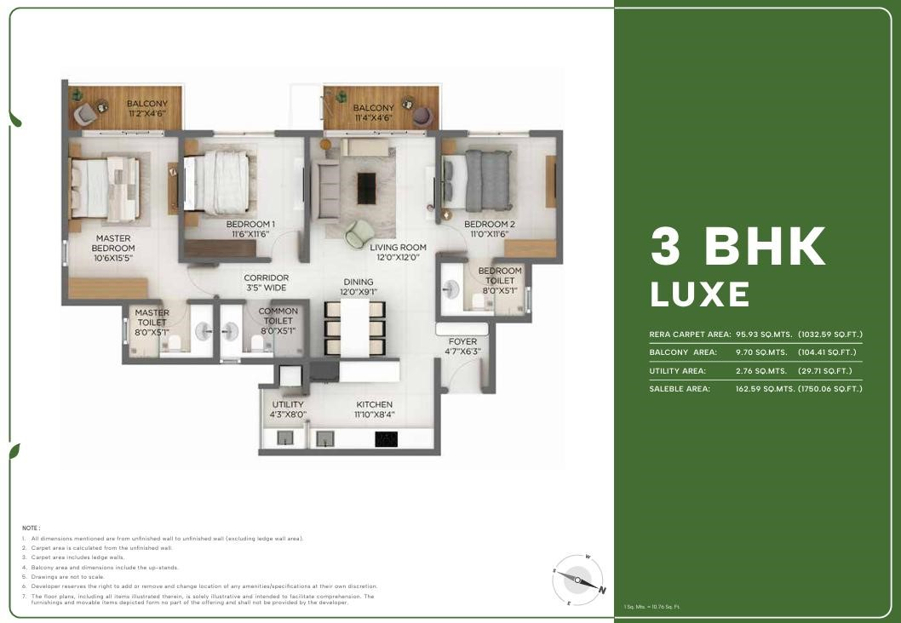

Digital Collaterals - Godrej Parkshire, Bangalore
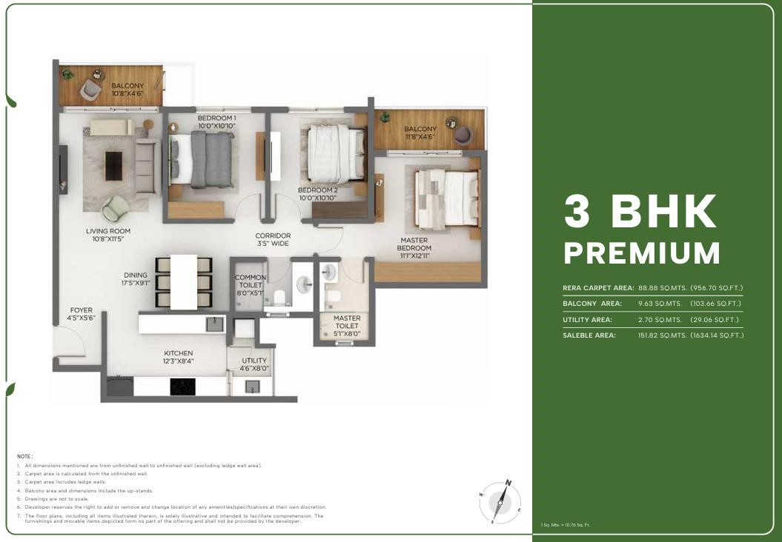

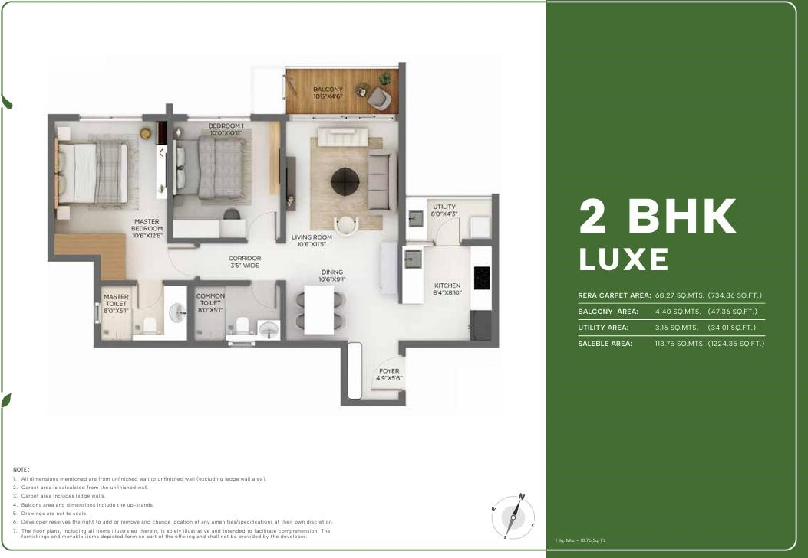

6. Location Advantages

🚗 Connectivity
- Old Madras Road – 7 mins*
- Hoskote Industrial Area – 16 mins*
- Hope Farm Junction – 20 mins*
- Whitefield Main Road – 22 mins*
- KIADB Aerospace Park – 35 mins*

🚉 Commute & Transport
- Satellite Town Ring Road (STRR) – 10 mins*
- Whitefield Metro Station (Namma Metro) – 22 mins*
- Whitefield Railway Station – 22 mins*
- Kempegowda International Airport – 40 mins*

🛍️ Recreational & Lifestyle Hubs
- Orion Uptown Mall – 12 mins*
- Decathlon OMR – 16 mins*
- INOX SBR Horizon – 18 mins*
- Vivanta Bengaluru Whitefield – 24 mins*
- Nexus Shantiniketan Mall – 28 mins*
- Phoenix Marketcity – 28 mins*

💼 Tech Parks & Employment Hubs
- Bearys Global Research Triangle – 15 mins*
- Brigade Signature Towers – 16 mins*
- International Tech Park Bangalore – 24 mins*
- ITPL – 25 mins*
- RMZ Infinity – 28 mins*
- Bagmane World Technology Centre – 30 mins*
- EPIP Zone – 30 mins*

🎓 Schools & Colleges
- Delhi Public School – 8 mins*
- Winmore Academy – 9 mins*
- The Polaris International School – 10 mins*
- One World International School – 14 mins*
- New Baldwin School – 16 mins*
- MVJ Engineering College – 18 mins*
- National Public School – 22 mins*
- Orchids International School – 30 mins*

🏥 Healthcare Facilities
- Siliconcity Hospital – 7 mins*
- MVJ Medical College & Research Hospital – 10 mins*
- Sathya Sai Orthopedic & Multispecialty Hospital – 16 mins*
- East Point Hospital – 20 mins*
- Manipal Hospital Whitefield – 24 mins*
- Vydehi Hospital – 24 mins*
- Aster Whitefield Hospital – 24 mins*

7. Micro Marketing Understanding

📍 Market Overview
Hoskote is emerging as a high-potential residential corridor in East Bangalore, driven by its strategic location between Whitefield and key industrial zones. Traditionally known as an industrial hub, Hoskote is now witnessing a shift towards organized residential development, making it attractive for both end-users and long-term investors.

📈 Growth Story
The growth of Hoskote is anchored on three key pillars:

1. Whitefield Spillover Effect
With Whitefield reaching saturation in terms of pricing and density:
- Buyers are moving outward in search of affordable alternatives
- Hoskote offers significantly lower entry prices
- Travel time remains within 20–25 minutes, making it a viable residential option
👉 This creates a strong end-user demand pipeline

2. Industrial & Employment Backbone
Hoskote is not just a residential extension—it has a self-sustaining economic base:
- Presence of Hoskote Industrial Area
- Proximity to KIADB zones and logistics hubs
- Growing warehousing and manufacturing activity
👉 This ensures consistent rental demand and workforce-driven housing needs

3. Infrastructure-Led Appreciation
Upcoming and existing infrastructure is a major catalyst:

Satellite Town Ring Road (STRR) improving regional connectivity
- Access to Old Madras Road (NH 75)
- Connectivity to Namma Metro via Whitefield
- Improved access to Kempegowda International Airport
👉 Infrastructure expansion is expected to unlock land value appreciation over the next 5–10 years

💰 Price Positioning Advantage
- Hoskote is currently 30–40% more affordable than core Whitefield
- Offers larger homes at lower ticket sizes
- Ideal for first-time homebuyers and budget-conscious IT professionals
👉 Positioned as:
“Early-entry market with future upside potential”

👥 Buyer Profile
- First-time homebuyers
- Salaried professionals working in Whitefield / ITPL
- Industrial workforce (mid-management & above)
- Long-term investors looking for appreciation

🏗️ Developer Activity & Market Maturity
- Increasing entry of branded developers like Godrej Properties
- Shift from plotted developments to integrated apartment communities
- Gradual improvement in social infrastructure (schools, hospitals, retail)
👉 Indicates transition from “emerging” to “establishing” micro-market

⚖️ Competitive Landscape
Compared to Whitefield:
- Lower price
- Slightly longer commute
Higher appreciation potential
Compared to Budigere / Old Madras Road belt:
- More industrial demand
- Better price entry
- Faster land absorption

8. FAQs Used By Sales & Pre-Sales Teams

General Project FAQs
- Where exactly is the project located?
Godrej Parkshire is located in Hoskote, East Bangalore, next to NH-648, offering easy access to major IT hubs.
- Who is the developer?
The project is developed by Godrej Properties, one of India’s most trusted real estate brands.
- Is the project RERA approved?
Yes
- What is the possession timeline?
December 2030
- What configurations are available?
2BHK and 3BHK

Pricing & Costing FAQs
- What is the starting price?
1.32cr on wards
- What are the additional charges?
GST, PLC, FRC, AM, SDR
Are there any hidden costs?
No there are no hidden charges

1% Payment Plan FAQs
- What is the 1% payment plan?
Pay monthly one percent of the property value after initial booking amount.
- Does the 1% include GST and registration?
No Those are not included.
- How much do I need to pay upfront?
10 percent of property value.
- When does the home loan EMI start?
After 10 percent of initial payment home loan can start.
- Can I prepay or exit the 1% plan?
NO

Location & Connectivity FAQs
• How far is Whitefield?
20 min from whitefield
- Is metro connectivity available?
Yes its available
- How far is the airport?
50 min from airport

Investment & Decision-Making FAQs
- Is this a good investment?
Yes, due to:
- Rapid infrastructure growth in East Bangalore
- Proximity to IT corridors
- Upcoming metro expansion

- Who is this project ideal for?

- First-time homebuyers
- IT professionals working in Whitefield
- Long-term investors

Construction & Quality FAQs
• What is the current construction status?
Under Construction, Basement

Conflict Handling FAQs
- Why should I buy in Hoskote instead of Whitefield?
You get larger homes at lower prices with future appreciation potential, while still being close to Whitefield.
- Isn’t Hoskote too far or underdeveloped?
Not anymore—Hoskote is seeing rapid infrastructure growth, highways, and planned metro connectivity.
Because of:
- Trusted brand (Godrej Properties)
- Better construction quality
- Modern amenities & community living
- Why is this priced higher than nearby local builders?

- What if the project gets delayed?

Being a reputed developer, delays are rare—and RERA ensures accountability and compensation clauses.
- Is the 1% plan really beneficial?
Yes, it reduces financial burden during construction and improves cash flow flexibility.

Closing-Oriented FAQs
- What is the best unit available now?
Premium-facing units (park view / corner units) are currently in high demand and offer better long-term value.
- Are there any current offers?
1 percent payment plan
• How do I block a unit?
Token amount of 5 percent

9. Legal Disclaimers

PRM/KA/RERA/1250/304/PR/090126/008393, available at website: http://rera.karnataka.gov.in. Site
Address: Godrej Parkshire, SY NO 36/1, 36/2, 36/3, 36/4A1, 36/4A2, 36/4B1, 36/4B2, 36/5, 36/6, 36/7, 36/8,
36/9, 66/1, 66/2, 66/3, 67/1A1, 67/1A2, 67/1A3, 67/1B1, 67/1B2, 67/1B3 67/2, 67/3, 67/4, 68/1, 68/2, 68/3, 68/4 AND 68/5 Sarkariguttahalli Village, Kasaba Hobli, Hosakote, Bengaluru Rural, Karnataka - 562114. The project is registered as Godrej Parkshire.
The official website of Godrej Properties Ltd. is www.godrejproperties.com. Please do not rely on the information provided on any other website. The sale will be subject to the terms of the application form, allotment letter and Agreement for Sale. The specifications/amenities mentioned in the Agreement for Sale and/or uploaded on Karnataka RERA website shall be final and binding on the Developer and Purchaser. Recipients are advised to apprise themselves of the necessary and relevant information of the Project prior to making any purchase decisions. *This refers to the payment plan offer. Please refer to payment terms as mentioned in the AFS. Basis sole discretion of the developer. Limited time period offer. Date of publication 14th April, 2026. T&C Apply

