Industrial Internship Report on
”Foodly – A Localized Full-Stack Food Delivery Platform”
Prepared by
Vansh Tripathi

Executive Summary
This report provides details of the Industrial Internship provided by upskill Campus and The IoT Academy in collaboration with Industrial Partner UniConverge Technologies Pvt Ltd (UCT).
This internship was focused on a project/problem statement provided by UCT. We had to finish the project including the report in 6 weeks’ time.
My project was Foodly, a full-stack, MERN-inspired food delivery platform (built with React 19, TypeScript, Express and Tailwind CSS) that replicates real-world products like Swiggy and Zomato, localized for the Indian market with INR pricing and an Indian cuisine menu. It provides four dedicated dashboards — Customer, Restaurant Owner, Delivery Partner and Platform Admin — covering order placement, live GPS delivery tracking, menu and kitchen management, driver earnings, and platform-wide financial analytics.
This internship gave me a very good opportunity to get exposure to Industrial problems and design/implement solution for that. It was an overall great experience to have this internship.

TABLE OF CONTENTS
1 Preface 3
2 Introduction 4
2.1 About UniConverge Technologies Pvt Ltd 4
2.2 About upskill Campus 8
2.3 Objective 9
2.4 Reference 9
2.5 Glossary 10
3 Problem Statement 11
4 Existing and Proposed solution 12
5 Proposed Design/ Model 13
5.1 High Level Diagram (if applicable) 13
5.2 Low Level Diagram (if applicable) 13
5.3 Interfaces (if applicable) 13
6 Performance Test 14
6.1 Test Plan/ Test Cases 14
6.2 Test Procedure 14
6.3 Performance Outcome 14
7 My learnings 15
8 Future work scope 16

Preface
Over the course of this internship, I designed and built Foodly, a full-stack food delivery platform, progressing from requirement analysis and system design in the early weeks to iterative development of the customer, restaurant, delivery and admin modules, followed by integration, testing and documentation in the final weeks.
A relevant industrial internship bridges the gap between academic learning and real-world software engineering practice, giving students like me hands-on exposure to production-style architecture, coding standards, and end-to-end project ownership that classroom coursework alone cannot provide — this is especially valuable for someone targeting full-stack and Gen AI engineering roles at product-based companies.
The problem statement was to design and build a realistic, multi-role food delivery platform — covering customer ordering, restaurant order management, delivery logistics and platform administration — as a single, cohesive full-stack application rather than a single-user CRUD demo.
This opportunity, provided by upskill Campus and UniConverge Technologies Pvt Ltd, allowed me to work independently on a project of real-world scale and complexity, with the freedom to make architectural decisions, choose the technology stack, and take the product from concept to a working, demo-ready application.
The 6-week program was planned in four broad phases: (1) requirement gathering and system design, (2) core module development — customer ordering and restaurant dashboards, (3) delivery-partner and admin module development along with GPS tracking simulation, and (4) integration, testing, and report preparation.
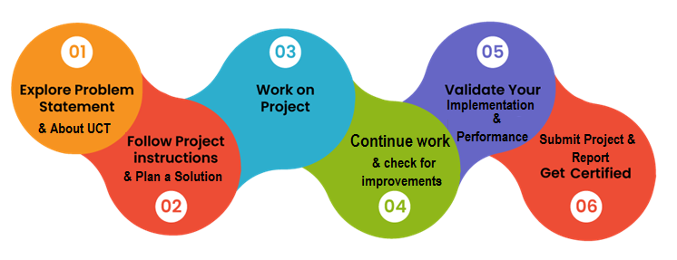
Through this internship I strengthened my practical skills in React, TypeScript, Express and REST API design, learned to structure a multi-role application with shared type safety across the frontend and backend, and gained experience translating a broad problem statement into a scoped, demo-ready product — overall, it was an enriching, confidence-building experience.
I would like to thank my mentors at Alfido Tech, upskill Campus and UniConverge Technologies Pvt Ltd for their guidance throughout this internship, as well as my faculty at Sharda University for their continued support.
To my juniors and peers: pick a project that genuinely stretches you across the full stack, keep your GitHub commits and README documentation clean from day one, and treat every internship deliverable as a portfolio piece you would be proud to show a recruiter.

Introduction

About UniConverge Technologies Pvt Ltd
A company established in 2013 and working in Digital Transformation domain and providing Industrial solutions with prime focus on sustainability and RoI.
For developing its products and solutions it is leveraging various Cutting Edge Technologies e.g. Internet of Things (IoT), Cyber Security, Cloud computing (AWS, Azure), Machine Learning, Communication Technologies (4G/5G/LoRaWAN), Java Full Stack, Python, Front end etc.
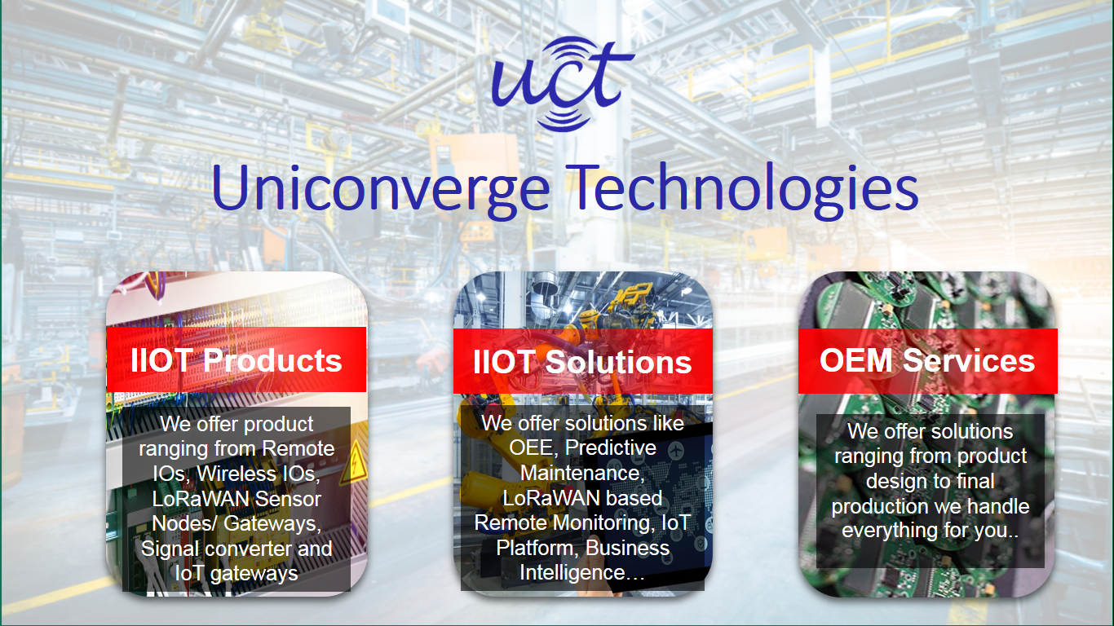
- UCT IoT Platform ()
UCT Insight is an IOT platform designed for quick deployment of IOT applications on the same time providing valuable “insight” for your process/business. It has been built in Java for backend and ReactJS for Front end. It has support for MySQL and various NoSql Databases.
- It enables device connectivity via industry standard IoT protocols - MQTT, CoAP, HTTP, Modbus TCP, OPC UA
- It supports both cloud and on-premises deployments.
It has features to
• Build Your own dashboard
• Analytics and Reporting
• Alert and Notification
• Integration with third party application(Power BI, SAP, ERP)
• Rule Engine

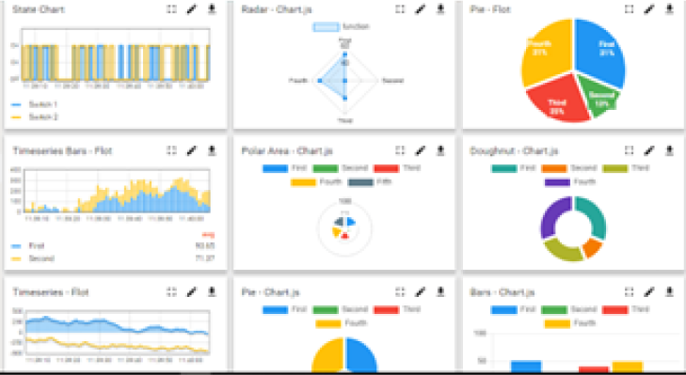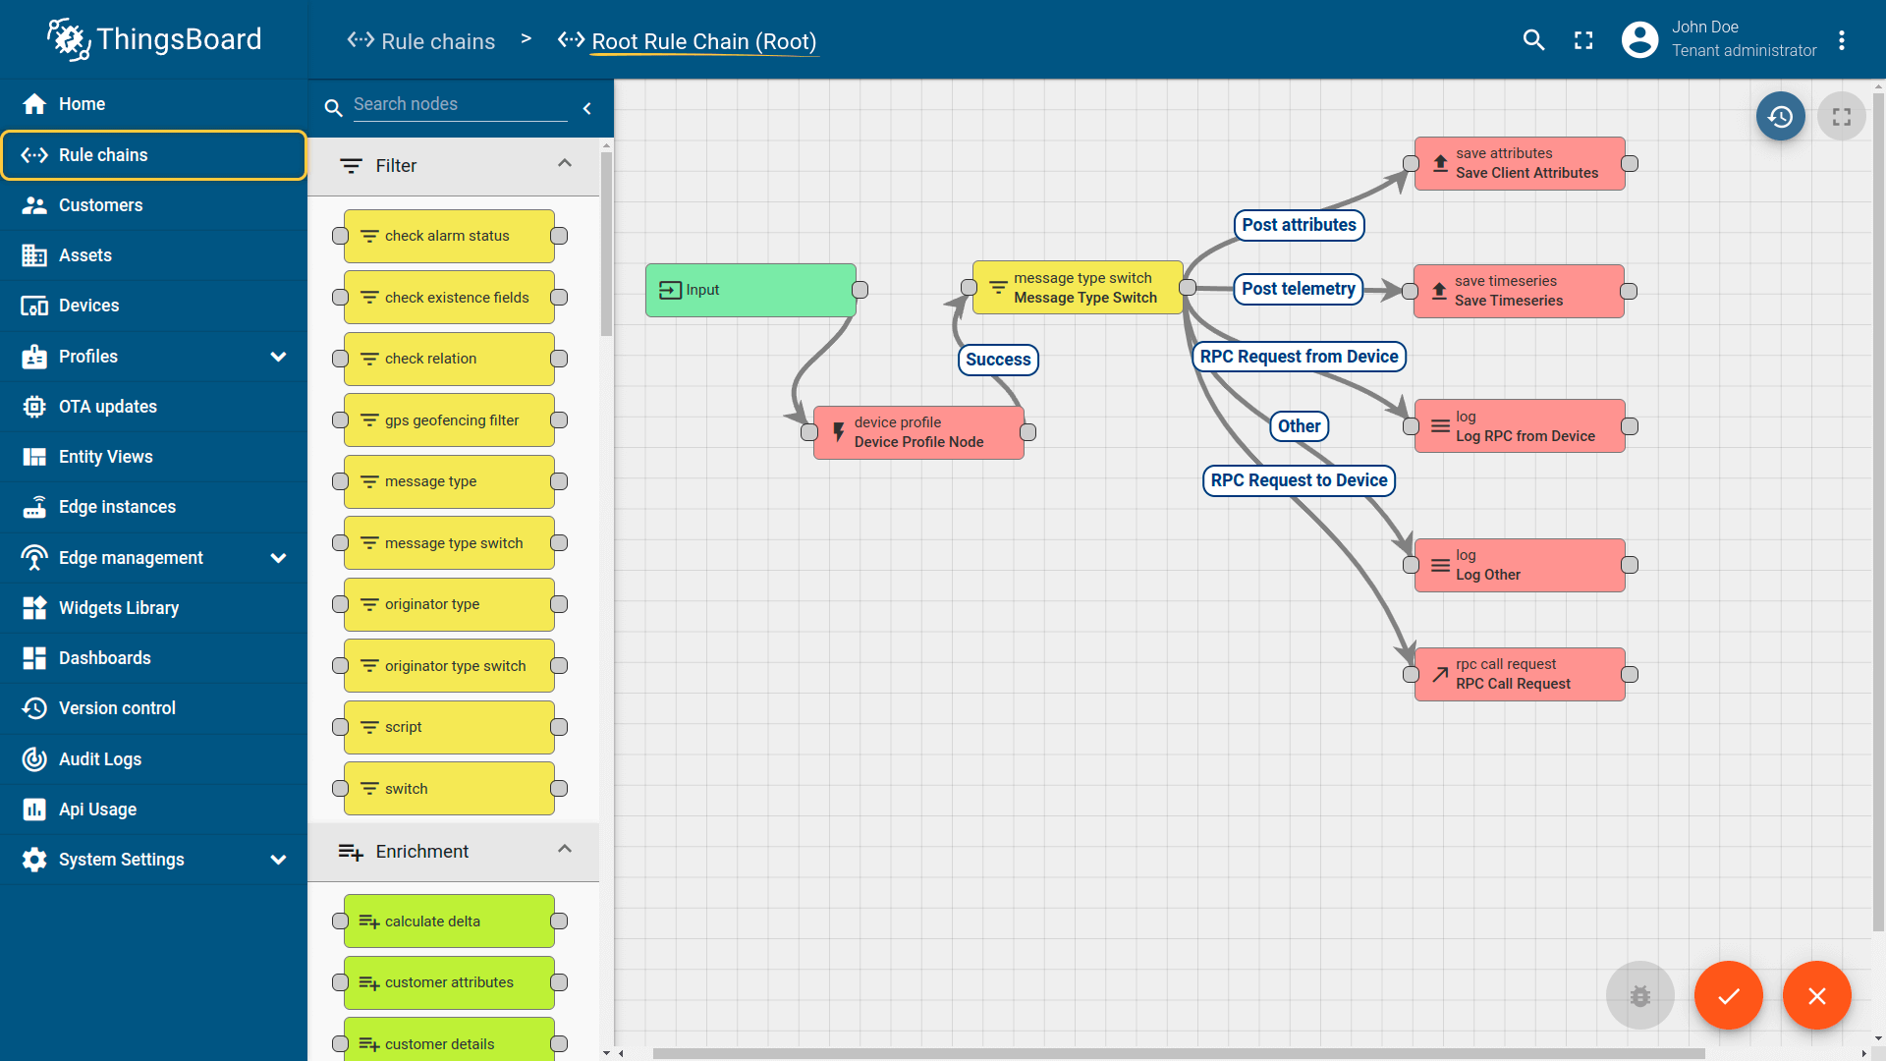

- Smart Factory Platform ()
Factory watch is a platform for smart factory needs.
It provides Users/ Factory
- with a scalable solution for their Production and asset monitoring
- OEE and predictive maintenance solution scaling up to digital twin for your assets.
- to unleased the true potential of the data that their machines are generating and helps to identify the KPIs and also improve them.
- A modular architecture that allows users to choose the service that they what to start and then can scale to more complex solutions as per their demands.
Its unique SaaS model helps users to save time, cost and money.
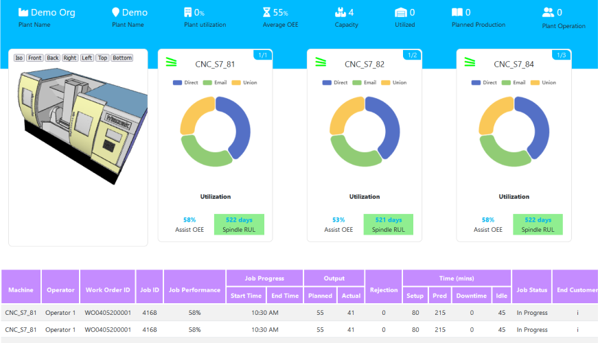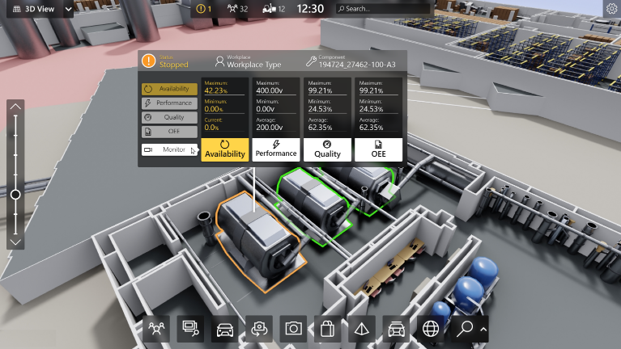

- 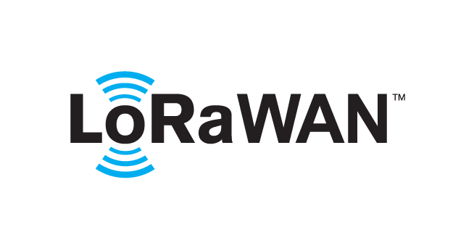 based Solution
UCT is one of the early adopters of LoRAWAN teschnology and providing solution in Agritech, Smart cities, Industrial Monitoring, Smart Street Light, Smart Water/ Gas/ Electricity metering solutions etc.
- Predictive Maintenance
UCT is providing Industrial Machine health monitoring and Predictive maintenance solution leveraging Embedded system, Industrial IoT and Machine Learning Technologies by finding Remaining useful life time of various Machines used in production process.
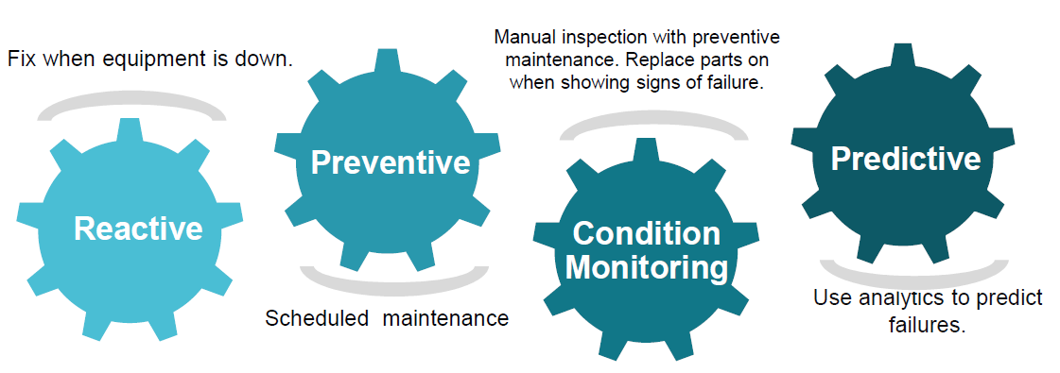

About upskill Campus (USC)
upskill Campus along with The IoT Academy and in association with Uniconverge technologies has facilitated the smooth execution of the complete internship process.
USC is a career development platform that delivers personalized executive coaching in a more affordable, scalable and measurable way.




Seeing need of upskilling in self paced manner along-with additional support services e.g. Internship, projects, interaction with Industry experts, Career growth Services
https://www.upskillcampus.com/
upSkill Campus aiming to upskill 1 million learners in next 5 year

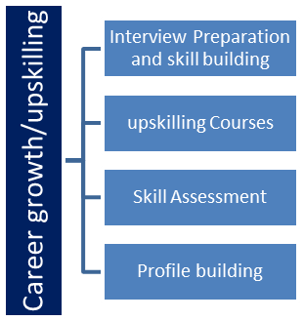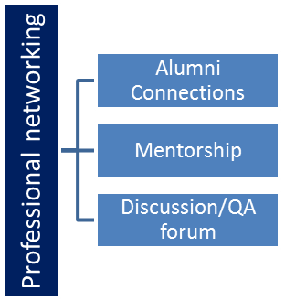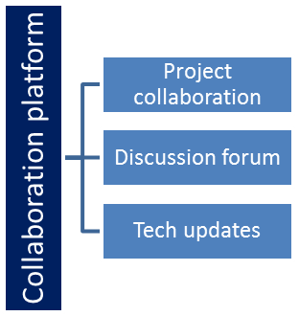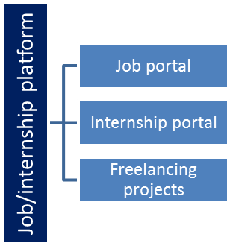

The IoT Academy
The IoT academy is EdTech Division of UCT that is running long executive certification programs in collaboration with EICT Academy, IITK, IITR and IITG in multiple domains.

Objectives of this Internship program
The objective for this internship program was to
☛ get practical experience of working in the industry.
☛ to solve real world problems.
☛ to have improved job prospects.
☛ to have Improved understanding of our field and its applications.
☛ to have Personal growth like better communication and problem solving.

Reference
[1] Foodly Project Repository: https://github.com/vanshtripat/project_foodly
[2] React 19 Documentation: https://react.dev
[3]

Glossary
Terms | Acronym
MERN | MongoDB, Express.js, React, Node.js technology stack
API | Application Programming Interface
REST | Representational State Transfer
GPS | Global Positioning System (simulated in this project)
CRUD | Create, Read, Update, Delete

Problem Statement
In the assigned problem statement
Design and develop a full-stack, multi-role food delivery platform localized for the Indian market — supporting real-time ordering, kitchen order management, delivery logistics with live tracking, dynamic pricing (taxes, delivery charges, coupons), and platform-level financial oversight — while keeping the codebase type-safe end-to-end and easy to extend.

Existing and Proposed solution

Established platforms such as Swiggy, Zomato and Uber Eats solve food delivery at massive scale, but as closed commercial products they offer no visibility into their underlying architecture, and existing open-source clones typically implement only the customer-ordering flow, leaving out the restaurant, delivery-partner and admin sides needed to understand the platform as a whole.
Foodly: a single, cohesive full-stack application built with React 19, TypeScript, Express and Tailwind CSS, implementing all four roles — Customer, Restaurant Owner, Delivery Partner and Admin — on a shared, type-safe data model, with a simulated live GPS delivery tracker, dynamic coupon and pricing engine, and role-specific analytics dashboards.
Compared to typical academic clones, Foodly adds a complete order lifecycle across all four roles, shared TypeScript types between frontend and backend for end-to-end type safety, a live GPS delivery simulation on a vector road grid, and merchant/platform analytics dashboards — making it a realistic demonstration of production-style full-stack architecture rather than a single-flow demo.

Code submission (Github link)
https://github.com/vanshtripat/project_foodly

Report submission (Github link) : https://github.com/vanshtripat/project_foodly

Proposed Design/ Model

The system follows a client-server architecture: a React 19 + TypeScript single-page frontend communicates over REST APIs (via Axios) with an Express.js + TypeScript backend, which persists state through a local JSON-based data layer. Shared TypeScript types in a common module keep request/response contracts identical on both sides. A customer places an order, which flows to the relevant restaurant owner's cookboard as a new order; the owner advances it through Accepted → Preparing → Ready for Pickup; an available delivery partner then claims it and advances it through Picked Up → On the Way → Delivered, while the customer watches progress on a simulated live GPS tracker; the completed order finally rolls up into the admin's platform-wide financial analytics.

High Level Diagram (if applicable)

Figure 1: HIGH LEVEL DIAGRAM OF THE SYSTEM

Low Level Diagram (if applicable)
At the module level: the frontend is organized into role-specific dashboard components (CustomerDashboard, OwnerDashboard, DriverDashboard, AdminDashboard) that consume a shared Redux store; the backend exposes REST routes under /api that call into a shared database module (db.ts) backed by data.json, with shared/types.ts defining the order, user, restaurant and coupon models used identically on both sides.

Interfaces (if applicable)
The frontend communicates with the backend exclusively through JSON-based REST endpoints under /api (e.g. /api/orders, /api/restaurants, /api/coupons), secured with role-aware request validation via Zod schemas. State flow between roles happens through order-status updates written to the shared data store and re-fetched by the relevant dashboards, while the delivery tracker interface updates the driver's simulated coordinates on a fixed interval and reflects them live on the customer's map view.

Performance Test

Performance testing establishes that Foodly behaves reliably under realistic, concurrent, multi-role usage rather than only in a single happy-path demo.
The main constraints identified were: API response latency under concurrent order placement, state consistency across the four dashboards when an order changes status, and correctness of the pricing engine (taxes, delivery charges and coupon deductions) under varied cart combinations.
These were addressed through shared TypeScript types and Zod-based schema validation to prevent invalid state transitions, a centralized pricing/coupon calculation module reused by both cart and checkout views to avoid duplicated logic, and a single source-of-truth JSON data layer on the backend so all four dashboards read consistent, up-to-date order state.
Manual and scripted testing across the demo sandbox accounts confirmed correct order-state propagation from customer to owner to driver to admin, accurate coupon and tax calculations across multiple cart scenarios, and stable UI behaviour when switching roles via the sandbox console without stale or conflicting data.
In this project, the relevant constraints were response consistency and data-integrity across roles rather than raw compute performance, since it runs as a lightweight Node.js/Express service.
Since the current backend uses a local JSON file rather than a production database, load/concurrency testing at scale was out of scope; the key recommendation is to migrate the persistence layer to MongoDB (with proper indexing) before any real-traffic deployment, which would also unlock horizontal scaling.

Test Plan/ Test Cases
Test cases covered: (1) placing an order with and without a coupon code, verifying correct tax and delivery-charge calculation; (2) an owner accepting, preparing and marking an order ready, verifying status updates reach the customer and driver views; (3) a delivery partner claiming, picking up and delivering an order, verifying the GPS tracker and earnings ledger update correctly; (4) an admin viewing GMV, commission and registration counts after several completed orders.

Test Procedure
Each test case was executed manually using the Foodly Sandbox Console to switch between the four demo accounts (Alice, Marc, David, Admin), performing the corresponding action in the UI and cross-checking the resulting state across all affected dashboards for consistency.

Performance Outcome
All test cases passed: order status transitions propagated correctly across roles, pricing and coupon calculations matched expected values in every scenario tested, and the GPS tracker and earnings ledger updated in sync with delivery progress, confirming the core order lifecycle is functionally reliable end-to-end.

My learnings

This internship strengthened my end-to-end full-stack skills — React 19 with hooks and Redux Toolkit for state management, TypeScript for type-safe contracts between client and server, Express.js REST API design, and Tailwind CSS for rapid, consistent UI development. Building four interconnected role-based dashboards on shared data models taught me to think in terms of system architecture rather than isolated features, which directly strengthens my portfolio for full-stack and Gen AI engineering roles at product-based companies.

Future work scope

Future enhancements include migrating persistence from the local JSON store to MongoDB with proper indexing, adding real payment gateway integration (e.g. Razorpay), integrating a real maps API in place of the simulated GPS tracker, adding JWT-based authentication with refresh tokens, and deploying the application on a cloud platform with CI/CD for continuous delivery.

