Title: Global Tuberculosis Burden and Trend Analysis (2020–2025)
Using WHO Provisional TB Notification Dataset

Name: Vansh Verma

Abstract
This analytical project investigates global Tuberculosis (TB) trends from 2020 to 2025 using the WHO Provisional TB Notification Dataset. The dataset contains country-wise, region-wise, monthly, and annual TB case notifications, reporting coverage, and reporting frequency. Using Power BI, the data was cleaned, unpivoted, modelled, and transformed into an interactive dashboard featuring KPIs, filled maps, monthly trends, Top-10 countries, scatter plots, and region-wise comparisons.
The analysis identifies a major disruption in TB notifications during 2020–2021 due to the COVID-19 pandemic, followed by gradual recovery in 2023–2025. Regions like South-East Asia and Africa continue to hold the highest TB burden, with countries such as India, Indonesia, China, Philippines, DR Congo, and South Africa ranking consistently at the top.
The dashboard supports public health decision-making by providing insights into reporting patterns, regional severity, and data quality. This project demonstrates how real-world public health data can be transformed into actionable intelligence using Power BI, enabling evidence-based planning toward WHO’s TB elimination targets.

1. Introduction
Tuberculosis (TB) remains one of the leading infectious diseases globally. WHO collects annual TB notifications from over 190 countries to monitor disease burden and evaluate progress toward elimination goals.
This report analyses global TB patterns from 2020 to 2025, a period marked by major disruptions due to COVID-19. TB detection and reporting dropped sharply during the pandemic, creating an urgent need to evaluate progress and recovery post-2022.
Power BI enables clear visualization of large datasets, allowing health authorities and researchers to understand burden, severity, and reporting gaps.

2. Need of the Analysis
This analysis was required to answer crucial questions:
✔ Why did TB notifications drop drastically during 2020–2021?
✔ Which regions and countries reported the highest burden?
✔ How did reporting coverage and frequency vary across countries?
✔ Is the world recovering towards WHO 2025 TB targets?
TB data is essential for:
- Public health planning
- Disease control strategies
- Targeted interventions
- Government & NGO decision-making
Using Power BI visuals + DAX, stakeholders can interpret trends quickly and take informed actions backed by data.

3. Motivation Behind Choosing This Report / Area
✔ Social Motivation:
TB affects millions annually and heavily impacts low-income populations.
✔ Academic Motivation:
Working with a real WHO public dataset helps develop real-world data skills.
✔ Relevance to SDGs:
This project aligns with:
SDG 3 — Good Health and Well-being
Specifically, Target 3.3: End epidemics of TB by 2030.
✔ Dataset Link:
WHO TB Data Portal:
https://www.who.int/teams/global-programme-on-tuberculosis-and-lung-health/data
Dataset used in project:
TB_provisional_notifications_2025-11-10.csv (Provided by the institution)

4. Objectives of the Analysis
- To analyse global TB case notifications from 2020–2025.
- To identify high-burden countries and WHO regions.
- To study year-wise, month-wise, and region-wise TB patterns using Power BI.
- To derive insights to support global TB elimination strategies.
- To visualize TB burden with interactive dashboards for better decision-making.

5. Report Details
- Source: WHO Provisional TB Notification Dataset
- File Used: TB_provisional_notifications_2025-11-10.csv
- Scope of Data:
  - Country
  - WHO Region
  - Year
  - Monthly notifications (m01–m12)
  - Quarterly totals
  - Reporting coverage
  - Reporting frequency
Used Tables / Columns:
- TB_Annual (cleaned)
- TB_Monthly (unpivoted)
- Region-wise distribution
- Country-wise TB burden
These datasets were used to build the Power BI dashboard.

6. Data Processing Steps
6.1 Data Extraction
- CSV file loaded into Power BI
- Preview inspected for missing values
- Dataset imported into Power Query for transformation

6.2 Data Cleaning
- Replaced null monthly values with 0
- Trimmed & cleaned country names
- Changed data types for numeric columns
- Created Total Annual Cases
- Standardized region codes
- Removed unnecessary columns

6.3 Data Modelling
Star Schema Design:
Fact Table:
- Monthly Cases
- Annual Cases
- Coverage
- Frequency
Dimension Tables:
- Dim_Country
- Dim_Year
Key Column:
Key = country & "-" & year
Relationships:
- TB Annual (1) → TB Monthly (*)
- Country dimension connected to both

6.4 Flowchart
Data Source
↓
Power Query Data Cleaning
↓
Unpivot Monthly Columns
↓
Create Measures (DAX)
↓
Build Visuals
↓
Dashboard Insights

7. Analytical Graphs & Interpretation
🔵 1. Cards
- Total Annual Cases
- Average Coverage
- YOY % Change
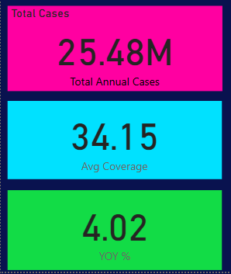

🔵 2. Filled Map (Global TB Burden)
Shows country-wise TB burden.
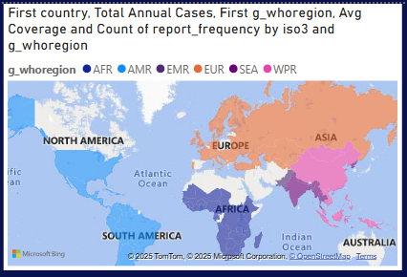

🔵 3. Top High-Burden Countries
Horizontal bar chart ranking countries by total TB cases.
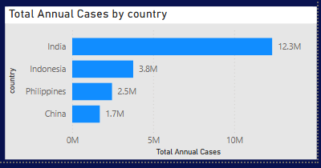

🔵 4. Monthly Trend (Line Chart)
Shows month-by-month TB case reporting.
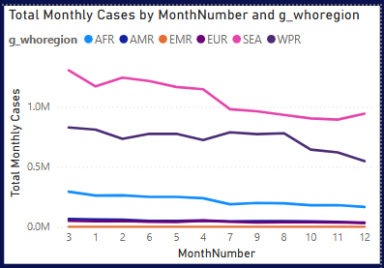

🔵 5. Region-Wise Area Chart
Compares WHO regions across months.
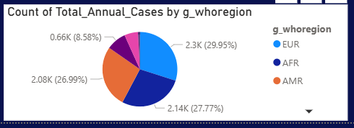

🔵 6. Clustered Bar Chart (Coverage vs Cases)
Coverage vs total cases shows reporting quality.
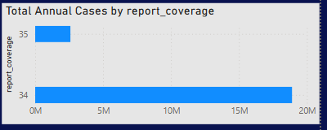

8. Further Scope of Work
- Add mortality & incidence rates
- Integrate population data to compute incidence per 100,000
- Build machine learning forecasting models
- Add treatment outcome data
- Automate dashboard refresh using APIs
- Country-level drill-through pages

9. Conclusion
This project demonstrates that Power BI is a powerful tool for transforming public health data into actionable insights. TB notifications drastically dropped during COVID-19, with signs of recovery from 2023 onwards. High-burden countries represent the majority of TB cases globally, indicating the need for targeted intervention.
Through interactive dashboards, users can explore trends, compare regions, identify anomalies, and support WHO TB elimination efforts with data-driven decisions.

10. Annexure
- Dataset Snapshot
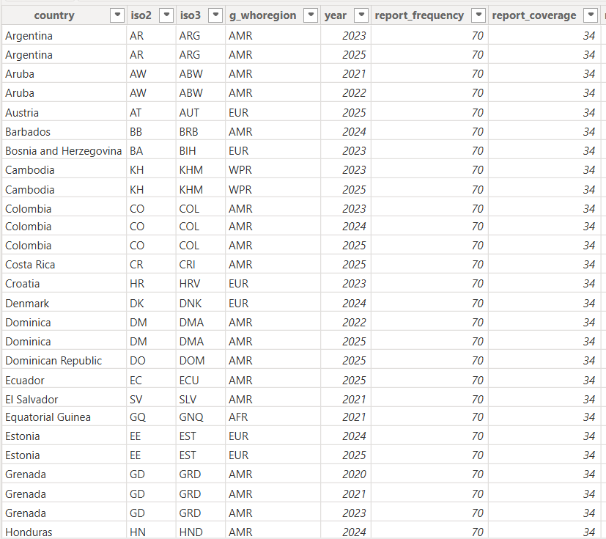
- Data Model Diagram
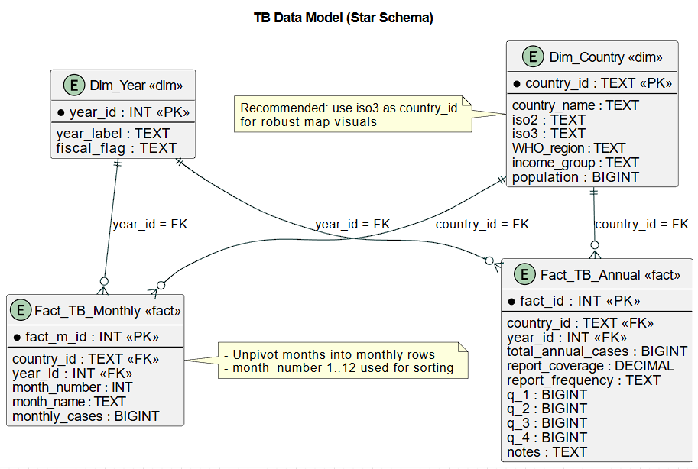
- DAX Formulas Used
  - Total Annual Cases
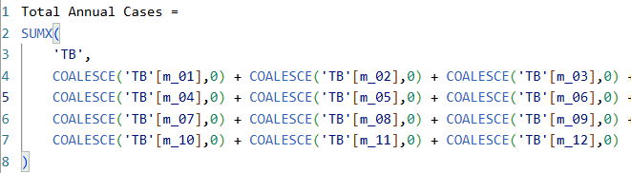
  - YOY %
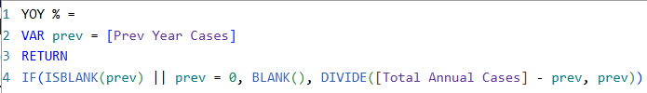
  - Average Coverage
- Screenshots of Dashboard Visuals
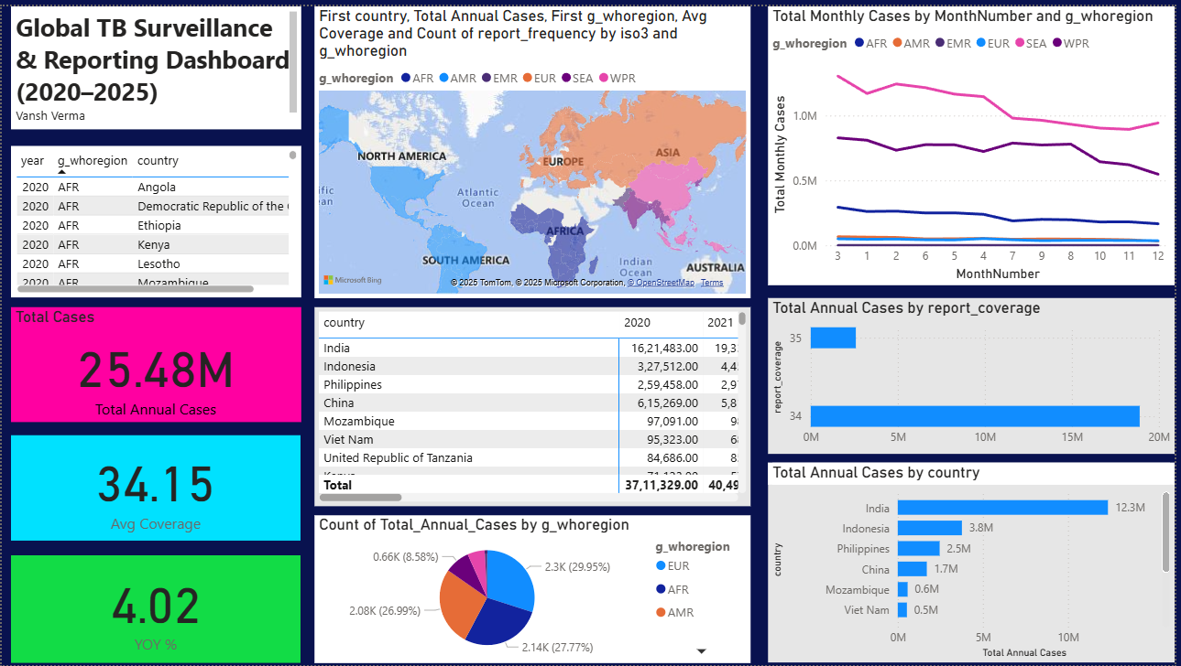
- WHO Dataset Link
https://extranet.who.int/tme/generateCSV.asp?ds=provisional_notifications

