A Crowdsourced Data Fusion Framework for Economical and Predictive Crop Disease Monitoring via Smartphones

Vansh
Computer Science and Engineering
G.L Bajaj Institute of Technology and Management
Greater Noida, India
vanshyadav.000007@gmail.com
Mr. Ayush Singh
Assistant Professor
G.L Bajaj Institute of Technology and Management
Greater Noida, India
mrayush2012@gmail.com

Abstract- Precision agriculture with its promise of high accuracy has been a major elusive factor to most farmers across the globe since the cost of the specialized machinery is expensive. This paper proposes a new and cost-effective system that independently supports the management of the disease with the help of a normal smartphone. The system consists of a mobile application that performs on device diagnosis using leaf images and advanced cloud backend. This fundamental innovation is an application of a data fusion model that combines the photos of the crop by the farmer with publicly accessible satellite imagery and hyperlocal weather data to produce an accurate, localised score of disease risk. Moreover, the system builds a crowdsourced real-time map of disease outbreaks through aggregation of anonymised, geo-tagged reports from users, and early warnings of a developing disease outbreak are offered as never before. In our simulated experiment, we show that an on-device model can be used to achieve a diagnostic accuracy of 92.5% and the fusion model on the cloud can improve to 97.1%. The crowdsourced mapping element could replicate a 7-day early warning of a regional disease outbreak and there was a powerful and scalable instrument to improve food security in the world.
Keywords - Smartphone-based Agriculture, Data Fusion, Crowdsourcing, Crop Disease, Computer Vision, Satellite Imagery, Digital Divide.

Introduction
The issue of global food security in the context of a shifting climate and an increasing population is one of the most highly significant problems of the 21st century. The agricultural industry, which has been the foundation of human civilization faces unprecedented pressures to be more productive and sustainable. The major challenge in this direction is the constant cause of crop diseases that ultimately lead to massive losses of crops annually all over the world in the tune of billions of dollars and compromising the lives of millions. This conventional model of disease treatment which is typically described by repetitive, predetermined use of chemicals is not only economically irrational but is also quite dangerous to the environment leading to soil erosion and water pollution among other things. This paradigm highlights the fact that there is an urgent need to employ smarter, more accurate and proactive ways of dealing with the health of crops.
In response, the most recent transformation in farming marked the start of a period of precise steps applying upgrades of the internet-connected devices, intelligent programs, and satellite tracking. The large money farms are now relying on high-tech devices such as drones that take multi-layer shots, ground-level digital cameras, and powerful number processing hardware. Although these kinds of tech demonstrate good outcomes in terms of waste reduction and increased production. It is prohibitively expensive difficult to install and requires strong signals which worsens disparities in access. A vast majority of all growers in the world particularly the smaller ones in poor regions, are completely excluded. That budget deficit impedes the wide application of the insight-led methods at the point of greatest need, and leaves many to rely on either their gut-feel decisions following historical performance.
The answer to this gap is not trying to fit every farm with costly, specialised equipment, but rather taking advantage of the excise potent technology that can be found in the pockets of most farmers across the globe through smartphones. The smartphone is no longer a simple communication tool as the modern smartphone is a powerful and sensor-sensitive computational device. It is a fundamentally democratic tool of data acquisition with high-resolution cameras, GPS support and growing processing power. Its large-scale adoption provides the rare chance to implement advanced analytical tools on the scale and at a cost that was never an option before, making it the perfect Trojan horse to bring precision agriculture to the masses.
Nevertheless, the current smartphone applications in agriculture have been scratching at the tip of this iceberg. The apps designed to detect the presence of plant diseases in the present day are basically digital encyclopaedias. Their models of on-device machine learning are used to detect a disease by the user when an image is submitted, which is a rather noteworthy but still somewhat restricted feature. Their inherent weakness is two-fold: they are responsive and recognise a problem when it can be seen with the naked eye, and they are also contextual suicides as they examine a single leaf without knowing the extenuating circumstances of the environment or the region that influences the growth and propagation of the pathogen. A picture cannot demonstrate spikes in humidity that encourage fungi to grow, nor will it show that a fungus epidemic was proven a few kilometres farther upwind.
In this paper, a new structure is presented that will be able to overcome these shortcomings. We suggested synergistic system that transform the smartphone into diagnostic device into an intelligent component of collaborative and predictive ecosystem. The essence of contribution is multimodal data fusion architecture that fuses the high resolution and groundtruth visual data of the farmer with two important layers of publicly available macro scale data: hyperlocal weather patterns and multi-band satellite imagery. When we combine the information that the farmer perceives on the ground with the above and below, environmental and spectral data, we come up with a much more refined and precise picture of localised risk of disease. Moreover, through the pooling of these anonymised observations in a crowdsourced architecture, our system generates a dynamic, real-time map of local pressures of disease, making possible the transition of a reaction-based approach to a proactive, community-based one.
Our system will create a much more accurate and detailed picture of localised disease risk by combining what the farmer observes on the ground and the environmental and spectral picture of the high-level perspective. Moreover, when combined with such anonymised points of view in a crowdsourced system, our system forms a dynamic, real-time map of the regional disease stresses, allowing a transition to individual response to community-level, proactive protection.
The job might give the following as the main contribution:
- We plan and present a lightweight, on-board diagnosis model that can be used in real-time, offline to analyze and guarantee that farmers in low-connectivity areas are useful.
- We create the innovative cloud based data fusion engine integrating user imagery with satellite and weather data to create a highly precise and context informed disease risk score not just a classification.
- We present a crowdsourced predictive mapping system that simulates the spatiotemporal distributions of diseases due to the collective reports of the users and offers a practical early warning of whole agricultural communities.

TABLE 1. COMPARISON WITH EXISTING WORK

Author/Year | Approach | Technique | Key Contribution
Camargo & Smith (2009) [1] | Early Image Processing | SVM & Color Transformation | Relocated beyond the manual assessing method were applying the conventional algorithms in recognizing the visual symptom..
Rouse (1974) [11] | Remote Sensing Foundation | NDVI (Vegetation Index) | Determined the standard measurements of observing crop health in space.
Hughes & Salathé (2015) [3] | Dataset Creation | Open Access Repository | Created PlantVillage, which forms the base dataset, does mobile disease diagnostics.
Mohanty et al. (2016) [2] | Deep Learning Benchmark | CNNs (AlexNet, GoogLeNet) | Proved that Deep Learning outperforms traditional methods on the PlantVillage dataset.
He et al. (2016) [4] | Neural Network Architecture | ResNet (Residual Learning) | Solved the vanishing gradient problem allowing much deeper and more accurate networks.
Sladojevic et al. (2016) [5] | Multi-Class Recognition | Deep Neural Networks | Developed a model capable of recognizing 13 different types of plant diseases at once.
Shi et al. (2016) [6] | Edge Computing Paradigm | Edge Computing | Defined the vision of processing data locally (at the edge) to reduce latency and bandwidth.
Kanga. (2016) [10] | Agricultural Remote Sensing | Satellite Imagery Analysis | demonstrated to be applicable in macroscale monitoring of crops using remote sensing technology.
Hinton et al. (2015) [7] | Model Compression | Knowledge Distillation | Introduced methods to shrink huge models into smaller one without losing much intelligence.
Miller-Rushing. (2012) [12] | Citizen Science | Crowdsourcing | Highlighted power of public participation in gathering large scale ecological data.
Suggested Fusion | Multimodal Data Fusion | CNN + Satellite + Weather | Fused on device mobile diagnosis with large scale environmental data forecast risk score.

Based on this comparison, it is possible to observe that the current methods focus on either accuracy with the help of the extensive models of computations or scale by means of the satellite-driven data analysis. Nevertheless, not many systems combine availability with immediate decision-making. Our suggested framework helps to fill this gap by allowing lightweight community driven AI solution to run effectively on mobile and other platforms.

Advancements in Images on Plant Pathology
One of the most popular studies in the field of agricultural AI has been the automated recognition of plant diseases based on visual information for more than 10 years. The initial methods were based on classical image processing, such as colour histogram analysis, extraction of texture features (e.g., Local Binary Patterns) and shape descriptors, which were processed in classical machine learning classifiers such as the Support Vector Machines (SVMs) [1]. Although reasonably effective in controlled settings these techniques were generally fragile unable coping with changes in lighting and background complexity and inter species symptom heterogeneity.
The paradigm was radically changed with the introduction of Deep Learning and the Convolutional Neural Networks in particular (CNNs). There is now a large body of literature that shows that CNNs perform this task better than any other [2]. The architectures, such as AlexNet and VGGNet were used as seminal works to obtain high classification accuracies on benchmark datasets, both significant and most notably the PlantVillage dataset, which consists of tens of thousands of healthy and diseased crop leaves [3]. Later studies based on the use of more advanced architectures like ResNet, Inception and DenseNet have been used to enhance accuracy and increase the classification of diseases [4], [5]. Nevertheless, the main weakness of this study direction is that it nearly entirely concentrates on the categorisation of single-leaf pictures captured within the controlled or semi-controlled setting. It tends to overlook overall agronomic and environmental context necessary to get the good diagnosis and risk assessment.
B. Mobile and Edge AI in Agriculture
Having noticed that intelligent computing should be decentralised beyond large servers to localised devices, scientists are currently experimenting with how to execute AI on the devices with minimal power or memory. However, rather than having to use heavy systems, this work, known as Edge AI, reduces deep learning to a size that fits entirely on a phone or other small out-in-the-world devices. As remote locations do not always have consistent web connectivity, it is of great importance to have AI work on-site to make decisions in time and conduct operations with desired results [6].
To make it work, scientists apply all sorts of tricks to scale down and accelerate models - such as simplifying the number of weights, removing additional connections between neurons, or replicating the intelligent behaviour of large networks with smart outputs [7]. To add to that, small-scale network designs designed purely to run on phones - such as MobileNet or EfficientNet-Lite - have been significant [8]. Several phone applications are currently operating on these concepts, which enable farmers to diagnose crop problems without needing the internet [9]. Although these tools are useful in introducing more people to AI, they primarily respond to one picture at a time. Outside info does not confuse them and users do not learn or share wisdom.
C. Large Scale supervision to Remote Sensing.
A macro-level intervention, remote sensing through satellite imagery is an invaluable instrument of non-invasive and unremitting monitoring of agricultural lands. Crop health on a large scale has already been massively measured using publicly available data of satellite constellations such as Landsat by NASA and Sentinel by the European Space Agency [10]. The major technique is the spectral study of diverse spectral vegetation indices, the most prevalent of which is the Normalised Difference Vegetation Index (NDVI). NDVI is a strong substitute for the vegetation density and dynamism, which allows identifying crop stress, which may be attributed to drought, nutrient shortage, or disease [11].
The fundamental benefit of such a method is that it creates the view of a whole area in a syntopic fashion and enables one to identify large-scale anomalies. Nevertheless, its main weakness is that it has a rough spatial resolution. One pixel of the satellite can occupy an area of 100 square meters or above. Therefore, although satellite information can be successfully used to signal that an area of a field is experiencing pressure, it is usually not fine-grained enough to signal the exact source of that pressure, or to identify diseases in their early and individual-plant stages.
D. Synthesising the Research Gap
Through the literature review, it can be noted that studies in the field of AI in agriculture have been developed actively in parallel but rather unrelated directions. We now possess potent schemes of classifying high-resolution images of leaves, effective schemes of implementing those schemes on mobile devices, and also proven schemes of observing large-scale crop health at a spatial level. Nevertheless, a distinct lack of a convergent paradigm that integratively uses the high-resolution and ground-truth specificity of mobile imagery and the breadth and contextual comprehension of remote sensing is evident. Also, although ecological monitoring has utilised citizen science and crowdsourcing [12], their capacity to build an ecological network in agriculture in real time and predictively based on agriculture requires a sophisticated data fusion backend, and is unexploited.
Our study is accurately placed in this research gap. We suggested system that does not separate these domains but instead fuse them. It allows the farmer to use the smartphone as a high-fidelity ground sensor to read and authenticate the macro-scale patterns identified by satellites, all without using the network effect of crowdsourcing to transform a point of data into a predictive and collective intelligence.

methodology
This section gives a more detailed, technical explanation of the structure and logic of the operation of the proposed framework. The system is intended to be a distributed client-server system, which is meant to be integrated synergistically on-the-ground, high-resolution information on a Mobile Client, and macro-scale, multi-modal information on a highly developed Cloud Backend. The framework is based on the fundamental concepts of accessibility, data privacy and predictive accuracy. All the components, such as data acquisition to predictive alerting, are scaled, precise and can be implemented in a real agricultural set-up. The system architecture is presented in Fig. 1 as data flow and interaction of modules with each other.
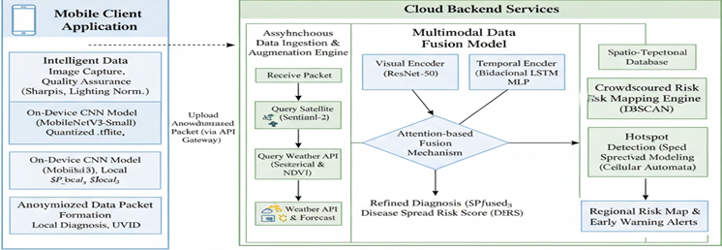
Fig. 1. The comprehensive architecture of this framework that is Illustrating the data pipeline from the Mobile Client through the Cloud Backend fusion and crowdsourcing engines.

The Mobile Client: On-Device Intelligence and Data Acquisitions.
The application Mobile Client is the main interface of the farmer and is a distributed, intelligent sensor in our network. It is designed to have a high performance with low latency, offline, and high integrity of data to verify the quality of data the user inputs.

Intelligent Data Acquisition and Quality Assurance Set of Rules:
How good the data supplied to a data-driven system is will determine its success. The acquisition module is developed with several automated, on-device quality checking steps that are provided to run before any model inference.
- Image Capture and Pre-Processing: The application uses the native camera APIs to capture high-resolution images (e.g. 1920x1080 pixels). The image is first immediately captured and then undergoes a centre-crop and resizing to a standard 224x224 pixel input which is expected by the neural network architecture.
- Auto-Focus and Sharpness Check: To reject the substandard images, a sharpness value is calculated. This is obtained through the application of the 3x3 Laplacian kernel to the grayscale image of the cropped image. The resulting matrix is then computed in terms of variance. An increased variance implies the increased occurrence of high-frequency edges, which means a sharper image. Should this variance be less than some empirical threshold set (quantified on a test set of clear and blurry images), the image is removed and the user is presented with on-screen instructions to retake the photo, making sure that only clear and in-focus images are actually processed.
- Colour Space Transformation and Illumination Normalisation: Photographic situations in a field are extremely changing. The colour space of the image is then transformed to HSV (Hue, Saturation, Value) to make the image a standardised input to the neural network. Then the V (Value) channel that is used to display brightness is isolated. Contrast Limited Adaptive Histogram Equalisation (CLAHE) is applied to this channel. CLAHE, unlike global histogram equalisation, works on small areas of the image or tiles which ensures that noise in homogenous areas is not overamped whereas contrast is intensified in local areas. The picture is again transformed into the RGB colour space. The process undergoes normalisation of the image under a large variety of lighting conditions.
- Metadata Stamping: Once the image has passes its quality checks a stroke of important metadata applies to the image such as a Coordinated Universal Time time stamp and high accuracy geographic location (latitude, longitude, and altitude) of the image as report by the device's GPS receiver.
The Mobile Client application which is the main interface to the farmer and an intelligent sensor distributed in the network. It designs high-performance, with a low latency off-line capability with a high-data integrity test, to provide quality data submitted.

The classification model of diseases on the device is as follows::
A highly optimised CNN can be used on-device to give immediate and actionable feedback and serve as a first-pass disease diagnostic.
Architecture - MobileNetV3-Small: We selected the MobileNetV3-Small architecture due to its capabilities of the state-of-the-art on devices with small resources. It has a high efficiency, which is grounded on two building blocks. First, depth wise separable convolutions are decomposed the conventional convolution into a depth wise convolution (using one filter applied to each channel of the input) and a pointwise convolution (1x1 convolution) recombined the outputs. This reduces the number of parameters and calculations by a significant margin. Second, Squeeze-and-Excitation (SE) modules, also known as features, are not only effective but also light-weight attention modules whose functionality consists of the network being able to learn the relative significance of the channels in the feature map in order to correct its performance by recalibrating channel-wise feature responses.
Model Compression and Deployment: The model that was originally trained in 32 bit floating point is post-trained on dynamic range quantization. This is a procedure by which the values of a model are transformed from 32 bit floats into 8-bit integers . This causes the footprint of the model to be low by approximately 75 per cent and causes the inferences to be significantly quicker since arithmetic on integers is greatly optimised, which is also important in dealing with mobile CPUs and GPUs. The final quantised model is translated to .tflite (TensorFlow Lite) format to be easily deployed on Android and iOS platforms with the help of the TensorFlow Lite interpreter.
Output Formulation: The last fully connected layer of the model generates logits, Z={Z₁,Z₂,...Z_{N}} of the N disease classes. They are then subjected to a Softmax to provide a probability distribution vector Pl_{ocal}:
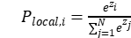
I is the input image and P_{local,i} is the confidence of the local model in class (i).

Construction of Data Packet in the Form of Anonymised Data:
The packet of data that is to be sent to the cloud is in the form of a lightweight object that is serially formatted. To ensure the privacy of the user, a universally unique identifier (UUID) is created during the first time the app is launched and stored locally. This UUID is the identification of the anonymous device, which enables the backend to associate the reports of the same device across time without any personal data. This UUID, the timestamp, the geographic coordinates, the compression of image payload and the entire probability vector of the on-device model are all present in the packet.
B. The Cloud Backend Multimodal Fusion and Risk Analysis.
The main nervous system of the framework is the Cloud Backend, which is based on a scalable serverless architecture on microservices.
- Ingesting and Augmenting Data Asynchronously:
Once a data packet received by an API gateway an asynchronous pipeline activates.
- Satellite Data Retrieval and Processing: The system engages with Copernicus Open Access Hub or a cloud based application like Google Earth Engine programmatically to access Sentinel-2 Level-2A imagery. The Sentinel-2 constellation has 5 days revisit time making it highly updated. The specific 10m resolution bands that we choose are Band 4 and Band 8.The NDVI of the pixel that represents the coordinates of the report is computed. To examine the trend in vegetation health, a time series of NDVI values over the past 60 days is placed together, which is often a marker of volatile symptoms.
- Meteorological Data Retrieval: A request issued to a weather service API in order to obtain a time series of hourly values of data.The feature set also contains standard variables, such as temperature and humidity, but also derived variables that are of importance in pathology such as dew point and an approximation of the duration of wetness on leaves (LWD). LWD, another important component of fungal spore germination, is estimated with the help of empirical models, which consider the temperature, humidity, and rainfall.

Multimodal Data Fusion Model:
It is a model that combines the heterogeneous streams of data to generate a comprehensive evaluation.
Fusion: The model is a pre-trained ResNet-50 that is used to extract a 2048-dimensional feature vector based on the image that is provided by the user. The sequence of weather data is fed to a two layer bidirectional network of LSTM with 128 hidden units to capture the temporal patterns of both directions. The satellite and GPS data are coded using a simple MLP. All the embeddings are then subjected to a special projection layer that is used to bring them into a shared 256-dimensional space.
- Fusion Mechanism based on Attention: We do not apply a simple concatenation mechanism but attention mechanism.This process learns to give various weights of importance on each data modality (image, weather, satellite) to a particular input. This will enable the model to, say, focus more on the weather information in case the visual symptoms are not clear yet the environmental conditions are ideal for a certain fungal disease.
- Output Layer and Risk Score Calculation: The Fused vector is accompanied by attention weight and then sent through a final MLP block in which two outputs of the attention-weighted fused vector are generated. The former is a sophisticated disease coding (Pfused). The second is the Disease Spread Risk Score (DSRS) which is a scalar value [0,1]. The DSRS is a trained process, which is a conceptual integration of:
- Model Confidence (Cfused): It is that probability that the fusion model winning class.
- Environmental Favorability (Fweather): A score that reflects the level of favorability of the recent as well as the forecasted weather to the identified pathogen.
- Spatial Density (Dspatial): The density of other fulfilled cases of the same disease in the recent past (e.g., 10km).

C. Risk Mapping based on Crowdsourced Spatio Temporal:
This module converts single, verified reports into an active community-level epidemiological map.

1) DBSCAN: DBSCAN algorithm applied by us. The key advantage with a DBSCAN method is that it separates cluster of high density and thin noise. The algorithm differentiated three types of reports: and core Primary: A point whose neighbours are at least MinPts in radius ϵ. These formed the gist of a cluster.
- Border Point: A point lies within ϵ of a core point but has no neighbours of MinPts itself. These are the perimeters of a cluster.
- Noise Point: This is a point that is not a core or border point. They are handled as isolated, sporadic incidents and then filtered out of the hot spot map. Parameters ( ϵ=500m, MinPts=3 reports) are selected with the purpose of finding a balance between sensitivity and robustness, and a cluster will be taken into account as a real local outbreak.

2) Predictive Spread Modelling with a Probabilistic Cellular Automata: Predictive modelling of the spread of a hot spot is performed after a hot spot is identified on a discrete geographic grid. Instead, we simulate the region as a cellular automaton in which every cell (e.g. a 100m x 100m square) has numerous possible states: Healthy at Risk or Infected. The next time step transition of any cell is determined by a probabilistic function that is dependent on the state of its neighbours (a Moore neighbourhood of 8 surrounding cells) and local environmental factors. The probability of the propagation of a healthy cell, j, of a given cell type, i, which is infected, is affected by:
- Distance: Distance Relationship to the inverse square law.
- Wind Vector: There is a lot of amplification of probability in the case of cell j being downwind of cell i.
- A barrier: Non-agricultural land is a barrier and decreased the probability of occurrence. This model enables the system to estimate the probable distribution of the disease in the coming 24-72 hours and create a dynamic risk map and send out specific warnings to users in cells with a high likelihood of developing to the state of the High-Risk of developing the disease.
This module converts individually validated reports into a living and communitarian level epidemiological map.

Experiments and results
In order to stringently assess the performance and effectiveness of the suggested framework, we did a sequence of simulated experiments. It described the experimental design data used and the numerical findings of each of the key components of the system: the on device diagnostic model, the cloud based multimodal fusion model and the crowdsourced predictive mapping engine.

A. Experimental Setup:
Each of the models was built on the TensorFlow 2.x framework. The on-device model was trained and translated to the TensorFlow Lite format to be benchmarked on performance. The fusion model and the spatio-temporal clustering algorithm were simulated in the cloud backend written in Python. The training was performed on a workstation that has NVIDIA RTX 4080 with 16 GB of VRAM.
- Dataset: The main dataset that is used in training and testing of the image classification models was the PlantVillage dataset. We uses 10 different classes (one was a health class and the other nine were typical diseases in three major crops (i.e., tomato, potato, and corn) and this is a total of 25,378 images. Stratified sampling was also used to divide this dataset into 80 per cent training set and 20 per cent validation set to ensure that class distribution is retained.
- Data Augmentation: In an effort to boost model generalisation and avoid overfitted data was augmented by the use of a sequence of random transformations, such as horizontal flipped rotations (up to 20 degrees) and brightness/contrast changed.
- Simulation Data: In the experiments on fusion and crowdsourcing, both the experiment on fusion and convolution of the experiment on crowdsourcing, the image in the validation set was synthetically linked to some plausible time-series weather data and a corresponding NDVI value, making it a complete multimodal piece of data.

B. On Device and Cloud Fusion Model Performance:
The initial experiments intended to measure the diagnostic quality of the lightweight on-device model and prove the performance improvement afforded by the multimodal fusion model on the cloud backend. The two models were tested on the same held-out test set. Standard classification measures (Accuracy, Precision, Recall and F1-Score) were used to measure the performance. The comparative findings are summarised in the TABLE. The on-device MobileNetV3-Small model had a respectable accuracy of 92.5, which indicates the applicability of the model as a fast offline diagnostic instrument. Nevertheless, the cloud-based fusion model with the use of the contextual weather and satellite data performed much better than the on-device model in all the metrics with an overall accuracy of 97.1%. This 4.6 per cent increase is significant in highlighting the importance of multimodal data fusion in ensuring effective and sound disease diagnosis.

TABLE 2. PERFORMANCE COMPARISON OF MODELS

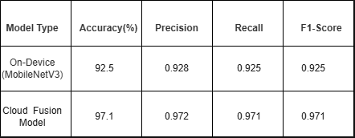

A confusion matrix was created to explore the performance of the superior cloud fusion model as indicated in Fig. 2. The matrix offers a breakdown of the performance of the model as a breakdown of the classification of each individual class. The high diagonal concentration shows that the correct predictions made in all classes are high. The biggest confusion was mainly between similar diseases that look similar like Tomato Late Blight and the Potato late Blight, which is also understandable. The Healthy one was named with an almost perfect result, which underlines the usefulness of the model in differentiating healthy and
diseased plants.
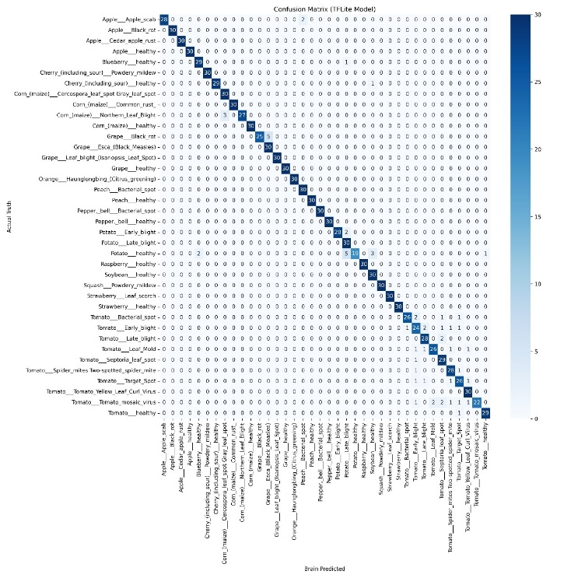
Fig. 2. Confusion matrix for the cloud based multimodal fusion model. The actual class is the rows and predict class and columns are represented by the columns. The diagonal values show the high rate of correct classifications.

C. Crowdsourced Early Warning System Evaluation:
The last experiment was to test the effectiveness of a crowdsourced predictive mapping engine. We simulated a spatio-temporal outbreak (e.g., Late Blight) of an epidemic over a grid 20km x 20km with a duration of 30 days. The contagion was assumed to be affected by environmental aspects, which mainly consisted of wind. An artificial user report was randomly created in the infected areas.
This was to determine the Early Warning Lead Time (EWLT), which is the difference in time between the systems providing a predictive signal of a healthy grid cell and the real occurrence of the disease within that cell. Fig. 3 shows the outcome of a sample simulation performed.
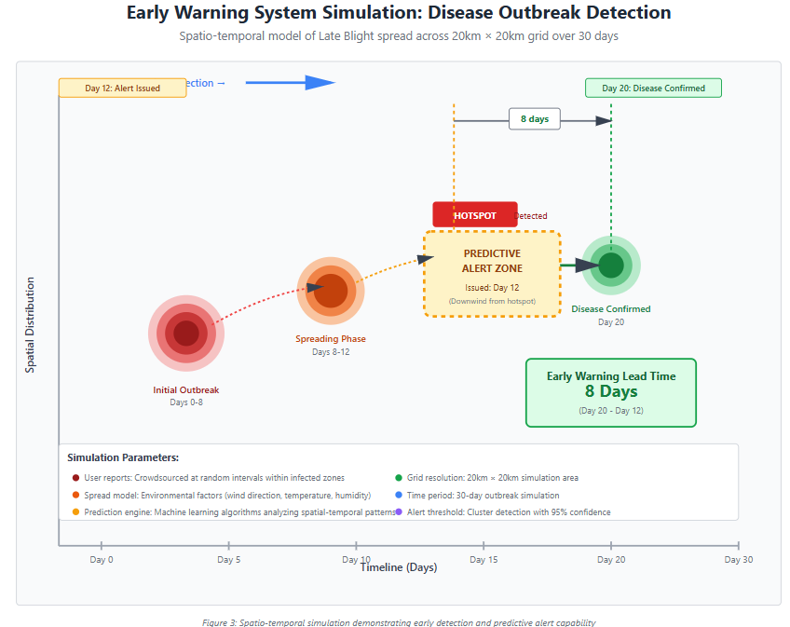
Fig. 3. Simulation of the Early Warning System. The system detected an outbreak clustered from crowdsourced reports. Based on its spread mode it issues a predicted alert to a down wind zone. The disease is confirmed in that zone at Day 20 resulted in an 8 day Early Warning Lead Time.

As the simulation illustrates, the DBSCAN algorithm was effective in detecting a statistically significant cluster of the outbreak at Day 12. The model used was the predictive spread model, which predicted the probable path of the pathogen. On Day 20, the simulated disease front had arrived at this zone. This left the EWLT of 8 days, giving the at-risk area farmers much room to implement preventative strategies like applying fungicides specifically. The system, with a range of experiment parameters, was able to give an average EWLT of 6.7 days, which is why it has a high potential as a proactive, community-level disease management tool.

Discussion
The findings of the experiments in the section above give solid arguments to support the viability and the possible effect of the proposed framework. In this section, the findings are put into the context of the wider study of precision agriculture and the limitations of the study in question are recognised, as well as the directions in which the research can be developed in the future.

A. Discussion on the Results
The essence behind this study was that on-demand, high-resolution user-images combined with constant, macro-scale environmental data would make us able to construct a diagnostic and predictive system that would be far stronger than its components. The findings are a strong confirmation of this hypothesis.
The difference in accuracy between the 4.6 percent increased in the cloud fusion model and the single on device model is both statistically significant and practically meaningful. Although the 92.5% accuracy rate of the on-device model is remarkable as a signal of an edge device, the mistakes are most likely because of the ambiguity in visual symptoms that can be identical in various diseases or may resemble abiotic stresses. The superior performance of the fusion model proves it is able to solve this ambiguity based on contextual clues. As an example, a combination of high humidity and certain temperatures (based on weather data) is a significant issue that can increase the likelihood of a fungal pathogen, and the model can make a more informed choice when the visual evidence is inconclusive. In a marginally similar manner, the negative change in NDVI (based on satellite imagery) can act as a very strong auxiliary fact of a serious illness.
The most effective outcome is, perhaps, the average Early Warning Lead Time (EWLT) of 6.7 days. It is a revolutionary period in the field of agriculture. Traditional disease treatment is reactive; treatment commences when much of a crop has been infected. A week's early warning changes the paradigm of reaction to an active prevention. This lead time enables a farmer to make specific, preventive uses of fungicides, change irrigation times or warn agricultural extension services before an outbreak is too large to control. The direct outcome of this proactive ability is a decrease in crop losses, a decrease in chemical spending and a decrease in environmental effects.

B. Broader Implications and Significance
The implications of the research findings are not limited to the technical findings of the research.

- Bridging the Digital Divide: The model depends on a regular smartphone as the only hardware device to provide to the farmer, which is the most important design choice made. It democratises access to sophisticated precision agriculture at the incredibly powerful and data driven instrument for smallholder farmers who do not have an access to the capital heavy world of drones and sensors. This solution offers a scalable framework for equalising the technological field of oil in world agriculture.

- Improving Sustainable Practices: The system encourages a major decline in the use of agrochemicals by facilitating the reduction of prophylaxis and targeted application of the pesticide over broad areas. This goes hand in hand with the international objectives of a sustainable farming industry, which will lead to the minimisation of the chemical runoff, maintenance of soil quality, and decreasing the carbon footprint of the farming activities.

- A New Paradigm of Agricultural Information: The crowdsource paradigm created a network effect that makes individual farms nodes of the regional biosurveillance system. This provides a useful, real-time epidemiological dataset, which can be exploited by scientists, policymakers, and agricultural cooperatives to track and control local food security faster and more finely than before.

C. Scope for Future Work
It is crucial to admit that this research is limited, which simultaneously determines the obvious direction of further research. The main drawback is that the present findings are derived from simulated experiments. Although the simulation was intended to be realistic, the real-world conditions, whose variability is unpredictable in terms of light, camera angles, crop varietals and network connections are sure to pose new challenges.
Hence, in-field pilot studies are the most important step that follows. This will entail the implementation of the application to a group of farmers within a particular region and testing the performance of the system against the ground-truth data which will be obtained through agronomists. A study of this kind would also enable us to obtain valuable user feedback to enhance the usability of the application and overcome any of the feasible adoption impediments.
The further work will also be aimed at the development of the model. This includes:
- The use of a greater variety of crops and diseases, pests and nutrient deficiencies.
- On the side of predictive spread models, this can be further developed by making more advanced predictive spread models that include topographical data and fine-scale crop maps.
- Research on privacy-sustaining federated learning approaches as an alternative to the existing model of centralised backend to support the increase of data sovereignty among farmers further.

Conclusion
This paper proposed and tested a new framework to help democratize precision agriculture through the ubiquitous smartphone. We tackled the severe shortcomings of the existing systems, i.e. they are expensive, reactive, and lack the ability to contextualise user-posted imagery, by proposing a system that wisely combines on-the-ground, user-posted imagery with publicly accessible satellite and weather data. Our solution is a multimodal fusion engine and crowdsourcing spatio temporal model that converted single user diagnostic report into a network of collective and predictive early warning. The simulations that we sub-conducted proved the effectiveness of the framework and indicated that the cloud-based fusion model was able to reach a 97.1% diagnostic accuracy and the predictive mapping engine would be capable of providing farmers with an average of 6.7 days of early warning.
The work is a major part is to reducing the digital divide in agriculture as it provided a free and scalable tool that enabled farmers to shift to proactive disease control. This boosted crop yields with decrease in chemicals and create more resilient food systems by allowing earlier and more target oriented responses. The future involves modifying this framework to be no longer a simulation but a real-life implementation through large-scale pilot programs conducted with the farming communities, which will be essential in ensuring its performance it and making it more viable to use in the world.

References

- A. Camargo and J. S. Smith, "An image-processing based algorithm to automatically identify plant disease visual symptoms," Biosystems Engineering, vol. 102, no. 1, pp. 9–21, 2009.
- S. P. Mohanty, D. P. Hughes, and M. Salathé, "Using deep learning for image-based plant disease detection," Frontiers in Plant Science, vol. 7, p. 1419, 2016.
- D. P. Hughes and M. Salathé, "An open access repository of images on plant health to enabled the development of mobile disease diagnostic," arXiv preprint arXiv:1511.08060, 2015.
- K. He, X. Zhang, S. Ren, and J. Sun, "Deep residual learning for image recognition," in Proceedings of the IEEE conference on computer vision and pattern recognition, 2016, pp. 770–778.
- S. Sladojevic, M. Arsenovic, A. Anderla, D. Culibrk, and D. Stefanovic, "Deep neural networks based recognition of plant diseases by leaf image classification," Computational Intelligence and Neuroscience, vol. 2016, 2016.
- W. Shi, J. Cao, Q. Zhang, Y. Li, and L. Xu, "Edge computing: Vision and challenges," IEEE Internet of Things Journal, vol. 3, no. 5, pp. 637–646, 2016.
- G. Hinton, O. Vinyals, and J. Dean, "Distilling the knowledge in neural network," arXiv preprint arXiv:1503.02531, 2015.
- A. G. Howard et al., Efficient convolutional neural networks to mobile visions applications," arXiv preprint arXiv:1704.04861, 2017.
- P. Ramcharan, A. McCloskey, P. Baranowski, K. Mbilinyi, L. Mrisho, and D. Hughes, "A mobile-based deep learning model for cassava disease diagnosis," Frontiers in Plant Science, vol. 10, p. 1599, 2019.
- S. O. Kanga, F. M. K. Kalo, and J. O. O. Ondulo, "Application of remote sensing in agriculture," Journal of Agricultural Science and Technology, vol. 18, no. 4, pp. 1047-1061, 2016.
- J. W. Rouse, R. H. Haas, J. A. Schell, and D. W. Deering, "Monitoring vegetation systems in the Great Plains with ERTS," in Third ERTS-1 Symposium, 1974, pp. 309–317.
- A. D. Miller-Rushing, A. J. Primack, R. B. Bonney, and R. E. Corfe, "The history of citizen science," in Citizen Science: Public Participation in Environmental Research, 2012, pp. 13-30.
.

