Patrick Van Stee

Quiz 1­

1. Instead of storing the red, blue, green and alpha values of each pixel together in a single array, four arrays could be used to store color values separately. Each array would store four consecutive values as a single word for a specific color. For instance, you would have an array just for the red colors and in the first item of that array you would store the red color values of the first four pixels, one in each byte of a four-byte word.

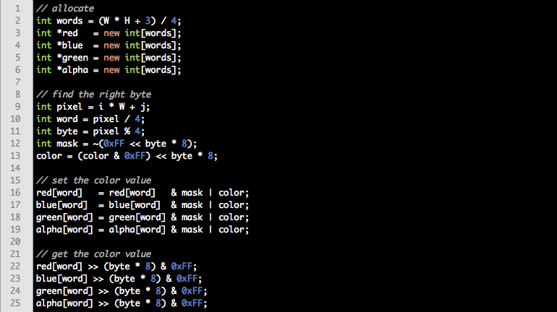

1. This data structure is more efficient if you are doing color-specific, sequential operations on the entire image since you won’t waste space in your cache by pulling up the other colors from memory for each pixel. Also, you can leave out the alpha values while still taking advantage of four byte words. However, if you are accessing each pixel sequentially and need to grab every color value for each pixel, this data structure is not as efficient since you’d have to pull a new word out of memory for each color. Another disadvantage, which is very minor, is if the number of pixels in your image is not evenly divisible by four you could waste up to twelve bytes of memory.